BAR – Backup ARchiver
Version 0.16
Table of Contents
Overview 5
Features 5
Requirements 5
Supported entry types 6
Installation 6
Packages 6
Network connection key files 7
Usage 7
Creating archives 8
File archives 8
Image archives 8
List archives content 9
Test archives 9
Compare archives 10
Extract archives 10
Incremental/Differential archives 10
Compress archives 12
Encrypt archives 12
Asymmetric encryption 13
Split archives 13
Store archives 14
File system 14
Remote server 14
CD/DVD/BD 15
Device 15
Server 16
Daemon 16
Database 16
Graphical front end 17
Status tab 18
Jobs tab 18
Files 18
Images 19
Filters 20
Storage 20
Schedule 21
Restore tab 22
Appendix 24
Archive file name macros 24
BAR command line options summary 25
Basic commands 25
Include/Exclude files 26
Incremental/Differential archives 26
Compression 27
Encryption 29
Splitting 30
Storage 30
FTP 30
SSH 30
CD/DVD/BD 31
Device 33
Restore 34
Server 34
Misc 35
BAR configuration and job files 38
Additional configuration entries 39
Block configuration entries 40
FTP server 40
SSH server 40
Device 40
Example configuration file 41
BARControl command line options summary 42
BARControl configuration file 43
Archive file format 44
Compilation 45
Development 46
Frequently asked questions 47
Contact and bug reports 51
License 51
References 52

Illustration Index
Figure 1: Graphical front end main window (status tab) 17
Figure 2: Files 19
Figure 3: Images 20
Figure 4: Filters 20
Figure 5: Storage 21
Figure 6: Archive name editor 21
Figure 7: Scheduler 22
Figure 8: Restoring files 23

Index of Tables
Table 1: Supported entries 6
Table 2: Certificates and key files 7
Table 3: Server ports 16
Table 4: Archive file name macros 24
Table 5: Pattern types 26
Table 6: Compression algorithms 28
Table 7: Encryption algorithms 29
Table 8: Log information types 36
Table 9: Compilation packages 46

Overview
BAR is backup archiver program. It can create compressed, encrypted and splitted archives of files and disk images which can be stored on a hard disk, cd, dvd, bd or directly on a server via ftp, scp or sftp. BAR can create full and incremental/differential archives. A server-mode and a scheduler is integrated for making automated backups in the background.

Features
- create, list, test, compare and extract archives of files and disk images,
- fast access to entries in archives: can find and extract single files without decompressing or decryption of the whole archive
- full and incremental/differential backup of files into archives,
- support for raw and several file systems for disk images (ext, fat, reiserfs),
- can split archives into parts of selectable size, each part can be read independently,
- compress archives with zip, bzip2 or lzma algorithms,
- encrypt archive content with gcrypt algorithms (BLOWFISH, TWOFISH, AES, a. o.),
- asymmetric encryption of content with RSA keys,
- store archives directly on external server via ftp or scp,
- with external tools: store archives on CD/DVD/BD including error correction codes,
- support storage on a generic device,
- server mode with included scheduler for doing backups regularly. Controlling the server can be done via network connection (plain & TLS/SSL),
- optional internal database with information to all stored files and disk images,
- graphical front end for server to check server status, create jobs, start jobs and stop jobs.

Requirements
To execute BAR you need:
- glibc 2.3.2 or higher
- BAR binary
- JRE 1.6 [JRE, JDK] (for graphical font end only)
Optional external tools for creating CDs/DVDs/BDs with BAR:
- growisofs [growisofs]
- mkisofs [dvd+rw-tools]
- dvdisaster [dvdisaster]
BAR is either available as a binary package for different systems or as source code for compilation. If you are not familiar with using a C compiler it is recommended to use one of the binary packages. Please check the website http://www.kigen.de/projects/bar/index.html for available binary packages.
To compile BAR you need:
- C development environment with gcc, GNU make
- perl
- zlib library [zlib]
- JDK 1.6 [JRE, JDK]
Optional for compilation are:
- bzip2 library [bzip2]
- lzma library [LZMA]
- ssh2 library [libssh2]
- gcrypt library [libgcrypt]
- gnutls library [gnutls]
- ftplib [ftplib]
- ant, launch4j [ant, launch4j]
- epm [epm]
For more details to compile BAR by yourself please see chapter Compilation, page 45.

Supported entry types
BAR support the entry types listed in table 1: Supported entries.
Type | Comment
File | Regular file entries
Image | Disk block images
Directory | Regular directory entries
Link | Symbolic link entries
Hard link | Hard link entries
Special | Special files like character devices entries, block device entries, socket entries, fifo entries.
Table 1: Supported entries

Installation

Packages
Installation of BAR can be done either from pre-compiled binary package files or from the sources. Pre-compiled binary packages are available from the web site
http://www.kigen.de/projects/bar/index.html
for some major Linux distributions. If there is no pre-compiled binary package available for your platform, you must compile BAR by yourself from the sources. The chapter Compilation (see page 45) give some instructions how to compile BAR.
Installation of Debian packages:
sudo dpkg –install <BAR package file>.deb
Installation of RPM packages:
sudo rpm –install <BAR package file>.rpm

Network connection key files
To use the SSL network connection to the BAR daemon a SSL key-pair must be generated. The script bar-keygen can be used to create the required public and private key files as well as the Java key file required for the front end. To generate a new key-pair call:
sudo bar-keygen
bar-keygen uses either the key generator tool openssl from the OpenSSL project [OpenSSL] or certtool from GNU TLS project [gnutls] and the Java JRE tool keytool [JRE, JDK]. Thus to create the key files either OpenSSL or GNU TLS and Java JRE must be installed on the computer.
The generated and installed key files in the appropriated directories are shown in table 2:Certificates and key files.
File | Description
/etc/ssl/cert/bar-ca.pem | BAR certificate
/etc/ssl/private/bar-key.pem | BAR private key
/etc/ssl/cert/bar-server-cert.pem | BAR server certificate
/etc/ssl/private/bar-server-key.pem | BAR server private key
/etc/bar/bar.jks | BAR Java front end key
Table 2: Certificates and key files
Note: keep the key files always in private!

Usage
BAR is a command line tool which can be called with several options to e. g. create, list, test, compare and extract archives, include and exclude files, directories, links, hard links, special files and devices, enable compression and encryption and other things. The general syntax is:
bar [<options>] <archive file name> <file>...
BAR options are prefixed by either - (short name) or -- (long name) and may occur at any position. If an option is specified more than one time all values (for options which may occur multiple times) resp. the last value (for options which only can occur one time) are used.
The archive file name is the first non-option argument and specify the name of the archive to read or write. The archive file name can contain various macros which are expanded on runtime (see Archive file name macros, page 24 for available macros).
The following arguments are names or patterns of files which are stored, listed or restored. The number of names or patterns is only limited by the max. command line length.
Note: For server mode see chapter Server, page 16. For the graphical front end see chapter Graphical front end, page 17.
The following chapters describe the different commands and useful options. A full list of all options can be found in the appendix BAR command line options summary, page 25.
The following nomenclature is used in the following sections:
- <name> or <number> stay for a parameter, e. g. a name, a number or some text,
- [...] optional parameter,
- ... repeat the parameter one or more times,
- <size> specify a byte size. Sizes can be specified as numbers including the following optional units: G, M, K which multiply the given number by 1073741824 (1024³), 1048576 (1024²), 1024 respectively.

Creating archives
BAR can create archives containing files, directories, links, hard links, special files, or block device images. Multiple entries to store into an archive can be specified on the command line. With the options -# or --include resp. -! or --exclude pattern can be specified to explicitly include or exclude entry or device patterns. By default include/exclude patterns can contain the meta characters * and ? to match multiple or single characters. With the option --pattern-type also regular expression or extended regular expression patterns can be enabled.
Note: If * or ? are used the pattern may be wrapped with '…' to avoid expansion of the pattern by the shell.
Note: If a directory contain the file .nobackup or .NOBACKUP all files in this directory and all sub-directories are excluded. The .nobackup/.NOBACKUP file will be ignored (and included in the BAR archive, too, if not excluded otherwise) when the option --ignore-no-backup-file is specified.
Note: When the option --dry-run is specified all operations are executed except compression, encryption and storage into archives, creating incremental file lists and update the index database. The --dry-run option can be used to do a dry-run to see what may be done.

File archives
To create an archive containing files, directories, links, hard links, or special files enter the command:
bar --create <archive file name> <file or directory>...
bar -c <archive file name> <file or directory>...
Examples:
bar --create home.bar /home
bar -c backup1.bar /home/foo/file1.txt /home/foo/file2.txt
bar -c backup2.bar /home/foo/*.txt -# 'documents/*' -! '*/trash/*'
bar -c backup3.bar /home --dry-run

Image archives
To create an archive containing the image of a disk or partition enter the command:
bar --image <archive file name> <device name>...
bar -m <archive file name> <device name>...
Examples:
bar --image home.bar /dev/hda
bar -m home.bar /dev/hda1
When you create an archive with disk images BAR tries to detect the used file system on the device. If the file system is known only blocks used by the file system are stored. Not used blocks are stored as “0”-blocks, thus when compression is used disk images become smaller. To disable detection of the file system and store all blocks (raw image) use the option --raw-images.
Currently supported file systems are:
- ext2
- ext3
- fat12
- fat16
- fat32
- reiserFS (version 3.5/3.6)
Experimental supported file systems are:
- ext4
- reiser4

List archives content
To list the content of archives enter the command:
bar --list <bar archive file>...
bar -l <bar archive file>...
or simply:
bar <bar archive file>...
Examples:
bar --list home.bar
bar -l backup1.bar backup2.bar
bar backup3.bar
The content of the specified archives are listed in short list format with byte sizes. To get a long list format use the option -L or --long-format, to get human readable sizes use option -H or --human-format.

Test archives
To test the integrity of an archive enter the following command:
bar --test <bar archive file>...
bar -t <bar archive file>...
Examples:
bar --test home.bar
bar -t backup1.bar backup2.bar
The specified archives are tested if all data can be read, decrypted and decompressed. If some data cannot be read, decrypted or decompressed an error is reported.

Compare archives
To compare the content of archives with the content in the file system, disk or partition enter the following command:
bar --compare <bar archive file>...
bar -d <bar archive file>...
BAR compare the archive with the content in the file system, disk or partition and report any entry or image which differs. The compare function can be used to check if an archive still contain the entries or images which are on disk.
Examples:
bar --compare home.bar
bar -d backup1.bar backup2.bar
The content of the specified archives are compared with the existing file system entries or disk image content. If some entry or image in an archive differ from the file system/image on disk a message is printed.

Extract archives
To extract (restore) the content of an archive enter the following command:
bar --extract <bar archive file>...
bar -x <bar archive file>...
BAR extract the content of the archive and restore all files,directories, links, hard links, special files and disk images which are stored in the specified archive files. Existing files, directories, links, hard links and special files will not be overwritten if not specified different by the option --overwrite-files. The destination of restored files, directories, links, hard links, special files, and disk images can be modified with the option --destination.
Note: When the option --dry-run is specified all operations are executed except actually restoring archive entries. The --dry-run option can be used to do a dry-run to see what may be restored.
Examples:
bar --extract home.bar
bar -x backup1.bar backup2.bar
bar -x backup3.bar –dry-run

Incremental/Differential archives
BAR can also create incremental and differential archives:
- Incremental archives: contain all changed files, directories, links, hard links and special files since the last incremental archive was created.
- Differential archives: contain all changed files, directories, links, hard links and special files since the last full archive was created.
Note: Incremental/Differential archives are not useful for storing disk images.
To detect which files, directories, links, hard links, or special files are changed since the last incremental archive resp. the last full archive was created, BAR create an incremental data file when the first full archive is created resp. update this file when an incremental archive is created. With the information stored in this “incremental data file” it is detected which files, directories, links, hard links, or special files must be stored in an incremental or differential archive, because they were modified in the meantime.
The incremental data files have by default the extension .bid. The full name is derived from the created archive file by the following pattern:
<path>/<archive name><date><number>.bar
will create an incremental data file with the name
<path>/<archive name>.bid
The derived default incremental data file name may be overwritten with the option -I or --incremental-list-file.
Note: Incremental data files are not encrypted, not compressed, and always stored on the local hard disk and are never transmitted to a remote server. The incremental data files are only used by BAR itself to create incremental or differential archives.
To create an incremental or differential archive first create a full archive with all entries using the following command:
bar --full --incremental-list-file=<incremental data file name> --create <archive file name> <file or directory>...
Note: Use the option --no-storage to create the incremental data file only.
Example:
bar --full --incremental-list-file=home.bid --create home.bar /home
This example command create the files home.bar and home.bid.
To create an incremental archive after some files, directories, links, hard links, or special files were modified use the command:
bar --incremental --incremental-list-file=<incremental data file name> --create <archive file name> <file or directory>...
bar -i -I=<incremental data file name> --create <archive file name> <file or directory>...
To create a differential archive after some files, directories, links, hard links, or special files were modified use the command:
bar --differential --incremental-list-file=<incremental data file name> --create <archive file name> <file or directory>...
Examples:
bar --incremental --incremental-file-name=home.bid --create home-incremental.bar /home
bar --differential --incremental-file-name=home.bid --create home-differential.bar /home
These commands read in the incremental data file home.bid and store all modified files from /home into the new archive home-incremental.bar resp. home-differential.bar. After the incremental archive is created the incremental data file home.bid is updated, too.

Compress archives
To save space in the created archive files it is highly recommended to compress the data. BAR offer different compression algorithms. If compression is enabled each entry in the archive is compressed separately. This result in a slightly bigger archive file than compressing the complete archive like e. g. tar do with the appropriated compression algorithm, but with single compressed entries BAR can list and search archive content very fast, because it is not required to decompress the whole archive content before a single entry in the archive can be read. With separately compressed archive entries also not corrupted parts of a partially corrupted archive may still be readable.
To compress the archive content use the following option:
--compress-algorithm=<name>
or
-z <name>
The supported compression algorithm names can be listed with the option -h or --help. All possible compression algorithm names are listed in table 6: Compression algorithms (see page 28).
Examples:
bar --create home.bar /home --compress-algorithm=zip1
bar --create home.bar /home -z bzip9
bar --create home.bar /home -z lzma9
The resulting compression ratio depend on the used compression algorithm.

Encrypt archives
BAR archive files can be encrypted. Encryption is done after compression and is highly recommended for archive files which are stored on external servers or CDs/DVDs/BDs to avoid non authorized access of the content.
To enable encryption use the following option:
--crypt-algorithm=<name>
or
-y <name>
When encryption is enabled, a pass phrase must be entered when the archive is created. The content of the archive may later only be accessed when the pass phrase is entered correctly again.
Note: Because of the internal structure of the archive files, the general structure (how many entries, entry types) can be read without knowledge of the pass phrase. Nevertheless all data content including meta-data like file names are encrypted and can only be read with the correct pass phrase.
For encryption the crypt algorithms of libgcrypt [libgcrypt] are used. The supported crypt algorithm names can be listed with the option -h or --help. All possible crypt algorithm names are listed in table 7: Encryption algorithms (see page 29). The strength of encryption depend on the used algorithm and the used pass phrase. Currently e. g. AES256 may be a good choice for the encryption algorithm.
Note: Do not weaken the encryption by weak pass phrases! If your pass phase used for encryption is to weak and may be guessed easily encryption become useless. Use a pass phrase of at least 8 characters and use not only characters, but digits and special characters, too. See also e. g. http://en.wikipedia.org/wiki/Passphrase how to select a good pass phrase.
Note: There is no way to restore the archive content if you forgot the pass phrase!

Asymmetric encryption
For asymmetric encryption the RSA algorithm with a public/private key-pair is used. A hybrid-encryption is used where the data is encrypted with the selected symmetric encryption algorithm (see option --crypt-algorithm) and a random generated password key. The random generated password key is RSA encrypted with the public key and stored into the archive. It can only be decrypted with private key. For each new archive part a new random key is generated.
To use asymmetric RSA encryption a public/private key-pair must be generated in advance. The key-pair can be generated with BAR with the following command:
bar –generate-keys <key file name>
<key file name> is some file name where the created key-pair should be stored. The files <key file name>.public and <key file name>.private are created. The public key is used to encrypt the random data encryption key before storing the encrypted key into the archive. The private key file is required to decrypt the random generated encryption key and the data of the archive. Thus the public key must be stored on the computer where BAR is used to create archives while the private key must be available on the computer where archive files should be read or extracted.
Example:
bar –generate-keys key
This command ask for a password phrase for the private key and then create a pair of files with the names key.public and key.private which contain a RSA key-pair.

Split archives
Complete backup archives can grow to big files depending on the content to store and the used compression algorithm. BAR offer the possibility to split archives into parts of a specific size. Parts can usually be stored more easily e. g. on a server or on CD/DVD/BD. Each created part can be read independently. Even when a single part is missing or cannot be read anymore because it became destroyed by some reason, e. g. read error on CD/DVD/BD, other parts can still be read by BAR and restored. Thus not the whole archive will get lost. Parts which cannot be read are restored as “0”-bytes in the resulting file or image.
To split an archive into pieces of a specific size use the following option:
--archive-part-size=<size>
or
-s <size>
Note: The size of a single part may become a little bit larger than the specified size when compression is used. The reason for this is that the compression algorithms usually use an internal buffer for some data which may be flushed and appended to the archive part when the part size reached the specified size.
When splitting is enabled the archive file name should contain one or more #. A consecutive sequence of # is then replaced by a unique number for each created archive part. If no # is found in the specified archive name, BAR append .###### to the archive name which result in an appended 6-digit part number.

Store archives
Created archives can be stored to several destination places by specifying an URI (Uniform Resource Identifier) at the beginning of an archive file name. The default is storing into the local file system when no URI is given. BAR can store archives directly to a remote server or with some externals tools also on CD/DVD/BD.
To create an archive which should be stored at a specific destination use the following command:
bar --create <uri><archive file name> <file or directory>...
<uri> can be one of the URIs described in the following sections.

File system
To store the archive into the file system of the local computer use the following URI:
file://<file name>
or simply
<file name>
Examples:
bar --create file:///backup/home.bar /home
bar --create /backup/home.bar /home

Remote server
BAR can store archives directly on a server either via the ftp protocol when the ftplib [ftplib] is compiled-in or via the ssh/scp protocol when the libssh2 [libssh2] is compiled-in.
To store the archive directly on a remote server use the following URIs:
ftp://[<login name>[@<login password>]]<file name>
scp://[<login name>[@<login password>]]<file name>
sftp://[<login name>[@<login password>]]<file name>
The archive (part) is first created on the local hard disk in a temporary file and is then transmitted to the remote server. Thus the local hard disk should have enough free space to hold at least one archive part. See option --max-tmp-size to limit the space BAR may use for temporary files. Transmission of an archive part to a remove server is done with full speed of the network connection uplink. To limited the used bandwidth use the option --max-band-with.
Examples:
bar --create ftp:///backup/home.bar /home
bar --create scp://foo@mypassword/backup/home.bar /home
bar --create sftp://foo@mypassword/backup/system.bar /boot /etc /usr

CD/DVD/BD
When the external tools growisofs, mkisofs [growisofs] and optionally dvdisaster [dvdisaster] are installed, BAR can also create CDs, DVDs and BDs with optionally added error correction codes. To store the archives on CD/DVD/BD use the following URIs:
cd://<file name>
dvd://<file name>
bd://<file name>
To add error correction codes in the space not used on the CD/DVD/BD the external tool dvdisaster can be used to add Reed Solomon error correction codes. BAR will call dvdisaster after creating the CD/DVD/BD image to add the error correction codes to the image when you specify the following option:
--ecc
Note: To create a CD/DVD/BD the archive files are first created in a temporary directory before they are written to the CD/DVD/BD. Thus the local hard disk should have enough free disk space to store the archive files and additionally the size of the CD/DVD/BD image. In general around 1.5GB for a CD, 9GB for a DVD (single layer), and up to 50G for a BD (single layer) of temporary disk space may be required. BAR will output a warning when the free disk space in the temporary directory may not be sufficient to create a CD/DVD/BD.
Examples:
bar --create cd://home.bar /home
bar –ecc --create dvd://home.bar /home

Device
BAR can store archives also on some general device. This could be a tape system or some other type of storage device which can be accessed via some device name.
To store the archive on a device use the following URI:
device://<device name>:<file name>
Example:
bar --create device:///device/backup/home.bar /home

Server

Daemon
BAR can be started as a server (daemon) which is running in the background and execute backup or restore jobs. To control the server you can connect to a running BAR server instance on some computer – including on a remote system – with a network connection. The network connection can either be a plain TCP/IP socket connection or it can be a protected and encrypted TLS (SSL)-socket connection (recommended).
To start BAR in server mode enter the following command:
bar --daemon
This start BAR and detach the process to run in the background. To prevent detaching the process use the option -D (may be useful for debugging purposes).
BAR server use the default ports for accepting network connections from the graphical front end as listed in table 3: Server ports. The default port settings can be overwritten with the options shown in the table in the last column.
Port | Type | Option to overwrite default value
38523 | plain connection | --server-port=<n>
38524 | TLS (SSL) connection | --tls-server-port=<n>
Table 3: Server ports

Database
When BAR is started as a server (daemon) and the optional internal database is configured (see configuration entries database-... in /etc/bar/bar.cfg) BAR create for all stored entries and disk images an entry in an internal index database. Also stored archives in the file system and on external servers are scanned and an index is created automatically if they are not already in the index. With the internal database searching for entries and disk images for restoring is much faster and possible without having direct access to the storage files.
Note: If archive files are deleted externally the corresponding BAR index database entries are not deleted automatically.
Single storage files can be added to or removed from the database index with the command line options --index-add and --index-remove of barcontrol or via the BARControl front end, tab restore in the context menu of the lists.
Note: The internal database file need some disk storage. If the database is not required or a huge number of files are stored the database feature may be disabled by removing the configuration entry database-file in /etc/bar/bar.cfg.

Graphical front end
The graphical front end BARControl for BAR can be used to control a BAR server instance running on the local or some remote computer. Via the front end the status of a server can be display, backup or restore jobs can be create, edited, deleted, started, paused, suspended or canceled.
Note: To execute the graphical front end the Java Run time Environment 1.6 [JRE, JDK] must be installed. The front end use SWT [SWT]. The required SWT libraries for Linux (32- and 64bit), Solaris (32bit), Windows (32- and 64bit), and OS X (32- and 64bit) are included in BARControl.
The graphical front end is started with:
barcontrol [<server>]
resp. with:
barcontrol.bat [<server>]
The main window look like in example figure 1: Graphical front end main window (status tab).
Note: Most input fields and buttons have a short online-help as tool tips. The tool tips are shown when you keep the mouse pointer over some field or button for a short time.
Note: To hide the shell window which is opened on Windows, create a Windows link and select in the properties settings of the Windows link the option “minimized”.
The front end try to connect to the specified server or the local computer if no sever name is specified either via a TLS/SSL encrypted connection or via a plain connection.
Note: For TLS/SSL encrypted connections a TLS/SSL key pair must be generated. The BAR tool bar-keygen can generate the key files. See chapter Network connection key files, page 7.
BARControl also have some useful command line options. See appendix BARControl command line options summary, page 42.
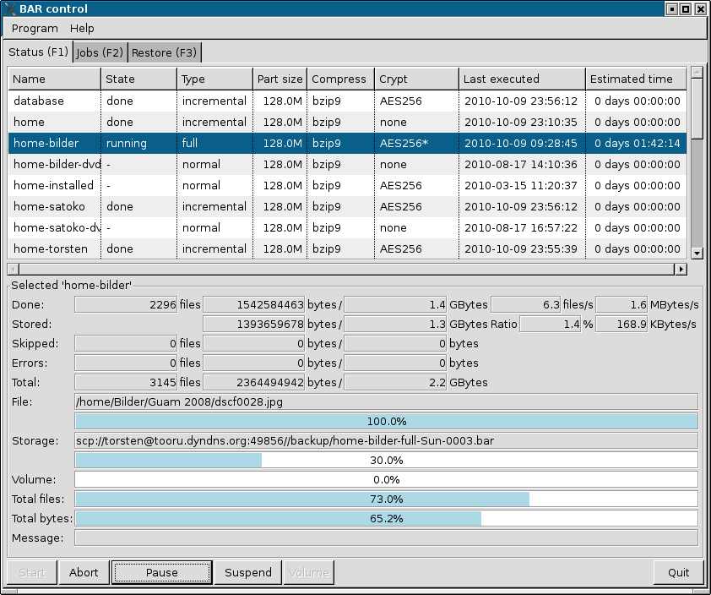Figure 1: Graphical front end main window (status tab)

Status tab
In the status tab (see example in figure 1: Graphical front end main window (status tab)) the list in the upper part show the defined backup jobs and their current status. The lower part show the detailed status of the currently select job in the list. Via the button ruler at the bottom a backup job can be started, aborted, paused or suspended.
After selecting a job in the list which is not already schedule to run or running, the job can be started with the “Start” button. In the appearing dialog you can select the specific operation:
- normal: create an archive with all entries as specified in the job. Do not read or create any incremental data files.
- full: create an archive with all entries as specified in the job. Create incremental data file.
- Incremental: create an incremental archive with all entries as specified in the job which changed since the last incremental or full archive was created. Update incremental data file.
- Differential: create an differential archive with all entries as specified in the job which changed since the last full archive was created. Do not update incremental data file.
- Dry-run: do a dry-run of all operations except compression, encryption and storing data.
When data is written to a CD, DVD, BD or a device and a new volume is required, a message appear that a new volume should be inserted. With the button Volume BAR is informed that a new volume is loaded and can be used to store the next part of the data.
The message line also show error messages in case some job execution fail due to some error.
Note: The complete long text of the field “Message:” can be displayed in a tool tip box when the mouse is positioned over the text.

Jobs tab
In the jobs tab backup jobs can be created, copied, edited, renamed and deleted. Each job have a unique name and is stored into a text file by the BAR server (default directory is /etc/bar/jobs). A job file contain the following data:
- included entry names
- included images
- excluded entries
- storage information
- schedule information
The jobs tab have some sub tabs to edit these pieces of data.

Files
With the files tab (see example figure 2: Files) files and directories can be included and excluded into/from a backup job. A double-click on a directory resp. the arrow symbol open or close the directory. With the buttons at the bottom files, directories, links, hard links and special files can be included (entry become green) or excluded (entry has a red cross). Entries which are not either explicitly included or excluded will become included or excluded in the backup when the parent entry is included or excluded.

Images
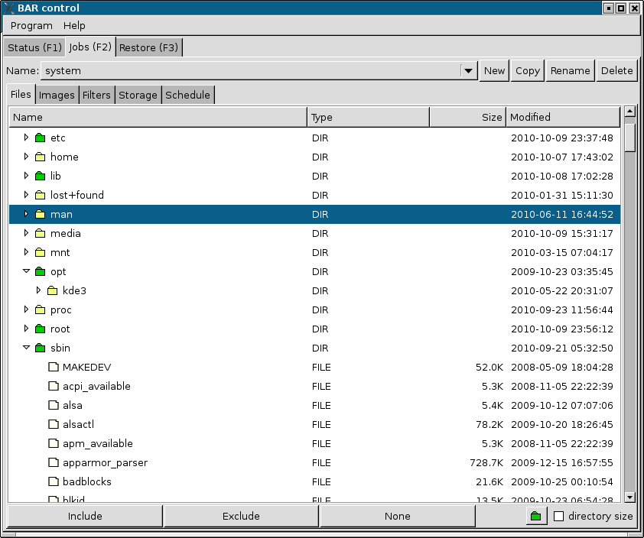Figure 2: Files
Similar to files, directories, links, hard links and special files in the files tab, in the images tab (see example figure 3: Images) devices can be selected to be stored into an archive as block device images.
Note: The block device should not be mounted while creating an image backup.

Filters
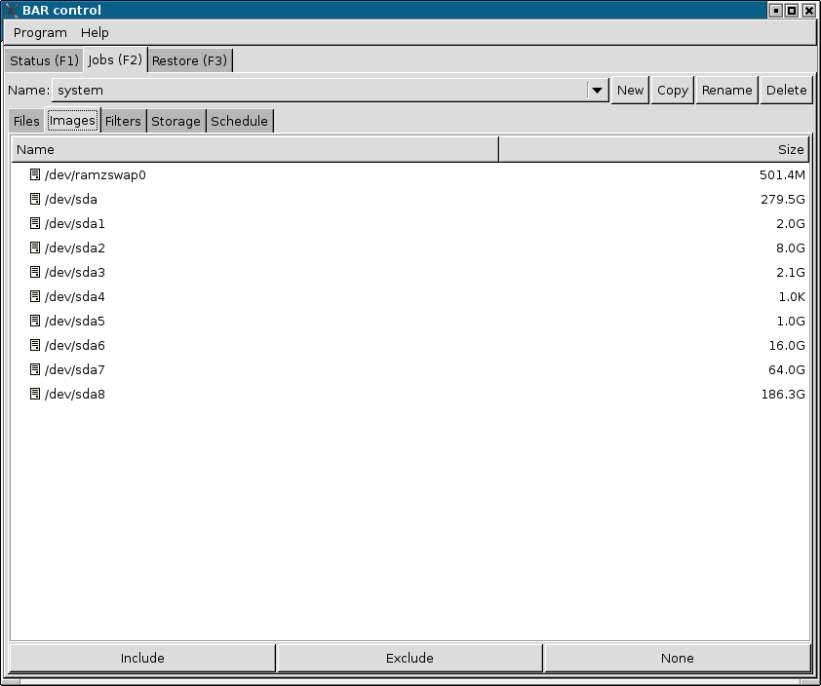Figure 3: Images
In the filters tab (see example figure 4: Filters) general include and exclude filters can be specified. Files, directories, links, hard links, special files, and device matching to an include filter and do not match to an exclude filter are included into the created archive. Entries which are explicitly excluded will never be stored into an archive.

Storage
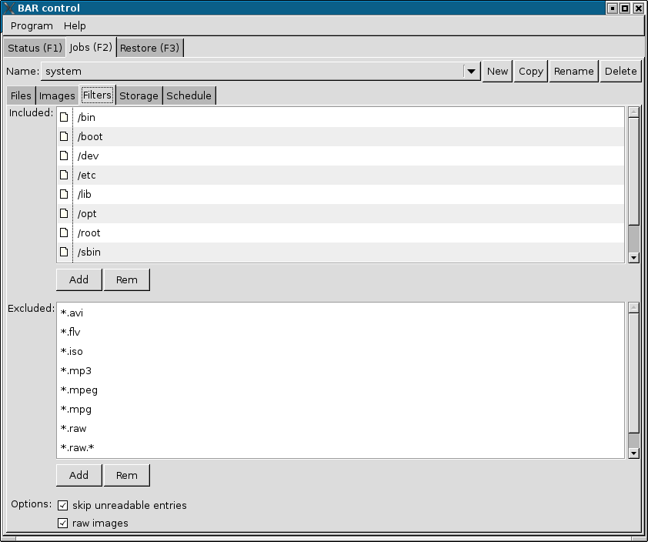Figure 4: Filters
With the storage tab (see example figure 5: Storage) different settings for storing created archive files can be edited. In this tab the archive part size, compression, encryption and the storage name and location can be set.
In the archive file name field the button to the right open an editor dialog for the archive file name. This dialog include all possible variable patterns the name may include (see example figure 6: Archive name editor). The archive file name can simply be created by drag and drop of the variable patterns into the name field. Parts can be removed by drag and drop onto the trashcan symbol or by pressing the DEL key on the keyboard.
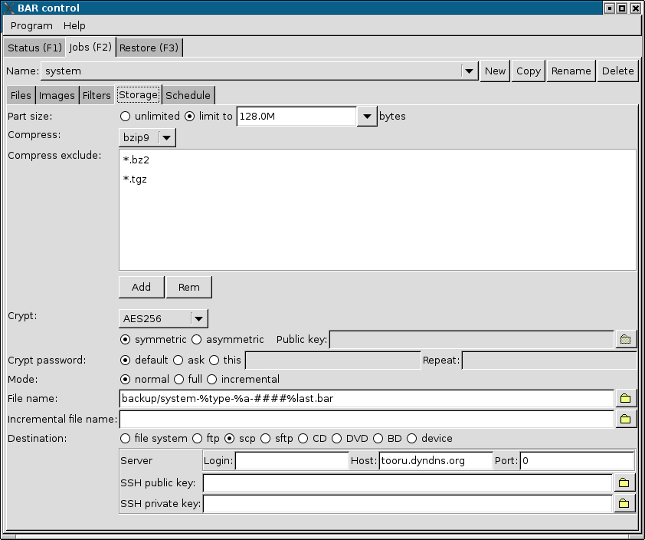Figure 5: Storage

Schedule
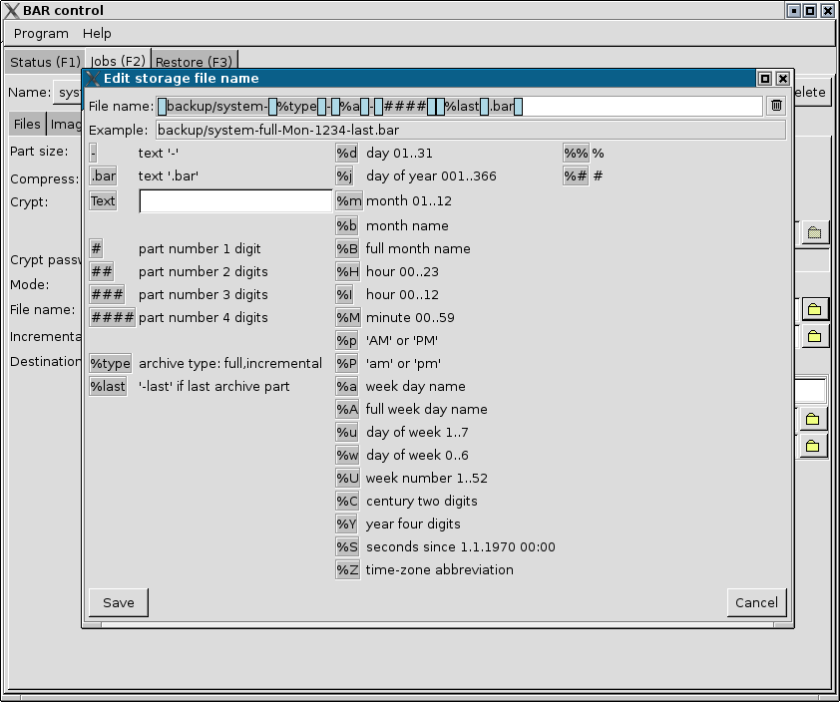Figure 6: Archive name editor
In the schedule tab (see example figure 7: Scheduler) repeated schedule time and dates for the backup job can be defined. Also the type of the created archive (default, normal, full, incremental, or differential) can be defined. The backup job will automatically executed at the specified time and dates if the job is not disabled.
Note: If a backup job was missed to execute because the BAR server was not running at the specified time, the missed job will executed immediately when the BAR server is restarted the next time.
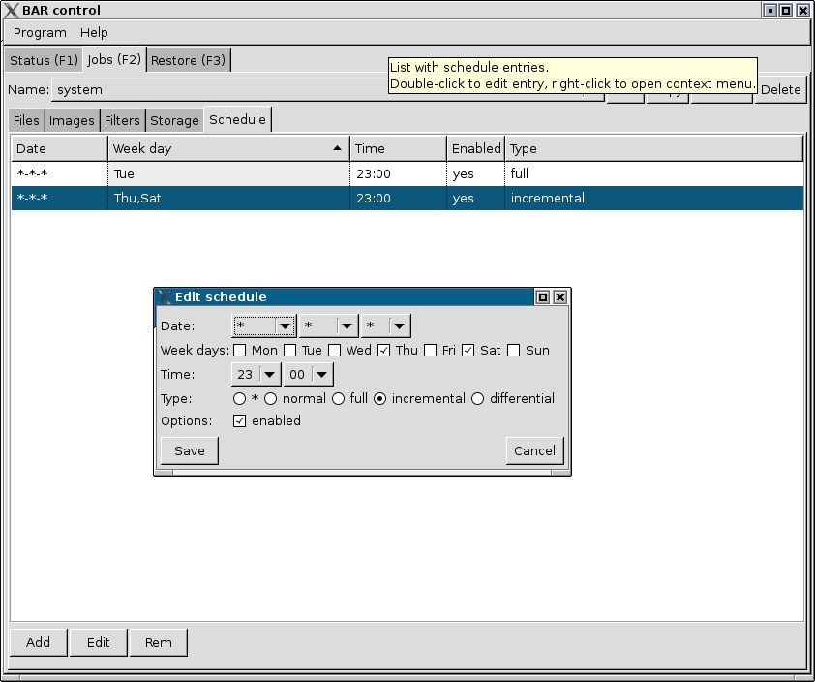Figure 7: Scheduler

Restore tab
In the restore tab (see example figure 8: Restoring files) files can be restored from archives. In the upper list all known storage archives are listed. In the input field “Filter:” below parts of storage archive names can be entered. The matching entries are listed immediately. After selecting some storage archives the whole archives can be restored with the “Restore”-button.
The bottom list show entries which are stored in some archive. By entering parts of names matching entries are listed immediately. After selecting some entries those entries can be restored with the “Restore”-button. If the check box “newest entries only” only the newest entries are shown, otherwise all existing entries are shown.
Note: The number of entries in the lists are limited. The default are 100 entries. With the selector to the right in the filter line the max. number of entries can be selected.
If a different restore destination is required, the directory to do the restore can be selected in the bottom input field. By selecting the check box “overwrite exiting files” already existing files are overwritten.
Note: Details for storage archives in the upper list and entries in the lower list can be displayed by positioning the mouse over an entry in the left part of the list.
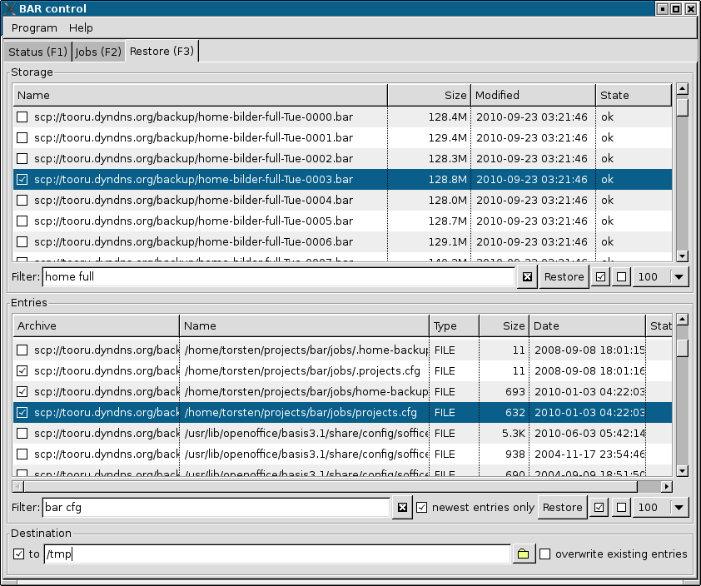Figure 8: Restoring files

Appendix

Archive file name macros
The following table list the macros which may be used in an archive file name. The macros are expanded on runtime to create the final used archive file name.
Macro | Description | Example
# | single digit of part number | 1
%type | archive type (normal, full, incremental, differential) | incremental
%last | last for last part, empty otherwise | last
%d | day of month (01..31) | 04
%j | day of year (001..366) | 134
%m | month (01..12) | 06
%b | month name (Jan..Dec) | Jun
%B | full month name (January...December)8 | June
%H | hour (00..23) | 20
%I | hour (00..12) | 08
%M | minute (00..59) | 25
%p | AM or PM | PM
%a | week day name (Mon..Sun)8 | Tue
%A | full week day name (Monday...Sunday)8 | Tuesday
%u | day of week (1..7) | 2
%w | day of week (0..6) | 1
%U | week number starting with first Sunday (00..53) | 22
%W | week number staring with first Monday (00..53) | 22
%C | century two digits | 20
%y | year two digits | 11
%Y | year four digits | 2011
%S | seconds since 1st January 1970 00:00:00 | 12345678
%Z | time zone abbreviation | JST
%% | insert % | %
%# | insert # | #
Table 4: Archive file name macros
Note: BARControl has a nice archive file name editor. See the at the archive file name field in tab Jobs, sub-tab Storage (see Storage, page 20).

BAR command line options summary
The following sections list the BAR command line options.

Basic commands
--create, -c
Create an archive with files, directories, links and special files like device-, pipes- and sockets-descriptors.
--image, -m
Create an archive with disk or partition images. BAR try to detect the file system on disk or partition and will store not used data blocks with binary content “0”. To disable this feature use option --raw-images.
Note: When compression is enabled not used data blocks will almost use no space in the created archive.
--list, -l
List content of archives. Amount and type of data shown can be selected with options --long-format, --human-format and --no-header-footer.
--test, -t
Test content integrity of archives.
--compare, -d
Compare content of archives with content in file system.
--extract, -x
Extract content of archives.
--generate-keys
Generate a public/private key pair for asymmetric encryption/decryption of archive content with RSA.
Note: RSA encryption is only used for the public/private key pair. The archive content itself is encrypted with AES 256 with a random selected password key of 2048 bit. The random password is encrypted with the public key and stored into the archive. For each part a new random password is generated. This mechanism is known as “hybrid-encryption”. Using hybrid-encryption instead of plain RSA encryption is a common technique to avoid the expensive and usually slow RSA encryption for huge amounts of data.
--generate-keys-bits=<n>
Specify number of bits to use for a RSA key pair. It can be 1024, 2048 or 3072 bits. Default value are 2048 bits.

Include/Exclude files
--include=<pattern>, -#
Define a simple file pattern (glob pattern), a regular expression, or a extended regular expression which must match to files which are included into the created archive. Default pattern type is simple file pattern. To select regular expression or extended regular expression pattern use one of the prefixes listed in the table 5: Pattern types.
Prefix | Type | Example
g: | simple pattern (glob pattern) | g:/home/foo/*.txt
r: | regular expression | r:/home/foo/.*.txt
x: | extended regular expression | x:/home/foo/.*.txt
Table 5: Pattern types

--exclude=<pattern>, -!
Define a simple file pattern (glob pattern), a regular expression, or a extended regular expression which must match to files which are excluded from the created archive. Default pattern type is simple file pattern. See table 5 how to specify different pattern types.
Note: Exclusions have precedence over include patterns.

Incremental/Differential archives
--normal
Create a normal archive. No incremental data is used or stored.
--full, -f
Create a full archive and store incremental data.
--incremental, -i
Create an incremental archive by using stored incremental data. All files, directories, links, hard links or special files which changed since the incremental data was collected or updated are stored into the archive. The stored incremental data is updated after creating an incremental archive.
See option --incremental-list-file to specify the incremental data file to use.
--incremental-list-file=<file name>
Define the file to use for storing incremental data. If the file does not exist, it is created when the the option --full is specified.
Note: Incremental data files are compressed nor encrypted and are not stored on CD/DVD/BD or transmitted to a remote server. They are used only locally by BAR.
--differential
Create an differential archive by using stored differential data. All files, directories, links, hard links or special files which changed since the incremental data was collected are stored in the archive. The incremental data is not updated after creating an differential archive.
See option --incremental-list-file to specify the incremental data file to use.

Compression
--compress-algorithm, -z
Specify the compression algorithm to use for archive content data. Which compression algorithm can be used depend on the compiled-in libraries. If all supported compression algorithms are compiled into BAR then either none or one of the zip [zlib], bzip2 [bzip2] or LZMA [LZMA] algorithms can be used. Usually LZMA have a better compression ratio than BZIP2 than ZIP. The ratio depend on the size and type of data which should be compressed. Small files and already compressed files can usually not further be compressed.
The different compression algorithms have different levels of compression. Usually a higher level result in a better compression, but require more cpu time or memory. Table 6: Compression algorithms list all supported compression algorithms.
Name | Description
none | no compression
zip1 | ZIP compression level 1
zip2 | ZIP compression level 2
zip3 | ZIP compression level 3
zip4 | ZIP compression level 4
zip5 | ZIP compression level 5
zip6 | ZIP compression level 6
zip7 | ZIP compression level 7
zip8 | ZIP compression level 8
zip9 | ZIP compression level 9
bzip1 | BZIP2 compression level 1
bzip2 | BZIP2 compression level 2
bzip3 | BZIP2 compression level 3
bzip4 | BZIP2 compression level 4
bzip5 | BZIP2 compression level 5
bzip6 | BZIP2 compression level 6
bzip7 | BZIP2 compression level 7
bzip8 | BZIP2 compression level 8
bzip9 | BZIP2 compression level 9
lzma1 | LZMA compression level 1
lzma2 | LZMA compression level 2
lzma3 | LZMA compression level 3
lzma4 | LZMA compression level 4
lzma5 | LZMA compression level 5
lzma6 | LZMA compression level 6
lzma7 | LZMA compression level 7
lzma8 | LZMA compression level 8
lzma9 | LZMA compression level 9
Table 6: Compression algorithms

Note: In the archive files created by BAR each entry is compressed separately. This may result in slightly bigger files than archives which are compressed at whole, because meta data like the archive structuring data is not compressed as well compression of the separated files may be not as efficient than a single block of files. Nevertheless when each entry is compressed separately, each entry can be read and extracted separately as well, thus result in faster listing and access of single entries in an archive file.
--compress-min-size=<size>
Specify the minimal size in bytes a file must have to become compressed. Usually small files cannot be compressed efficiently. Thus it is better to store them directly into the archive. By default this option is disabled (set to 0).
--compress-exclude=<pattern>
Define a simple file pattern (glob pattern), a regular expression, or a extended regular expression which must match to files, images or hard links which are excluded from compression in the created archive. This option may be useful to suppress compression for entries which are already compressed, e. g. JPEG files, zip files a. o., and which may not be compressed further. Default pattern type is simple file pattern. See table 5: Pattern types how to specify a different pattern type to use.

Encryption
--crypt-algorithm, -y
Specify the encryption algorithm to use for archive content data. Which encryption algorithm can be used depend on the compiled-in libgcrypt [libgcrypt] library. Table 7: Encryption algorithms list all supported encryption algorithms.
Name | Description
none | no encryption; store as clear-text-data
3DES | 3DES cipher
CAST5 | CAST5 cipher
BLOWFISH | Blowfish cipher
AES128 | AES cipher 128bit
AES192 | AES cipher 192bit
AES256 | AES cipher 256bit
TWOFISH128 | Twofish cipher 128bit
TWOFISH256 | Twofish cipher 256bit
Table 7: Encryption algorithms

Usually one of the AES encryption algorithms, e. g. AES 256, is a good choice. For details about the encryption algorithms see the documentation of libgcrypt [libgcrypt] or http://en.wikipedia.org/wiki/Block_cipher_security_summary.
--crypt-type=symmetric|asymmetric
Use symmetric or asymmetric encryption (RSA).
Note: For asymmetric encryption a hybrid-encryption is used. See option --generate-keys for details.
--crypt-password=<password>
Default crypt password phrase to use.
Note: Use this option with care! Password phrases specified on the command line may be stored in the history of your shell, thus can be recovered by displaying the command history.
--crypt-public-key=<file name>
Name of file with the RSA encryption public key.
--crypt-private-key=<file name>
Name of file with the RSA encryption private key.
Note: Because the RSA encryption private key is a critical piece of data, always keep this key at a secret place!

Splitting
--archive-part-size=<size>, -s=<size>
Create archive parts of the specified size. Specified size may have postfixes G (1024³bytes), M (1024²bytes), or K (1024bytes).
Note: The size of a single created part may be slightly bigger than the specified number of bytes. The reason for this are internal buffers used in the compression algorithms which must be stored, too, when an archive part is completed.

Storage

FTP
--ftp-login-name=<name>
Specify the general FTP login name.
--ftp-password=<password>
Specify the general FTP login password.
Note: Use this option with care! Passwords specified on the command line may be stored in the history of your shell, thus can be recovered by displaying the command history.

SSH
--ssh-port=<n>
Specify ssh port to use. Default is 22.
--ssh-login-name=<name>
Specify the default ssh login name.
--ssh-password=<password>
Specify the default ssh login password.
Note: Use this option with care! Passwords specified on the command line may be stored in the history of your shell, thus can be recovered by displaying the command history.
--ssh-public-key=<file name>
Specify the file name with the ssh public key.
--ssh-private-key=<file name>
Specify the file name with the ssh private key.

CD/DVD/BD
--cd-request-volume-command=<command>, --dvd-request-volume-command=<command>, --bd-request-volume-command=<command>
Command to execute when a new CD/DVD/BD is required and should be placed into the CD/DVD/BD drive. Usually this command open some interactive dialog for the user. If a CD/DVD/BD changer unit is available the appropriated command to change the CD/DVD/BD may be send to this unit as well.
Available macros: %device, %number.
--cd-unload-volume-command=<command>, --dvd-unload-volume-command=<command>, --bd-unload-volume-command=<command>
Command to unload a CD/DVD/BD volume. The default value is the eject command.
Available macros: %device, %number.
--cd-load-volume-command=<command>, --dvd-load-volume-command=<command>, --bd-load-volume-command=<command>
Command to load a CD/DVD/BD volume. The default value is the eject command.
Available macros: %device, %number.
--cd-volume-size=<n>[G|M|K], --dvd-volume-size=<n>[G|M|K], --bd-volume-size=<n>[G|M|K]
CD/DVD/BD volume size. Default value are 560MB, 3.4GB, and 20GB.
Note: Of course CDs/DVDs/BDs can be completely filled. Nevertheless if dvdisaster is used as a post processing tool when creating a CDs/DVDs/BDs the size of 560MB/3.4GB/20GB is a useful value for CDs/DVDs/BDs. The rest of the available space is then used by dvdisaster to store Reed-Solomon error-correction codes. These error-correction-codes may be used to recover physically destroyed parts on the CD/DVD/BD. For more information to dvdisaster see [dvdisaster].
--cd-image-pre-command=<command>, --dvd-image-pre-command=<command>, --bd-image-pre-command=<command>
Pre-precess command to execute before creating a CD/DVD/BD image. This can be some arbitrary command which should always be executed before a new CD/DVD/BD image is created.
--cd-image-post-command=<command>, --dvd-image-post-command=<command>, --bd-image-post-command=<command>
Post-precess command to execute after creating a CD/DVD/BD image. This can be some arbitrary command which should always be executed after a new CD/DVD/BD image is created.
--cd-image-command=<command>, --dvd-image-command=<command>, --bd-image-command=<command>
Command to create a CD/DVD/BD image. Default is mkisofs.
Available macros: %device, %file, %image, %sectors, %number.
--cd-ecc-pre-command=<command>, --dvd-ecc-pre-command=<command>, --bd-ecc-pre-command=<command>
Command to execute before error-correction codes (ecc) are added to a CD/DVD/BD image.
--cd-ecc-post-command=<command>, --dvd-ecc-post-command=<command>, --bd-ecc-post-command=<command>
Command to execute after error-correction codes (ecc) are added to a CD/DVD/BD image.
--cd-ecc-command=<command>, --dvd-ecc-command=<command>, --bd-ecc-command=<command>
Command to added error-correction codes (ecc) to a CD/DVD/BD image. A useful command is dvdisaster to add Reed-Solomon codes to the CD/DVD/BD image.
Available macros: %device, %file, %image, %sectors, %number.
--cd-write-pre-command=<command>, --dvd-write-pre-command=<command>, --bd-write-pre-command=<command>
Command to execute before CD/DVD/BD image is written.
--cd-write-post-command=<command>, --dvd-write-post-command=<command>, --bd-write-post-command=<command>
Command to execute after CD/DVD/BD image is written.
--cd-write-command=<command>, --dvd-write-command=<command>, --bd-write-command=<command>
Command to write on CD/DVD/BD.
Available macros: %device, %file, %image, %sectors, %number.
--cd-write-image-command=<command>, --dvd-write-image-command=<command>, --bd-write-image-command=<command>
Command to write a CD/DVD/BD image.
Available macros: %device, %file, %image, %sectors, %number.

Device
--device=<device name>
Specify device name.
--device-request-volume-command=<command>
Command to request new volume for device.
--device-load-volume-command=<command>
Command to load volume for device.
--device-unload-volume-command=<command>
Command to unload volume from device.
--device-volume-size=<size>[G|M|K]
Device volume size. Specified size may have postfixes G (1024³bytes), M (1024²bytes), or K (1024bytes).
--device-image-pre-command=<command>
Pre-precess command to execute before creating a device image. This can be some arbitrary command which should always be executed before a new device image is created.
Available macros: %device, %file, %image, %number.
--device-image-post-command=<command>
Post-precess command to execute after creating a device image. This can be some arbitrary command which should always be executed after a new device image is created.
Available macros: %device, %file, %image, %number.
--device-image-command=<command>
Command to create a device image.
Available macros: %device, %file, %image, %number.
--device-ecc-pre-command=<command>
Command to execute before error-correction codes (ecc) are added to a device image.
Note: Still not implemented!
--device-ecc-post-command=<command>
Command to execute after error-correction codes (ecc) are added to a device image.
Note: Still not implemented!
--device-ecc-command=<command>
Command to added error-correction codes (ecc) to a device image.
Note: Still not implemented!
--device-write-pre-command=<command>
Command to execute before device image is written.
Available macros: %device, %file, %image, %number.
--device-write-post-command=<command>
Command to execute after device image is written.
Available macros: %device, %file, %image, %number.
--device-write-command=<command>
Command to write a device image.
Available macros: %device, %file, %image, %number.

Restore
--directory-strip=<n>, -p=<n>
Strip specified number of directory levels from file names of restored files.
--destination=<path>
Restore files into specified path.
--owner=<user>:<group>
Set specified user and group for restored files. <user> is a user name which must exists on the system. <group> is a group name which must exists on the system.

Server
--daemon
Run BAR in daemon mode (as a server).
--no-detach, -D
Do not detach process when running in daemon mode.
--server-port=<n>
Specify server port to use. Default is: 38523.
--server-tls-port=<n>
Specify TLS (SSL) server port to use. Default is: 38524.
--server-ca-file=<file name>
Specify TLS (SSL) server certificate authority file (CA file) to use. Default is /etc/ssl/certs/bar-ca.pem.
--server-cert-file=<file name>
Specify TLS (SSL) server certificate file to use. Default is: /etc/ssl/certs/bar-server-cert.pem.
--server-key-file=<file name>
Specify TLS (SSL) server key file to use. Default is: /etc/ssl/private/bar-server-key.pem.
--server-password=<password>
Specify server password.
Note: Use this option with care! Passwords specified on the command line may be stored in the history of your shell, thus can be recovered by displaying the command history.
--server-jobs-directory=<path name>
Specify server jobs directory. Default is: /etc/bar/jobs.
--nice-level=<n>
Specify the nice-level the server should run. On Linux the nice level may be 0 (not nice) to 19 (very nice).
--max-band-width=<n>[M|K]
Specify the max. band width in bits per second to use to transmit archive files to/from a remote server. If the measured band width is above the specified limit BAR will throttle the transmission.
--remote-bar-executable=<file name>
Specify remote executable of BAR binary.
--database-file=<file name>
Specify the file name of the internal database. Default is: /var/lib/bar/index.db.
--database-create
If the database file does not exist, a new empty database file is created.
--no-auto-update-database-index
Do not automatically update database index with archives found on the file system or some remote server.

Misc
--config=<file name>
Read configuration from the specified file.
--tmp-directory=<path>
Use the specified directory for temporary files.
--max-tmp-size=<size>[G|M|K]
Use max. specified size for temporary files. If the space is occupied pause creating new files. Specified size may have postfixes G (1024³bytes), M (1024²bytes), or K (1024bytes).
--log=<name>[,<name>...]
Specify the information stored in the log file. One or more log information types can specified separated by a comma (,). Table 8: Log information types show the available information log types.
Log type | Description
none | no logging (default)
errors | log errors
warnings | log warnings
ok | log stored/restored files
unknown | log unknown files
skipped | log skipped files
missing | log missing files
incomplete | log incomplete files
excluded | log excluded files
storage | log storage
all | log everything
Table 8: Log information types

--log-file=<file name>
Specify the log file name.
--log-post-command=<command>
Command to execute as a post-processing command for a log file. This command is executed when a archive was created or restored and can e. g. be a mail command to send the log file via mail.
--pid-file=<file name>
BAR process identifier file to use.
--group, -g
Group files when listing archive content.
--all
Show all files, not only the newest version of a file when listing archive content.
--long-format, -L
Use long output format when listing archive content.
--human-format, -H
Print sizes in human readable format (number and unit) instead of bytes.
--no-header-footer
Suppress output of header/footer when listing archive content.
--delete-old-archive-files
Delete all old archive files after creating new archive files.
--ignore-no-backup-file
Ignore .nobackup/.NOBACKUP file and store directories containing this file, too.
--skip-unreadable
Skip unreadable files instead of reporting an error.
--overwrite-archive-files, -o
Overwrite existing archive files instead of reporting an error when ab archive file already exists.
--overwrite-files
Overwrite existing files when restoring files instead of reporting an error.
--wait-first-volume
Wait for first volume (CD/DVD/BD or device). If not specified BAR assume the first CD/DVD/BD or device volume is already available.
--raw-images
Store all blocks of a disk in an archive instead of storing used blocks only.
Note: BAR always store all blocks of a disk into the archive. Not used blocks are stored with content “0”. When compression is enabled those blocks almost use no space in the created archive.
--dry-run
Do not compress, encrypt and store archives, restoring files, create/update incremental file lists, or update database index. This option can be used to do a dry-run of a job to see what may be done without actually create archive files or restore something.
--no-storage
Do not store archives (skip storage) and skip updating the index database. This option may be useful to create e. g. incremental file lists only with the option --create and --full.
--no-bar-on-medium
Do not store a copy of BAR on a CD/DVD/BD medium. By default a copy of the BAR executable is stored on a created CD/DVD/BD, too, to be able to restore the files in the archive easily.
--stop-on-error
Immediately stop when an error occur.
--no-default-config
Do not read personal configuration file ~/.bar/bar.cfg.
--ecc
Enable generation of error correction codes when creating CD/DVD/BD or device images. For CDs/DVDs/BDs the external tool dvdisaster is required.
--quiet
Be quiet and suppress any output.
--verbose=<n>, -v=<n>
Specify verbosity level. A range of 0..3 can be specified. Default is 1. A higher verbosity level produce more informational output.
--version
Output version of BAR.
--help, -h
Output help to options.
--xhelp
Output help to extended options.
--help-internal
Output help to internal commands.

BAR configuration and job files
Almost any option setting can be stored in text configuration files. A personal configuration file is read from the users home directory from .bar/bar.cfg. If BAR is started by root in server mode the configuration file /etc/bar/bar.cfg is read by BAR.
Note: Because the configuration files may contain sensitive data like passwords read access to these files should be limited!
The corresponding configuration file entries to the options
--foo
--foo=<value>
are in general
foo
foo=<value>
If a configuration file entry have a corresponding command line option then this configuration file entry is not described here. Please check the corresponding description in the chapter BAR command line options summary, page 25 for all configuration file entries which have a corresponding command line option. In the following sections only configuration file entries which does not have a corresponding command line option are listed.
Empty lines and lines starting with # (comments) are ignored.

Additional configuration entries
The following settings may be set additionally in the BAR configuration and job files:
archive-name=<name>
Specify the archive name. Usually this configuration entry is only found in job files.
archive-type=normal|full|incremental|differential
Specify the archive type to create. Usually this configuration entry is only found in job files.
crypt-password-mode=default|ask|config
Specify the password mode. Usually this configuration entry is only found in job files.
include-file=<pattern>
Include matching entries into the created archive.
include-image=<pattern>
Include matching devices as disk images into the created archive.
schedule=<schedule string>
Define a schedule date and time. Multiple schedules can be specified. The schedule string must have the following structure:
<year|*>-<month|*>-<day|*> [<week day|*>] <hour|*>:<minute|*> <enabled> <type>
with
- month names: Jan, Feb, Mar, Apr, May, Jun, Jul, Aug, Sep, Oct, Nov, Dec
- week day names: Mon, Tue, Wed, Thu, Fri, Sat, Sun
- enabled: 0, 1, on, off
- type: normal, full, incremental, differential
A * mean “do not care” or “always”.

Block configuration entries
Some settings, like server settings, can be defined multiple times. These settings are prefixed by a block descriptor of the form [<type> <name>].
If a server or device is specified by <name> all not explicitly in the URI specified values are read from the configuration entries from a matching block (type and name must match). It is recommended for security reasons and convenience to specify server passwords only in the block configuration entries and limit the read access to the configuration file.
The following sections describe the possible block descriptors and list also the possible configuration entries.
Note: The […] do not mean “optional”. Instead they are part of the syntax!
Note: The global settings block can be prefixed with [global].

FTP server
[ftp-server <name>]
ftp-login-name=<name>
ftp-password=<password>
Please see chapter FTP, page 30 for details to the configuration entires.

SSH server
[ssh-server<name>]
ssh-port=<n>
ssh-login-name=<name>
ssh-password=<password>
ssh-public-key=<file name>
ssh-private-key=<file name>
Please see chapter SSH, page 30 for details to the configuration entires.

Device
[device <name>]
device-request-volume-command=<command>
device-load-volume-command=<command>
device-unload-volume-command=<command>
device-volume-size=<size>[G|M|K]
device-image-pre-command=<command>
device-image-post-command=<command>
device-image-command=<command>
device-ecc-pre-command=<command>
device-ecc-post-command=<command>
device-ecc-command=<command>
device-write-pre-command=<command>
device-write-post-command=<command>
device-write-command=<command>
Please see chapter Device, page 33 for details to the configuration entires.

Example configuration file
# ----------------------------------------------------------------------
tmp-directory=/home/tmp
max-tmp-size=1G
nice-level = 19
log = errors,warnings,skipped
log-file = /var/log/bar.log
# ----------------------------------------------------------------------
compress-algorithm = bzip9
compress-min-size = 128
# ----------------------------------------------------------------------
crypt-algorithm = AES256
crypt-password = "foo"
# ----------------------------------------------------------------------
server-port = 0
server-password = ”foo”
server-jobs-directory = /etc/bar/jobs
# ----------------------------------------------------------------------
database-file = /var/lib/bar/index.db
# ----------------------------------------------------------------------
ecc = yes
skip-unreadable = yes
overwrite-archive-files = yes
quiet = yes
verbose = 1
# ----------------------------------------------------------------------
[ftp-server ftp1.org]
ftp-login-name = boell
ftp-password = “Ansichten eines Clowns”
[ftp-server ftp2.org]
ftp-login-name = hesse
ftp-password = “Unterm Rad”
# ----------------------------------------------------------------------
[ssh-server gegen-das-vergessen.org]
ssh-port = 1234
ssh-login-name = anne
ssh-public-key = /home/foo/.ssh/id_rsa.pub
ssh-private-key = /home/foo/.ssh/id_rsa
ssh-password = "Anne Frank Tagebuch"
[ssh-server franz.kafka.org]
ssh-port = 1122
ssh-login-name = kafka
ssh-public-key = /home/kafka/.ssh/id_rsa.pub
ssh-private-key = /home/kafka/.ssh/id_rsa
ssh-password = "Die Verwandlung"
# ----------------------------------------------------------------------
[device /dev/tape]
volume-size = 2T
request-volume-command = “echo Please insert new tape!|mail -s 'Tape control' root”
unload-volume-command = eject %device
load-volume-command = eject -t %device
device-write-command = dd if=%file of=%device

BARControl command line options summary
The following sections list the BARControl command line options.

--port=<n>, -p=<n>
Server port. Default is:: 38523.
--tls-port=<n>
TLS server port. Default is: 38524.
--login-dialog
Force to open the login dialog.
--key-file=<file name>
Key file name. Default is: ./bar.jks or /home/<HOME>/.bar/bar.jks or /etc/bar/bar.jks.
--select-job=<name>
Select a job in the status tab.
--job=<name>, -j=<name>
Start execution of job <name> and terminate BARControl.
--archive-type=<mode>
Set job mode: normal, full, incremental, differential. Default is: normal.
--abort=<name>
Abort execution of job <name> and terminate BARControl.
--index-add=<name>
Add storage archive to database index and terminate BARControl.
--index-remove=<name>
Remove storage archive from database index and terminate BARControl.
--index-storage-list=<pattern>
List storage archives which match to pattern <pattern> (simple expression with * and ?) and terminate BARControl.
--index-entries-list=<pattern>
List index entries which match to pattern <pattern> (simple expression with * and ?) and terminate BARControl.
--pause=<n>, -t=<n>
Pause job execution for <n> seconds and terminate BARControl.
--ping, -i
Check connection to server and terminate BARControl.
--suspend, -s
Suspend job execution and terminate BARControl.
--continue, -c
Continue job execution and terminate BARControl.
--list, -l
List jobs and terminate BARControl.
--help, -h
Output help to options.

BARControl configuration file
BARControl also store a few settings into a personal configuration file in ~/bar/barcontrol.cfg. Some entries in the file are updated by BARControl. Entries which may be edited are the server settings.
The file may contain the following configuration entries:
pause-create=yes|no
Pause creating new archive files when pause-button is pressed.
pause-storage=yes|no
Pause storage of archive files when pause-button is pressed.
pause-restore=yes|no
Pause restoring archive files when pause-button is pressed.
pause-index-update=yes|no
Pause automatic updating database index when pause-button is pressed.
server=<name>
Name of computer running a BAR server daemon.
server-password=<password>
BAR server daemon password.
server-port=<n>
BAR server port number for plain network connections.
server-tls-port=<n>
BAR server port number for TLS/SSL network connections.

Archive file format
The BAR archive format is organized in so called chunks. Each archive consists of a sequences of chunks. Chunks can contain sub-chunks which have the same structure. All non-data entries are stored in big endian format.
The following data types are used:
uint8 | unsigned 8 bit integer
uint16 | unsigned 16 bit integer
uint32 | unsigned 32 bit integer
uint64 | unsigned 64 bit integer
int8 | signed 8 bit integer
int16 | signed 16 bit integer
int32 | signed 32 bit integer
int64 | signed 64 bit integer
string | string: uint16 length field, following string character data aligned to a 2-byte boundary
crc32 | unsigned 32 bit containing the CRC32 sum of the entry
data | arbitrary data

A single chunk have the structure:
- ID (4 characters)
- size (uint64)
- data (n bytes)
The chunk ID is unique and specify how the data of the chunk must be interpreted. Size give the size of the chunk in bytes excluding the header (id and size). All chunk data except the chunk id, and size may be encrypted. Only data entries may become compressed.
Note: The file bar/archive_format.def contain the formal specification of all archive chunk types. This specification is compiled in to C source code with the perl-script bar/archive_format.pl.
The chunk format allow extension of the archive format in future development and is more robust when parts of an archive are destroyed. E. g. if a chunk is destroyed BAR can skip that chunk, search for the next one and can read the rest of the archive.

Compilation
To compile BAR by yourself you need a gcc compilation environment, make and some libraries. The following list the required packages to compile BAR including all features. If some package is not available, support of some features may be disabled by configure. If a mandatory package is missing configure will output an error:
Package | Requirement | Comment
gcc | mandatory | C compiler
openjdk-6-jdk | mandatory | Java development kit
make | mandatory | make program
zlib1g | mandatory | zip compression library
zlib1g-dev | mandatory | zip compression library
libbz2-1.0 | optional | bzip compression library
libbz2-dev | optional | bzip compression library
liblzma | optional | lzma compression library
liblzma-dev | optional | lzma compression library
libssl0.9.8 | optional | SSL/TLS library
libssl-dev | optional | SSL/TLS library
libssh2-1 | optional | ssh library
libssh2-1-dev | optional | ssh library
libgcrypt11 | optional | encryption library
libgcrypt11-dev | optional | encryption library
gnutls-bin | optional | TLS tools
libgnutls26 | optional | TLS library
libgnutls-dev | optional | TLS library
ftplib3 | optional | FTP library
ftplib-dev | optional | FTP library
epm | optional | package creating tool (only needed when rpm/deb/pkg package should be created)
ant, launch4j | optional | tool to pack barcontrol into a single-binary (only needed when a single-binary exe-file should be created on Windows)
Table 9: Compilation packages
To compile BAR usually the command sequence:
./configure
make
make install
will create and install a BAR binary on your system.

Development
The BAR sources are currently hosted on:
http://developer.berlios.de/projects/bar
There you may find the most recent development version of the sources and additional developer information.

Frequently asked questions
If you try to use BAR or recompile BAR by yourself and you run into some problem, please check the following questions and answers list before creating a bug report. Some problems are known and are not caused by BAR.
- Why is BAR linked static by default?
BAR is not fully linked static, but partially. All needed libraries are linked static except libc, libm and libpthread. The advantage of this type of linkage is that BAR can be executed on many systems, even when some specific libraries like libraries for compression or encryption are not available on the target system. BAR can also be started from a CD or DVD without installation. If a dynamic linked BAR version is required set the configure option --enable-link-dynamic.
- Can I build a dynamic linked version of BAR?
Yes. Use --enable-link-dynamic when calling configure. The resulting binary is linked dynamic.
- Can I create incremental archives even the file system does not have an "archive" bit?
Yes. BAR create his own incremental list files (.bid files). These list files contain information which are used to check which files changed.
- Can I just create the incremental list file?
Yes. Use option --no-storage. The incremental list file is created, but no archive files are neither created nor stored.
- I cannot establish a TLS/SSL connection with BARControl.
For the TLS/SSL connection in BARControl a TLS/SSL key is required. Create that key once with "make keys" and copy the keys with "make install_keys" in the appropriated directories of your system or use the command bar-keygen.
- I tried to list a *.bid-file, but it does not show anything.
The .bid-files are not archive files, instead these are files with lists of file names needed for an incremental backup. Do not modify, delete or copy those files. The content is not encrypted. BAR does not store them on an external server or CD/DVD/BD.
- When I specify -# /foo/ the list of included files is different to -# /foo. Why?
The option values for -# and -! are patterns, not file or directory names.-# /foo/ match to everything which starts with /foo/ including the trailing "/". If the directory /foo contain sub-directories only those sub-directories are included. If you specify -# /foo the directory foo including all sub-directories and all files in "/" starting with "foo" are included.
- I get the error "configure: error: function zlibVersion() is not available".
The zlib library [zlib] is mandatory. Please install the zlib package (binary and development files) with your distribution package tools.
- Instead of the SWT JAR included in BAR I like to use another one I already have. BARControl is starting, but some of the buttons does not work properly. What is wrong?
This is probably a bug in the SWT JAR you are using in combination with the installed GTK libraries on your system. Probably SWT 3.5.x and GTK 2.18 or newer versions seems not to work together anymore. I could avoid this problem by using SWT 3.6.
- Why is BAR using his own archive format and some already existing one?
BAR is using his own (chunk based) archive format, because features like encryption and splitting cannot be handled very well by other formats. Another design decision for a new format is that it should be more robust when there is an read-error.
- Is the BAR archive format robust when there are read-errors or something is lost?
Yes. The archive format of BAR is based on chunks (see also Archive file format, page 44). If some part of an archive is destroyed and cannot be read anymore, e. g. read-error on a CD, the rest of the archive which is following and which is still readable can be processed by BAR. Also if some part of a splitted archive is missing the other still existing parts can be read independently. BAR can partially restore files, even when archives are broken or got lost.
- When I create an archive, BAR append a 6-digit number to the archive name. Why is BAR doing this and how can I avoid it?
When you enabled to create splitted archives and there is not a single # in the specified archive name, BAR append internally ###### to the archive name for the part number. The result is a continuous increasing 6-digit-number appended to the name.
To avoid appending the number either disable splitting archives (see Splitting, page 30) or place some # into the archive file name where you want to have the generated part number.
- When I compile BAR with the libgcrypt library installed my system, the private key file cannot be read. I get the “Unable to initialize private key file from file”. Whats wrong?
I also saw this problem and I assume it is a bug in some libgcrypt versions. When I use libssh2 with the compiled-in libgcrypt-functions and OpenSSL (configure options --without-libgcrypt and --with-openssl) this error disappears.
- When I compile a static linked version of BAR, I get linker errors for some libraries. What is wrong?
Maybe there is no static version of some external library available on your system. Try to download the required libraries with the script download-third-party-packages.sh. These libraries are linked static.
- When I create the key files with bar-keygen it takes a very long time. Why is this so slow?
If some specific version of certtool is used to generate the key files it may use /dev/random instead of /dev/urandom to get random data for generating the keys. Reading /dev/random may block when there is not enough entropy to generate new random numbers. This slow down the key generation. Try to install OpenSSL and use the option --openssl when calling bar-keygen.
- I like to use BAR on my system, but I don't know if it is compatible. How can I verify this?
Check if there is a pre-compiled package available for your system. Usually pre-compiled packages for an older system version will work on newer versions, too. If you are using a system which is currently not listed at all on the web-site, send me an email with information about your system (operating system, version, etc.). Maybe I can compile a package for your system.
- I like to use BAR to backup some remote folder, but I do not like to use the full client-server-mode. How can this be done?
You can execute BAR on the remote computer to store the folder into an archive and then let BAR transmit this archive to your local computer. For this you must have either a FTP server (not recommended, because the connection is not encrypted!) or a SSH server (recommended) running on your local system. The user which executes BAR on the remote system must be able to login on your local system. If this is working, you can specify the local system as the archive destination when execution BAR on the remote system, e. g. with via FTP “ftp://NAME@LOCAL_MACHINE_NAME/foo.bar” or via SSH “scp://NAME@LOCAL_MACHINE_NAME/foo.bar”.
Note: you may store FTP or SSH server data like login names and passwords as well as key file names in your configuration file ~/bar/bar.cfg or /etc/bar/bar.cfg to avoid to reveal sensitive information on the command line.
- Can I store BAR archives on a Samba server?
Yes. Just mount the destination directory of the Samba server where you want to store the archive files and use file system storage of BAR (see File system, page 14).
- BARControl does not start on my system. I get the error “No more handles [gtk_init_check() failed]”. What is wrong?
Probably BARControl cannot connect to the running X11 server. Either the environment variable DISPLAY is not set correctly or connections to the X11 server are not allowed. Please check the variable and execute xhost <host name> to allow an X11 server connection for <host name>. Further details to this problem can be found here:
http://www.eclipse.org/tptp/home/downloads/releasenotes/releasenotes4_3_0.html
- BARControl ask me for a password I do not know? What is that password for and were do I define it?
There are no default passwords in BAR. Depending on the operation which require the password, the password BAR is asking for may be either a login password needed for FTP or SSH or it is the encryption password for an archive.
The FTP or SSH passwords are defined in the FTP or SSH server resp. SSH keys you are using. BAR may as for this password with the text output “FTP login password" resp. "SSH login password". Please check the configuration of the FTP or SSH server and the password you have used when you created the SSH key files.
The encryption password for an archive can be selected by you when you create the archive. The same password is required to read the created archive later again. There you see the text output “Crypt password for”.
If you start BARControl then the password to login on a (remote) running BAR is required. This password is defined in bar.cfg under “server-password”.
- Can I automate the login with BARControl?
Yes. You can store the login name and password in your personal BARControl configuration file ~/.bar/barcontrol.cfg under “server-password”. By default BARControl first try the password stored in ~/.bar/barcontrol.cfg. If this is failing, the login dialog is presented.
Note: Because ~/.bar/barcontrol.cfg may contain sensitive informational, it is recommended to limit read access to this file.
- BAR server is running with the Linux root account on my system. Is is required that BARControl is also running as root?
No, this is not required. Any user account can be used for starting BARControl and connect to the running BAR daemon. Authorization is done via the BAR server login password. If access to BAR server should be limited, then set a login password in /etc/bar/bar.cfg via the entry server-password.
Note: If no server password is set, BAR print a warning on startup.
- When I created an encrypted archive and I restore it via BARControl, BARControl is not asking for the encryption pass phrase, but BAR can read the archive. Why is BARControl not asking for the pass phrase?
When BAR (in daemon mode) is requested by BARControl to create an encrypted archive the pass phrase is cached internally in BAR. If you immediately restore the encrypted archive the required pass phrase for reading the archive is read from the internal cache, thus BARControl is not asking for the pass phrase. If the pass phrase is unknown, BARControl will ask for the it.
Note: The cache is cleared when the BAR daemon is restarted.
- When I try to create a backup on DVD with BAR I always get the error message “Is a directory: ...” in barcontrol. What is going wrong?
Please check the settings for the DVD device to use in the “Jobs” tab under “Storage”. You can leave this field empty for using the default DVD device of your system or you can specify the DVD device, e. g. /dev/dvd, to use for writing on the DVD.
- How can I display the content of my SSL/TLS server certificate?
This can be done with e. g. the openssl command:
openssl x509 -text -in /etc/ssl/certs/bar-server-cert.pem
- Is the graphical front end available as a separated package?
Yes. Download bar-gui-<version>.zip. The archives contain the compiled BARControl graphical front end for Linux, Windows, Solaris, and MacOSX.
- I cannot establish a direct connection to the BAR server running on a remote computer, because of firewall restrictions. Can I use a SSH tunnel to connect to the BAR server?
Yes. You can use a SSH tunnel to forward the network ports used to communicate with the BAR server on the remote computer. You may create a SSH tunnel for the default ports like this:
ssh -L38523:localhost:38523 <user>@<host>
ssh -L38524:localhost:38524 <user>@<host>
where <user> is the SSH login user name and <host> is the remote computer running the BAR server.
- I want to start BAR as a daemon on Linux at boot time automatically. How can this be done?
You can use the supplied script /etc/init.d/barserver to start BAR as a server at boot time. Edit in the run-level editor of your Linux distribution to start barserver e. g. in run-levels 3 and 5. Then BAR is started as a daemon when the computer it booted.
You can also start and stop the BAR daemon manually by calling /etc/init.d/barserver with the arguments start or stop.

Contact and bug reports
If you find a bug in BAR, please send me a bug report including the following information:
- version number of BAR
- description of your system environment (Linux distribution and version)
- if you used a pre-compiled version and which package or a self-compiled source-version
- steps to trigger the bug
- what is going wrong
In case of a fatal error where BAR is crashing, please send me – whenever possible – a C stack trace or a Java stack trace. To get a C stack trace you must compile BAR with the configure option --enable-debug and start BAR inside a debugger like gdb. You get the C stack trace after the crash with the gdb command bt.
In case of a fatal error where BARControl is crashing, please start the program with the option --debug. With this option a Java stack trace should be printed with detailed information of the crash.
Please send the report to:
torsten.rupp@gmx.net
I will try to reproduce the problem and fix it as soon as possible.

License
BAR and all included files are under the GPL version 2. The full GPL version 2 license text can be found here:
http://www.gnu.org/licenses/gpl-2.0.html
BARControl is using SWT [SWT]. SWT is under the "Eclipse Public License" which can be found here:
http://www.eclipse.org/org/documents/epl-v10.php

References
ant http://ant.apache.org/manual
bzip2 http://www.bzip.org
cdrtools http://cdrecord.berlios.de/old/private/mkisofs.html
dvd+rw-tools http://fy.chalmers.se/~appro/linux/DVD+RW/
dvdisaster http://dvdisaster.net/en/index.html
epm http://www.epmhome.org/
ftplib http://nbpfaus.net/~pfau/ftplib
gnutls http://www.gnu.org/software/gnutls
growisofs http://fy.chalmers.se/~appro/linux/DVD+RW
JRE, JDK http://www.java.com
launch4j http://launch4j.sourceforge.net
libgcrypt http://directory.fsf.org/project/libgcrypt
libssh2 http://www.libssh2.org
LZMA http://tukaani.org/lzma
OpenSSL http://www.openssl.org
SQLite http://www.sqlite.org
SWT http://www.eclipse.org/swt
zlib http://www.zlib.net

Alphabetical Index
--abort 43
--all 37
--archive-part-size 13, 30
--archive-type 43
--bd-ecc-command 32
--bd-ecc-post-command 32
--bd-ecc-pre-command 32
--bd-image-command 32
--bd-image-post-command 32
--bd-image-pre-command 31
--bd-load-volume-command 31
--bd-request-volume-command 31
--bd-unload-volume-command 31
--bd-volume-size 31
--bd-write-command 32
--bd-write-image-command 32
--bd-write-post-command 32
--bd-write-pre-command 32
--cd-ecc-command 32
--cd-ecc-post-command 32
--cd-ecc-pre-command 32
--cd-image-command 32
--cd-image-post-command 32
--cd-image-pre-command 31
--cd-load-volume-command 31
--cd-request-volume-command 31
--cd-unload-volume-command 31
--cd-volume-size 31
--cd-write-command 32
--cd-write-image-command 32
--cd-write-post-command 32
--cd-write-pre-command 32
--compare 10, 25
--compress-algorithm 12, 27
--compress-exclude 29
--compress-min-size 29
--config 35
--continue 43
--create 8, 25
--crypt-algorithm 29
--crypt-password 30
--crypt-private-key 30
--crypt-public-key 30
--crypt-type 29
--daemon 34
--database-create 35
--database-file 35
--delete-old-archive-files 37
--destination 34
--device 33
--device-ecc-command 33
--device-ecc-post-command 33
--device-ecc-pre-command 33
--device-image-command 33
--device-image-post-command 33
--device-image-pre-command 33
--device-load-volume-command 33
--device-request-volume-command 33
--device-unload-volume-command 33
--device-volume-size 33
--device-write-command 34
--device-write-post-command 34
--device-write-pre-command 34
--differential 26
--directory-strip 34
--dry-run 37
--dvd-ecc-command 32
--dvd-ecc-post-command 32
--dvd-ecc-pre-command 32
--dvd-image-command 32
--dvd-image-post-command 32
--dvd-image-pre-command 31
--dvd-load-volume-command 31
--dvd-request-volume-command 31
--dvd-unload-volume-command 31
--dvd-volume-size 31
--dvd-write-command 32
--dvd-write-image-command 32
--dvd-write-post-command 32
--dvd-write-pre-command 32
--ecc 38
--exclude 26
--extract 10, 25
--ftp-login-name 30
--ftp-password 30
--full 26
--generate-keys 25
--generate-keys-bits 25
--group 36
--help 38, 43
--help-internal 38
--human-format 37
--ignore-no-backup-file 37
--image 25
--include 26
--incremental 26
--incremental-list-file 26
--index-add 43
--index-entries-list 43
--index-remove 43
--index-storage-list 43
--job 43
--key-file 42
--list 9, 25, 43
--log 36
--log-file 36
--log-post-command 36
--login-dialog 42
--long-format 37
--max-band-width 35
--max-tmp-size 36
--nice-level 35
--no-auto-update-database-index 35
--no-bar-on-medium 38
--no-default-config 38
--no-detach 34
--no-header-footer 37
--no-storage 37
--normal 26
--overwrite-archive-files 37
--overwrite-files 37
--owner 34
--pause 43
--pid-file 36
--ping 43
--port 42
--quiet 38
--raw-images 37
--remote-bar-executable 35
--select-job 42
--server-ca-file 34
--server-cert-file 35
--server-jobs-directory 35
--server-key-file 35
--server-password 35
--server-port 34
--server-tls-port 34
--skip-unreadable 37
--ssh-login-name 30
--ssh-password 31
--ssh-port 30
--ssh-private-key 31
--ssh-public-key 31
--stop-on-error 38
--suspend 43
--test 9, 25
--tls-port 42
--tmp-directory 35
--verbose 38
--version 38
--wait-first-volume 37
--xhelp 38
-! 26
-# 26
-c 25, 43
-d 25
-D 34
-f 26
-g 36
-h 38, 43
-H 37
-i 26, 43
-j 43
-l 25, 43
-L 37
-m 25
-o 37
-p 34, 42
-s 13, 30, 43
-t 25, 43
-x 25
-y 29
-z 12, 27
.nobackup 8
A
archive-name 39
archive-type 39
B
bar-keygen 7
basic commands 25
C
chunks 44
compare archive 10
compress archive 12
compression 27
creating archive 8
crypt-password-mode 39
D
differential archive 10
E
encryption 29
extract archive 10
F
file format 44
G
graphical front end 17
I
include-file 39
include-image 39
include/exclude files 26
incremental archive 10
L
list archive 9
P
pause-create 44
pause-index-update 44
pause-restore 44
pause-storage 44
S
schedule 39
server 16, 34, 44
server-password 44
server-port 44
server-tls-port 44
split archives 13, 30
store archives 14, 30
T
test archive 9
U
URI 14

RSA is a cryptographic algorithm of Ron Rivest, Adi Shamir and Leonard Adleman which uses separated key data for encryption and decryption (public-key-encryption). See http://en.wikipedia.org/wiki/RSA for more details.
The pre-compiled packages have these libraries compiled-in.
http://en.wikipedia.org/wiki/Reed%E2%80%93Solomon_error_correction
Accessing BAR on a remove system may require to open the BAR server control ports in routers and firewall settings. As an alternative a SSH tunnel may be used. See the FAQ, page 47 for this.
The sqlite SQL database engine is used [SQLite].
The symbol may different on different operating systems. It is part of SWT framework resp. the underlaying window manager.
The internal database must be enabled to use the functions on the restore tab.
The name depend on the current locale.
Pre-compiled binary packages contain all supported compression libraries.
Pre-compiled binary packages contain all supported libraries.
Instead of the OpenJDK package a standard JDK package may be usable, too.
Currently ant/launch4j is not fully supported in the BAR make file.
See http://samba.org.
When the gcrypt library support secure memory, such memory is used for storing pass phrases in memory at runtime. This make sure pass phrases are not unintended written to the hard disk e. g. into virtual memory swap file or when a memory dump is created. If secure memory is not available, BAR use a least a simple XOR obfuscation to avoid plain text pass phrases in RAM.

