

This guide is written to help the programmer to see how we have organized the architecture. This guide shows you, what technologies we have used to adapt one model into another. We see in this guide how does the program run, what bugs are into the programs and what you can do to improve the program.

Summary

Summary 2
I File description 3
II Techniques and tools used into the project 8
III How does the program run? 11
IV Bugs 12
V Improvement that one can bring 12
VI Contacts 13
Table of contents: 14
Table of illustrations: 15

I File description

1) View of the workspace directory

The project is defined with such a tree file:

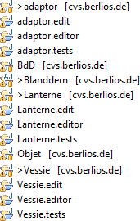

1 Workspace file tree

The project is divided into 2 main projects:
- Adaptor project: describes all the metamodel that permit to adapt a model into another model. adaptor.edit, adaptor.editor and adaptor.tests are projects which were generated by means of EMF
- Blanddern project: describes all the tools that we need to do the pattern engine.

All the others projects can be called as you prefer. Projects BdD and Vessie are projects to create via EMF. In fact Objet and Lanterne projects are meant to create and generate code for the target model.
We will try to define all the package roles that are in the Adaptor project and Blanddern project in the second and the third part of this chapter.

2) Description of files in adaptor project

This project is divided into three mains folder: one source folder and two ordinary folders. The src source folder contains 4 packages that are generated through the EMF code generation. The metamodel folder contains a file called adaptor.ecore and a file called adaptor.ecore_diagram. These two files describe the adaptor metamodel. We find in this folder another file, called adaptor.genmodel that is used to generate java source files and find impl packages in our project, etc… The model folder contains adaptor models that you can re-use to test the project. All the other files are meant to build correctly the project.

Here is an image which shows us the file tree in Adaptor project:

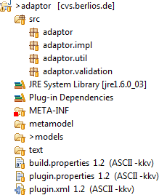

2 Adaptor file tree

3) Description of files in Blanddern project

The Blanddern project is divided into 6 folders. Here is an image of the folder tree:

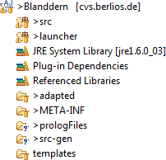

3 Blanddern file tree

The adapted folder contains the jar file of the new implementation of the target metamodel. The prologFiles folder contains all the prolog files that we have generated. The src-gen folder contains the AspectJ files that we have generated. And the template folder contains all the JET files we have written to generate source files.
The src source-folder contains files which are generated with JET. The launcher source-folder contains the core of the pattern engine.

Here is a UML model of the launcher source-folder:

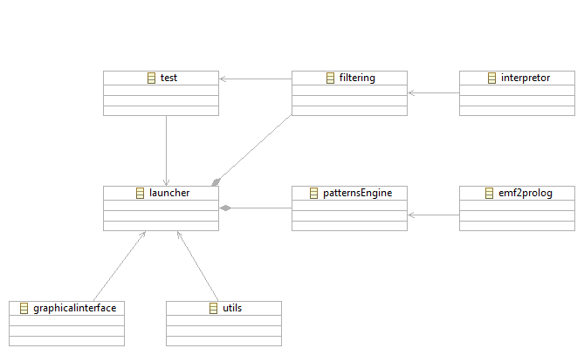
4 Package model

We will now describe all the packages separately.

a. Test package

The goal of the package is to have some test classes. The 3 files are examples of the way to run the Blanddern project. Here is the model UML of the test package.

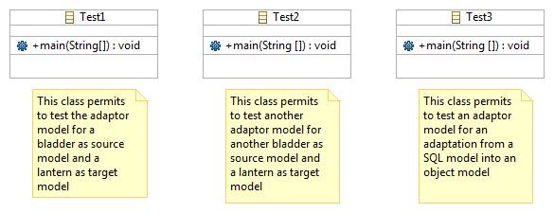
5 Test-package class model

b. Launcher package

This package allows to put together all the other packages. It is used to execute instruction in the logical chronologic. The class called ArgumentsList is used to give more than one argument to the AspectJ files. Here is the UML model of the package.

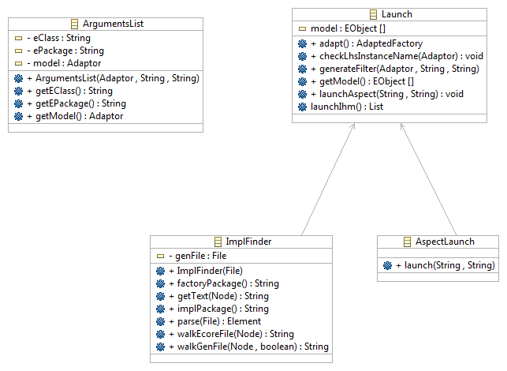
6 Launcher-package class model

c. GraphicalInterface package

This package contains 2 classes: FileFilterSelection that permits to create filters for genmodel file, for instance, and GraphicalInterface permits to build a graphical interface to ask some file paths. Here is a UML model of the package content.

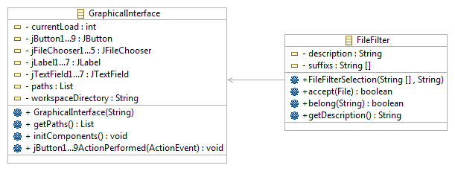
7 GraphicalInterface-package class model

d. Utils package

This package contains a class that offers some methods which help us, for instance, to load a model or to save a result String into a file. Here is the UML model of the class.

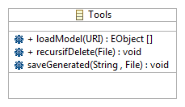
8 Utils-package class model

e. Filtering package

This package contains two classes (PatternFilter.java and RunQuery.java) that are automatically generated. This package contains two others classes that help to adapt the model elements (AdaptedFactory class) and to have many arguments to give to JET file which generates the RunQuery.java file. Here is a UML model that shows you how the classes are bound.

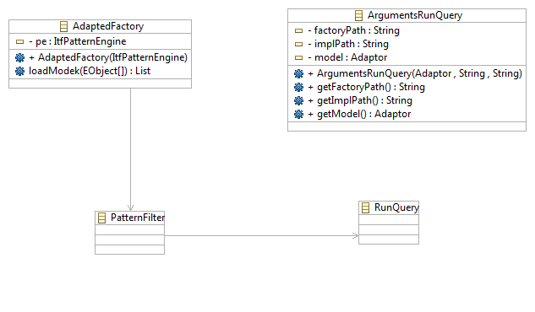
9 Filtering-package class model

f. Interpretor package

This package contains some files which interpret java code. This is used to interpret java code which is written by the user in the query request (in the adaptor model). We didn’t code this classes, but you can send us an email (sees Contacts part of this guide) if you have some questions.

g. PatternEngine package

This is used to transform the source model into a prolog program and requests which are present in the adaptor model into prolog queries. Then it executes prolog queries into the prolog program and finally finds patterns which are presents in the source model and correspond to proxies of the adaptor model. Here is the UML model of relations and classes of this package.

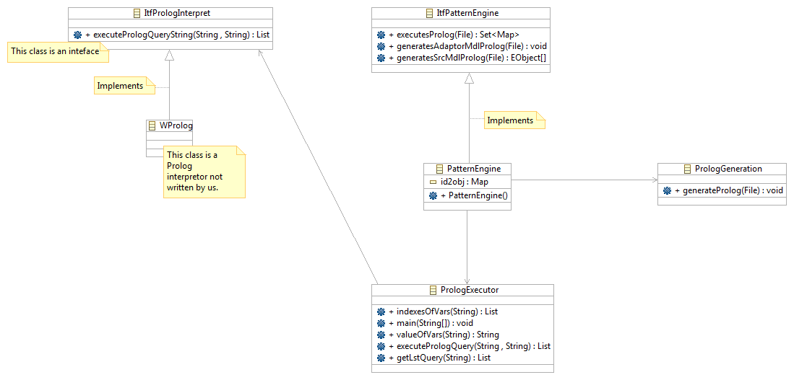
10 PatternEngine-package class model

h. Emf2Prolog package

This package contains all the files the application needs to transform a model EMF into a prolog program. The code isn’t written by us. It’s written by Alix Mougenot. He comes from lip6 (computer science laboratory of Paris 6).

II Techniques and tools used into the project

1) JET

This is a tool that helps you to generate source code while going through an EMF model. This is a generic template engine that can be used to generate code into languages like java, SQL, etc… The syntax of JET is JSP-like. In our Blanddern project we use JET to generate AspectJ, java and Prolog files that we have to use later.
To see the syntax of JET and how to use it, here is a tutorial http://www.eclipse.org/articles/Article-JET/jet_tutorial1.html (part1) and http://www.eclipse.org/articles/Article-JET2/jet_tutorial2.html (part2). To know what are the manipulations you must do to install, refers yourself to the user’s guide.

There are two actions to perform in order to use JET:
- Right click on the Blanddern project → New → Other → Java Emitter Templates → Convert Projects to JET Projects → Select Blanddern project →Click on Finish.
- Right click on the Blanddern project → Properties → JET Settings :
  - In Template container field, enters the name of the JET file folder.
  - In Source container field, enters the name of the generated file folder.

Normally, there is no need to do this to run the Blanddern project, the project is initially a JET project.

2) AspectJ

We use the aspect technique in our project. This technique is based on the fact that we can modify the code or the execution of a program while he is running. There are two main types of aspect: dynamic and static aspects. The dynamic aspect modifies the code during the execution. The advantage is that it is easy to trace a code to find a bug which appears during the execution. The static aspect is used to modify or add some methods or properties. This type of aspect is used in Blanddern project to modify getters and setters, and to add proxies in the target class files.
To use this technique, we have used AspectJ. This is a tool that makes use of aspect technique easy into a java project. To see the syntax of AspectJ refers yourself to the documentation at this link: http://www.eclipse.org/aspectj/ . To see how it is installed in Blanddern project, see the user’s guide.

3) EMF

This is a framework that permits modeling and generating code for tools based on data model structure. To use this technology, we use the Eclipse development environment. You can see documentation on the web site: http://www.eclipse.org/modeling/emf/. We use EMF in Blanddern project, to create and generate code for Adaptor model and for source and target models.

4) Prolog

Prolog is a logical programming language. Prolog is based on the fact that we use logic and not a succession of instructions that the computer will execute. Prolog is commonly used in AI programs and in linguistics treatment with computer.
To see the story of prolog and his syntax, you can see on this web site http://en.wikipedia.org/wiki/Prolog, here http://bat710.univ-lyon1.fr/~csolnon/prolog.html or here http://pcaboche.developpez.com/article/prolog/presentation/. We use Prolog to find the source model and the corresponding datas are specified in the adaptor model. We use a prolog interpreter called WProlog. We will speak about in the next point.

5) WProlog

This tool is a prolog interpreter. It means that we find, with this tool, elements that are in a prolog file and are called in a prolog request. We have used this tool without the graphical interface. You can see documentation and information about WProlog on this web page: http://goanna.cs.rmit.edu.au/~winikoff/wp/.

6) Java

Java is an oriented programming language oriented object. Java is a portable execution computer science environment. You can see documentation on the official website: http://www.java.com. Here is the official java documentation for developer http://java.sun.com/. We use Java in Blanddern project to organize and arrange all program elements. The pattern engine and the filter are written in Java.

7) Emf2Prolog

This tool was developed by Alix Mougenot, in LIP6. This tool permits to transform a UML model into a prolog program. To use it correctly, we have to transform the program: it no longer transforms UML model but EMF model into Prolog. You can see here a documentation link about Emf2Prolog: http://doi.acm.org/10.1145/1368088.1368158. We needed this tool because we wanted to generate from an EMF model a prolog program, which is used later in the pattern engine.

III How does the program run?

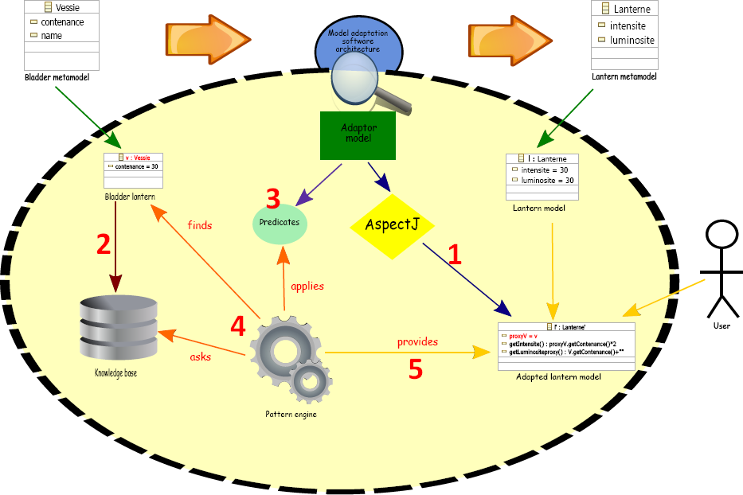

11 Schema that describes how does the application run

The figure 1 shows us how does the application run. Here is all the chronological execution:

- Transformation of the code of the target model with AspectJ: we add proxies in the target metamodel implementations which come from the source model. We also go through the source model with the JET tool.
- Creation of the knowledge database from the source model.
- In this phase, all the requests (predicates) are generated from the adaptor model.
- The pattern engine asks the knowledge database to execute requests and also to find the correct source model.
- Then, the pattern engine performs the source model adaptation into the target model.
This is the execution order of the adaptation from a source model to a target model.

IV Bugs

We have noticed two mains bugs:
- At first we have problems refreshing folders. As you can read it in the user guide, you must run the program twice to not have problem. We have done some research of this problem, but we do not have the response.
- The other bug is appeared when the generation of the RunQuery.java file was done. There was an exception and the program can’t run anymore. There was an error in the generated program. To resolve the bug, we have changed the version of java (but it is not a problem of java version). We think that it is a problem of eclipse workspace refreshment.

V Improvement that one can bring

1) Create a new prolog interpreter

As you can see, we have used a WProlog to interpret prolog query in a prolog program. The website of this tool is http://goanna.cs.rmit.edu.au/~winikoff/wp/
But if you want, you can integrate or develop your own prolog interpreter. It is easy to integrate your interpreter. You just have to change instantiation of WProlog object to your new Interpreter. Your new interpreter only must implements the ItfPrologInterpret interface. With this interface you should have at least one method called executePrologQuery which returns a List and owns 2 arguments: the string which represents the filename of the prolog queries and another string which represents the filename of the prolog program.

2) Create a new pattern engine

You can use another pattern engine that the one we have developed. You just must implements the ItfPatternEngine interface and then define the three methods:
- generatesSrcMdlProlog which generates the source model into a prolog program
- generatesAdaptorMdlProlog which generates the adaptor model into a prolog program
- executesProlog which executes a query prolog file into a prolog program and returns the resulted maps of patterns in a Set

3) More programming language for request

You can improve the use of more programming language for requests. To do this, you must do:
- Modify the adaptor metamodel by adding a new attribute into the class Langage
- Re-write the file called RunQuery.javajet according to the new language and find a new language interpreter than the java interpreter in the interpretor package.
- In the adaptor.aspectjjet file you have to respect the syntax of the new language

4) Do the dynamic adaptation of references in AspectJ

If the Feature in a CorrespondanceRule is an EReference, the user must do himself the adaptation between the Feature type and the type of the accessed field in a proxy.
The improvement you could do would let the user write an expression that returned a type of the source metamodel, which would be automatically adapted into the correct type in the adaptor.aspectjjet file.
For instance, an expression must returns a Class but getFk().getTable() method of the self.col proxy returns a Table. The user must do the adaptation by writing : objet.ObjetFactory objectInstanced = objet.ObjetFactory.eInstance; objet.impl.ClasseImpl o = (objet.impl.ClasseImpl)objectInstanced.createClasse(); o.t=self.col.getFk().getTable(); return o;
The improvement would allow the user to write such an expression as: return self.col.getFk().getTable(). The program’d take care of the Table to Class adaptation.

VI Contacts

If you meet some bugs or problems, please send us an email, with a short description of your bug.
Here are contact emails:
- Frédéric Fondement: frederic.fondement@uha.fr
- Jérémie Scheer: jeresch@gmail.com
- Loïc Sutter: loic_sutter@yahoo.fr

Table of contents:

Summary 2
I File description 3
1) View of the workspace directory 3
2) Description of files in adaptor project 3
3) Description of files in Blanddern project 4
a. Test package 5
b. Launcher package 6
c. GraphicalInterface package 6
d. Utils package 7
e. Filtering package 7
f. Interpretor package 7
g. PatternEngine package 8
h. Emf2Prolog package 8
II Techniques and tools used into the project 8
1) JET 8
2) AspectJ 9
3) EMF 9
4) Prolog 9
5) WProlog 10
6) Java 10
7) Emf2Prolog 10
III How does the program run? 11
IV Bugs 12
V Improvement that one can bring 12
1) Create a new prolog interpreter 12
2) Create a new pattern engine 12
3) More programming language for request 12
4) Do the dynamic adaptation of references in AspectJ 13
VI Contacts 13
Table of contents: 14
Table of illustrations: 15

Table of illustrations:

1 Workspace file tree 3
2 Adaptor file tree 4
3 Blanddern file tree 4
4 Package model 5
5 Test-package class model 5
6 Launcher-package class model 6
7 GraphicalInterface-package class model 6
8 Utils-package class model 7
9 Filtering-package class model 7
10 PatternEngine-package class model 8
11 Schema that describes how does the application run 11

