Technical Specification for function bpEstim

Function by Mathieu Merzereaud.

Document by David Maxwell. Last updated 18 December 2008.

Description
This function works on data supplied by a csDataCons object.

Estimates of weight-at-length, maturity-at-length, proportion-female-at-length, proportion-immature-at-length and their variances are calculated directly from the biological data (ca table).

If the argument adjust is FALSE, the length distribution in the biological data is assumed to be representative of the catch. Estimates of weight-at-age, maturity-at-age, proportion-female-at-age and their variances are calculated directly from the biological data. If adjust = TRUE, the estimates-at-age are calculated by adjusting for the length distribution in the hl table. This is suitable for length stratified sampling schemes.

Stratification
Estimates are provided for each combination of the space and time strata specified in the dbeObject supplied to the function.

The biological data (ca table) does not include technical stratification. Therefore, the same biological data is applied to each technical stratum.

Details
Define X as the variable of interest so that:
for weight at age: x_{i} = individual weight
for proportion mature: x_{i} = 0 if immature, 1 if mature
for proportion female: x_{i} = 0 if male, 1 if female.

The estimates at length and, if adjust=FALSE, the estimates at age are calculated using the standard formulae for a sample (x₁,…, x_{n}).

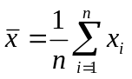

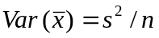
where 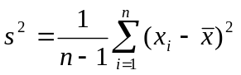

AT THE MOMENT THE OUTPUT IS s² I THINK IT SHOULD BE 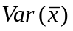

When adjust=TRUE weighted means and variances are calculated for weight-at-age, proportion-female-at-age and proportion-immature-at-age.

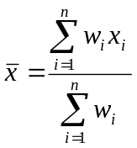

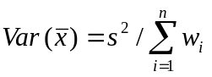

where 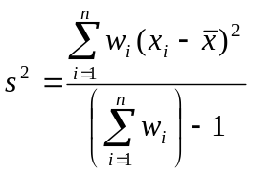

AT THE MOMENT THE OUTPUT IS s² I THINK IT SHOULD BE

The statistical weight, w_{i} for each fish with biological data was determined as follows.

Define a raising factor r_{g} = n_{g} / m_{g}
where n_{g} is the number of fish measured within a length group g, and m_{g} is the number of fish sampled for the biological parameter in the same length group.

Calculate the sum of the raising factors for each age group a,
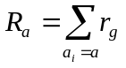
where a_{i} denotes the age of fish i.
Assign statistical weight, to fish i in length group g and age a
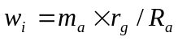
where m_{a} is the number of fish of age a with biological data.

For each age group the sum of statistical weights will equal the number of fish with biological data.

Notes & Warnings
When there is one fish in a stratum the variance estimate is set to zero. [I would prefer it to be NA]

As the same biological data is applied to each technical stratum the estimates by technical strata will be correlated. Simply adding their variances to calculate an estimate of the total variance for all technical strata will give an inaccurate result.

Currently, maturity is defined as immature if the field matStage = 1 and mature otherwise. There are a few species and maturity scales where this is not appropriate. For these cases the data must be converted to a scale with only matStage=1 representing immature.

The approach used to estimating the variance of the proportions gives a value a factor of n/(n-1) larger than using the Normal approximation to the Binomial distribution, Var(p) = p(1-p) / n ,where p is a proportion of n observations.

