


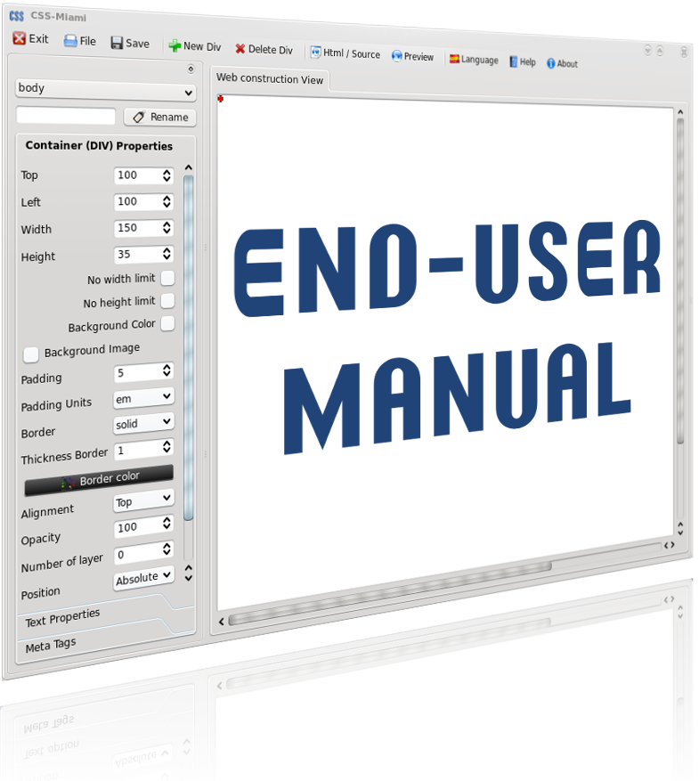

Index

Pag.

- Introduction / What is CSS-Miami 1

- How does CSS-Miami work? 2

- Starting with CSS-Miami (Step-by-Step) 3

- Interface of CSS-Miami 5
  - Menu 6
  - Controls 9
    - Container properties page 10
    - Text properties page 13
    - Meta-tags page 14
  - Interface of CSS-Miami: WorkSpace 16

- Containers (Div) 17
  - Add/Remove Containers 17
  - Selecting Container (Div/Body) 18
  - Container's (Div or Body) Name 19
  - Moving Containers 20
  - Resizing Containers 21

- Content Editor 22
  - Menu & Shortcuts 23
  - Image Dialog 25
  - Table Dialog 26
  - Link Dialog 26
  - Final Advices – Final Step 26

- Creating our first web (less than 5 minutes) 27

- That's all folks! 31

- Support 31

- Other Webs Created with CSS-Miami 31

- Authors 32

- License 33
1- Introduction / What is CSS-Miami?

CSS-Miami is an easy web creator that introduces a new concept on web creation standard concept. HTML pages created with CSS-Miami, uses completely CSS technology, with all facilities that CSS gives to you: you can move content of your web page wherever you want to appear, fast changes on styles, colours, borders, and content, and much more!
While you are making your web, CSS-Miami is completely WYSIWYG.

¿What is WYSIWYG?
WYSIWYG is the acronym of What You See Is What You Get. While you are developing, you already are watching the final look of your web, because what you are watching is what you get it when you save. For this reason is a powerful application. It’s visual, easy and fast. You don’t need to understand or know HTML code to develop a professional web, because you are watching final result of your web at the same time that you are developing it.

You can drag’n’drop the content inside your web, moving titles, menus, images or whatever you need it, simply moving your mouse. You don’t need to write any HTML code.

With CSS-Miami anyone can create a web page, you can save lots of money and you can create a professional web page, with a professional look in some minutes.

CSS-Miami is for inexperienced users, because you can create web page in WYSIWYG mode by default, and so easy, and also it's for experienced users, because you can view in advanced mode HTML code of your page, if you want it.

CSS-Miami only uses CSS. And CSS technology is fully W3 standard compliant, it’s the future of the internet web pages, it’s flexibility and extreme power in your hand.

Developed with Python and QT4 open a new horizon of possibility of use, and flexibility, it’s fully integrated in desktop that you uses, and fast to work with it, no matter the platform.

Begin now to work with CSS-Miami and feel the experience.
This new concept of web creation it’s really the future of web creator tools.

Use the future, use the easiest way to make web pages, look you web while you are making it, create webs in few minutes and feel the CSS-Miami power in your mouse in three languages on the platform that you want.

Feel CSS-Miami
2- How does CSS-Miami work?

CSS-Miami uses 100% CSS technology. This is a new concept on web develop, because, when you create a web, really you are creating two files: HTML page and CSS template.

- HTML File
In this file there are header and footer of the web page, to be read by browsers. And in the body part, only there’s the text content. HTML no stores any style. This allow you to have an HTML file clean, simple and human-readable. Stores web page contents, menus, links, whatever it’s the content.

- CSS Template
This file is also called CSS Style Page or Page Style. This file only stores styles as position, colour, font family, font weight, size, background, etc. In this file there isn’t content. This allows you to have a HTML, and only changing CSS-Template, you can give it a full change of look. Like CMS (Content Management Systems) as Joomla, Php Nuke or others, do.

Content and how it are presented, are separated.
Gives to you more simplicity to edit and change HTML, flexibility to renew the look.

CSS technology is the future and this is the new standard to make professional webs on the internet, ready to upload to your server.

When you save your make a new web, you have to define the folder path where you want it; so, whan you save it, on your folder path there's your web page with a folder named “css” and another named “img”, that stores webpage style and images, respectively. This web is ready to upload to your internet or local server to be accessed through the net.

Requirements Linux:
Python 2.4 or higher
QT4 4.4 or higher
Optionally browsers: Firefox, Amaya, Galeon, Konqueror, Opera

Requirements Windows (executed by .py file):
- Python 2.4
- QT4 4.4 or higher
- Optionally browsers: Firefox, Internet Explorer

Requirements Windows (executed by exe file – download on css-miami.org):
- Optionally browsers: Firefox, Internet Explorer

Q: I want to know how I can create my own web page!
A: Ok. Let's go step-by-step. You have to begin knowing CSS-Miami, fist.

3- Starting with CSS-Miami (Step-by-Step)

Now it's the moment to start to work with CSS-Miami. First of all we have to prepare the workspace in order to create our first web page.
When you open CSS-Miami, you view like this. (Figure 1)
Application widgets may change depending your operative system)

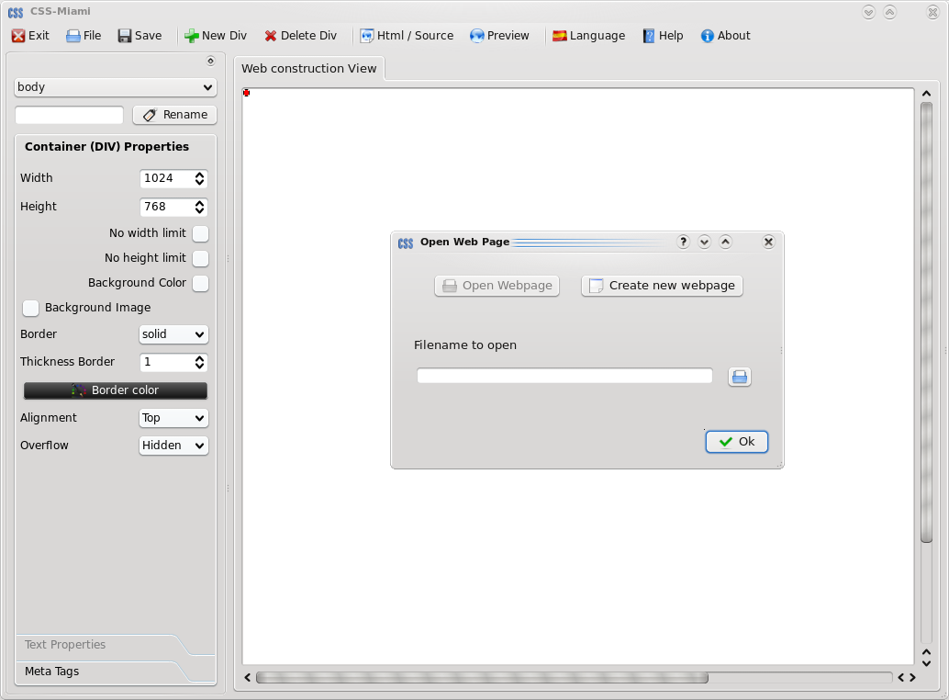

Figure 1: CSS-Miami Main Window

Now it's the moment to Create New Web or Open a previous created.

When you start CSS-Miami it opens open file dialog (Figure 2)

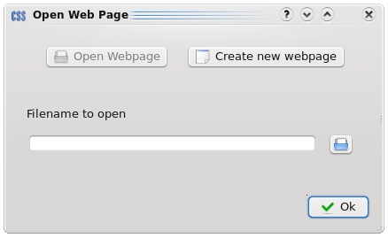

Figure 2: File Dialog

You can change dialog to create a new one, by clicking on “Create new webpage”. Then CSS-Miami will show you next dialog (Figure 3)
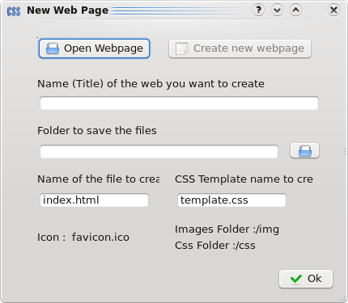

Figure 3: New web page Dialog
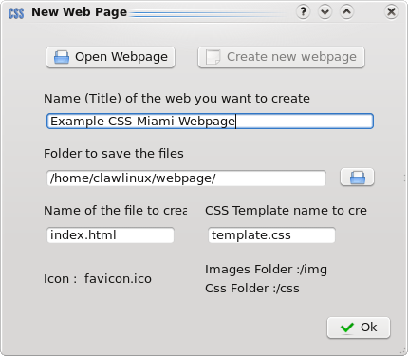
You have to browse (using button) for a folder to save your web page. And optionally you can enter the web page title; it's optionally but so recommended.
Once you have filled these fields, and press Ok button, it's ready to begin to create your web page.
Dialogs has desapeared, and you are on CSS-Miami (Figure 4), ready to work.

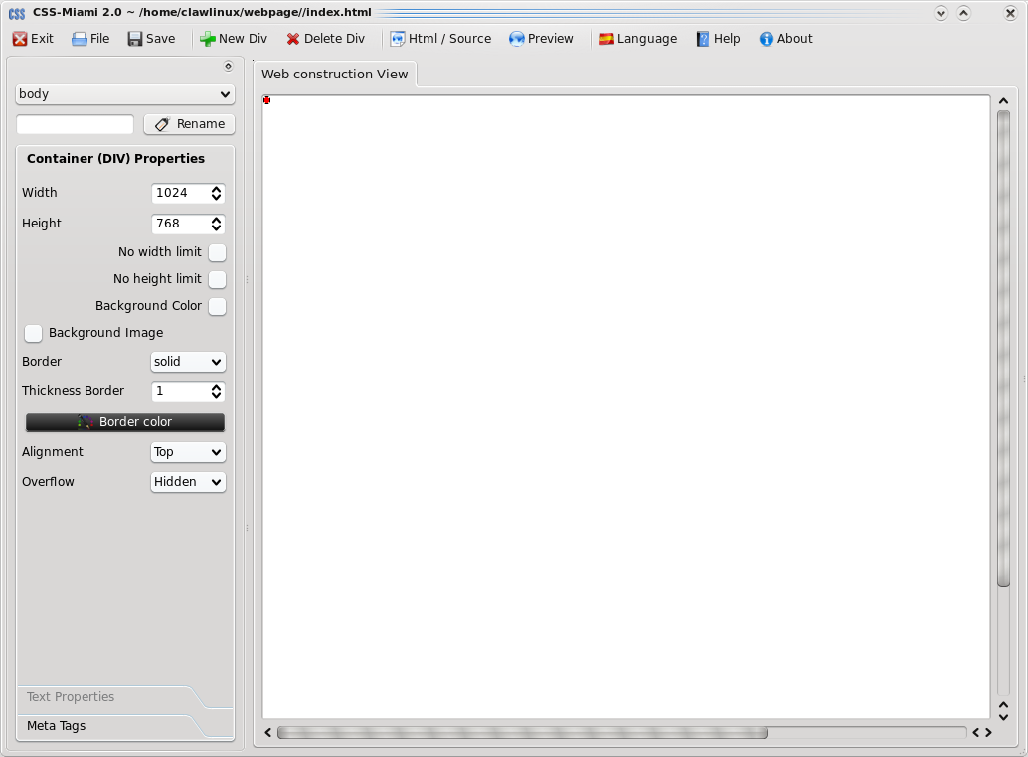
Figure 4: CSS-Miami Ready to work

On top window decorator you can see what web page you are editing (Figure 5)

Figure 5: Window decorator with your web page file

4- Interface of CSS-Miami

CSS-Miami it's designed to be so intuitive, for this reason, application is visually separated, to give to the user an easiest usability.
Basic use of CSS-Miami can be made on these three big groups (Figure 6).
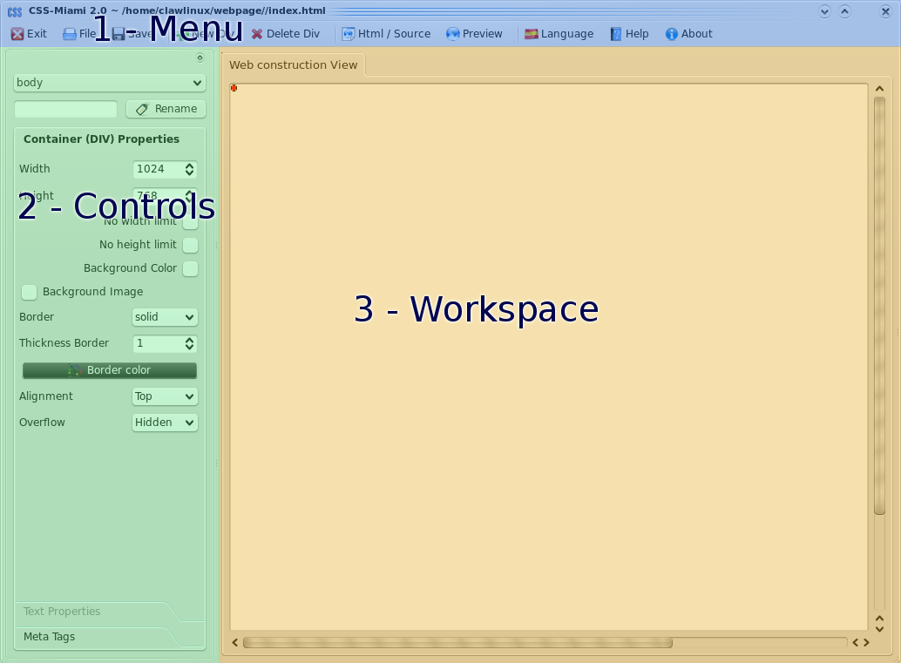

Figure 6: Basic Controls

1- Menu

In this area you can do basic application use. You can save/open/create new web page.
Preview in a new browser, or change interface language.

2- Controls

In this area you can change Container's properties: size, colour, position, etc
Also you can change meta-tags. Later we will talk more about each of one. Meta-Tags are important because it's the method how search engines (as google, yahoo, etc) search for your page and index it.

3- Workspace

In this area you are watching in the moment how it's viewing your web page.
That's it's the feature WYSIWYG.
Also you can design your web, using your mouse.

Now let's see each of one at great length.
4.1- Interface of CSS-Miami: Menu
First of all we will talk about the menu (Figure 7). It's separated on four, parts.

Figure 7: The Menu

File Section
This section is for basic controls of the application

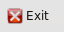 | Obviously, this option is for exit application.  Will warn you to save the web before close it.
 | This open the “Open dialog” (Figure 2) to load a created web, and has possibility to open the “Create New Webpage” dialog (Figure 3), to create a new one.
 | Save current webpage to the specified folder. Usually it's named index.html, but you can change the name, when you want, on Controls, the “Meta Tags” page.

Content Section
Second section of the menu it's dedicated to add/delete content of your web.
On CSS-Miami we assume Div as a container to put your content on your web, this is because on basic HTML/CSS structure, it have the same word: “Div”s of content.
Here we use the word Div as a Container. No matter what kind of content you'll put inside.

This button add a new container to your web, it can be viewed in your workspace (Figure 6 and 8).
Each container have independent properties. Inside the container (Div) you later will insert your content.
This one, deletes the selected current Container (Div) and all of the content inside it. Take care to be sure when you're going to delete a container.

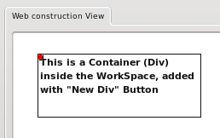

Figure 8: Container (Div) inside the workspace, after used “New Div” Button

View Section

Third section is about visualization and preview options.

By default CSS-Miami it's WYSIWIG. This means CSS-Miami only shows your web as you see it when you save it. But with this button you can toggle to Source View, to show source HTML code, or change again to WYSIWIG Mode.

This button opens your web in a external browser. Preview dialog (Figure 9)
While you are creating your web, you can view the final result. But each browser has different configurations, different font sizes, different styles, etc. for this reason this button allow you to preview the result of your web page in external browsers such as Mozilla Firefox.
See List of current supported browsers *

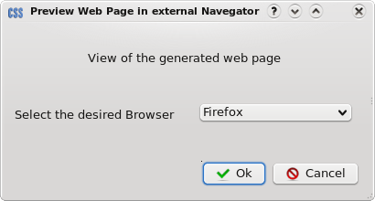

Figure 9: External Browser Preview's Dialog

* Current supported external browser list:

Linux: Amaya, Galeon, Konqueror, Opera
Windows: Internet Explorer

All plattforms: Mozilla Firefox
Extra Section
This is the last section where there are miscellaneous options.

This button open language dialog (Figure 10), to change on execution time the CSS-Miami language.
This one, opens help end-user manual (What you are reading now).
Also you can open it by pressing F1.
This button opens a dialog talking about authors of CSS-Miami (Figure 11).

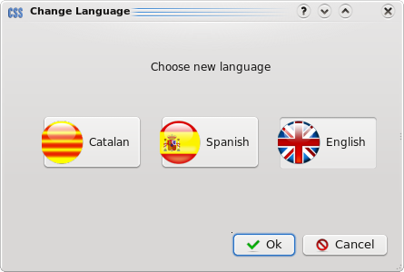

Figure 10: Language Dialog

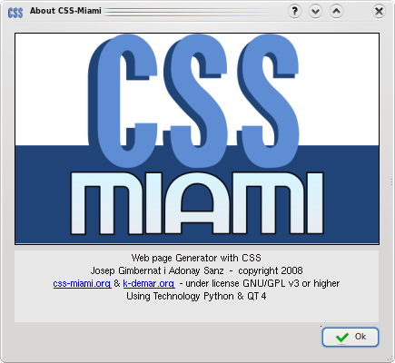

Figure 11: Dialog About

4.2- Interface of CSS-Miami: Controls
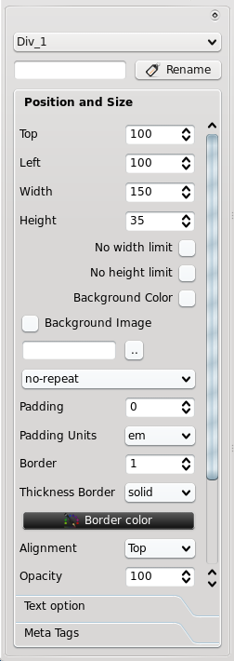

Next big area on CSS-Miami that you have to know about it, it's the Control Area (Figure 12).
This area it's essential to change Container (Div) properties, such as position, colour, background, etc.
In the right top corner of controls there's an icon ( usually or would depend your platform) that allows you to separate toolbox from the main window, and dock, right or left, of CSS-Miami, or work it with an undocked position.

Also you can use handler to undock, positioned left of this icon,
usually with view

By clicking, and drag and drop to left or right of CSS-Miami you can dock it to a new position. Here's an image with CSS-Miami with the Control Toolbox docked at right (Figure 13).

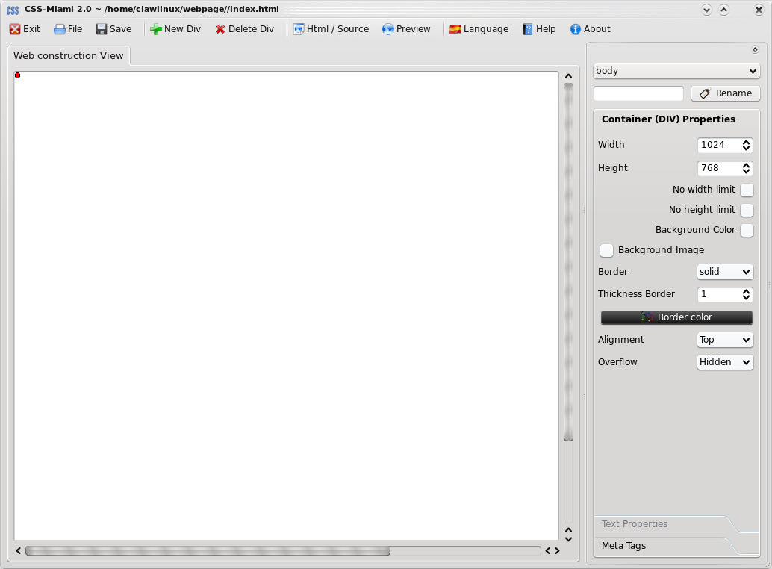

Figure 12: Control Area Toolbox

Figure 13: Toolbox docked at right

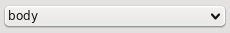
First and second controls are for selecting and renaming Containers, and rename it, respectively.

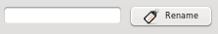
But on Containers Chapter we take a view at great length, over it.
These two tools are so useful, for this reason, are always visible on the top of the toolbox
For this moment it's all you have to know about these two tools. Next we'll see all pages and its controls, and then we'll return to these two tools, and Containers explanation on the Containers Chapter.
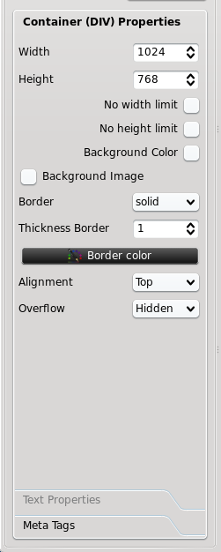
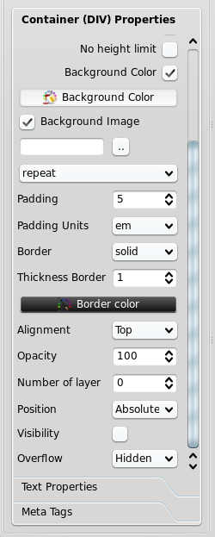
4.2.1- Container (Div) Properties Page

Each Container (Div) have separated properties, that can be modified in this page.
First properties page it's about physical Container properties, such as position, size, color, background, layer, border and other properties
These properties won't affect to content of your Container.
All properties are about selected Container (Div). To know what container is selected, you should read the Container's Chapter.
For its nature, Main Container (Called Body) have much less options, as you can see at right picture.

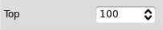 | This is the top position.  It's the amount of pixels from top border to the container (div)  Container's position of main container (body) cannot be changed.
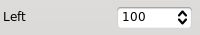 | This is the left position.  It's the amount of pixels from left border to the container (div)  Container's position of main container (body) cannot be changed.
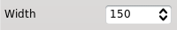 | This is the width of the container.  Doesn't appears if “No width limit” is enabled.
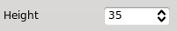 | It's the height of the container.  Doesn't appears if “No height limit” is enabled.

This check box disable width limit on your container, making no matter how many content is inside.
This check box disable height limit on your container, making no matter how many content is inside.

This check box is disabled by default.
Enables background color capability of your container. When clicked “Background Color” button appears.
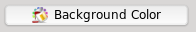 | This button appears when “Background Color” is checked. On click, you can choose color of container (Div), with a dialog as Figure 14, depending on your platform may change.

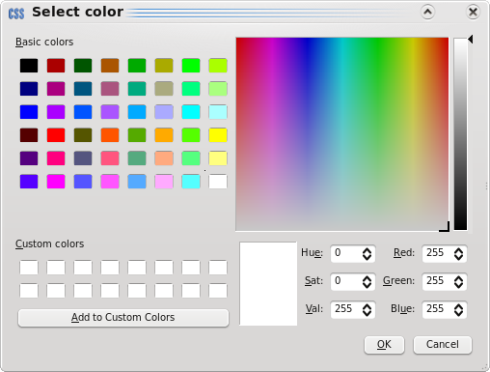

Figure 14: Color Dialog

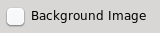 | By default is disabled. Checking it, you can insert a image on background of the Container (Div/Body). If you put any text will be appear over the image.
 | This line appears when “Background image” is checked. With the right button you can browse for a image to put on the container (Div/Body) background.
This combo box appears when “Background image” is checked.
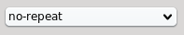
Here you can define the image repeat, if you want it. By default is not repeated.
No-Repeat: Background image is shown once.
Repeat-X: Repeat image horizontally.
Repeat-Y: Repeat image vertically.
Repeat: Repeat image on two axis.

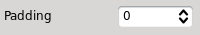 | Here you can define amount of Units you want to padding the content inside the container (Div). On main Container (body), cannot be changed.
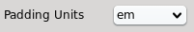 | You can select padding Units: Em or Px. On main Container (body), cannot be changed.

 | Border by default is enabled to be visible the container. But you can define a border type, or you can have an invisible one. There's different kinds of border that you can choose.
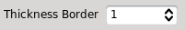 | If border is none, this spin box will not appear. Here you can define border weight in pixels.
 | If border is none, this button will not appear. This button will show a color dialog as Figure 14 to change border color.
You can align vertically the content inside your Container (Div) at any position with this combo box. Horizontally you can do it in the content Editor.

This option defines the opacity of the Container (Div). Allows you to define a transparency and show back content, or whatever you imagine. On main Container (body), cannot be changed.
This property is not supported by some browsers.
See Figure 15

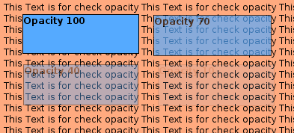

Figure 15: Different opacity test for Containers

Like many image editor programs (such as Gimp, Photoshop, etc) CSS-Miami also has support for layers for Containers (Div). By defining number of layer ( 0 by default), more than 0, Container and its content, can be in front of another or back. Main Container (body) layer, cannot be changed.
And there's no containers limit on a Layer.
A bigger number indicates a more raised Layer.
You can See two examples on Figure 16 and 17

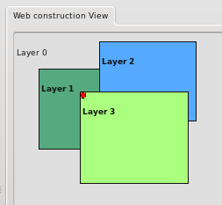
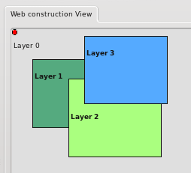

Figure 16: Green container on layer 3 Figure 17: Blue container on layer 3

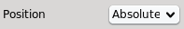 | Where you can define position of the container (Div) absolute, or relative to the div you are working on. Absolute it's selected by default. On main Container (body), cannot be changed.

This is a boolean, if you want the Container to be showed or not.
On main Container (body), cannot be changed.

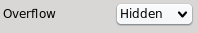 | In this option you can modify what it have to do with content that overflow the border of the container.  Hidden: Will hide the content  Visible: Will overflow the container. No matter bounds.  Scroll: Will appear an scrollbar to move it.  Auto: Will make browser's default behaviour.

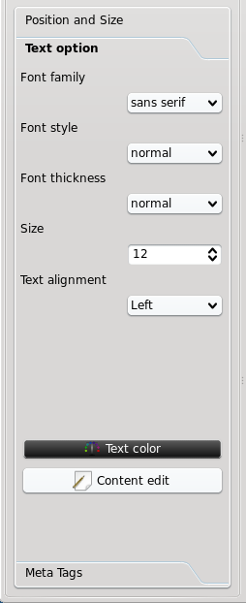

4.2.2- Text Properties Page

Text properties is working for the text inside your Container (Div), no have any kind of influence on images, background or other content.

These properties are the default, but remember that you can override it on the content editor.
This page, allows you to open the Content Editor, but on Content Editor chapter will take a great length of it.

Main Container (body), cannot contain text, so, Properties Page will be disabled.

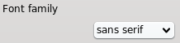 | Here you can change default font family.
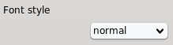 | Here you can change default font style.
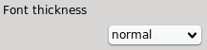 | Here you can change default font height.
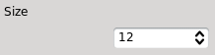 | Here you can change default font size.
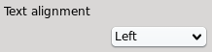 | Here you can change default text align.

 | Here you can define default text color through a color dialog (Figure 14) for the selected Container (Div). Also you can have words in other color, defined in the content editor.
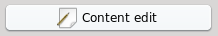 | This opens the content editor. Also you can open it, by double clicking on the Container you want to edit. On Contaiers chapter we will take a great view

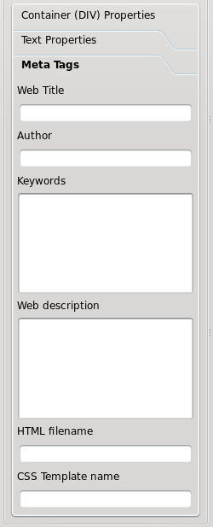
4.2.3- Meta Tags Page

Meta tags are a kind of data stored on header of the HTML page, to provide some extra information to browsers, and search engines.

Except title, these properties aren't visible by user.

These properties are about how search engines index your web page, and after users search for it.

It's a useful data, if you want to upload your web page on a internet server, but if you want to have on a local server, this data isn't necessary and isn't useful.

Meta Tags data are about whole web page, this is a page always visible, but its properties are global (no depends on the container you have selected)

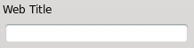 | This field is optional, but so recommended.  This Web Title will be showed on browser's window docorator.  You can see Figure 18 to have an example.
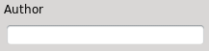 | This field is optional.  You can enter here your name/s of who have created the webpage.
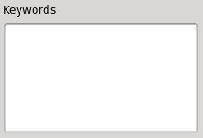 | This field is optional, but so recommended if you'll upload to an internet server.  Search engines index your web page following these keywords. Have to be a list, comma separated, of max. 20 words, that describes the content of your web page.  Example: A high mountain hotel, called Pastuira, with sky station near.  Example keywords: Pastuira, Hotel, Sky Station, High Mountain, Snow, Flowers, Climbing
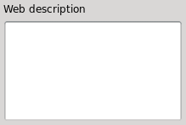 | This field is optional, but so recommended if you'll upload to an internet server.  Your description 10-20 words, would make you to have a better ranking on search engines, should not contain promotional words (such as: cheap, free, etc.) and try not to repeat keywords, if you can.

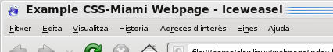

Figure 18: Title example configured on meta-tags

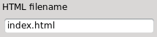 | Here you can change your HTML file name.  Will be applied on next save.
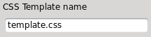 | Here you can change your CSS file name.  Will be applied on next save.

It's the end of Area of controls of CSS-Miami, now we go to last big area, and later we'll go to talk about Containers (Div).
4.3- Interface of CSS-Miami: WorkSpace

Workspace (Figure 19) it's where you design your web and view the result.
How use workspace to edit your web page Containers (Div), how to interact with your mouse on workspace on your content and how to put content on your web, it's described when we talk about Containers on a next chapter.
First of all you have to know a basic thing of workspace. It has two views:

- WYSIWYG View (by default) – (Figure 20)
With this view you don't see any HTML code. This mode it's used by default to develop web pages in CSS-Miami, because you are watching the result while you are developing your web page and it's more friendly for any kind of developer.

- Source View – (Figure 15)
But also CSS-Miami it's friendly for experienced HTML code developers, when you activate it, workspace only shows Source code on its Containers (Div) (Figure 21).

You can toggle these two view by pressing button on the menu
.
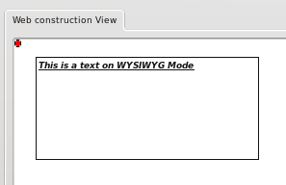
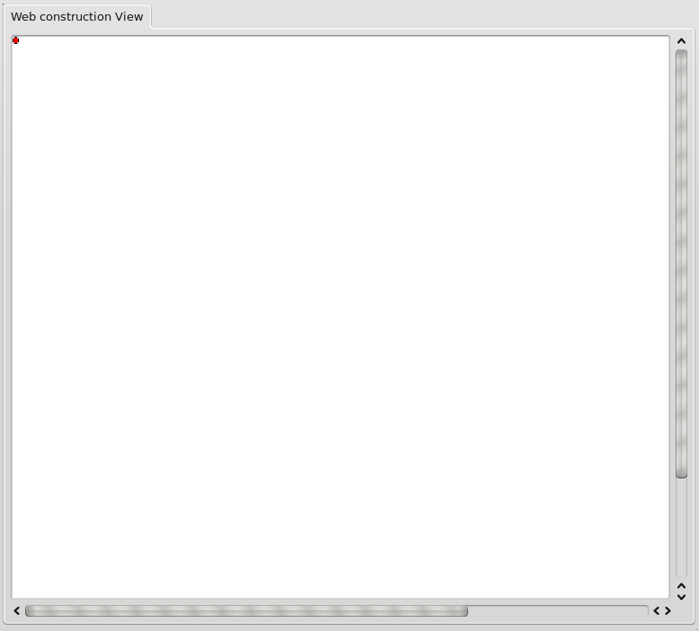

Figure 20: WYSIWYG View Mode

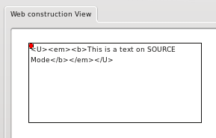

Figure 19: Workspace

Figure 21: Source View Mode
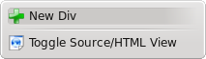

By pressing right mouse button on every place of main container (Body), visible by default on workspace there's a contextual menu that helps you to do some basic functions that you'll need in every moment (Figure 22). If you click on a container (Div), not main container, contextual menu will have more options, as you can see on Figure 23. Figure 22: Contextual menu of
Main Container (Body)
5- Containers (Div)

Q: What it's a Container?
A: Next explanation will help you to know.

Container it's the physical recipient for any content.
So, to add a content on your web, first of all you need to add a container or Div (it's the same, but in HTML language is called Div; for this reason we use this word), to put your content inside it.

In this chapter will show you how move containers to any position on your web page, resize container, delete containers, and how to edit content.

First of all, about containers, you have to know that always there's a main container that conaints all rest of containers that you create. This container is called body, and cannot be moved of its position (top and left 0), cannot be changed of its layer and cannot be removed.
And all your Containers you create later, will be inside this one, for this reason we called Main Container or body.

Add Containers

Q: Ok! I want to add a Container on my web page!
A: There are two ways so useful to do it, listen.

To add, you can use two ways. First one, you can use the menu, placed at top of CSS-Miami (Figure 7).
Second one is by right clicking on workspace, no matter where, and select “Add Div” from the contextual menu
that appears. Figure 23: Contextual menu of Main Container
Now you have added a new one (Figure 25)

Remove Containers

Q: I want to delete a content, how do I do?
A: There are two ways to do it, but, be careful.

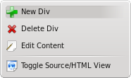
First one, you can use the menu, placed at top of CSS-Miami (Figure 7), with “Delete Div” button
Second one, by using right click on the Container (Div) that you want to remove.
You'll only delete Container (Div) that you have selected
You only can remove Containers (Div) that not are the Main
Figure 24: Contextual menu Container (Body). If you make a right click on the Body, will show
of Containers (Div) Contextual menu of Main container (Body) (Figure 23) instead of
Contextual menu of Containers (Div) (Figure 24).
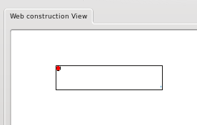

Figure 25: Workspace with a new recent added Container (Div)

Selecting Container (Div or Body)

To change properties from controls, and interact with all Containers you have to select it one. You have to know, always, controls from toolbox are referencing to the selected Container.

Q: How do you know what Container is selected?
A: You need to know first, how select a Container.

As usually, in CSS-Miami, you can do it by two ways.

You can select a Container, by selecting its name on the combo box always visible on the upper corner of the Control Toolbox (Figure 26).

Figure 26: Combo Box for Manual Container (Div) Selection

Or you can do it by clicking on it on Workspace (Figure 19)
When you select one, all properties controls (Seen on Interface: Controls) make reference to this Container (Div/Body).

Q: Well, now I know how to select a Container. Now, how I know what Container is selected?
A: It's the correct question in the correct place. As usual, in CSS-Miami, there are two ways :)

First one is by identifying its name on the combo box always visible on the upper corner of the Control Toolbox (Figure 26), but this is so hard to remember.
For this reason, CSS-Miami has a second way to know what Container is selected, easier.

On workspace there's always an icon that shows you what Container is selected.
This icon is only a reference for you, to know what Container is selected. Will no saved on your web.
You can select Containers by clicking on it on workspace, and automatically will appear on container's top-left corner as you see on Figure 27.
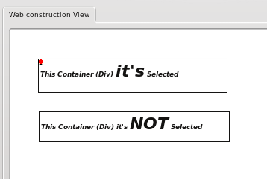

Figure 27: Selected Container

No matter how do you select your containers, CSS-Miami will do same things.

Container's (Div or Body) Name
Q: I don't want to remember that Div_1 contains my logo image, or whatever.
A: For this reason, you can rename default name.

When you create a blank web page, by default CSS-Miami create a big container, called “body” that will contain all of containers that you create.
All Containers that you'll created inside it, will take “Div_#” name (assuming # as a number), but maybe you want to identify by a name, to be more easy the selection from check box, see Figure 28
But using you can insert a new name, and press “Rename” button,

to rename the Container's default Name, to have a useful descriptive name, such as “Title” or “Menu”, like you see on Figure 29.
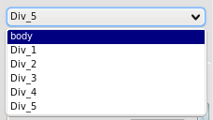
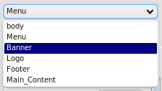

Figure 28: Selection Combo Box default names Figure 29: Selection Combo Box renamed names

No matter how you rename your containers, because it's useful only for developing purposes, browsers doesn't show any Container's name.

Q: By default Containers are added on workspace but I want to move it.
A: Let's see how you can move your Containers.

Moving Containers

You can move contents by two ways, as normally in CSS-Miami.

The first one it's manual. By using controls (Seen on Interface: Controls), manually you can input a new position number of X axis (Left), and Y axis (Top), to move Container. Or using arrows of these spin box, will move pixel by pixel the container.
Basically, this method is for doing a fine adjust.

Second one it's more user-friendly, for this reason, it's the prefered way.
You can move the Container by drag'and'drop it: you can click and holding it, move mouse to the desired position, and then, drop. That's all.

Drag'n'Drop the Container. And put it wherever you want.

There's a an image (Figure 30) that show you drag'n'drop concept.

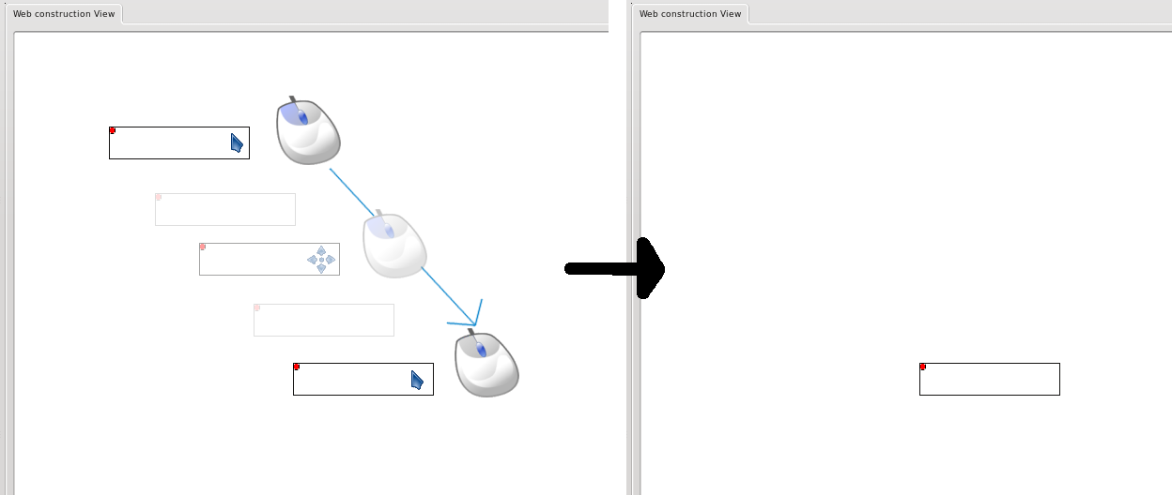
Figure 30: Drag ' & ' Drop to Move Containers (Div)

Containers (Div) cannot be moved outside of main container (Body), for this reason if you need more space in your web page, you'll need to increase body margins, using width and height controls of main Container.

We recommend to use drag'n'drop system to move your content wherever you want and then if you need make a fine adjust, do it with manual positioning through controls.

Main container (Body) cannot be moved by mouse ways. You'll need to define it manually by using position controls.
Resizing Containers

Q: But my Container it's so small!!! my data doesn't fit inside!!!
A: You can resize it to have the size that you want.

The resize action can be, as usual, by two ways. :)
First one it's manual using height for X axis, and width for Y axis.
Resize, from Controls (Seen on Interface: Controls), indicating new size by number or using arrows of spin box.

Second one it's more user-friendly, for this reason, it's the prefered way.

And also you can resize container (Div) using drag'n'drop method. By clicking and holding it, while move mouse to the desired position, and then, drop. But in this case, first of all, you have to hold first “control” key, usually at down-left corner of your keyboard. That's all.

Control + Drag'n'Drop the Container. And resize it to contains your data.

Next image (Figure 31) show you control + drag'n'drop concept for resize.
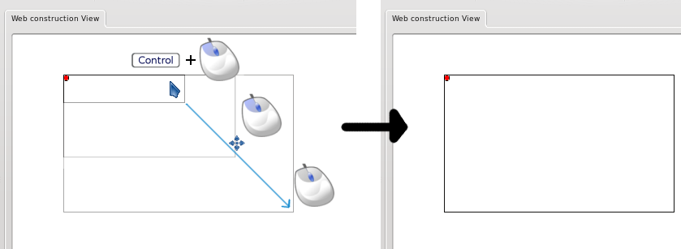
Figure 31: Drag ' & ' Drop to Resize Containers (Div)

Containers (Div) cannot be bigger than main container (Body), for this reason if you need more space in your web page, you'll need to make increase body margins, using width and height controls of main Container.

We recommend to use drag'n'drop system to resize your content wherever you want and then if you need make a fine adjust, do it with manual size through controls.

Main container (Body) cannot be resized by mouse ways. You'll need to define it manually by using size controls.
Content Editor

Q: How do I put my content on my Containers?
A: I have a good new for you: now has arrived the moment to fill your Containers!
You can access to content editor, by three ways:
- First the long, long way:
going to Text Options toolbox and pressing to Edit content button

- Second, the long way:
By right clicking the Container on contextual menu select “Edit Content" (Figure 24)

- Third, the fast and prefered:
By double clicking on the Container that you want to modify.

Will open a window like these one (Figure 32).

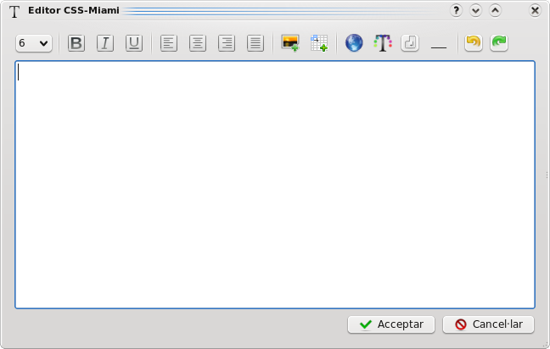

Figure 32: Content Editor

In this window you can edit content inside the container (div), and when you click Accept button, the content is inserted.

We have mainly two big areas on this window that you can see on next figure (Figure 33)

1- Menu:
In this area there are text style buttons, to modify and interact with text you have write on the content area.

2 – Content:
In this area is really where you'll add your content, that later will fill the Container (Div).
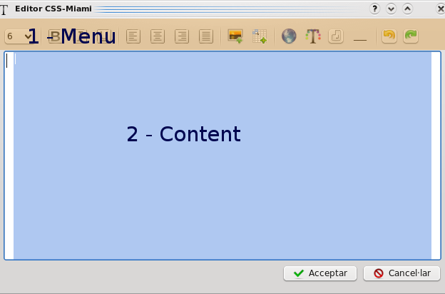

Figure 33: Main areas of Content Editor.

Menu & Shortcuts

Let's see the menu. To bring facilities when you write, there are some shortcuts, that you can use with keyboard, but also all functionalities are visually on buttons.

If you want, you don’t have to remember, but it’s a easiest way to modify your content if you uses.
Also in any moment, you can put your mouse over any button, and it will show you its shortcut.

Button / Function | Shortcut | Long Description
  Bold | Ctrl + B | Puts the selected text in Bold weight
  Italic | Ctrl + T | Puts the selected text in Italic style
  Underline | Ctrl + U | Puts the selected text underlined
  Justify left | Ctrl + L | Justifies all the text to left
  Justify Center | Ctrl + N | Justifies all the text to the center
  Justify Right | Ctrl + R | Justifies all the text to right
  Justify Fill | Ctrl + F | Justifies all the text to fill the content. Justified
  Image | Ctrl + M | Open Image dialog to insert an image (Figure 34)
Table | Ctrl + E | Open Table dialog to insert a table (Figure 35)
  Link | Ctrl + S | Open Link dialog to reference to another page, if has selected text, convert it to the link. (Figure 36)
  Color | Ctrl + O | Open text color dialog to colourize selected text (Figure 14)
  <Br> line | Ctrl + W | Insert manually <br> (enter) line
<Hr> line | Ctrl + H | Insert <hr> horizontal line
Undo | Ctrl + Z | Undo last action
Redo | Ctrl + Y | Redo last action

On this version, Content Editor shows HTML code, because it's better to the developer to have full control to what's happening on your code. For this reason, the better solution to make a new line, is using “<br> line” button, instead of using “Enter/Intro” key.

Talking about shortcuts, there also standard shortcuts and system shortcuts that it's useful to know. there lots more, but there's a list so complete.

Shorcut | Action
Escape | Close editor without put the content (cancel)
Backspace | Deletes the character to the left of the cursor.
Delete | Deletes the character to the right of the cursor.
Ctrl+C or Ctrl+Insert | Copy the selected text to the clipboard.
Ctrl+K | Deletes to the end of the line.
Ctrl+V or Shift+Insert | Pastes the clipboard text into text edit.
Ctrl+X or Shift+Delete | Deletes the selected text and copies it to the clipboard.
Ctrl+Z | Undoes the last operation.
Ctrl+Y | Redoes the last operation.
LeftArrow | Moves the cursor one character to the left.
Ctrl+LeftArrow | Moves the cursor one word to the left.
RightArrow | Moves the cursor one character to the right.
Ctrl+RightArrow | Moves the cursor one word to the right.
UpArrow | Moves the cursor one line up.
DownArrow | Moves the cursor one line down.
PageUp | Moves the cursor one page up.
PageDown | Moves the cursor one page down.
Home | Moves the cursor to the beginning of the line.
ctrl+Home | Moves the cursor to the beginning of the text.
End | Moves the cursor to the end of the line.
Ctrl+End | Moves the cursor to the end of the text.
Alt+WheeL | Scrolls the page horizontally (the Wheel is the mouse wheel).

Image Dialog

After to select the image that you want, will appear this dialog.

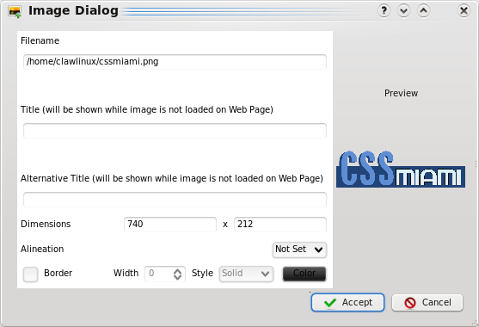

Figure 34: Image Dialog

It's recommended to fill Title field, because pages that has this field (mainly is for accessibility) has more ranking on search engines (like meta-tags do).

Dimension:
You can change dimensions of an image. Be aware because it's a soft resize. This is that the file image isn't resized, and image weight would be the same that if you don't resize it. If you want to decrease image weight, you'll need to resize with an image editor such as Gimp, or Photoshop.

Alineation:
Set alineation on the text (can override text default align defined on controls).

Border:
Set a border to the image if you want. You can change Border Style, width and color.

Table Dialog

This (Figure 35) it's the dialog that will be opened.
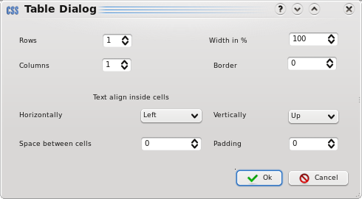
In this dialog you can select how many rows & columns do you want.
About external settings of table, you can modify size width % (referencing only of your Container), and border.

And about inside content, you can choose the text align, space between cells and padding. Figure 35: Table Dialog

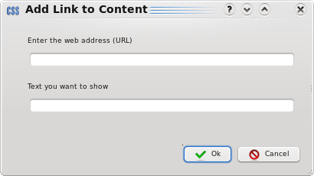
Link Dialog

This (Figure 36) it's the link dialog.

Basically that you need to know to use this dialog it's the URL. That means the web page that you want to open.
Text to show if you doen't fill it, will be the same URL that you have filled.

Figure 36: Link dialog
Final advices – Final Step

After you have modified what you want on the Content Editor, you click on Accept, button, and your container is filled with your data.
If you want to see the code, don't forget to change to Source View. (Seen on Interface: Workspace)

In any moment, you can press F1 or “Help” button to open this manual.

You can preview your page on a external browser such as Mozilla Firefox, by using “Preview” button, on the menu (Figure 7).

Content of folder where you have created your web, is ready to upload to your server, without any changes. You have to upload too “css” and “img” folder, and enjoy your web.
Now you have the real CSS-Miami Power on your hand
There isn't more explanation, now let's see how you can create web pages with all this knowledge.

You can create the web page as you imagination can reach, but, we have the last advice for you:

Use your force, Luck.
Creating our first web (less than 5 minutes)

Here you have a little tutorial step-by-step about how to create a web with knowledge of this manual. These screenshots are taken from other platform to show you different possible views of CSS-Miami on different platforms and configurations.

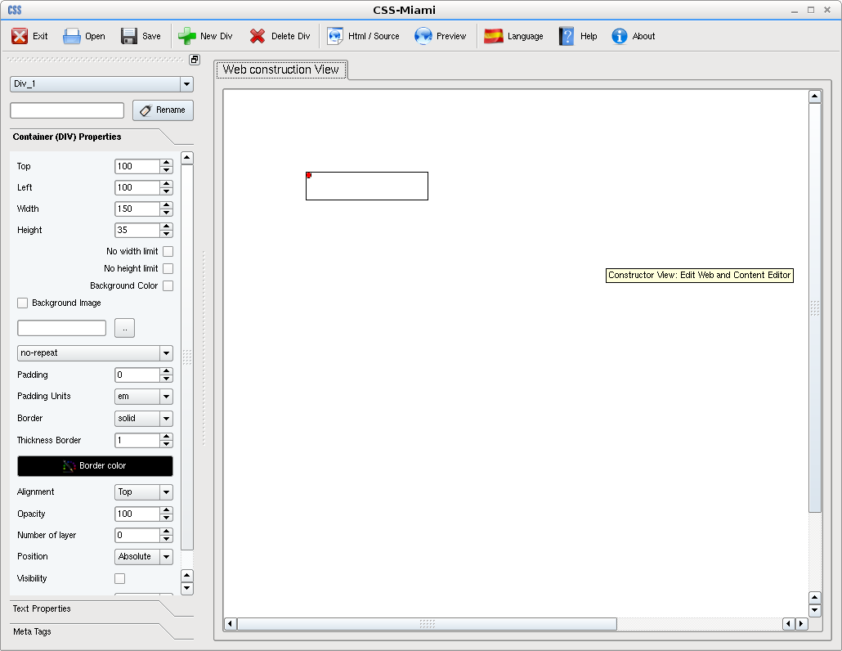
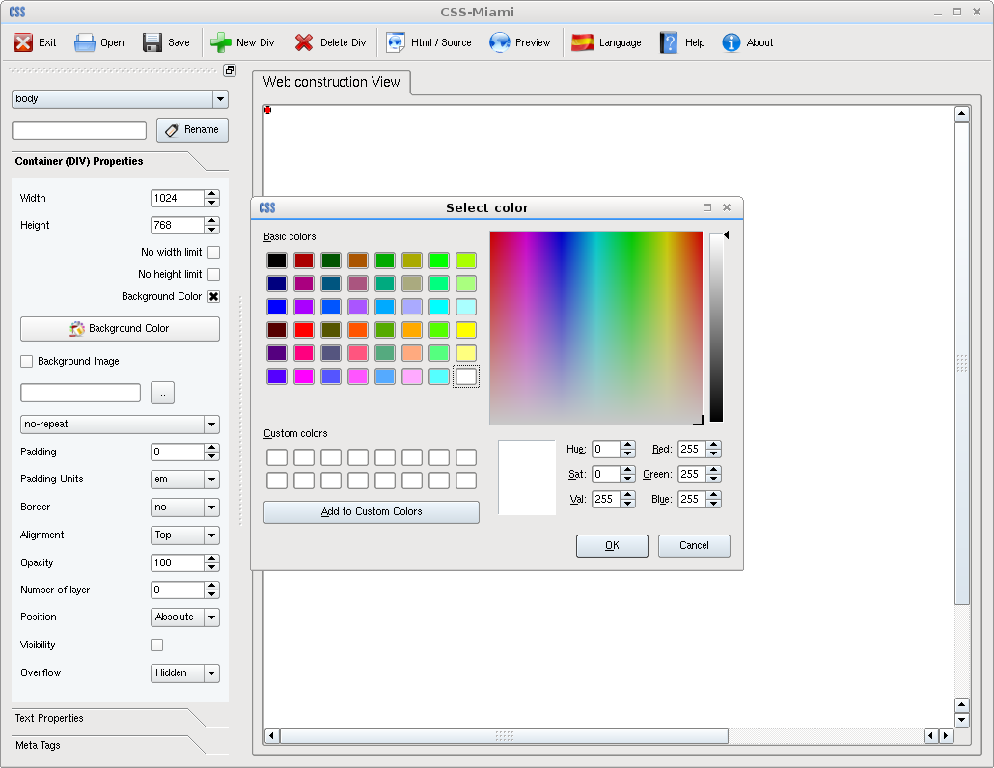

We begin with a CSS-Miami ready to work, and add a new div. Then change body background color, to have the Container more visible.

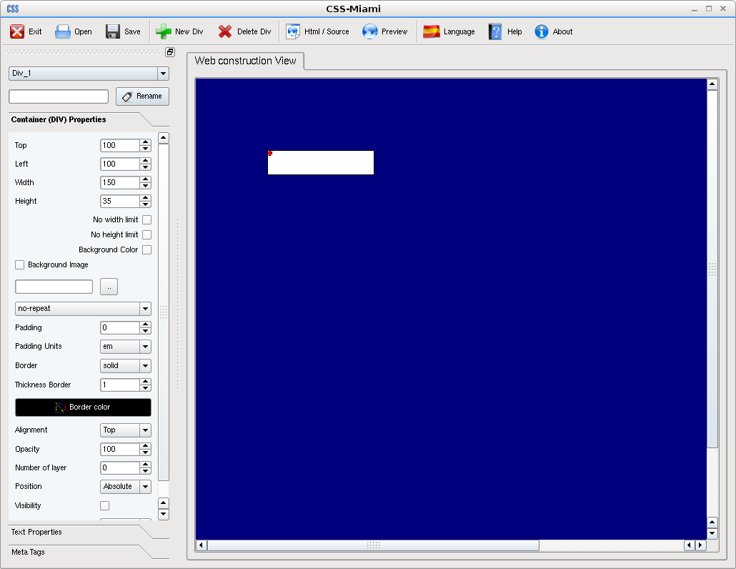
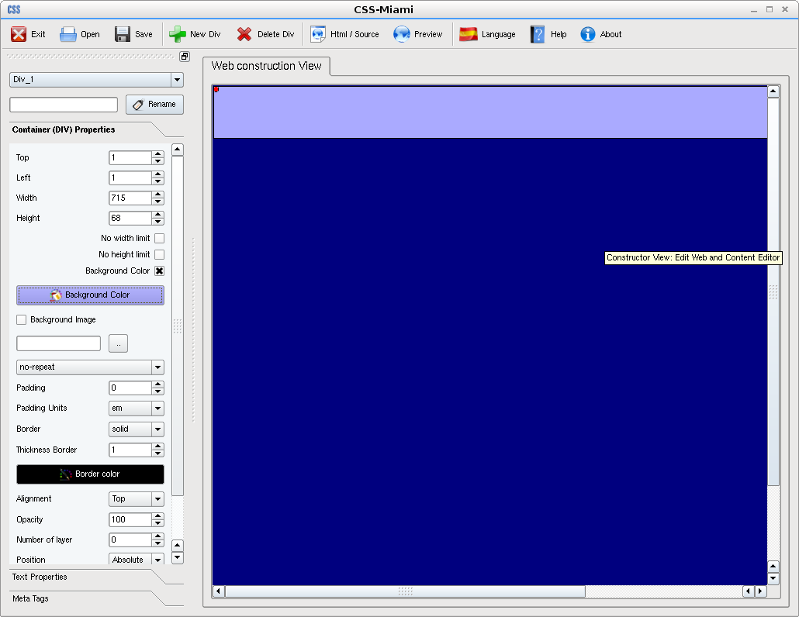

After, we put first Container on top, resized and changed the background colour.

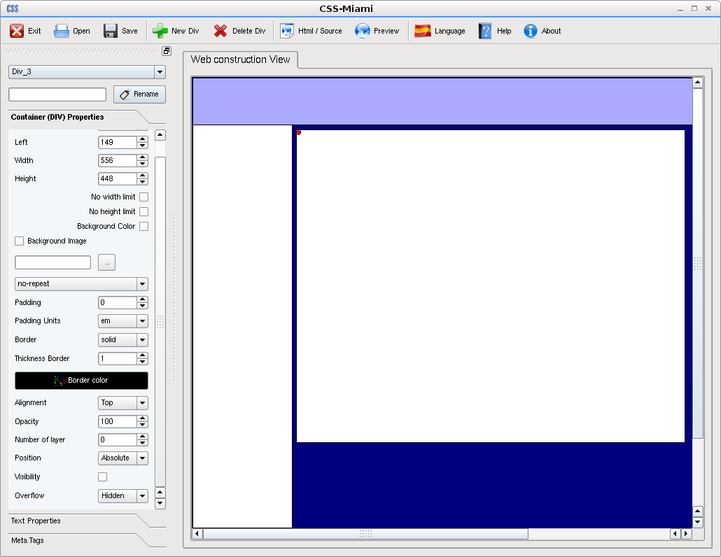
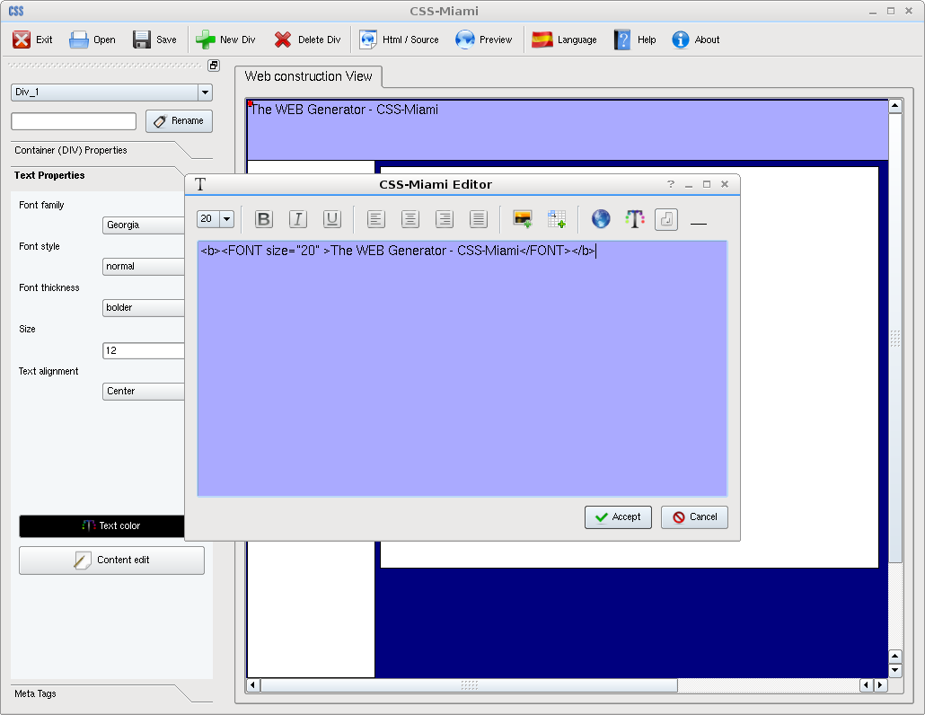

Then we add two Containers more, resized to be the menu and the main container of the webpage where really will have the useful information. Then we add on the top Container webpage title.

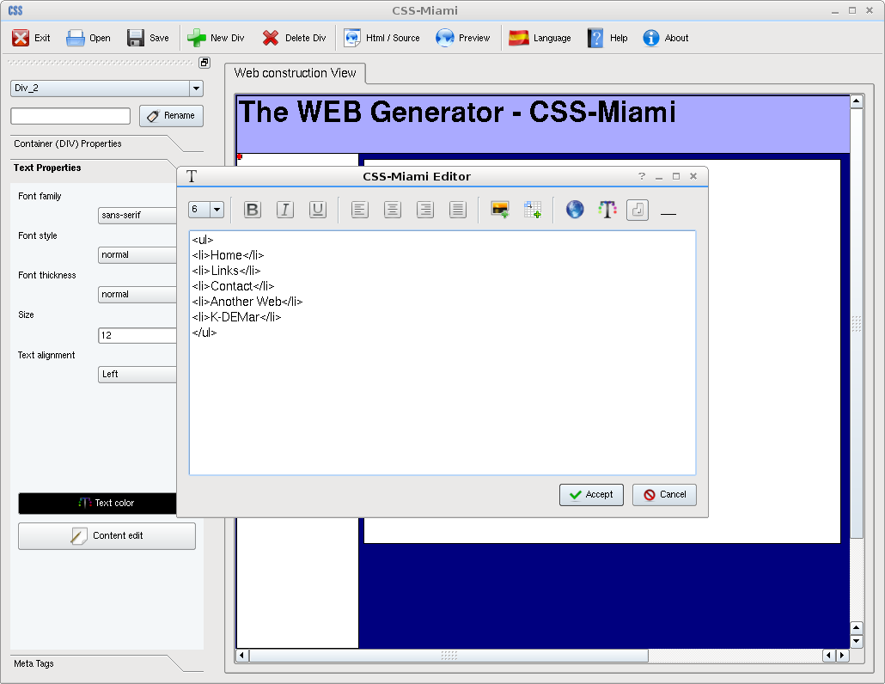
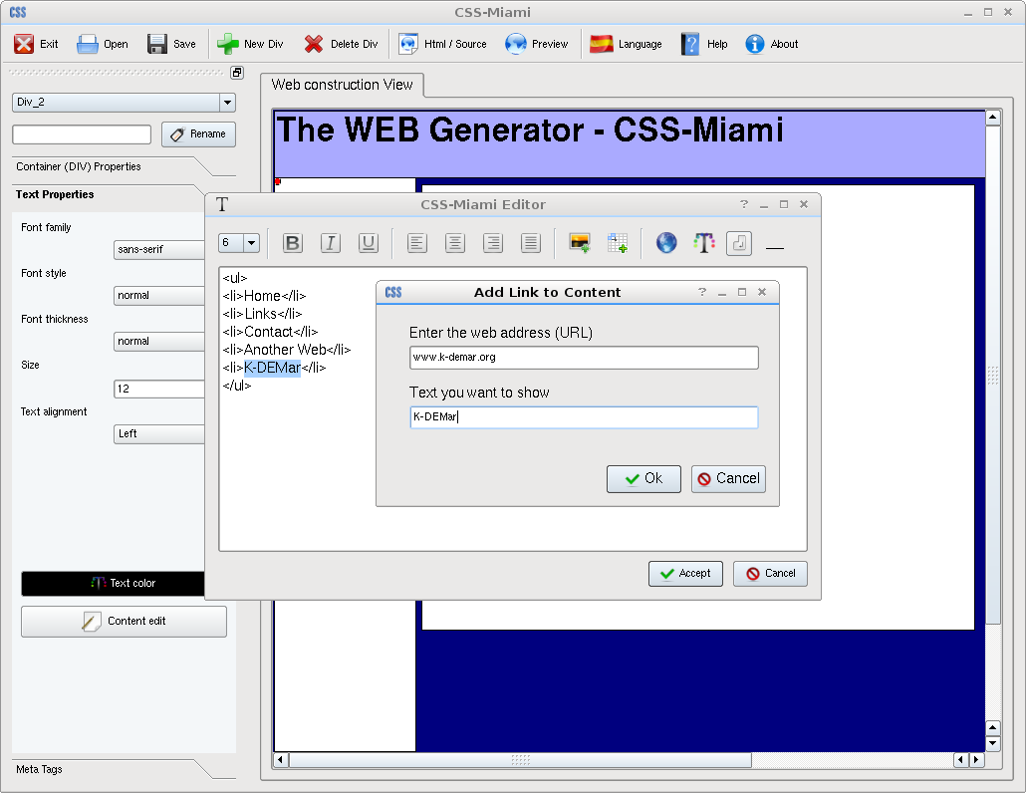

And add the menu content, with a link, pointing to http://www.k-demar.org

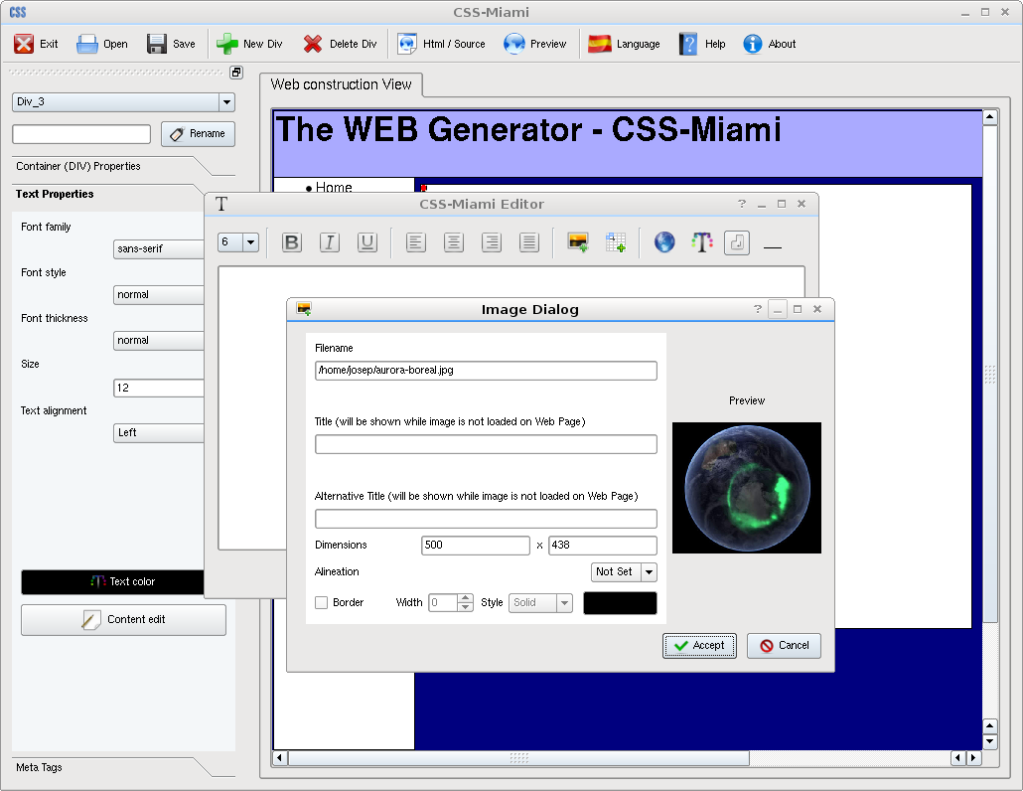
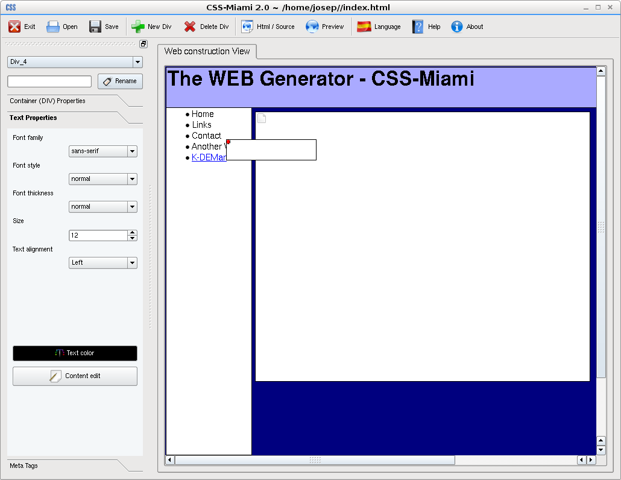

On the main content we add an image. And we make a page footer, by adding first a new Container,.

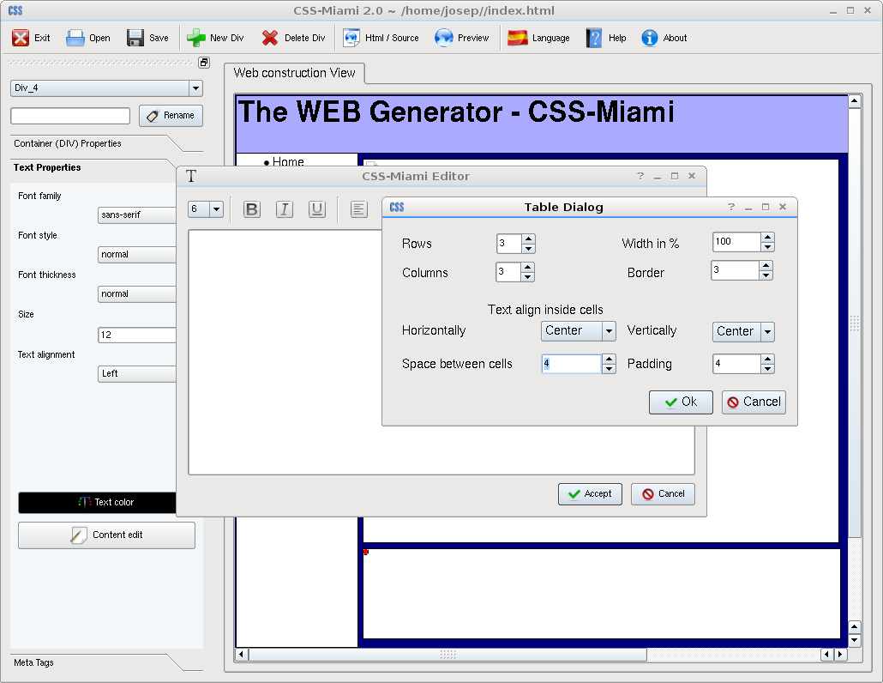
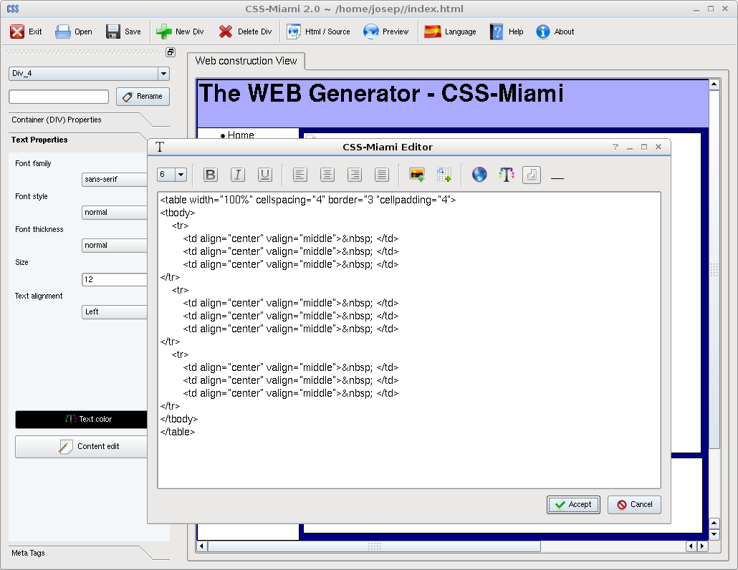

Then we resized Container to take bottom part of the pate, and add a table.

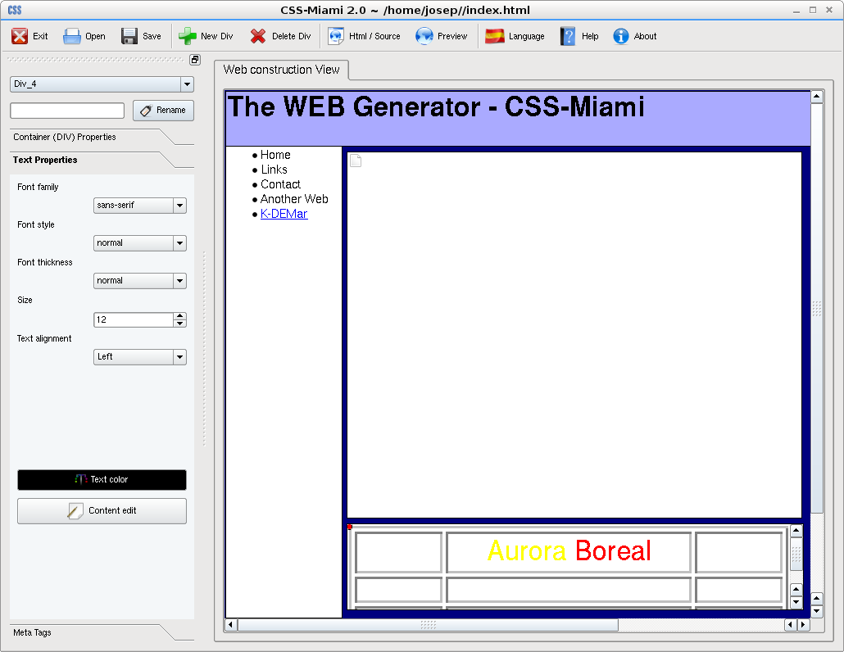
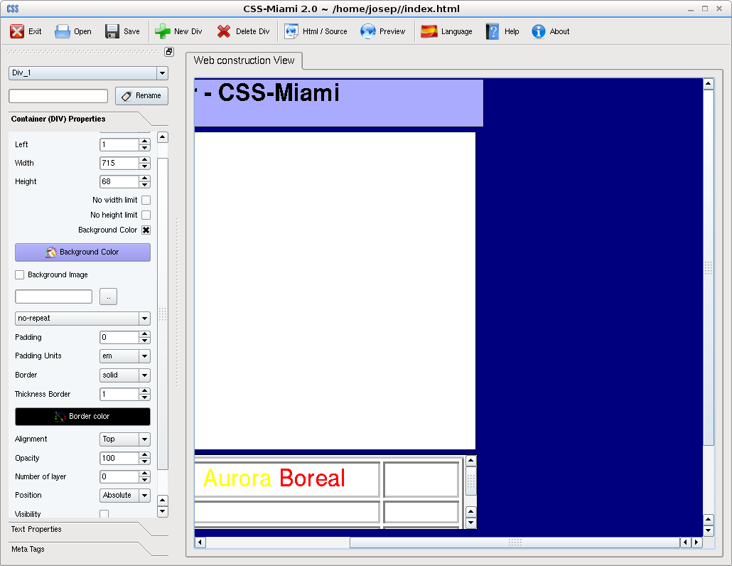

Table we filled with the name of the image. Then we go to right margin and adjust to make Containers finish on the same point.

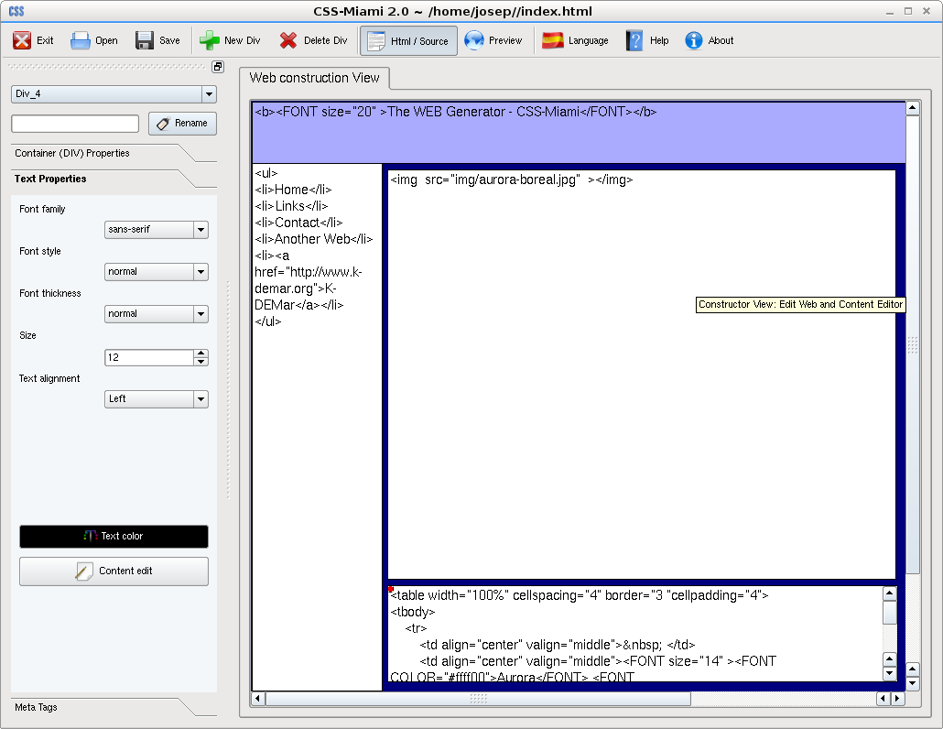
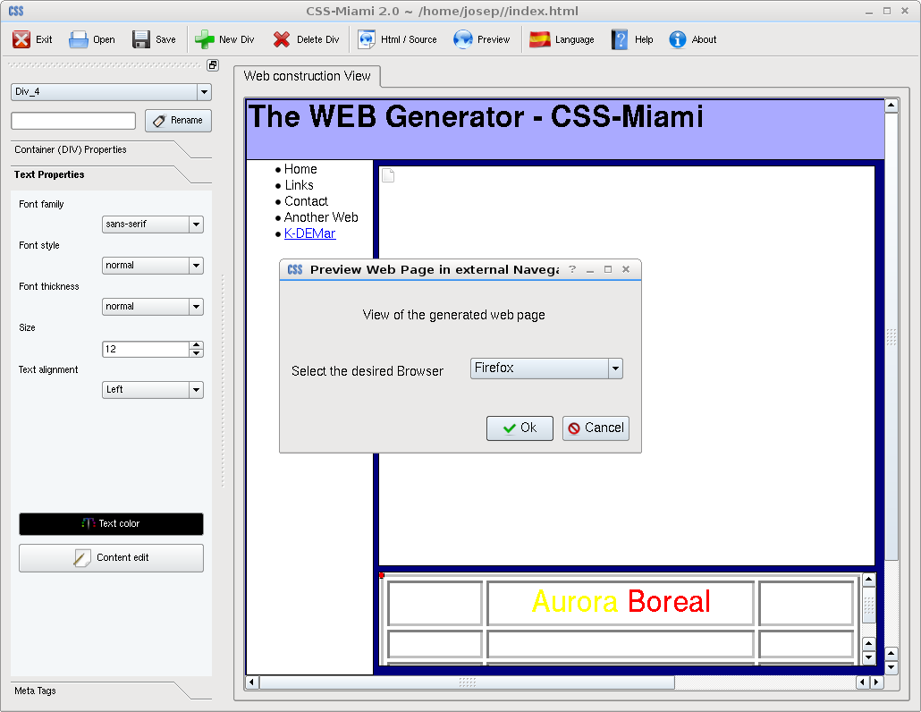

Now source view shows this lines, and let's save and take a preview with Mozilla Firefox.

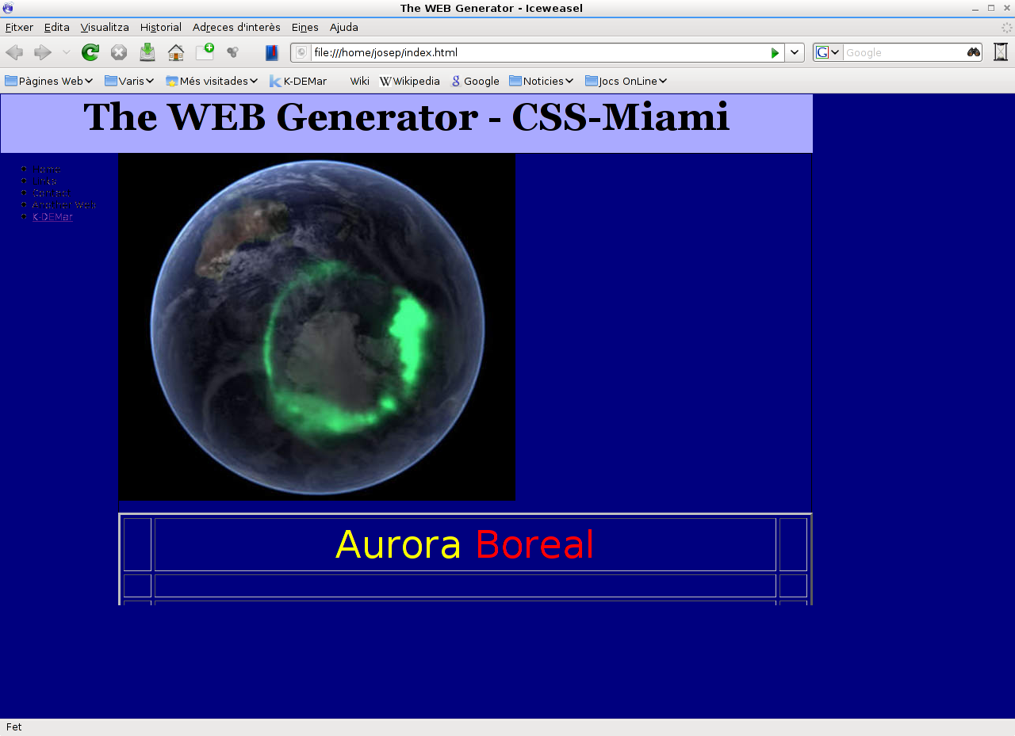
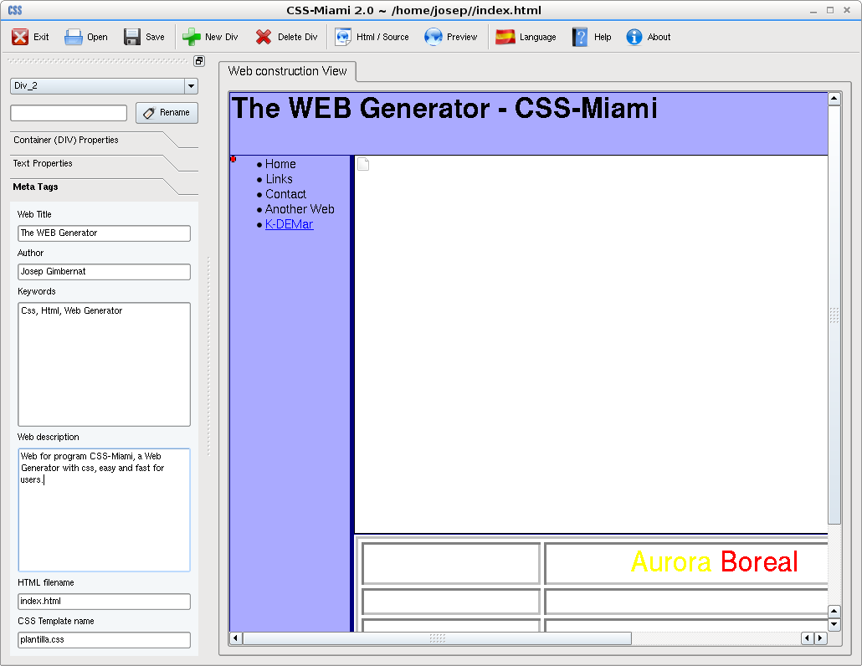

Here's the view with. Now we see that left menu it's really unreadable. We change background Content menu color, and we also fill meta-tags.

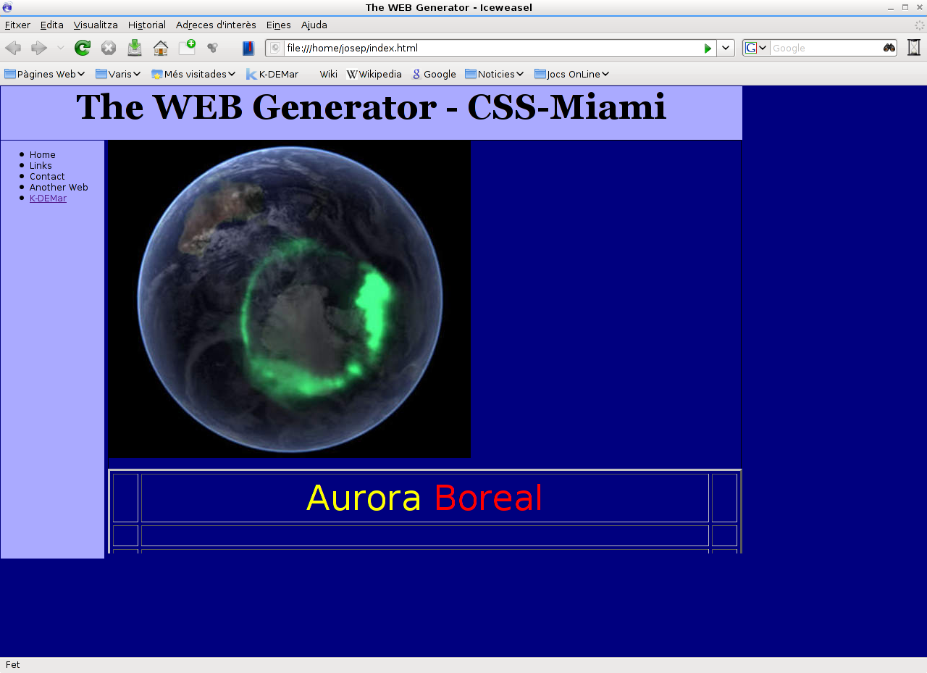

And here it is! This is your first web with CSS-Miami

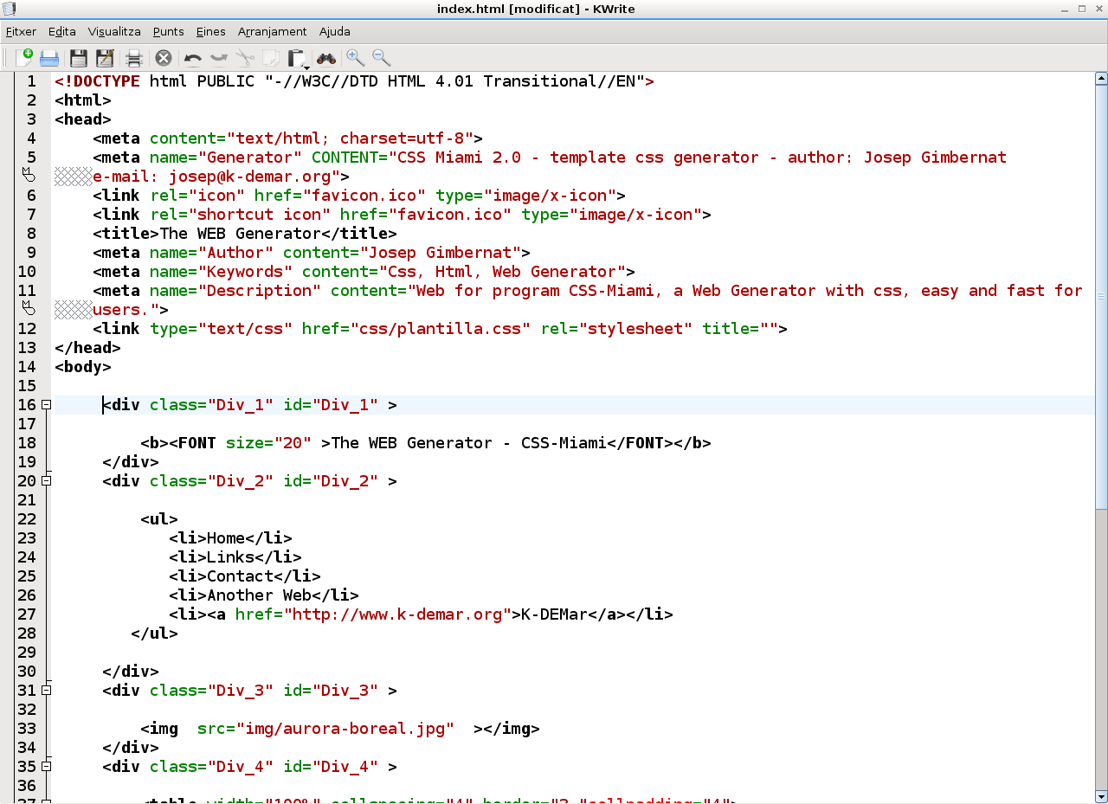
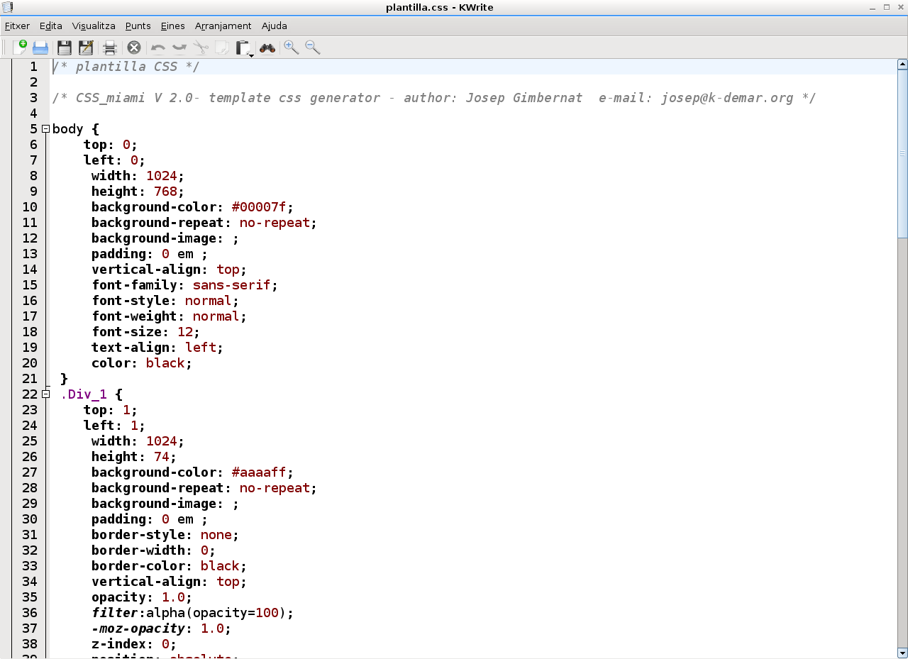

As you can see, HTML web page code it's really clean, and so human readable. This is really good, because there are few editors that makes a Clean code like this.

That's All Folks!

This is the last Chapter of this manual.

Thanks for reading and using CSS-Miami

We hope you like it, and enjoy using CSS-Miami: The Web Creator Tool.

Support for End-User

For any question, new releases, downloads, technical support, suggest, comment (that we will appreciate a lot) or whatever you need, don't forget to visit us at:
http://css-miami.org

Other Webs Created with CSS-Miami

At this moment, you can see other web pages currently online that have been created with the previous version of CSS-Miami (v1)

http://www.camideservei.org/

http://hostalsayola.cat

http://sportcat.cat

Authors

· CSS-Miami is developed by:

· Josep Gimbernat

· Adonay Sanz

copyright 2008 – GNU/GPL v3

CSS-Miami: End user documentation (aka: this manual)

copyright 2005-2008

Creative Commons Attribution-NonCommercial 2.5 License

· Theme icon it's taken from Oxygen KDE Theme
· Developed by Oxygen Team.

Can know who are them on:
http://www.oxygen-icons.org/?page_id=16

copyright 2005-2008
Creative Commons Attribution-NonCommercial-NoDerivs 2.5 License

· Flag icons from language dialog are taken from kde-look.org

· Doug M

Can visit his webpage on:
http://kde-look.org/content/show.php/Flag+Icons?content=4778

copyright 2003

License of CSS-Miami

CSS-Miami 2.0 it's licensed under GNU/GPL v3 or higher.
A copy of this license, can be found on http://www.gnu.org/licenses/gpl-3.0.html
Here there's a reduced copy, not usable by law.

GNU/GPL v3 – Reduced Copy by GNU “A Quick Guide.”

Nobody should be restricted by the software they use. There are four freedoms that every user should have:
- the freedom to use the software for any purpose,
- the freedom to change the software to suit your needs,
- the freedom to share the software with your friends and neighbors, and
- the freedom to share the changes you make.
When a program offers users all of these freedoms, we call it free software.
Developers who write software can release it under the terms of the GNU GPL. When they do, it will be free software and stay free software, no matter who changes or distributes the program. We call this copyleft: the software is copyrighted, but instead of using those rights to restrict users like proprietary software does, we use them to ensure that every user has freedom.
We update the GPL to protect its copyleft from being undermined by legal or technological developments. The most recent version protects users from three recent threats:
- Tivoization: Some companies have created various different kinds of devices that run GPLed software, and then rigged the hardware so that they can change the software that's running, but you cannot. If a device can run arbitrary software, it's a general-purpose computer, and its owner should control what it does. When a device thwarts you from doing that, we call that tivoization.
- Laws prohibiting free software: Legislation like the Digital Millennium Copyright Act and the European Union Copyright Directive make it a crime to write or share software that can break DRM (Digital Restrictions Mismanagement; see below). These laws should not interfere with the rights the GPL grants you.
- Discriminatory patent deals: Microsoft has recently started telling people that they will not sue free software users for patent infringement—as long as you get the software from a vendor that's paying Microsoft for the privilege. Ultimately, Microsoft is trying to collect royalties for the use of free software, which interferes with users' freedom. No company should be able to do this.
Version 3 also has a number of improvements to make the license easier for everyone to use and understand. But even with all these changes, GPLv3 isn't a radical new license; instead it's an evolution of the previous version. Though a lot of text has changed, much of it simply clarifies what GPLv2 said. With that in mind, let's review the major changes in GPLv3, and talk about how they improve the license for users and developers.

