Experiments with Czech Linguistic Data and ILP
Jan Dědek1, Alan Eckhardt1,2, Peter Vojtáš1,2

1 Department of Software Engineering, Charles University in Prague, Czech Republic
2 Institute of Computer Science, Czech Academy of Science
{dedek, eckhardt, vojtas}@ksi.mff.cuni.cz
Abstract. In this paper we present basic experiments that we have made in connection with our research in the domain of the Semantic Web. These experiments should demonstrate possibilities of employing ILP technique in the task of acquisition of semantic information from text of Czech Web pages. These experiments are preceded by complex linguistic analysis of the texts and the output of linguistic tools is processed in the ILP procedure.
Keywords: ILP, web, semantics, linguistics, text processing, Czech language.
1 Introduction
Our long-term aim is to extract semantic information from natural language texts. There is a large amount of texts publicly available on internet, but it is difficult to process it using a machine or software agent as it is suggested in the idea of the Semantic Web. These texts are suitable for human reader, who has to read them. Automatic machine processing of information hidden in the texts is very problematic.
The extraction of structured information from the text is often based on linguistic methods and we also process the texts by linguistic tools and use the resulting linguistic trees of sentences for easier extraction of information with help of ILP.
In Section 2 we describe basic methodology of our extraction. Experiments are described in Section 3 and in Section 4 is a conclusion.
2 Methodology
Our extraction method exploits several linguistic tools developed mainly in the Institute of Formal and Applied Linguistics in Prague, Czech Republic. These tools produce domain independent linguistic annotation. The linguistic annotation is then used in the extraction process. The extraction process is supported with extraction rules, which are learned in an ILP procedure. In this paper we present initial experiments with learning of extraction rules. After all semantic interpretation of extraction rules can provide semantics to the extracted data.
Domain independent intermediate linguistic annotation.
We use a chain of linguistic analyzers ([1], [2], and [3]) that process text presented on a web page and produce linguistic (syntactic) trees corresponding to particular sentences. These trees serve as a basis of our extraction process.
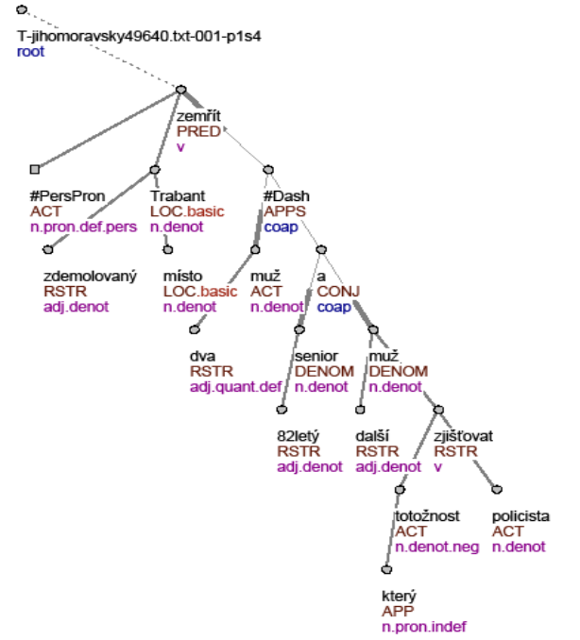
Fig. 1. A tectogrammatical tree of the sentence: “Two men died on the spot in the demolished Trabant...”
Unlike the usual approaches to the description of English syntax, the Czech syntactic descriptions are dependency-based, which means that every edge of a syntactic tree captures the relation of dependency between a governor and its dependent node. Especially the tectogrammatical (deep syntactic) level of representation [4] is closer to the meaning of the sentence. The tectogrammatical trees (see Figure 1) have a very convenient property of containing just the type of information we need for our purpose, namely the information about inner participants of verbs - actor, patient, addressee etc.
On the Figure 1 we can see the relationship between particular words of a sentence and nodes of tectogrammatical tree – the highlighted node of the tree corresponds with the word “two” in the sentence (also highlighted).
Domain and purpose dependent extraction.
Assume we have pages annotated by the linguistic annotator and we have a domain ontology. The extraction method we have used is based on extraction rules. An example of such an extraction rule is on Figure 2 (on the left side). These rules represent common structural patterns that occur in sentences (more precisely in corresponding trees) with the same or similar meaning. Mapping of the extraction rules to the concepts of target ontology would enable the semantic extraction. Example of such mapping is demonstrated in the Figure 2.

We experimented with obtaining extraction rules in two ways.
(1) Rules and mappings were designed manually (like the rule on the Fig. 2) and
(2) Rules and mappings were learned using ILP methods.

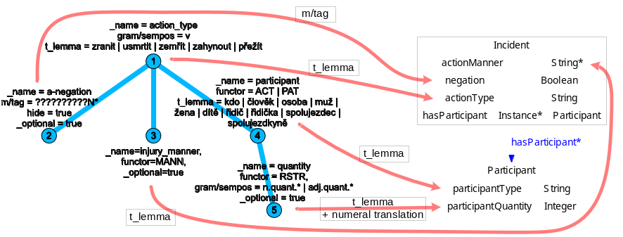
Fig. 2. An example of extraction rule and its mapping to ontology
Here we will present our experiments with learning of the rules. We discovered that we can use a straightforward transformation of linguistic trees to predicates of ILP (for example see Figure 3). Logic representation of a tree consists of three parts:
- nodes (represented as atoms nodeX_Y)
- edges (represented by predicate edge) and
- attributes of nodes (additional predicates e.g. t_lemma, functor, m_tagX).

%%%%%%%%%%%%%%%%%%%%%%%%%%%%%%%%%%%%%%%%%%%%%%%
% Two men died on the spot in the % demolished trabant – a senior 82
% years old and another man, who’s

%%%%%%%% Nodes %%%%%%%%
tree_root(node0_0). node(node0_0).
id(node0_0, t_jihomoravsky49640_txt_001_p1s4).

node(node0_1).
t_lemma(node0_1, zemrit).
functor(node0_1, pred).
gram_sempos(node0_1, v).

node(node0_2).
t_lemma(node0_2, x_perspron).
functor(node0_2, act).
gram_sempos(node0_2, n_pron_def_pers).
...

%%%%%%%% Edges %%%%%%%%
edge(node0_0, node0_1). edge(node0_1, node0_2). edge(node0_1, node0_3).
...
edge(node0_34, node0_35).

%%%%%%%% Injury %%%%%%%%
injured(t_jihomoravsky49640_txt_001_p1s4).
Fig. 3. A sample of the prolog representation of a sentence
3 Experiments
We tried to extract some semantic information from natural language texts. The aim was to find out the number of injured persons during car accidents. Firemen reports have been used; some of them were about car accidents, some were not. Each report was split into sentences and each sentence was linguistically analyzed and transformed into a tectogrammatical tree, as described in the previous section. These trees were converted to a set of the Prolog facts (see Figure 3).
Sentences, which talk about an injury during a car accident, were manually tagged by predicate injured(X), where X is the id of the sentence. Those sentences that do not talk about injured persons during a car accident were tagged as :-injured(X), which represents a negative example. This tagging can be done even by a user inexperienced in linguistics and ILP.
These tagged sentences formed the input for ILP; we used 22 sentences as positive examples and 13 as negative examples. We used Progol [5] as ILP software.
The rules ILP found are in Table 1.
Table 1. Rules found by ILP.
injured(A) :- id(B,A), id(B,t_plzensky57770_txt_001_p5s2).
injured(A) :- id(B,A), id(B,t_plzensky60375_txt_001_p1s6).
injured(A) :- id(B,A), id(B,t_plzensky57870_txt_001_p8s2).
injured(A) :- id(B,A), id(B,t_plzensky57870_txt_001_p1s1).
injured(A) :- id(B,A), edge(B,C), edge(C,D), t_lemma(D,zranit).
injured(A) :- id(B,A), edge(B,C), edge(C,D), t_lemma(D,nehoda).

The first four rules are over-fitted to match specific sentences. Only the last two represent generally applicable rules. But they do make sense – “zranit” means “to hurt” and “nehoda” means “an accident” in Czech. These two rules mean that the root element is connected either to a noun that means an accident or to a verb that means to hurt.
We tested these rules on a set of 15 positive and 23 negative examples. Results are in Table 2, overall accuracy was 86.84%. P is a sentence that ILP classified as positive, ~P is a negative sentence, A is a sentence that was manually tagged as positive and ~A is a sentence tagged as negative. Out of 15 sentences that were tagged as positive, 11 were also classified as positive by ILP and 4 were classified as negative. Out of 23 sentences that were tagged as negative, 22 were also classified as negative by ILP and only 1 was classified as positive.
Table 2. Results on the test set.
 | A | ~A
P | 11 | 1
~P | 4 | 22

We also tried to find the number of injured in each sentence. Each sentence was tagged by binary predicates number_injured and number_severe_injury. The first parameter is the id of a sentence; the second is the correct number of persons involved. We also added artificial negative examples with wrong numbers – we used the numbers present in the dataset: 1.2.3.4.5.6.7.8.9. Note that this task is more difficult than the previous one, because the number is sometimes not mentioned explicitly in the sentence. For example the sentence “both men died in the accident” speaks about two men, but the word “two” is not present in the sentence.
Two following rules were mined (see Table 3). We have excluded twenty rules – each covered only one sentence. These mined rules (in the Table 3) are quite interesting because they are not meaningless. Especially the second one is nearly exemplary. This second rule contains path form the root to the analytical leaf node E:
root_id(A)→node(B) →node(C) →node(D) →analytical_node(E).
Node D is connected in the role of patient – affected object (functor(D,pat)) and in the morphological description in the node E there is restriction on singular number of the node D (m_tag3(E,s)). So there should be only one participant of the injury.
Table 3. Rules found by ILP.
number_injured(A,1) :- id(B,A), edge(B,C), edge(C,D), edge(D,E), edge(E,F), m_tag2(F,m).
number_injured(A,1) :- id(B,A), edge(B,C), edge(C,D), edge(D,E), functor(D,pat), m_tag3(E,s).

The results in Table 4 look promising, but the high accuracy is attended thanks to the high number of negative examples. Overall accuracy was 96,30%.
However, ILP has succeeded to classify correctly 4 out of 6 positive examples.
Table 4. Results on the test set using only 6 sentences with a number of injured present.
 | A | ~A
P | 4 | 0
~P | 2 | 48

When we look at the predicate number_severe_injury, the situation is about the same. Only one useful rule was mined (leaving out three rules with ids):
Table 5. A rule found by ILP.
number_severe_injury(A,1) :- id(B,A), edge(B,C), edge(C,D), edge(D,E), m_tag3(E,s), m_tag4(E,1).

And the results are also similar:
Table 6. Results on the test set using only 8 sentences with a number of severe injuries present.
 | A | ~A
P | 4 | 1
~P | 4 | 64

Now only 4 out of 8 positive examples were classified correctly. Overall accuracy was 93.15%.
4 Conclusion
The main contribution of this paper was to try ILP as a learning procedure of extraction rules in our information extraction process supported by linguistic preprocessing of text data. We used a complex set of linguistic tools to transform natural language to linguistic trees; these trees were afterwards transformed into a Prolog representation.
The performance of ILP is questionable – we did use rather small data set for learning and results are not astonishing. However, the preliminary results are not desperate – some rules were found and their performance was not too bad. For real-world use, many optimizations should be made.
In future, we would like to do more experiments in different domains and extend the set of extraction tasks. We also would like to test this approach on a larger data set and study the dependence of the size of the training data and the time of the inductive process. Also, some ILP systems other than Progol can be used.

Acknowledgment
This work was partially supported by Czech projects 1ET100300517, 1ET100300419 and MSM-0021620838.
References
1. Jan Hajič. Morphological Tagging: Data vs. Dictionaries. In: Proceedings of the 6th Applied Natural Language Processing and the 1st NAACL Conference, Seattle, Washington, 2000, pp. 94-101.
2. Michael Collins, Jan Hajic, Eric Brill, Lance Ramshaw, and Christoph Tillmann. A Statistical Parser of Czech, in Proceedings of 37th ACL Conference, pp. 505–512, University of Maryland, College Park, USA, 1999.
3. Vaclav Klimes. Transformation-Based Tectogrammatical Analysis of Czech, in Proceedings of the 9th International Conference, TSD 2006, number 4188 in Lecture Notes In Computer Science, pp. 135–142, Springer-Verlag Berlin Heidelberg, 2006.
4. Marie Mikulova, Alevtina Bemova, Jan Hajic, Eva Hajicova, Jirı Havelka, Veronika Kolarova, Lucie Kucova, Marketa Lopatkova, Petr Pajas, Jarmila Panevova, Magda Razımova, Petr Sgall, Jan Stepanek, Zdenka Uresova, Katerina Vesela and Zdenek Zabokrtsky. Annotation on the tectogrammatical level in the Prague Dependency Treebank. Annotation manual, Technical Report 30, UFAL MFF UK, Prague, Czech Rep. 2006.
5. S. Muggleton. Learning from positive data. In Proceedings of the Inductive Logic Programming Workshop, 1996.

http://ufal.mff.cuni.cz

