Running head: Web Semantization

Web semantization
Jan Dědek, Alan Eckhardt, Leo Galamboš, Peter Vojtáš
Department of Software Engineering, Faculty of Mathematics and Physics, Charles University Institute of Computer Science, Academy of Sciences of the Czech Republic Abstract
On this page, you write your abstract. The abstract is a brief, comprehensive summary of the contents of your paper. It provides a snapshot of your paper for the reader. Abstracts should be concise, specific and accurate. The length of your abstract should not exceed 120 words. Please note that the abstract is not indented. If your paper does not include an abstract, you can delete this page. To do so, select all of the text on this page and press the “Delete” key. If necessary, press the “Delete” key again to remove the page break completely.

1 Introduction
In their Scientific American 2001 article [2], Tim Berners-Lee, James Hendler and Ora Lassila unveiled a nascent vision of the semantic web: a highly interconnected network of data that could be easily accessed and understood by an desktop or handheld machine. They painted a future of intelligent software agents that would … answer to a particular question without our having to search for information or pore through results (quoted from [3], emphasized authors). Lee Feigenbaum, Ivan Herman, Tonya Hongsermeier, Eric Neumann and Susie Stephens in their Scientific American 2007 article [3] conclude that “Grand visions rarely progress exactly as planned, but the Semantic Web is indeed emerging and is making online information more useful as ever”. L. Feigenbaum et al. support their claim with success of semantic web technology in drug discovery and health care (a several further applications). These are mainly corporate applications with human annotated data. Ben Adida when bridging clickable and Semantic Web with RDFa ([1]) assumes also human (assisted) activity by annotations of newly created web resources.
Nobody seems to care in the semantic web community about the content of the web of today. By our opinion the content of the web of today is too valuable to be lost for emerging semantic web applications.
In this paper we would like to address the problem of semantization (enrichment) of current web content as an automated process of annotation for making (at least a part) of today web accessible for machine processing and hence enabling intelligent tools for searching and recommending things on the Web [4].
Our main idea is to create a semantic repository of information automatically extracted from the Web and corresponding annotated copies of (mainly textual) parts of web pages, and make it available to intelligent agents. We give a proof of concept that this idea is realizable in the size of several TB of Czech web (domain *.cz).
Our web crawler (see Fig.1) downloads a part of the web to a web store. Resources with semantic content can by uploaded directly to Semantic store. Extractor 1 (classifier) extracts those parts of Web store which are suitable to for further semantic enrichment (we are able to enrich only a part of resources. Further semantic content is created by several extractors and annotators in several phases. Emphasis is on automation and usage of such data.

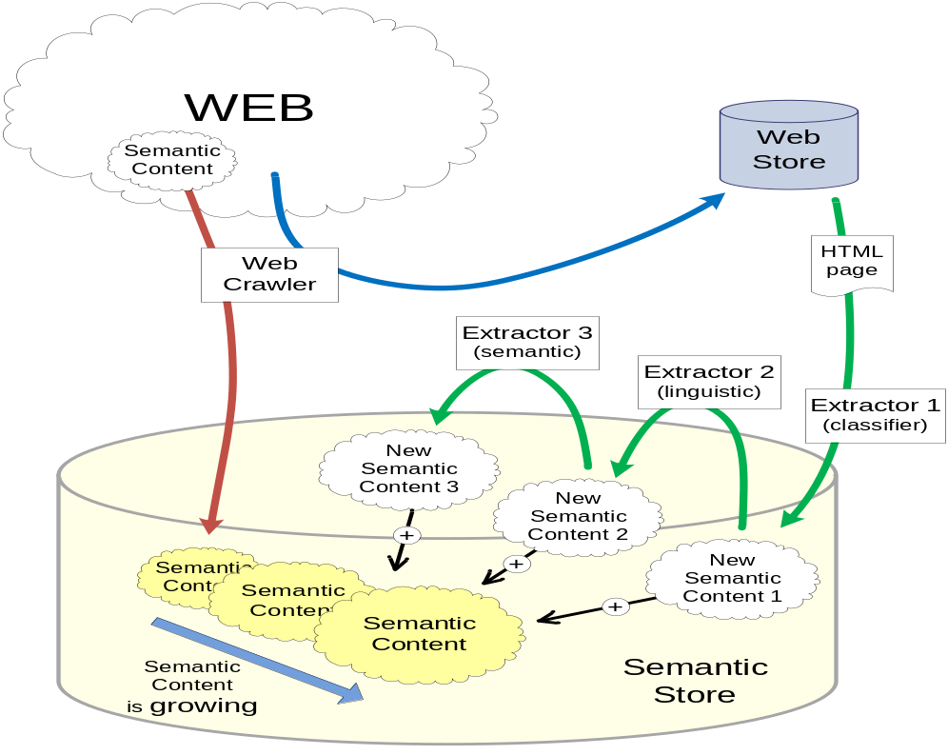
Figure XXSemantization. The process of semantization of the web.

1.1 Motivation example

Our motivation example aims to illustrate a possible use of such a semantized web by an intelligent agent.
Imagine a user wanting to buy a car. She has special requirements on car properties (possibly containing conflicting objectives as price and consumption) and its safety when used in Czech Republic (she knows about the increase of traffic accidents after unification of Germany, when fast western cars crashed on narrow roads of eastern part often [6]). Information about car properties can be extracted from several web shop pages typically in tables. Information about involvement in traffic accidents and if involved, then of injury rate, are hidden e.g. in textual traffic accidents reports of regional fire department (in Czech Republic responsible for emergency recovery). Our semantic store contains these information annotated (by possibly several tools) also by uncertainty of extraction and/or annotation process. Our intelligent agent can aggregate these (often conflicting) information and offer user best (top-k) answers according to a user dependent equilibrium between car properties, safety and reliability of these information.

1.2 Our contributions
Our main contribution is the proof of concept of idea of semantization of the web of today making it ready for intelligent search. Particular contributions consists of
- Web repository based on highly efficient web crawler with extended classification (search) capabilities, which help to classify pages suitable for further processing (see chapter 4)
- Automated domain independent annotation of some pages from our web repository. Annotation uses two general ontologies. First for linguistic annotation of pages which dominantly consists of grammatical sentences (using third party tool). Second for annotation of table structures in pages. Main objective is to achieve annotation which makes further domain dependent annotation more efficient and correct (see chapter 5)
- Domain dependent annotation (of already domain independent annotated pages) wrt a given ontology with initial learning assisted by a human expert (see chapter 6) with extraction ontology and ILP learning from structured data.
- Semantic repository serving as a sample of semantized web and extension of the ontology model for additional annotation (e.g. uncertainty annotation). Our ontology engineering part is developed in bottom up way, first instances and then ontology suitable for description (see chapter 7)
- Intelligent agent je potreba dopsat (see chapter 8).

2 (Problem) Where is the problem with semantization of the web of today?
Web of today contains lot of valuable information which is worth of being subject of intelligent search (also archived non-existing pages, e.g. http://www.archive.org/index.php and http://www.searchengineshowdown.com/others/archive.shtml). Main obstacle is that these resources are designed for human consumption and are hardly understandable for a machine. The size of these resources excludes human search. Using traditional search engines has limited capabilities. One solution is to semantically enrich these pages and make them machine processable. As it is not an easy task, the problem is who will do it and why. This is well under way for new corporate applications and publishers willing to annotate their resources and the driver can be better services (and higher profit, faster emergency warning, ...) [3].
A step in this direction is presented by indexes of various search engines – they represent a certain sort of semantic enrichment. The problem is that those are not available for writing own applications. Moreover search engines of today fail in linguistic search and the use of page rank prohibits one to find relevant pages which are not highly quoted (e.g. traffic accident reports). Web shops offer only conjunctive query search. Web shops are mainly classified as hidden web, and are hard for machine processing. Survey pages je pro to nejaky nazev? can usually offer cheapest item (when you know what you want). Linguistic search engines are just starting to be developed (Natural Language Search Engine http://www.codeproject.com/KB/vbscript/Natural_Language_Search.aspx , http://www.lexxe.com/ , http://www.cognitionsearch.com/ , http://www.powerset.com/ , http://www.hakia.com/ , U.S. Securities and Exchange Commission (Home Page) - How the SEC Protects Investors, Maintains Market Integrity, and Facilitates Capital Formation, SemNews, ...) ANEBO TO PRIJDE DO PREHLEDU SOUCASNEHO STAVU
Another step to semantic enrichment offer different web information extraction tools and some of them make their results accessible (domy v americe? Hianwei Han na ICDE v Istambulu?) but again for humans and not for machines. Mozno spomenout mashups are also an approach to semantically enrich information from the web, nevertheless they do not annotate it and do not make it machine accessible. ANEBO TO PRIJDE DO PREHLEDU SOUCASNEHO STAVU

Main problems of semantic enrichment of the web are:
- How to do it automatically, in which order, which pages should be enriched first, …? Do enrichment in the time of query or in advance?
- Where to store such enriched (annotated) pages?
- With respect to which ontology to make annotation?
- What are metrics of satisfactory semantic enrichment?
- When done, how to use it? Current RDF querying languages are not very promising for intelligent search.
- How to achieve Reusability/social web – agent once trained can be used by other user (with changed user preferences) (which extractors are trustworthy, which URLs to search (Czech car offers))
- User friendly – no need to search by keyword, only user preferences input.
- Automation – when a new offer emerges on a page, extractor captures the information, stores it in the semantic store and agent has always information up-to-date.
- When one extractor misses an attribute value, another can find it and store it. Such an automated semantic enrichment will be error prone. How to represent uncertainty? Problem of complete information?

3 (Idea) Idea of Web semantization
First idea is the idea of a web repository. In details it develops as follows. Semantic enrichment is in fact an inductive task (although a special one) - to add to web documents knowledge (which is obvious for human perception not for a machine). Such an inductive task will be easier to solve when there is a sort of repetition (modulo some similarity). So our initial idea is to use repetitions for our inductive task (which is to annotate data by concepts from an ontology which is the same as to map instances to ontology).
Semantically enrich the web by an automated process is a time consuming task (not mentioning other problems) and hence only durable pages are worth to semantically annotate (so to say, before they are changed).
Further restriction is to enrich only textual content, no multimedia (this substantially reduces size of information we have to store). Especially we restrict to pages which either dominantly contain grammatical sentences (let us call them grammatical pages) and those containing large number of table cells (let us call them structured). Of course this division need not be disjoint, and will not cover the whole web.
To be able to separate durable grammatical or structured pages with repetitions poses special requirements to search in our repository.
Second idea is to split annotation process to two parts, one domain independent automation without any concerns about user and second domain dependent user directed annotation.
Domain independent annotation can be done with respect to general ontologies. First ontology is the general PDT tectogramatic structure which captures semantical meaning of a grammatical sentence (this is a task of computational linguistics, we make use of their achievements which were originally focused on machine translation). For structured pages we assume that their structure is not changing very often and many pages are generated by same tool, hence they are similar. So there is a chance that once learned and annotated we can make next annotation detecting data regions and data records and possibly also attributes. Here annotation tools will be also trained by humans – nevertheless only once.
Domain (task) dependent annotation is concerning only pages previously annotated by general ontologies. This makes second annotation faster. Here a assistance of a human is assumed for each domain and new ontology. For grammatical pages repetitions make possible to learn mapping from structured tectogramatic instances to a ontology. For structured pages the annotation tool has to learn some form of extraction ontology. This domain (task) dependent task can be avoided by a collaborative filtering method, assuming there are enough users acquaintance.
Further important idea is do design semantic repository. Besides above mentioned annotations it should contain some sort of uncertainty annotation. The main reason is that annotation process is error prone and we can have in future different alternative annotation tools and aggregate results.
Last, but most important idea is to design at least one agent which will give evidence that our semantization realy improved general web search. Besides using annotated data it should also contain some user dependent preference search capabilities

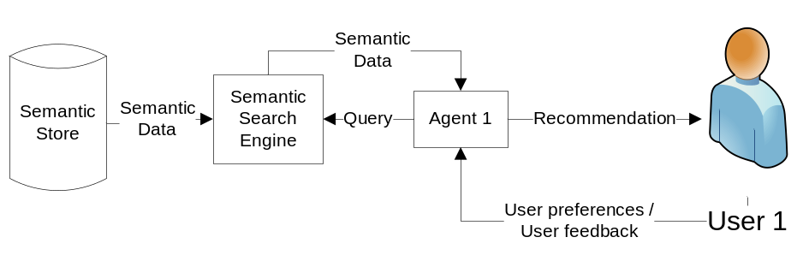
Figure XXProcess. Process of querying Semantic Search Engine by an agent

The process of a user searching for a used car is represented in Figure XXprocess. Our main focus is in the agent and in the extractors.

4 Egothor support (Detail 1)
Egothor allows an easier retrieval of Web documents stored in the Web repository for the semantic extractors. The respective functionality was already described together with the proposal of our agent (Section 4). This section extends the level of detail and explains how Egothor runs and supports the Semantic Search engine.

4.1 Crawler
Egothor crawler is designed for high-speed efficient Web crawling. The software was implemented in Java with a strict use of NIO operations. This technology ensures high throughput (up to several MB per second on a single node) and minimizes a number of crawler fetch threads.
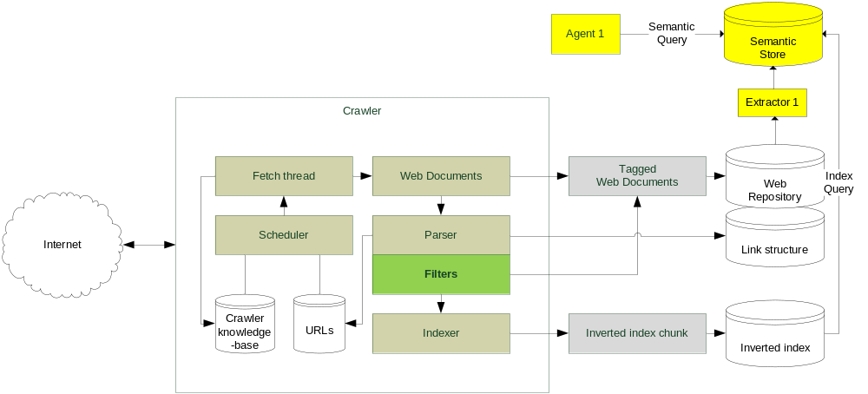
Figure XXEgothor. Schema of the components of Egothor

The central component of the crawler is a scheduler. It prepares a plan of URLs which are (re)crawled next. The plan is affected by many factors stored in crawler’s knowledge-base: network link quality, website size, number of HTTP errors during the communication with a website, history of changes in website documents in past, and other minor attributes. The knowledge-base allows the crawler to act promptly if anything (may) slow him down.
The plan is executed by a fetch thread and then the crawled documents enter a parser. The parser is responsible to extract a next fragment of a link structure and new URLs. It also prepares SAX stream which is later analyzed by an acyclic net of filters. Each of the filters may add new tags (labels on a document) and modify the SAX stream for successive filters. The output of the filtering machinery is processed by a full-text indexer and stored in an auxiliary buffer (index chunk). The index chunks are merged with a main index using a dynamization algorithm. Original Web documents, including the tags added by the filters, are stored in the Web repository.
The filters must operate on the SAX stream only and cannot use any context information (who points to this page, what pages are similar, etc.) due to performance reasons. Therefore, they are able to provide a simple classification like: page with HTML FRAMEs, TABLEs, real textual sentences (if the filter can find reasonable punctuation).

4.2 Web repository
The Egothor repository is a temporal repository of Web documents, therefore a document is identified by its id, revision number and a timestamp. The documents come together with their initial tags, and these tags can be freely modified later. The tags simplify a retrieval of documents, since you can use them instead of raw document ids and revision numbers. Moreover, the repository is also able to retrieve documents where a given Boolean formula of tags matches. The repository recognizes two tag groups: some tags are read as “for all revisions of a concrete document”, while others are tied with just a given document revision.
The architecture is based on three layers: core that saves documents and computes deltas between revisions to save space; symlink that maps core’s document and revision numbers to numbers published to a user; cloud that assigns tags and manages ACL on the tags. This way the system can modify the tags without overloading the main base of raw documents.
The repository supports document’s metadata, e.g. modification and creation dates. It keeps track of all changes in a document, so that it is able to provide information about a durable (persistent) text blocks or even subtrees in DOM.

5 (Detail2) Automated Web Information Extraction

5.1 Structural similarity extraction tool
First approach for Web information extraction is to use the structural similarity in web pages. This is often presented in web shops and on pages that presents more than one object (car). Each car is presented in a similar way and this fact can be exploited.
TODO – popsat a vysvetlit obrazek nize

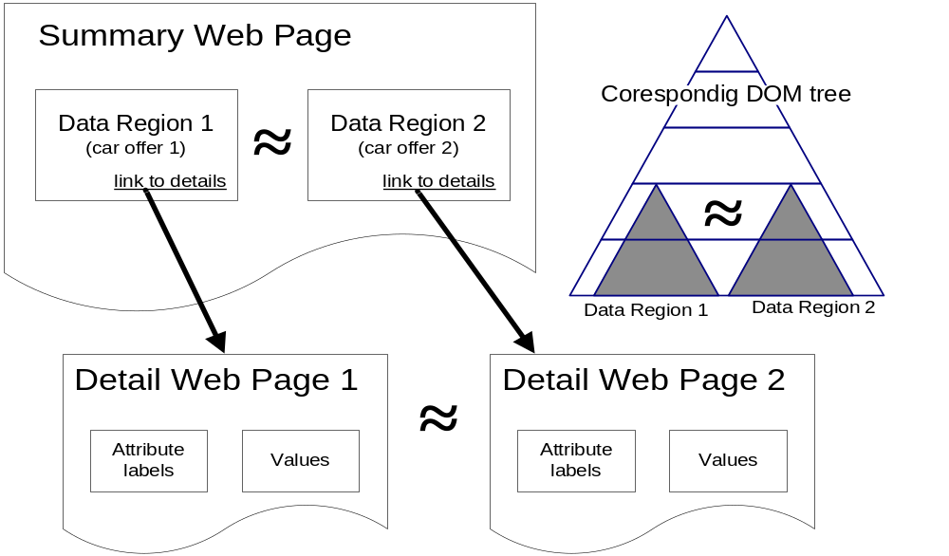
Figure XXMaruscak - Structural similarity in web pages.
We want to find data about car offers on a summary page (as seen in Figure XXMaruscak), but without any additional information; the only fact known is that the page contains some objects of interest. The similarity of these objects is used to determine the data region – a place where all the objects are stored. It is represented as a node in the DOM tree, underneath it are the similar sub-trees, which are called data records. Now we know that each data record represents a car offer and we want to extract information about attribute values from the data record. Additional information can be found in the detail page. If the link is present in the data record, it is considered to be a link to the details about the offer.
The main idea is to find same pieces of text in the data record and in the detail page. This occurs often, because a brief summary of the object is present in the data record. Somewhere near the attribute values are located the names of attributes in the detail page. These names of attributes can be extracted. The extraction of attribute names is easy because on every detail page the names will be the same. The names of attribute can be used as a simple low-level ontology - each object will have an id, represented by the URL of the detail page, and a set of properties that consists of the attribute values found on the detail page.
This simple ontology is created automaticaly, but can be later modified by a user as is described in Section 6.1.

5.2 Method based on Czech linguistics

Second approach for Web information extraction is based on Czech linguistics and NLP tools. We use a chain of linguistic analyzers (citace: tagger, parser, tecto-parser, …) that process text presented on a web page and produce linguistic (syntactic) trees corresponding with particular sentences. These trees serve as a basis of our semantic extraction.
Unlike the usual approaches to the description of English syntax, the Czech syntactic descriptions are dependency-based, which means, that every edge of a syntactic tree captures the relation of dependency between a governor and its dependent node. Especially the tectogrammatical (deep syntactic) level of representation (citace) is closer to the meaning of the sentence. The tectogrammatical trees (Such a tree can be seen on the Figure XXtree2) have a very convenient property of containing just the type of information we need for our purpose (extraction of semantic information), namely the information about inner participants of verbs - actor, patient, addressee etc.

6 (Detail2) Human assisted Web Information Extraction

6.1 Extraction based on extraction ontology
Domain ontology is the basis for extraction ontology. Extraction ontology (citace?) extends the domain ontology by adding some additional information about how the instances of a class are presented on web pages. We used regular expressions for some of the properties of class CarType. These regular expressions are matched against the text found on the web page.

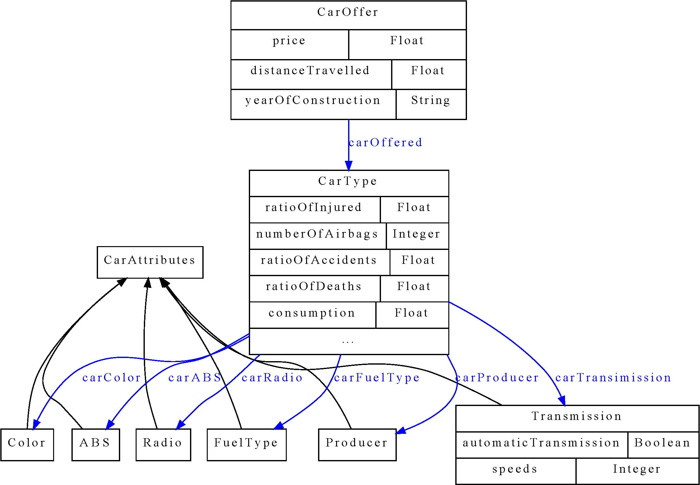
Figure XXDomainOnto. Domain ontology for car offers

The creation of extraction ontology has to be done by a very experienced user and has to be verified on a set of web pages.
TODO – dopsat sem ještě něco?

6.2 Extraction based on linguistics
The extraction method we have used is based on extraction rules. An example of such extraction rule is on the Figure XXtree1 (on the left side). These rules represent common structural patterns that occur in sentences (and in corresponding trees) with the same or similar meaning. Mapping of the extraction rules to the concepts of target ontology enables the semantic extraction. Example of such mapping is demonstrated in the Figure XXtree1.

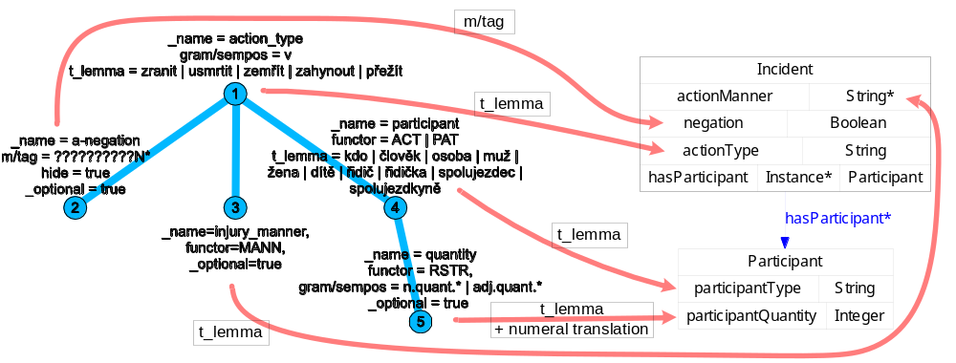
Figure XXtree1. An example of extraction rule and its mapping to ontology

We experimented with obtaining extraction rules in two ways.
(1) Rules were designed manually (like the rule on the Figure XXtree1) and
(2) rules were learned using Inductive Logic Programming (ILP) methods (see following section).

6.3 Inductive Logic Programming (ILP)
ILP is a method for generation of rules that describes some properties of data. It takes three kinds of input
- Positive examples – objects that have the desired property.
- Negative examples – objects that do not have the desired property.
- Background knowledge – facts about the domain.
ILP tries to generate such rules that all positive examples and no negative example satisfies. It uses concepts from the background knowledge in the body of rules.
The main advantage of ILP is that it can be trained to mine arbitrary data – the process of learning is dependent only on the positive and negative examples and on the amount of information we have about them. The more information we have, the more precise the learning will be.
Thanks to the fact that ILP learns from positive and negative examples, we can propose an assisted learning procedure for learning and also tuning the extractor (described in previous section). The process is such that extractor gets pure textual or semantically annotated (by the extractor) data from a web page and presents it to the user. He or she then annotates or only corrects the data saying which are good and which are badly annotated. Extractor can be learned and tuned to the desired goal in this way. Of course the user has to understand the semantics of the annotations - so he or she has to be an expert in that way of understanding the target ontology, but this ontology can be quite simple in the case we are interested only in a specific kind of information e.g. number of people injured during a car accident like in our experiments (see next section) and motivation.
We discovered that we can use a straightforward transformation of linguistic trees to predicates of ILP (example of the transformation is in the Figure XXProlog.) and the learning procedure responds with significant results, which are presented in next section.

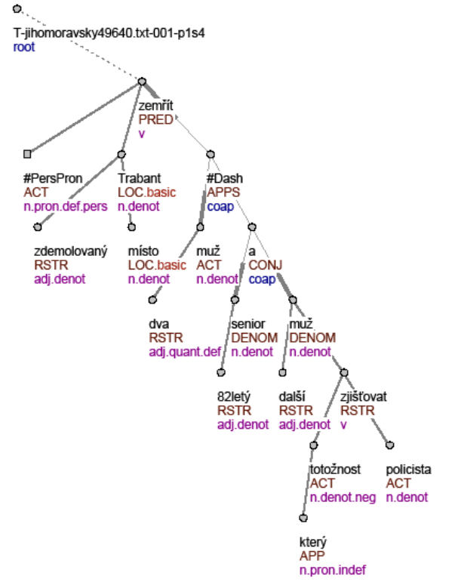
Figure XXtree2. A tectogrammatical tree of sentence: “Two men died on the spot in the demolished Trabant...”
%%%%%%%%%%%%%%%%%%%%%%%%%%%%%%%%%%%%%%%%%%%%%%%
% Ve zdemolovanem trabantu na miste zemreli dva
% muzi - 82lety senior a dalsi muz, jehoz ...
%
% Two men died on the spot in the demolished
% trabant – a senior 82 years old and another
% man, who’s ...

%%%%%%%% Nodes %%%%%%%%
tree_root(node0_0). node(node0_0).
id(node0_0, t_jihomoravsky49640_txt_001_p1s4).

node(node0_1).
t_lemma(node0_1, zemrit).
functor(node0_1, pred).
gram_sempos(node0_1, v).

node(node0_2).
t_lemma(node0_2, x_perspron).
functor(node0_2, act).
gram_sempos(node0_2, n_pron_def_pers).
...

%%%%%%%% Edges %%%%%%%%
edge(node0_0, node0_1). edge(node0_1, node0_2). edge(node0_1, node0_3).
...
edge(node0_34, node0_35).

%%%%%%%% Injury %%%%%%%%
injured(t_jihomoravsky49640_txt_001_p1s4).

Figure XXProlog. Sample from prolog representation of a sentence

On the Figure XXtree2 we can see the relationship between particular words of a sentence and nodes of tectogrammatical tree – the highlighted node of the tree corresponds with the word “two” in the sentence. This relationship allows propagation of information form user (which annotates just text of sentence) to the ILP learning procedure.

6.4 Experimentsprecist
Our experiment was to enable our agent to access information from various sources. The first source is data structured into tables, from which the semantic information is extracted. We used (CITE Maruscak) for the extraction. Data extracted in this way represents car offers with attributes of the car offered, the price, the seller of the car etc.

The second source is natural language text. We wanted to find out the number of injured persons during car accidents. We have used firemen reports; some of them were about car accidents, some were not. Each report was split into sentences and each sentence was linguistically analyzed and transformed into a tectogrammatical tree, as described in Section XSecLinguistic. These trees were transformed to a set of Prolog facts (see Figure XXProlog).
Sentences, which talk about an injury during a car accident, were manually tagged by predicate injured(X), where X is the ID of the sentence. Those sentences that do not talk about injured persons during a car accident were tagged as :-injured(X), which represents negative example. This tagging can be done even by an user unexperienced in linguistics and ILP, but he or she has to understand the semantics of information he is tagging (in usually means that he or she has to understand the target ontology).
These tagged sentences were input for ILP, we used 22 sentences as positive examples and 13 as negative examples. We used Progol (CITE) as ILP software.
The rules ILP found are in Table XXTProgol.
Table XXTProgol: Rules ILP found.
injured(A) :- id(B,A), id(B,t_plzensky57770_txt_001_p5s2).
injured(A) :- id(B,A), id(B,t_plzensky60375_txt_001_p1s6).
injured(A) :- id(B,A), id(B,t_plzensky57870_txt_001_p8s2).
injured(A) :- id(B,A), id(B,t_plzensky57870_txt_001_p1s1).
injured(A) :- id(B,A), edge(B,C), edge(C,D), t_lemma(D,zranit).
injured(A) :- id(B,A), edge(B,C), edge(C,D), t_lemma(D,nehoda).

The first four rules are overfitted to specific sentences. Only the last two represent generally applicable rules. But they do make sense – “zranit” means “to hurt” and “nehoda” means “an accident” in Czech. These two rules mean that the root element is connected either to a noun that means an accident or to a verb that means to hurt.
We tested these rules on the set of 15 positive and 23 negative examples. The result accuracy was 86.84%. Results are in Table XXTResults. P is the positive sentence from ILP, ~P is negative sentence, A is sentence tagged as positive and ~A is sentence tagged as negative. 11 sentences that were tagged as positive were also tagged as positive by ILP, 4 was tagged as negative by ILP. 22 sentences that were tagged as negative were also tagged as negative by ILP, only 1 was tagged as positive by ILP.
Table XXTResults: Results on the test set.
 | A | ~A
P | 11 | 1
~P | 4 | 22

In this case we learned set of rules that identify relevant sentences – roots of relevant tectogrammatical trees. We understand these results as proof of concept that ILP can be also used for finding other kinds of information present in nodes and structure of linguistic trees. Se we can for example extract number of injured people from relevant trees if we modify the training data.
The information extracted in this way can be combined with the information extracted from structured tables. If we extracted the information about the model of the car involved in the accident, we may count the number of accidents about each model; which may be valuable for the user when deciding about particular models of cars.

7 (detail3) Semantic repository
The semantic repository is a way of exchanging data between agents and extractors.
Extractors/annotators will add information about uncertainty and origin of annotations to annotations they make. This information can be used by agents or other extractors. Agents will use the information about the uncertainty of the information about a car and prefer those annotations that have high certainty. However, if the user’s feedback is bad, the agent may try to use annotation from some other extractor and correct the previously used one. If there is no other annotation available, it may ask the user to correct the attribute values showing her the original document from which the information was extracted.
Extractors may use the information about uncertainty for skipping some documents, which are already annotated with a precision high enough. The extraction of information can be speeded up in this way. They have to look also on the feedback, though; it makes sense to do the extraction, if the feedback is bad.
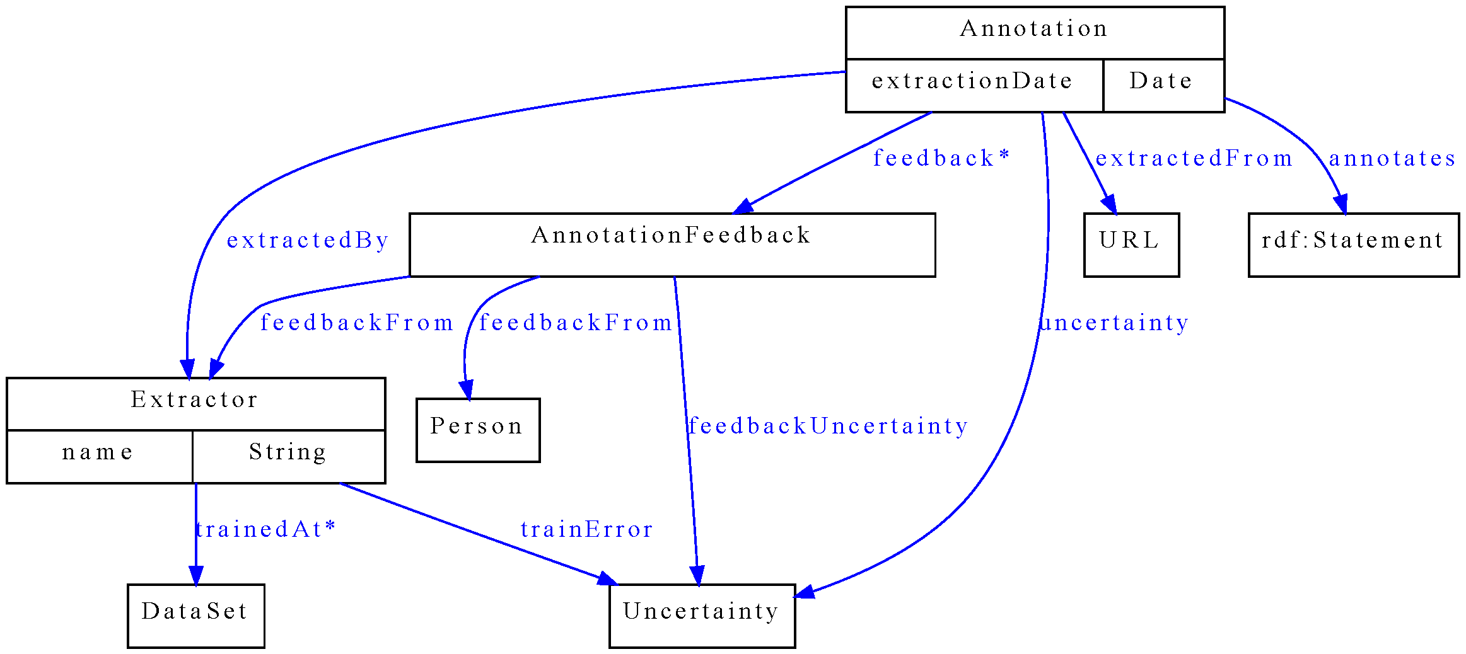
Figure XXAnotOnto. Annotation ontology
Figure XXanotOnto represents the annotation ontology that may be used for storing information about annotations. The main class is Annotation – it represents the annotation about some web document, which is identified by a URL. Annotation says that on URL is a statement specified by “annotates”. Annotation is made by an Extractor at time specified by “extractionDate”. There is an uncertainty level associated with the annotation (“uncertainty”). It express, how sure is the extractor that the statement is present on the web page.
Uncertainty represents the level of surety the extractor has about the annotation. It may be represented by different concepts, as proposed in (CITE Incubator Group).
Extractor may specify on which dataset is trained and what accuracy achieved (“trainError”). For example Table XXling shows surety that could be claimed by linguistic tool, which we have used to produce linguistic annotations and the final tectogrammatical trees. The claimed surety can be also supported with the information that these tools were trained on The Prague Dependency Tree Bank 2.0 (citace). Similar information can be obtained form the procedure of ILP learning and evaluation described in previous sections.

Name of the tool | Precision
Morphological tagging | 93 %
Collins' parser (Czech adaptation) | 81.6 %
Analytical function assignment | 92 %
Tectogrammatical analysis | dependences: 90.2 %  f-tags assignment: 86.5%
Table XXling. Precision of particular linguistic tools.

AnnotationFeedback is a class that permits other users/agents to express their opinions on the annotation (“feedbackFrom”). The suggested uncertainty, which the annotation should have, is proposed by “feedbackUncertainty”.

8 (Detail4) Idea/proposal of our agent

8.1 Source of data for the agent
The entry points of our architecture have roots in a classic Web search technology such a Web crawler and repository. Consequent layers are based on a stream access to the repository, and on-line querying with a use of the standard Vector model (if an extractor needs that).
Our semantic search engine must handle many user preferences. In some cases, the preference can rule that the user does not believe in the common opinion of the Web community, i.e. document popularity. It emphasizes the fact that the on-line querying does not include Page rank variants by default.
The stream access allows an extractor to read all Web documents which satisfy a Boolean formula over documents tags. The term “tag” has a meaning of “anybody-defined label” in this context; it has nothing to do with HTML tags.
The tags are placed onto the documents initially by a crawler (e.g. domain name, ratio HTML code/text, content type, language, etc.). Later, an extractor, which reads some documents in the repository and produces some semantic data, may also save new tags back onto the documents. The Semantic repository is a direct product of the extractors. It includes semantic annotations and pointers back into the Web repository documents.
Egothor version 3 is a multiplatform Web search engine which covers all our Web back-end needs. Its repository operates as a Web documents revision system watching the evolution of the Web documents. The Egothor HTML filters are based on NekoHTML library with roots in the Apache Xerces project. The library allows us to (re)construct a correct XML (DOM) structure even for the badly-formatted HTML documents. Egothor then adds a possibility to process textual DOM leafs, analyze sentences and find durable textual fragments.
All the Egothor features result in an easier Web page access and classification. The extractor is able to recognize and filter (in/out):
- textual/table/frame pages,
- web page domain, e.g. “cars”, “news”, “eshop”, etc.
- pages in an area of interest; specified by a given language, date of creation/visibility, keywords, URL regexp, etc.

8.2 User preference handling
One of the aspects of our proposed agent is to compare different car offers based on their attributes. We call this a "decathlon effect", or in economy terminology "conflicting objectives". The user has some preferences on car offer’s attributes; she wants low price and low consumption. These preferences are called objectives. We can use fuzzy logic notation and to each attribute A_{i} associate its fuzzy function 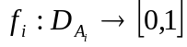, which normalizes the domain of the attribute.
Some of these objectives are conflicting e.g. wanting low price and low consumption. There is no clear winner, some of the car offers may be incomparable - Audi A4 has high price but also high consumption, on the other hand Fiat Punto may have lower price but also lower consumption. Regarding two objectives "low price" and "low consumption", these two cars are incomparable.
This undecidability is solved by an aggregation function, often denoted by @. This function takes preference on attributes and combines them into one global score of the car offer as a whole. In this way, the agent can order all car offers by their score. The aggregation function may be a weighted average, for example
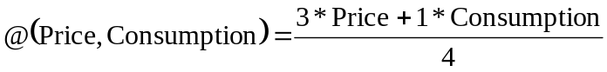,
where Price and Consumption are the degrees to which the car offer satisfies the use criteria.

Reliability
Rating
1
1
0
A
Audi A4
Audi A4
B
1.000€
10.000km

10.000€
1.000km

Figure XXReliable. An example of reliable and unreliable rating
Audi A4 denoted as A has much higher rating than the same Audi denoted as B in the example in Figure XXReliable. However, A has also much lower reliability. The reliability of the rating of A and B is determined by extractors that made the annotation. This may be caused for example by an error of extractor that switched the price (10.000(€)) with the distance travelled (1.000(km)). Thus A has much better price than B and consequently also the rating.

9 Related work (1-2 pages)
- Warmly acknowledge people who have helped you
- Be generous to the competition. “In his inspiring paper [Foo98] Foogle shows.... We develop his foundation in the following ways...”
- Acknowledge weaknesses in your approach
Crawler | #boxes/CPU | Pg/s | MB/s | year
Googlebot | 4/? | 25-32 | 0,2 | 1998
Nutch | 1/? | ? | 0,5 | 2004
Become.com | 50/? | 100 | 0,3? | 2004
Larbin | 1/2 | 80 | 2,1 | 2006
Egothor 2 | 1/2 | 100 | 5,0 | 2007

The table presents a summary of several benchmarks. Two benchmarks (Larbin and Egothor2) were run on CZ TLD domain by us. The result implies, that a web page may have about 25-50kB in size (including up to 10kB of text).

The generation of ordered list of car offers is widely addressed in the database engine field. Among most important are [7], [8]. These works concentrate to the problem how to get first k objects as fast as possible. They often deal only with a database environment, where data is stored inside one database. Different sources are permitted in [7]. This enable the distributed use - obtaining data from other web sources like web services. That is why we have chosen this approach as a base for our implementation of top-k algorithm.

10 Conclusions and further work (0.5 pages)
  - idea of web semantization, which can help to arch over the gap between Web of today and the Semantic Web.
  - a proof of concept that even today it is possible to develop a semantic search engine and an intelligent software agent.
Table XXTData: Some example data about cars. Dat sem uncertainty, price? …neprijde to k agentu?
Manufacturer | Model of car | Price | Consumption [l/100km] | % of heavy injury / death when in accident | Number of airbags
Skoda | 120 | 3 000 | 7 | 50 | 0
Trabant | Trabant Kombi | 8 000 | 7 | 10 | 0
Audi | A4 | 85 000 | 6,5 | 50 | 6
Fiat | Punto 1,1i | 32 900 | 6 | 50 | 2
Tatra | T613 | 48 000 | 12 | 50 | 0
Kia | Joice | 140 000 | 10 | 50 | 2
Ford | Focus 1.6i | 45 000 | 6,2 | 50 | 6

References
American Psychological Association (2001). Publication manual of the American Psychological Association (5th ed.). Washington, DC: American Psychological Association.
[ 1] Ben Adida. Bridging the Clickable and Semantic Webs with RDFa. ERCIM News 72 (2008) 24-25
[2] T. Berners-Lee, J. Hendler and O. Lassila. The Semantic Web. Scientific American, May 2001, 34-43
[3] L. Feigenbaum, I. Herman, T. Hongsermeier, E. Neumann and S. Stephens. The Semantic Web In Action. Scientific American, November 2007, 64-71
[4] T. Berners-Lee. The Web of Things. Keynote ERCIM News 72 (2008) p.3
[5]
[6] Wo kracht es am häufigsten? Die ZEIT magazin LEBEN, 24.01.2008 Nr. 05, Zeit online http://www.zeit.de/2008/05/Karte-05
[7] Fagin, R., Lotem, A., & Naor, M. (2001). Optimal aggregation algorithms for middleware. In proceedings of twentieth acm symposium on principles of database systems, 2001 (pods 2001) (p. 102-113). ACM.
[8] Ilyas, I. F., Aref, W. G., & Elmagarmid, A. K. (2003). Supporting top-k join queries in relational databases. In Vldb (p. 754-765).

The above reference is formatted by selecting the “References” option from the Style menu. It automatically formats the paragraph with a ½ inch hanging indent. Proper italicization of the title is your responsibility. Delete the above reference and this text, and then fill this page with your own lists of references per the instructions in the Publication Manual.

