Running head: RUNNING HEAD FOR PUBLICATION GOES HERE

Web semantization
Peter Vojtáš, Jan Dědek, Alan Eckhardt, Leo Galamboš
Department of software engineering, Faculty of Mathematics and Physics, Charles University Institute of Computer Science, Academy of Sciences of the Czech Republic Abstract
On this page, you write your abstract. The abstract is a brief, comprehensive summary of the contents of your paper. It provides a snapshot of your paper for the reader. Abstracts should be concise, specific and accurate. The length of your abstract should not exceed 120 words. Please note that the abstract is not indented. If your paper does not include an abstract, you can delete this page. To do so, select all of the text on this page and press the “Delete” key. If necessary, press the “Delete” key again to remove the page break completely.

1 Introduction
- A gap between Web of today and the Semantic Web
- Intelligent tools for searching and recommending things (information) form the Web are missing
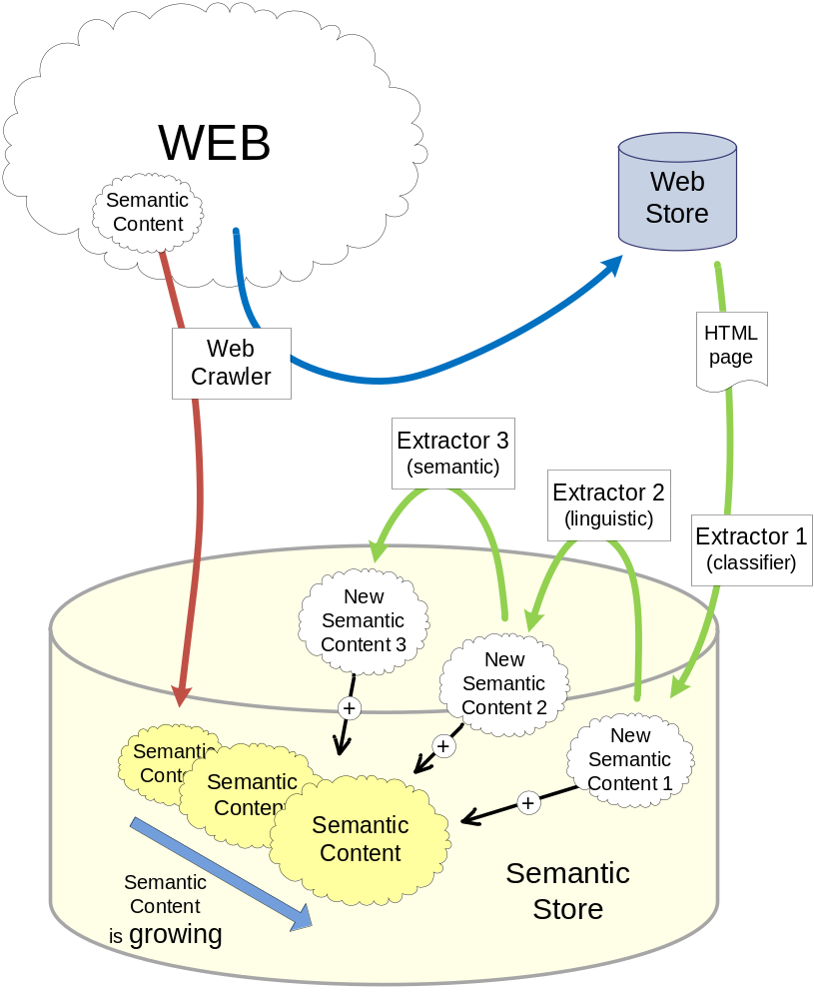
Figure XXSemantization. The process of semantization of the web.

1.1 Motivation example
Car – good, safe, …

1.2 State your contributions
- The idea of web semantization
  - Using 3rd party annotations + semantic search engine denoted to software agents
  - Additional annotations (uncertainty, details about extraction tool)
- Extraction/annotation tools - development and practical experiments
  - Czech linguistics + ILP
  - Structural similarity extraction tool with domain extraction ontology
- The idea of software agent that (uses semantic search engine and) exploits:
  - Decathlon idea
  - User preferences
  - User feedback
  - Additional ontology information (uncertainty, details about extraction tool)
  - History of (experience from) previous work with different information sources (different annotation tools, web pages)
- Proposal of higher complexity of semantic information coming form the Web
  - Uncertainty of information
  - Details about origin of the information
  - Including details about extraction (for extracted information)

2 (Problem) Intelligent software agents on the Web of today?
Yes – web semantization (and semantic search engine for software agents) makes it possible.

3 (Idea) Semantic search engine for software agents

Based on:
- web crawler
- web information extractors and semantic annotators
- semantic repository.
- agent
Getting information form:
- 3rd party annotations
- Directly form web pages – if it includes some semantic content
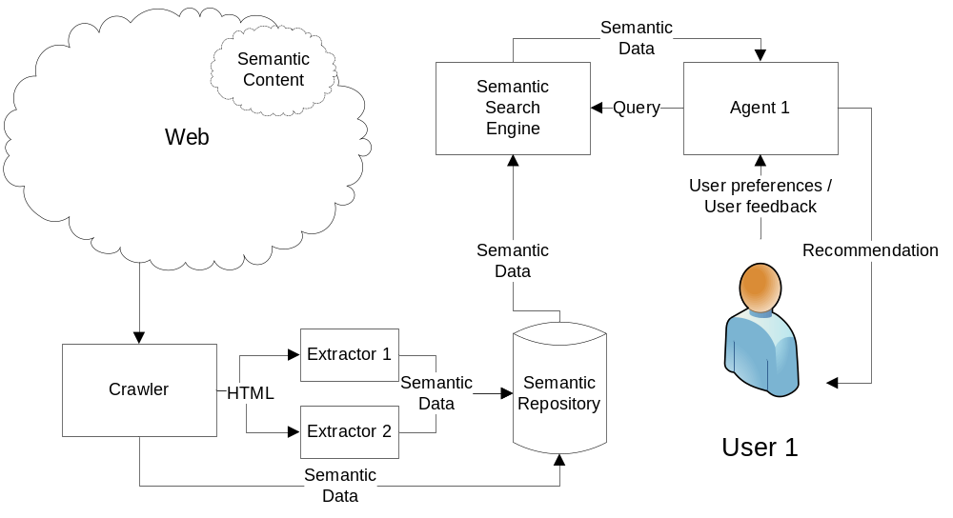
Figure XXProcess. Process of acuiring semantic data from web and querying Semantic Search Engine by an agent
The process of a user searching for a used car is represented in Figure XXprocess. Our main focus is in the agent and in the extractors.

4 (Detail1) Idea/proposal of our agent

5 (Detail2) Our Web Information Extraction tools

5.1 Structural similarity extraction tool
First approach for Web information extraction is to use the structural similarity in web pages. This is often presented in web shops and on pages that presents more than one object (car). Each car is presented in a similar way and this fact can be exploited.
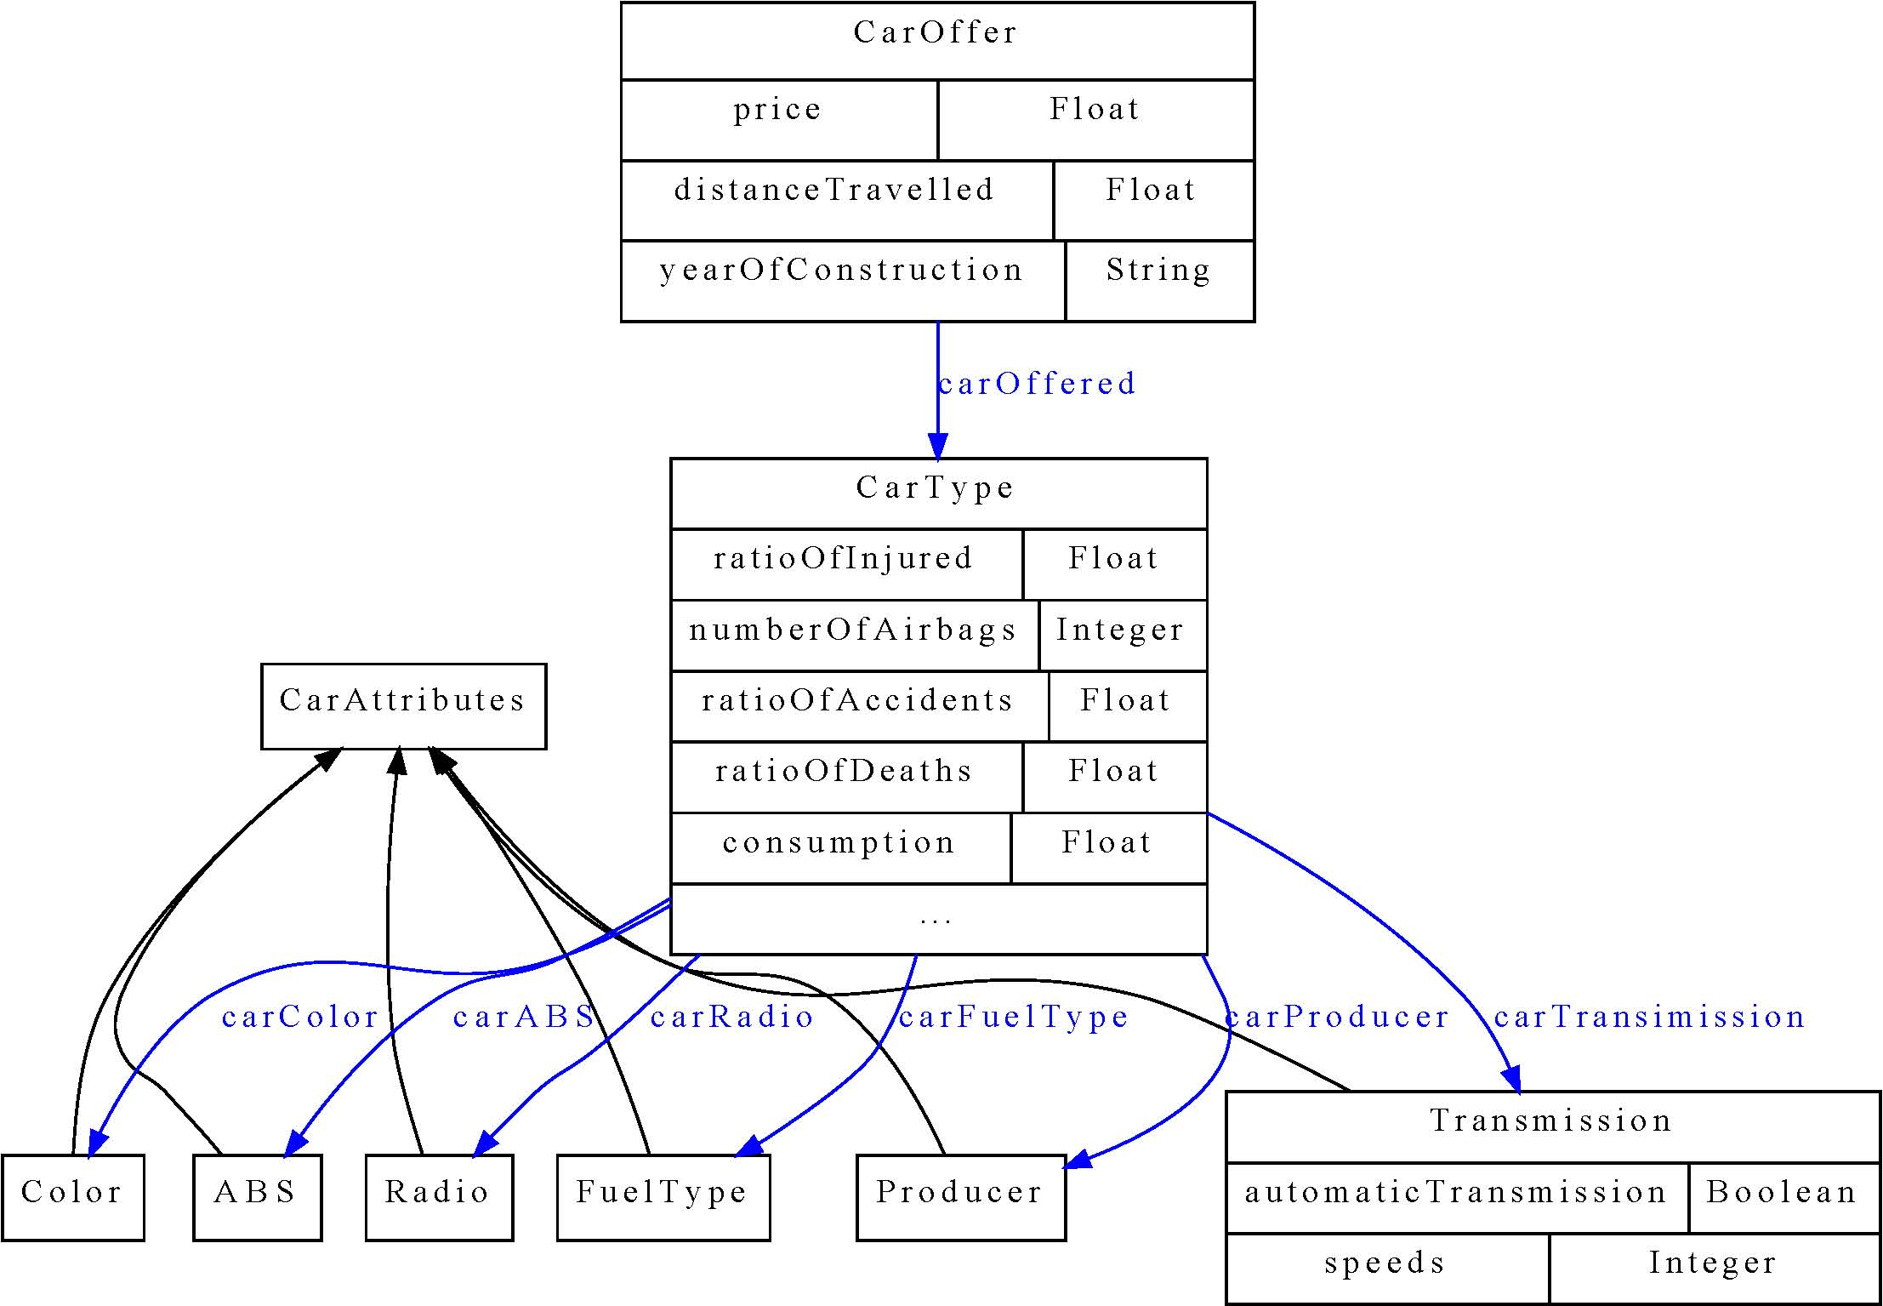
Figure XXDomainOnto. Domain ontology for car offers
Domain ontology is the basis for extraction ontology. Extraction ontology extends the domain ontology by adding some additional information about how the instances of some classes are presented on web pages. We used regular expressions for some of the properties of class CarType. These regular expressions are matched against the text found on the web page.

5.2 Method based on Czech linguistics

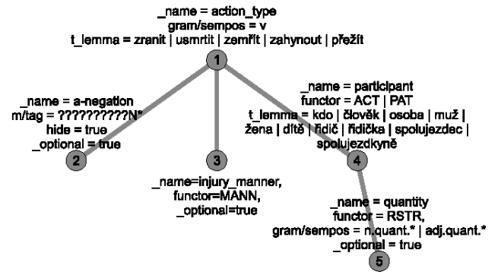
Figure XXtree1. A tectogrammatic tree of a sentence

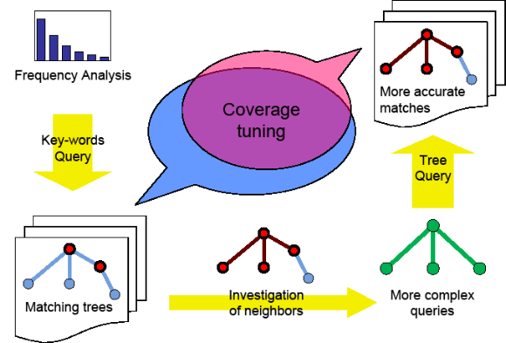
Figure XXQueryLearning. The process of query learning

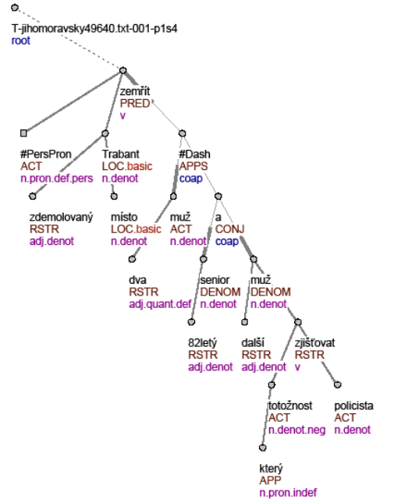
Figure XXtree2. An example of reliable and unreliable rating
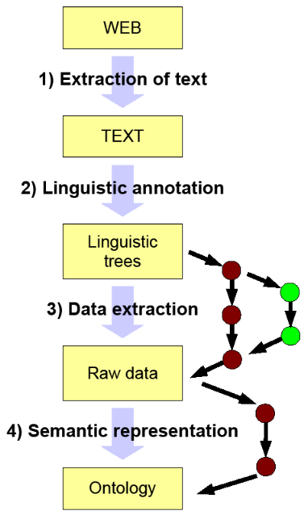
Figure XXTransformSent. The transformation of data in the process of semantization

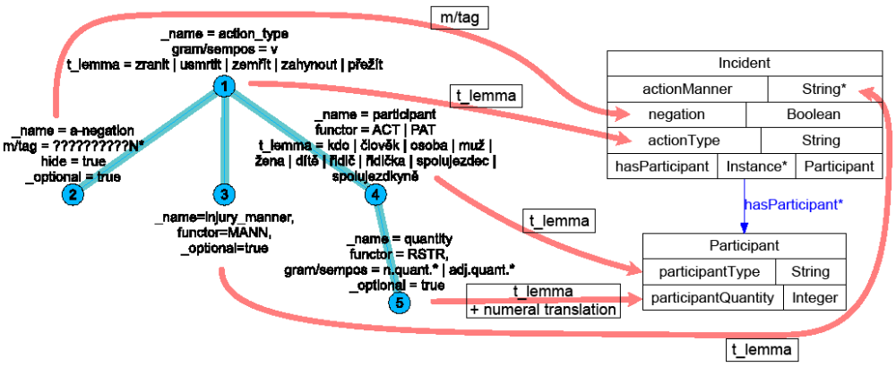
Figure XXMatching. Matching tree nodes on ontology elements

5.2.1 PDT…

5.2.2 ILP…
ILP is a method for generation of rules that describes some properties of data. It takes three kinds of input
- Positive examples – objects that have the desired property.
- Negative examples – objects that do not have the desired property.
- Background knowledge – facts about the domain.
ILP tries to generate such rules that all positive examples and no negative example satisfies. It uses concepts from the background knowledge in the body of rules.
Thanks to the fact that ILP learns from positive and negative examples, we can propose an assisted learning procedure for tuning extractor. The process is such that extractor gets semantic data from a web page and presents it to the user. He/she then corrects the data saying which are good and which are badly annotated. The process of training the extractor is in Figure XXtrainExtractor.

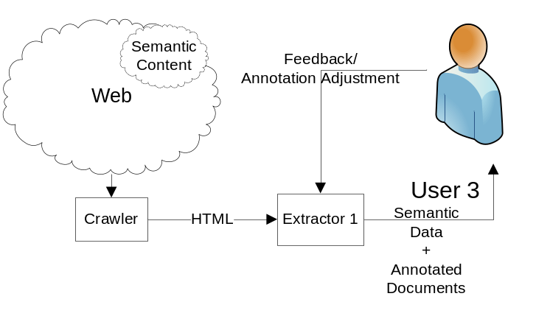
Figure XXTrainExtractor. How Extractor 1 is trained
Extractor can be tuned to the desired goal in this way.
The main advantage of ILP is that it can be trained to mine arbitrary data – the process of learning is dependent only on the positive and negative examples and on the amount of information we have about them. The more information we have, the more precise the learning will be.

5.2.2 Experiments
Our experiment was to enable our agent to access information from various sources. The first source is data structured into tables, from which the semantic information is extracted.
The second source is natural language text. We wanted to find out the number of injured persons during car accidents. We have used firemen reports; some of them was about car accidents, some was not. Each report was split into sentences and each sentence was linguistically analyzed and transformed into a tetragramatical tree, as described in Section XSecLinguistic. These trees were saved as a set of Prolog facts (see Figure XXProlog).
Experiments, transformaceXML
%%%%%%%%%%%%%%%%%%%%%%%%%%%%%%%%%%%%%%%%%%%%%%%%%%%%%%%%%%%%%%%%%%%%%%%%%%%%%%%%%%%%%%%%
% Ve zdemolovanem trabantu na miste zemreli dva muzi - 82lety senior a dalsi muz, jehoz ...
%
% Two men died on the spot in the demolished trabant – a senior 82 years old and another man,
% who’s ...

%%%%%%%% Nodes %%%%%%%%
tree_root(node0_0). node(node0_0). id(node0_0, t_jihomoravsky49640_txt_001_p1s4).
node(node0_1).
t_lemma(node0_1, zemrit). functor(node0_1, pred). gram_sempos(node0_1, v).
node(node0_2).
t_lemma(node0_2, x_perspron). functor(node0_2, act). gram_sempos(node0_2, n_pron_def_pers).
node(node0_3).
t_lemma(node0_3, trabant). functor(node0_3, loc). gram_sempos(node0_3, n_denot).
node(node0_4).
t_lemma(node0_4, zdemolovany). functor(node0_4, rstr). gram_sempos(node0_4, adj_denot). node(node0_5).
...
node(node0_34).
t_lemma(node0_34, policista). functor(node0_34, act). gram_sempos(node0_34, n_denot).

%%%%%%%% Edges %%%%%%%%
edge(node0_0, node0_1). edge(node0_1, node0_2). edge(node0_1, node0_3).
edge(node0_3, node0_4). edge(node0_4, node0_5). edge(node0_3, node0_6).
edge(node0_3, node0_7). edge(node0_3, node0_8).
...
edge(node0_29, node0_30). edge(node0_30, node0_31). edge(node0_29, node0_32).
edge(node0_28, node0_33). edge(node0_28, node0_34). edge(node0_34, node0_35).

%%%%%%%% Injury %%%%%%%%
injured(t_jihomoravsky49640_txt_001_p1s4).

Figure XXProlog. Sample from prolog representation of a sentence
Sentences that talks about some injury during car accident were manually tagged by predicate injured(X), where X is the ID of the sentence. Those sentences that does not talk about injured persons during a car accident was tagged as :-injured(X), which represents negation in Prolog.
These tagged sentences were input for ILP, we used 22 sentences as positive examples and 13 as negative examples. We used Progol (CITE) as ILP software.
The rules ILP found are in Table XXTProlog.
Table XXTProlog: Rules ILP found.
injured(A) :- id(B,A), id(B,t_plzensky57770_txt_001_p5s2).
injured(A) :- id(B,A), id(B,t_plzensky60375_txt_001_p1s6).
injured(A) :- id(B,A), id(B,t_plzensky57870_txt_001_p8s2).
injured(A) :- id(B,A), id(B,t_plzensky57870_txt_001_p1s1).
injured(A) :- id(B,A), edge(B,C), edge(C,D), t_lemma(D,zranit).
injured(A) :- id(B,A), edge(B,C), edge(C,D), t_lemma(D,nehoda).

The first four rules are overfitted to specific sentences. Only the last two represent generally applicable rules. But they do make sense – “zranit” is “to hurt” and “nehoda” is “an accident” in Czech. These two rules mean that the root element is connected either to a noun that means an accident or to a verb that means to hurt.
We tested these rules on the set of 15 positive and 23 negative examples. The result accuracy was 86.84%.

5.3 Egothor support

6 (detail3) Expressing uncertainty and origin of annotations
Extractors/annotators will add information about uncertainty and origin of annotations.
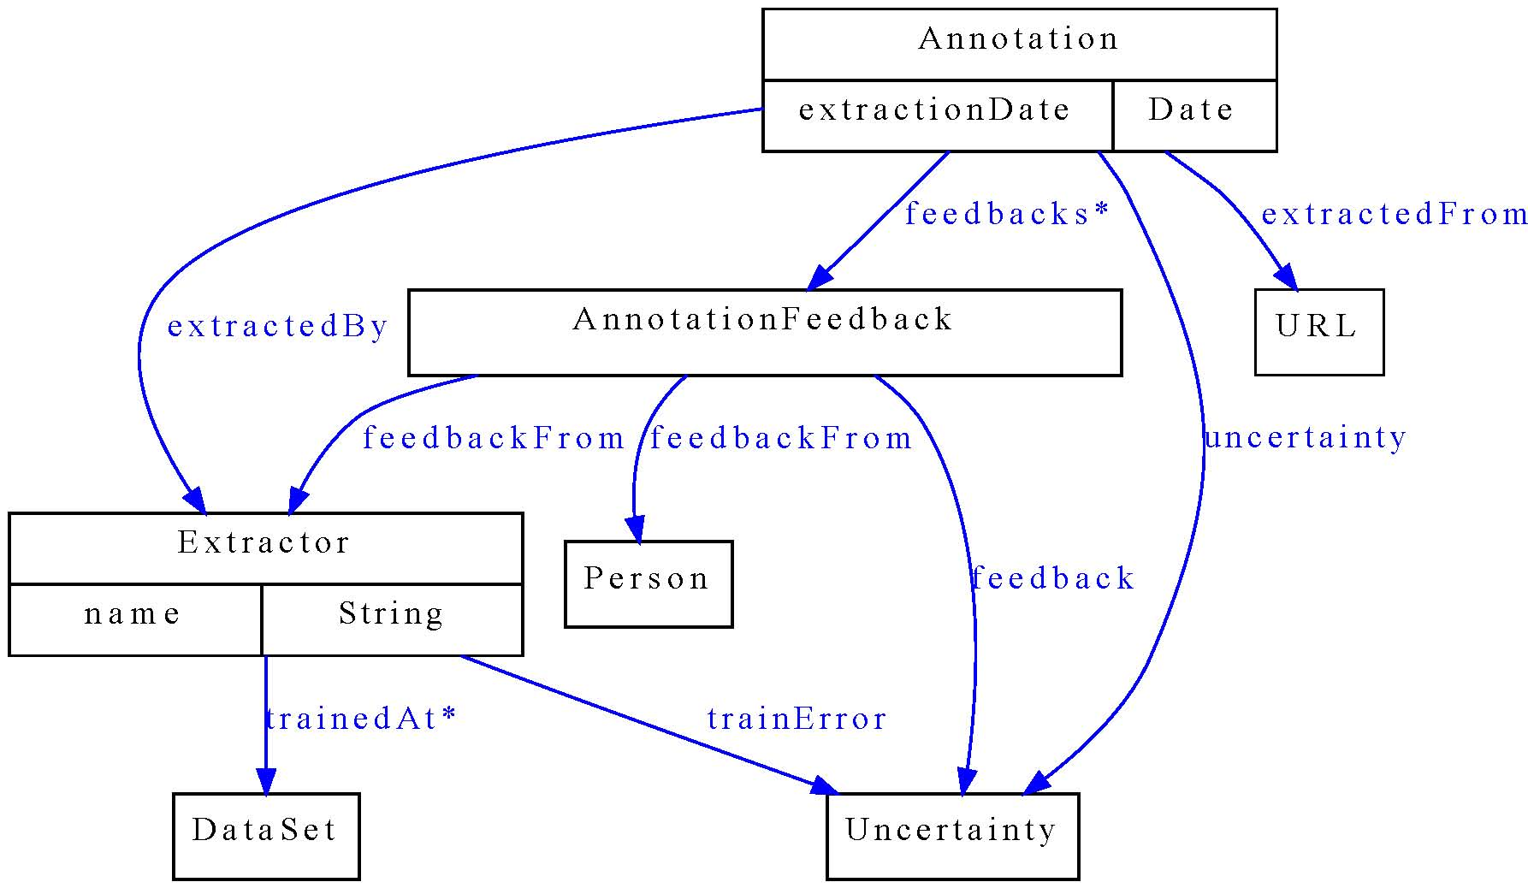
Figure XXAnotOnto. Annotation ontology
Figure XXanotOnto represents the annotation ontology that may be used for storing information about annotations. The main class is Annotation – it represents the annotation about some One important class is AnnotationFeedback, which permits other users to express their opinions on the annotation.
Reliability
Rating
1
1
0
A
Audi A4
Audi A4
B

Figure XXReliable. An example of reliable and unreliable rating
Audi A has much higher rating than the same Audi B. However, A has also much less reliability. This may be caused for example by an error of extractor that switched the price (10.000(€)) with the distance travelled (1.000(km)). Thus A has much better price than B and consequently also the rating.
Agents will use the information about uncertainty and origin of annotations.

7 Related work (1-2 pages)
- Warmly acknowledge people who have helped you
- Be generous to the competition. “In his inspiring paper [Foo98] Foogle shows.... We develop his foundation in the following ways...”
- Acknowledge weaknesses in your approach

8 Conclusions and further work (0.5 pages)
  - idea of web semantization, which can help to arch over the gap between Web of today and the Semantic Web.
  - a proof of concept that even today it is possible to develop a semantic search engine and an intelligent software agent.
Table XXTData: Some example data about cars.
Manufacturer | Model of car | Consumption [l/100km] | Number of accidents | Number of airbags
Skoda | 120 | 7 | 50 | 0
Trabant | Trabant Kombi | 7 | 10 | 0
Audi | A4 | 6,5 | 50 | 6
Fiat | Punto 1,6i | 5,8 | 50 | 2
Tatra | T613 | 12 | 50 | 0
Kia | Joice | 10 | 50 | 2
Ford | Focus 1.6i | 6,2 | 50 | 6

References
American Psychological Association (2001). Publication manual of the American Psychological Association (5th ed.). Washington, DC: American Psychological Association.

The above reference is formatted by selecting the “References” option from the Style menu. It automatically formats the paragraph with a ½ inch hanging indent. Proper italicization of the title is your responsibility. Delete the above reference and this text, and then fill this page with your own lists of references per the instructions in the Publication Manual.

