Web Semantization
Jan Dědek1, Alan Eckhardt1,2, Peter Vojtáš1,2

1 Department of Software Engineering, Charles University in Prague, Czech Republic
2 Institute of Computer Science, Czech Academy of Science
{dedek, eckhardt, vojtas}@ksi.mff.cuni.cz
Abstract. In this paper we developed the idea of web semantization, which can help to arch over the gap between Web of today and the Semantic Web. We present a proof of concept that even today it is possible to develop a semantic search engine (in the scale of pages of Czech domain – *.cz) and an intelligent software agent. In particular contributions consists of models, methods and tools of a web repository, two sorts of automated third party annotation of existing web resources, semantic repository serving as a sample of semantized web with extension of the ontology model for additional annotation (e.g. uncertainty annotation) and a proposal of an intelligent agent . In many places of this work, both in the modeling part and in implementation we are using soft computing techniques.
Keywords: We would like to encourage you to list your keywords in this section.
1 Introduction

Domain independent intermediate annotation can be done with respect to general ontologies. First ontology is the general PDT tectogrammatical structure which captures semantic meaning of a grammatical sentence (this is a task of computational linguistics; we make use of their achievements which were originally focused on machine translation). For structured survey pages we assume that their structure is not changing very often and many pages are generated by same tool, hence they are similar. So there is a chance to detect data regions and data records and possibly also attributes and values from detailed product pages. Here annotation tools will be also trained by humans – nevertheless only once for the annotation of the whole repository.
Domain (task) dependent (on demand) annotation is concerning only pages previously annotated by general ontologies. This makes second annotation faster and easier. Here an assistance of a human is assumed for each domain and new ontology. For grammatical pages repetitions make possible to learn mapping from structured tectogrammatical instances to an ontology. For structured pages the annotation tool has to learn some form of extraction ontology. This domain (task) dependent task can be avoided by a collaborative filtering method, assuming there is enough users’ acquaintance. In the future, the second should be doable by an administrator with average computer literacy.

Web information extraction is often able to extract valuable data. We would like to couple this process with consecutive semantic annotation (initially human trained; later it should operate automatically). In this chapter we would like to describe details of our idea to split this process in two parts – domain independent and domain dependent. There are several reasons of this.
The first domain independent annotation will serve as an intermediate annotation supporting further processing. This will run once on whole suitable data. Hence necessary human initial assistance by training can be done by a high skilled expert (indeed it can be a long process).
The second domain dependent annotation part can consists of large number of tasks with different domains and ontologies. This should be possible to train very fast and if possible with assistance of an average computer skilled administrator. Having intermediate annotation we can afford this.
We have identified two types of web resources where this can be done. First are “table pages”, containing large number of cells with abbreviated description of a resource and corresponding detailed pages. Here we assume that content of cells is similar and content of detailed pages is also similar. Second are pages dominantly consisting of grammatical sentences. Thanks the fact that we have a third party linguistic tool for creation of tectogrammatical trees of sentences, this can be done without requirement of similarity repetition. This situation is illustrated in the Table 1.

Type of annotation ↓ | Table pages | Grammatical pages
Intermediate general | Uses similarities | Does not use similarities
Domain dependent | Does not use similarities | Uses similarities
Table 1. Use of similarity in annotation approaches

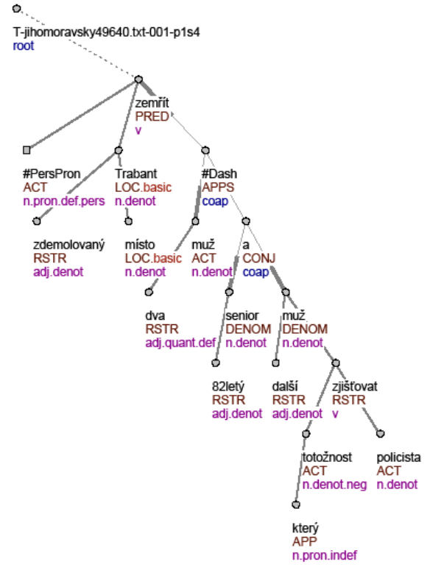
Figure 8. A tectogrammatical tree of sentence: “Two men died on the spot in the demolished Trabant...”

%%%%%%%%%%%%%%%%%%%%%%%%%%%%%%%%%%%%%%%%%%%%%%%
% Two men died on the spot in the % demolished trabant – a senior 82 % years old and another man, who’s

%%%%%%%% Nodes %%%%%%%%
tree_root(node0_0). node(node0_0).
id(node0_0, t_jihomoravsky49640_txt_001_p1s4).

node(node0_1).
t_lemma(node0_1, zemrit).
functor(node0_1, pred).
gram_sempos(node0_1, v).

node(node0_2).
t_lemma(node0_2, x_perspron).
functor(node0_2, act).
gram_sempos(node0_2, n_pron_def_pers).
...

%%%%%%%% Edges %%%%%%%%
edge(node0_0, node0_1). edge(node0_1, node0_2). edge(node0_1, node0_3).
...
edge(node0_34, node0_35).

%%%%%%%% Injury %%%%%%%%
injured(t_jihomoravsky49640_txt_001_p1s4).

Figure 9. Sample from prolog representation of a sentence

Manufacturer | Model of car | Price | Consumption [l/100km] | Number of airbags
Skoda | 120 | 3 000,- | 7 | 0
Trabant | Kombi | 8 000,- | 7 | 0
Audi | A4 | 85 000,- | 6,5 | 6
Fiat | Punto 1,1i | 32 900,- | 6 | 2
Tatra | T613 | 48 000,- | 12 | 0
Kia | Joice | 140 000,- | 10 | 2
Ford | Focus 1.6i | 45 000,- | 6,2 | 6
Table 2 Example of extracted data from cars offers

injured(A) :- id(B,A), id(B,t_plzensky57770_txt_001_p5s2).
injured(A) :- id(B,A), id(B,t_plzensky60375_txt_001_p1s6).
injured(A) :- id(B,A), id(B,t_plzensky57870_txt_001_p8s2).
injured(A) :- id(B,A), id(B,t_plzensky57870_txt_001_p1s1).
injured(A) :- id(B,A), edge(B,C), edge(C,D), t_lemma(D,zranit).
injured(A) :- id(B,A), edge(B,C), edge(C,D), t_lemma(D,nehoda).
Table 3: Rules found by ILP

 | A | ~A
P | 11 | 1
~P | 4 | 22
Table 4. Results on the test set.

