Introduction

- A gap between Web of today and the Semantic Web
- Intelligent tools for searching and recommending things (information) form the Web are missing

Motivation example
Car – good, safe, …

State your contributions

- The idea of web semantization
  - Using 3rd party annotations + semantic search engine denoted to software agents
  - Additional annotations (uncertainty, details about extraction tool)

- Extraction/annotation tools - development and practical experiments
  - Czech linguistics + ILP
  - Structural similarity extraction tool with domain extraction ontology
- The idea of software agent that (uses semantic search engine and) exploits:
  - Decathlon idea
  - User preferences
  - User feedback
  - Additional ontology information (uncertainty, details about extraction tool)
  - History of (experience from) previous work with different information sources (different annotation tools, web pages)
- Proposal of higher complexity of semantic information coming form the Web
  - Uncertainty of information
  - Details about origin of the information
    - Including details about extraction (for extracted information)

(Problem)Intelligent software agents on the Web of today?
Yes – web semantization (and semantic search engine for software agents) makes it possible.

(Idea)Semantic search engine for software agents
Based on:
- web crawler
- web information extractors and semantic annotators
- semantic repository.
- agent

Getting information form:
- 3rd party annotations
- Directly form web pages – if it includes some semantic content

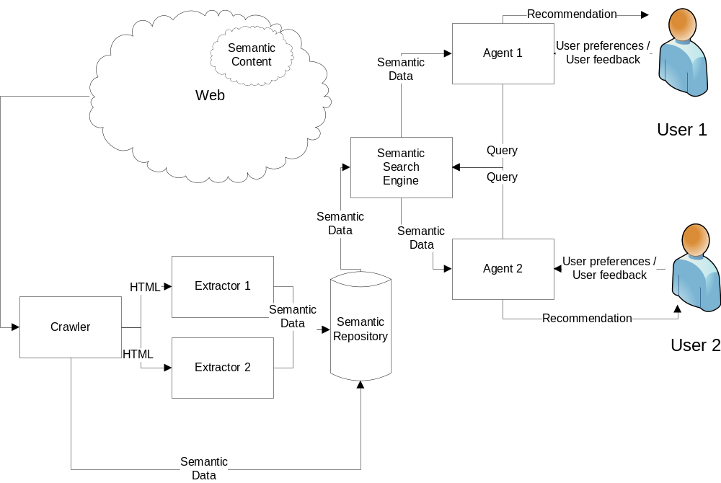

(Detail1) Idea/proposal of our agent

(Detail2) Our Web Information Extraction tools

Structural similarity extraction tool
with domain extraction ontology

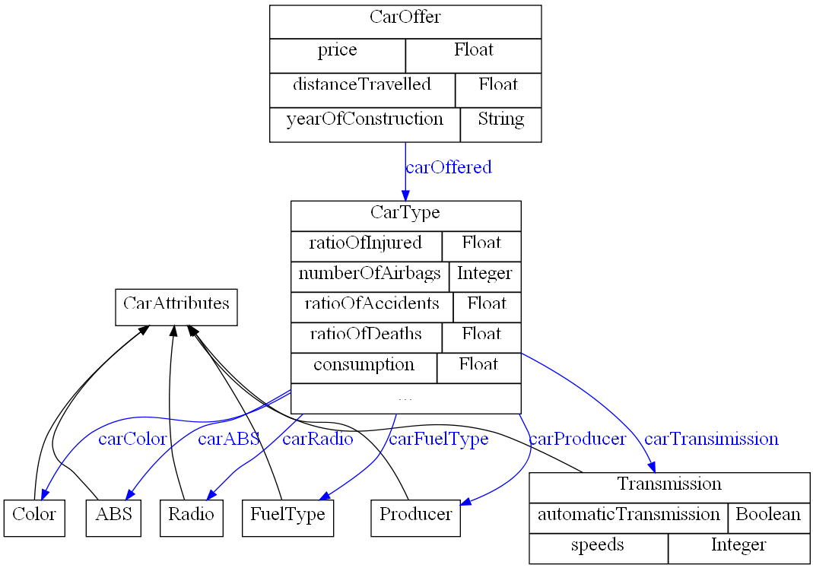

Method based on Czech linguistics

PDT…

ILP
Obecn7 popis ILP

Experiments, transformaceXML

Egothor support

(detail3) Expressing uncertainty and origin of annotations

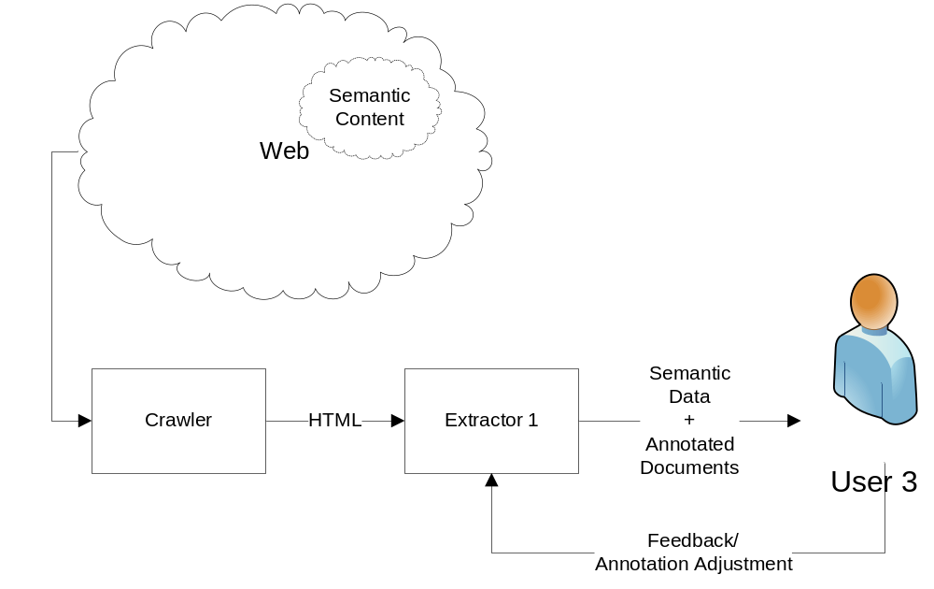

Extractors/annotators will add information about uncertainty and origin of annotations.

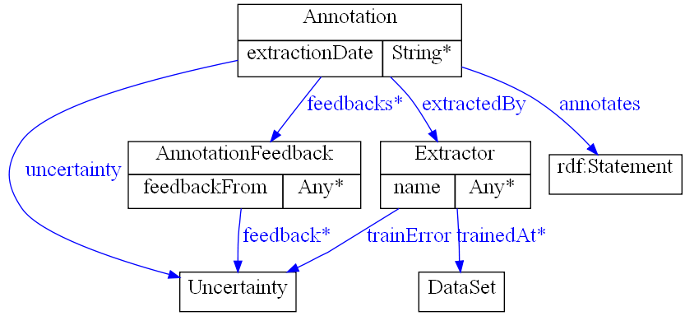

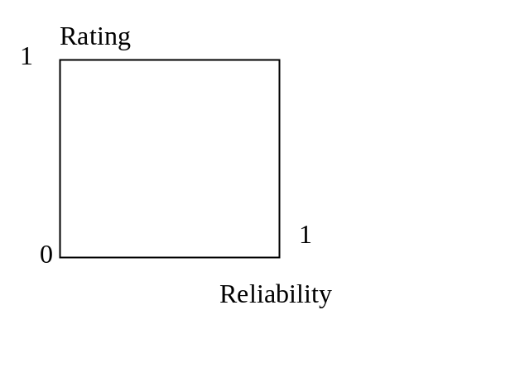
Agents will use the information about uncertainty and origin of annotations.

Related work (1-2 pages)
- Warmly acknowledge people who have helped you
- Be generous to the competition. “In his inspiring paper [Foo98] Foogle shows.... We develop his foundation in the following ways...”
- Acknowledge weaknesses in your approach

Conclusions and further work (0.5 pages)
- idea of web semantization, which can help to arch over the gap between Web of today and the Semantic Web.
- a proof of concept that even today it is possible to develop a semantic search engine and an intelligent software agent.

References

