Sympedia GenFw Tutorial 1

Generating JavaBeans

In this tutorial I will try to teach you the very basics of GenFw by walking through a simple example. You are expected to have some experience in Java programming, Eclipse plugin development and EMF usage (see http://www.eclipse.org/emf).

Let’s assume it’s our task to develop an Eclipse plugin that acts as a library of many JavaBeans, simple Java classes each with a set of properties (member fields plus getters and setters) and a property change listener for some of these properties. Our beans shall further provide arbitrary numbers of specific business methods. In order to keep this example simple, our beans will not support inheritance. They will look like this one:

public class PersonBean
{
protected int id;
protected String name;
protected double income;

public PersonBean(int id, String name, double income)
{
this.id = id;
this.name = name;
this.income = income;
}

public int getId() { return id; }
public String getName() { return name; }
public double getIncome() { return income; }

public void setName(String newName) { name = newName; }
public void setIncome(double newIncome) { income = newIncome; }
}

In fact this is not really a bean that conforms to Sun’s JavaBeans specification, because it does not have a default constructor. We accept this to better be able to enforce a changeable policy on the properties. Note, that the id of a PersonBean can only be set at construction time. To support property change notification, our beans will contain additional code:

import java.util.ArrayList;
import java.util.List;

public class PersonBean
{
private List<Listener> listeners = new ArrayList<Listener>();

[…]

public void addListener(Listener listener) { listeners.add(listener); }
public void removeListener(Listener listener) { listeners.remove(listener); }

public interface Listener
{
void notifyNameChanged(PersonBean source, String oldName, String newName);
void notifyIncomeChanged(PersonBean source, double oldIncome, double newIncome);
}
}

Note, that, since th id can not be changed after construction time, there is no notifyIdChanged() method in the PersonBean.Listener interface. Finally all the setters will look like this to call the registered property change listeners:

public void setName(String newName)
{
String oldName = name;
if (!EqualityHelper.equals(oldName, newName))
{
name = newName;
for (Listener listener : listeners)
listener.notifyNameChanged(this, oldName, newName);
}
}

The EqualityHelper class contains some convenience methods to blur the syntactic differences between primitive and reference types that are inherent to the Java programming language:

public class EqualityHelper
{
public static boolean equals(boolean a, boolean b) { return a == b; }
public static boolean equals(char a, char b) { return a == b; }
public static boolean equals(byte a, byte b) { return a == b; }
public static boolean equals(short a, short b) { return a == b; }
public static boolean equals(int a, int b) { return a == b; }
public static boolean equals(long a, long b) { return a == b; }
public static boolean equals(float a, float b) { return a == b; }
public static boolean equals(double a, double b) { return a == b; }

public static boolean equals(Object a, Object b)
{
if (a == null) return b == null;
return a.equals(b);
}
}

We are expected to deliver vast numbers of bean classes each of them having many properties. Rapidly we come to the conclusion that it would be a boring and error prone job to code all these classes by hand. They have so many similarities that we wish to separately specify the differences and the similarities. We want to factor out the differences into a meta model file and the similarities into a set of templates.

Out there are a lot of existing meta model formats and there are several template engines available so far. Note, that GenFw does neither provide an own meta model format nor does it provide an own templating engine. Rather it does provide the necessary means to integrate existing technologies like Ecore, JET, JMerge and others. Finally GenFw offers an extensible way to dynamically associate selected elements of the meta models with specific generators. To achieve this GenFw currently defines the following five concepts with simple interfaces:

- A ContentProvider is a facility to read a file into memory and iterate over the elements (called input objects) in a tree-like fashion.

public interface ContentProvider extends EObject
{
public List getRoots(String path);
public List getChildren(Object object);
}

- A Generator can produce an output string that depends on a given input object and a target path. Note, that a generator is not expected to write the output to the target file. The framework will do so if the generator returns a non-null result.

public interface Generator extends EObject
{
public String generate(Object inputObject,
String targetPath,
IProgressMonitor monitor) throws CoreException;
}

- A Rule can decide to invoke a certain Generator on a given input object. In addition the Rule is able to compute the target path for the given input object.

public interface Rule extends EObject
{
public boolean isMatching(Object inputObject);
public String getTargetPath(Object inputObject);
public Generator getGenerator();
}

- A RuleSet is nothing else than a named container for Rules.

public interface RuleSet extends EObject
{
public String getName();
public EList getRules();
}

- An Input points to a single meta model file, associates the ContentProvider to be used when loading the file into memory (this is often called instantiation) and specifies a number of RuleSets to apply when determining the Generators to invoke on the objects in the meta model.

public interface Input extends EObject
{
public String getFullPath();
public ContentProvider getContentProvider();
public EList getRuleSets();
}

RuleSets and Inputs are not not expected to be implemented by you. GenFw provides default implementations for both and usually there is no need to further subclass them.

The other three interfaces (ContentProvider, Generator and Rule) are subject to individual extension. I will explain how to integrate your own implementations of these concepts in another tutorial. For many purposes the shipped implementations are convenient enough.

So let’s see how this framework can help us with our tedious bean job. We want to use EMF for the specification of the meta model and the generation of the usual three EMF plugins (model, edit and editor), so that we can store our bean descriptions in XML files and modify them with a cool, tree-structured editor. To be even cooler, you can use a graphical designer for the structure of the meta model (there has always been the Omondo tool, UMLX is very young and currently I tend to use Topcased):

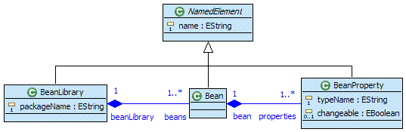

The visual designer creates the .ecore file and you have to create the .genmodel file and invoke the EMF CodeGen generator to produce the meta model classes (and other artifacts) for you. This step of generation does not belong to GenFw, it is only necessary because we decided to use Ecore as the meta model format.

- Create the project tutorial1.gen.beans with the Empty EMF Project wizard.
- Create a folder model in that project.
- Create the beans.ecore and the beans.genmodel file (you know how to do this).
- Generate the meta model plugins and compare your workspace with this one:
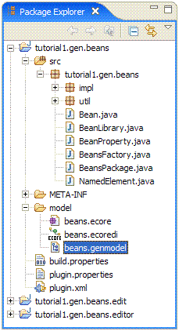

- Export the three plugins to the install location of your Eclipse instance.
- Close the plugin projects and restart your Eclipse instance.
- To test the new meta model, create a new Plug-in Project tutorial1.orderman. We don’t need an Activator class or UI support. This will become our Eclipse library for Order Management beans.
- Create a model folder in that project.
- Use the New Beans Model wizard that EMF has generated for you to create the orderman.beans file. Select the Bean Library as the (root) model object.
- In the generated Beans Model Editor (should open automatically after model file creation) you can already see the root object of the model, the Bean Library. Obviously the model is ready now to be populated with concrete Beans and their BeanProperties. For the PersonBean example introduced at the beginning, it could look like this:
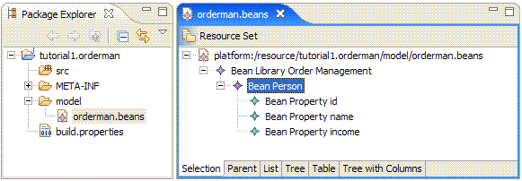

- After saving the model you should have a file with the following XML content:
<?xml version="1.0" encoding="UTF-8"?>
<beans:BeanLibrary xmi:version="2.0"
xmlns:xmi="http://www.omg.org/XMI"
xmlns:beans="http://beans"
name="Order Management"
packageName="tutorial1.orderman">
<beans name="Person">
<properties name="id" typeName="int"/>
<properties name="name" typeName="String" changeable="true"/>
<properties name="income" typeName="double" changeable="true"/>
</beans>
</beans:BeanLibrary>

Now that we have a formal description of the beans we want to generate, we have to think about how to specify the similarities of all our bean classes. We decide to use JET templates for that purpose. Support for generation with JET templates comes with the EMF distribution and should be available right now. Maybe you know already that there is a distinction between the so called JET Emitter Templates that simply produce text output and the JMerger that expects this output to be Java source code and is able to merge it with changes you have applied to former generation results. Anyway, we decide not to use JMerge, because we don’t like to mix generated code with hand-written code. Rather we like to be sure that our hand-written source is never touched by a generator and that, in the event that something goes wrong, we can simply delete the generated files and let them be re-generated.

Just recall that the only challenge with hand-written code in our example is caused by the “business methods” requirement. Now you should realize that our beans meta model does not contain the notion of a business method. Of course it would easily be possible to model Java methods and their parameters, but we decide to try another approach. The classes we will be generating are abstract super classes of the bean classes we are exposing. We will generate the base classes to the src-gen folder of the project and provide (hand-written) derived classes in the src folder. The derived classes can be augmented with the required business methods, we don’t need to write the repeating bean infrastructure ourselves and the generator will never touch our additions.

JET templates are written in a JSP like syntax and then compiled to Java classes by the JET template compiler. Later these template classes will be loaded by GenFw and used to produce the Java source code for our bean descriptions.

- Create the plugin project tutorial1.gen (Java, but no Activator, no UI).
- Add the src-gen source folder.
- Use the New Wizard Convert Projects to JET Projects and select the tutorial1.gen project for conversion. The templates folder should appear.
- Go to the properties of the new project and browse to the JET Settings category. Enter the path of the Source Container to let the JET compiler produce the template classes in the src-gen folder.
- Because the template we will be writing refers to our meta model, add a dependency on the tutorial1.gen.beans plugin to the MANIFEST.MF of the tutorial1.gen project.
- Now create the template source file BeanBase.javajet in the templates folder. Editing this file can be much, much more convenient, if you download and install the org.eclipse.emf.codegen.jet.editor plugin from the Merlin Generator project. At the moment the following content should enable us to quickly continue on the road to our first generated PersonBean:
<%@ jet package="tutorial1.gen"
imports="java.util.* tutorial1.gen.beans.*"
class="BeanBaseTemplate"%>
<%
Bean bean = (Bean)argument;

StringBuffer buffer = new StringBuffer();
for (Iterator it = bean.getProperties().iterator(); it.hasNext();)
{
BeanProperty prop = (BeanProperty)it.next();
buffer.append(prop.getTypeName());
buffer.append(" ");
buffer.append(prop.getName());
if (it.hasNext()) buffer.append(", ");
}

String ctorParams = buffer.toString();
%>
package <%=bean.getBeanLibrary().getPackageName()%>;

public abstract class <%=bean.getName()%>BeanBase
{
<%for (Iterator it = bean.getProperties().iterator(); it.hasNext();) {
BeanProperty prop = (BeanProperty)it.next();%>
protected <%=prop.getTypeName()%> <%=prop.getName()%>;
<%}%>

public <%=bean.getName()%>BeanBase(<%=ctorParams%>)
{
<%for (Iterator it = bean.getProperties().iterator(); it.hasNext();) {
BeanProperty prop = (BeanProperty)it.next();%>
this.<%=prop.getName()%> = <%=prop.getName()%>;
<%}%>
}
}

This looks a bit weird, but with more experience you will like the fact that the template logic is written in Java (and compiled to Java classes). The above template definition shall produce the base class skeleton with the fields and the constructor.

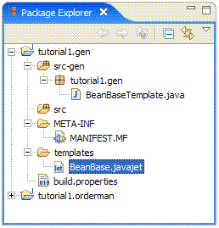

You should verify that the JET compiler has written the compiled templates to the proper location (/tutorial1.gen/src-gen/tutorial1.gen/BeanBaseTemplate.java).

Note, that the src folder is still empty. We will need it later, when we provide static helper methods that have to be reachable by the template code.

Now we have the meta model file and a JET template class. So far nothing special to GenFw has been used. The next steps will show how to configure a GenFw Generator Library.

- Create a model folder in the tutorial1.gen project.
- In the model folder create a new Generator Library named beans.genlib (New Wizard | Sympedia Generation | Generator Library).
- Add an EcoreContentProvider to the GenLib and in the Properties View name it ECORE. This enables GenFw to instantiate meta models that have been produced by EMF (i.e. they are in Ecore format). Note, that (with Ecore) it is not necessary to specify which Ecore model exactly has to be understood. In other words, the EcoreContentProvider is stateless (except for its instance id, the name feature).
- Add a JETTemplate to the GenLib and in the Properties View name it BeanBaseTemplate and enter the template class name tutorial1.gen.BeanBaseTemplate. This enables GenFw to load the template class. Note, that the template class is located in your workspace and is not reachable by normal Eclipse plugin class loaders! GenFw will construct a special ClassLoader to find and load the template class. The challenge here is that the template class, once loaded from the workspace, will most probably attempt to use the input object passed into the generate() method. At the moment GenFw uses the following strategy to construct a ClassLoader: For each ClassLoader of an input object a child URLClassLoader is created (and cached during a generator batch) with all the jars and bin folders in the build path of the Java project that contains the genlib file.
- Add a RuleSet to the GenLib and name it BeanRules.
- Add a BeanShellRule to the new RuleSet name it BeanBaseRule and choose the generator BeanBaseTemplate. Now enter the BeanShell expression that can decide for which input objects the chosen generator shall be invoked. You may use the identifier self to point to the input object itself. Since we want to invoke the BeanBaseTemplate on every Bean element in the meta model, enter self instanceof Bean. Now enter another BeanShell expression to compute the target path where the generated output shall be written. This expression must return a value of type String and again you may use self to refer to the input object itself. Note, that the target path expression may either return an absolute path which is interpreted relative to the workspace location or a relative path which is appended to the full path of the project with the genapp file that uses our genlib file. We will soon arrive at what a genapp file is. We choose to use a relative path to make our GenLib more reusable: "src-gen/" + self.getBeanLibrary() .getPackageName().replace('.', '/') + "/" + self.getName() + "BeanBase.java". Finally enter an import statement as boostrap code for this BeanShellExpression to enable short class names in the expressions (otherwise you should have written self instanceof tutorial1.gen.beans.Bean).
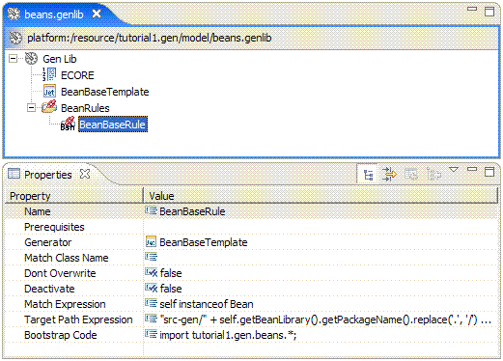

The configuration of the Generator Library is complete for the moment. Think of this genlib file (and the whole tutorial1.gen project together with the meta model plugins) as a reusable asset for generating bean libraries. This is why it’s called a Generator Library. Note, that so far we have not specified any concrete input files (meta model instances). This will be our last trail that follows here.

- Go back to the tutorial1.orderman project and in the model folder create a new Generator Application named orderman.genapp (New Wizard | Sympedia Generation | Generator Application).
- Add an Input element to the GenApp with the path model/orderman.beans. The property label Full Path is actually misleading since input paths can also be relative to the project that contains the genapp file. This makes copying the genapp file to other application easier! To be able to refer to elements of the genlib file, load the beans.genlib resource into the GenApp editor. Now select ECORE as the ContentProvider and BeanRules as a RuleSet to use.
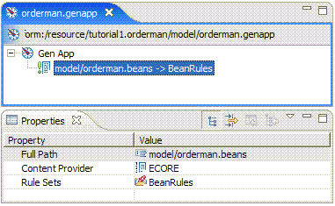

- Recall that in the BeanBaseRule we direcetd the output of the generation to the src-gen folder of the GenApp project. Don’t forget to add the src-gen source folder to the tutorial1.orderman project now!
- Save the genapp file and right-click on it in the Package Explorer. In the context menu select Sympedia Generation | Generate. That’s it. Look into the src-gen folder. GenFw has created a package with the PersonBeanBase class:
package tutorial.orderman;

public abstract class PersonBeanBase
{
protected int id;
protected String name;
protected double income;

public PersonBeanBase(int id, String name, double income)
{
this.id = id;
this.name = name;
this.income = income;
}
}

- To complete the template (getters, setters and listener infrastructure), re-open the BeanBase.javajet file and add the following before the constructor:
private java.util.List<Listener> listeners = new java.util.ArrayList<Listener>();

and the following before the last closing brace:

<%for (Iterator it = bean.getProperties().iterator(); it.hasNext();) {
BeanProperty prop = (BeanProperty)it.next();
String capName = StringHelper.capitalize(prop.getName());%>
public <%=prop.getTypeName()%> get<%=capName%>()
{
return <%=prop.getName()%>;
}

<%if (prop.isChangeable()) {%>
public void set<%=capName%>(<%=prop.getTypeName()%> new<%=capName%>)
{
<%=prop.getTypeName()%> old<%=capName%> = <%=prop.getName()%>;
if (!EqualityHelper.equals(old<%=capName%>, new<%=capName%>))
{
<%=prop.getName()%> = new<%=capName%>;
for (Listener listener : listeners)
listener.notify<%=capName%>Changed(this, old<%=capName%>, new<%=capName%>);
}
}

<%}%>
<%}%>
public interface Listener
{
<%for (Iterator it = bean.getProperties().iterator(); it.hasNext();) {
BeanProperty prop = (BeanProperty)it.next();
if (prop.isChangeable()) {
String capName = StringHelper.capitalize(prop.getName());%>
void notify<%=capName%>Changed(<%=bean.getName()%>BeanBase source,
<%=prop.getTypeName()%> old<%=capName%>,
<%=prop.getTypeName()%> new<%=capName%>);
<%}%>
<%}%>
}

- Note, that the reference to the StringHelper class can’t be resolved. This is where the src folder of the tutorial1.gen project comes into play. Create the following helper class in the src folder and re-generate:
package tutorial1.gen;

public class StringHelper
{
public static String capitalize(String text)
{
if (text == null || text.length() == 0)
{
return text;
}

if (Character.isLowerCase(text.charAt(0)))
{
return text.substring(0, 1).toUpperCase() + text.substring(1);
}

return text;
}
}

The generated PersonBeanBase contains unresolved references to the EqualityHelper class. We can’t create the EqualityHelper in the tutorial1.gen project, since this project is not part of the target application. It is only present during development time and usally never leaves the workspace (except when committing to a repository). We could create it in the tutorial1.orderman project, but that would prevent the generator project from being used in other generator applications. Rather we decide to create a reusable plugin that conatins all the runtime support classes for the generated classes. Typically we will place runtime helper classes here or interfaces that have to be implemented by the generated classes.

- Create a new Plug-in Project (Java, no Activator, no UI) named tutorial1.
- Add the Java class tutorial1.EqualityHelper and fill it with the code outlined at the beginning. Don’t forget to export the new package in the runtime section of the MANIFEST.MF file.
- In the tutorial1.orderman/META-INF/MANIFEST.MF file add a dependency on the new tutorial1 plugin.
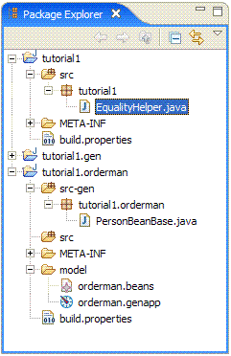

- Note, that the EqualityHelper class is in a package different from the package of the generated beans. Add an import statement to template!
Now the only problem is the missing PersonBean class. We could use the New Class wizard to derive it from PersonBeanBase by hand (and add the various business methods), but, recalling that many many beans will follow this first one, we decide to let GenFw create (empty) default implementations of the derived classes. This is a minor violation of our requirement that generated code goes to src-gen always, but we accept this because GenFw never touches existing files, if we mark the Rule as Dont Overwrite in the GenLib. Never forget about this!

- Add the new template Bean.javajet to the generator project:
<%@ jet package="tutorial1.gen"
imports="java.util.* tutorial1.gen.beans.*"
class="BeanTemplate"%>
<%Bean bean = (Bean)argument;%>
package <%=bean.getBeanLibrary().getPackageName()%>;

public class <%=bean.getName()%>Bean extends <%=bean.getName()%>BeanBase
{
public <%=bean.getName()%>Bean(<%=BeanHelper.formatParameters(bean, true)%>)
{
super(<%=BeanHelper.formatParameterNames(bean, false)%>);
}

/////////////////////////////////////////////////////////////////////
// Business methods
/////////////////////////////////////////////////////////////////////

}

- Add the missing class BeanHelper to the generator project tutorial1.gen, it is only used during generation:
package tutorial1.gen;

import tutorial1.gen.beans.Bean;
import tutorial1.gen.beans.BeanProperty;
import java.util.Iterator;

public class BeanHelper
{
public static String formatParameters(Bean bean, boolean withTypes)
{
StringBuffer buffer = new StringBuffer();
for (Iterator it = bean.getProperties().iterator(); it.hasNext();)
{
BeanProperty prop = (BeanProperty)it.next();
if (withTypes)
{
buffer.append(prop.getTypeName());
buffer.append(" ");
}

buffer.append(prop.getName());
if (it.hasNext()) buffer.append(", ");
}

return buffer.toString();
}
}

Consider to refactor the other template to profit from the new helper method formatParameters(). Btw. an even better place for this method is the meta model itself. Then you can call from the templatesand elsewhere: bean.formatParameters(true) instead of BeanHelper.formatParameters(bean, true). Since this is more „OO“, it will be easier to extend the meta model later. Don’t forget to export the meta model as deployable plugins after modifications, otherwise you will continue to work with the old versions. In the worst case you can corrupt existing meta model instances!

Note for repeated exports of the same plugins: When you change certain settings in the MANIFEST.MF (especially dependencies) before re-exporting, Eclipse tends to keep stale entries in its caches, even if you specify the –clear option. The problem will manifest itself through weird errors that are often hard to understand. As a workaround I do the following: Backup all my Eclipse preferences to an .epf file, exit Eclipse, delete everything in the configuration folder of eclipse (except the config.ini!!!), re-start Eclipse and import the previously exported preferences. It’s kind of annoying, but it works ;-)

To reduce the number of re-exports, you can launch a runtime workbench of course. There you can test your meta model until it is free of errors. Another trick is to use a local update site so that you can install the new meta model plugins into the running Eclipse instance. Then you need two additional projects for the feature and the update site. If you go this way, don’t forget to increase the version numbers each time before you publish the feature!

- Re-open the GenLib file and add a second JETTemplate generator named BeanTemplate.
- To the existing RuleSet add a second BeanShellRule (or copy and edit the first one). The most important thing here is to not forget switching Dont Overwrite to true!!! It should look like this:
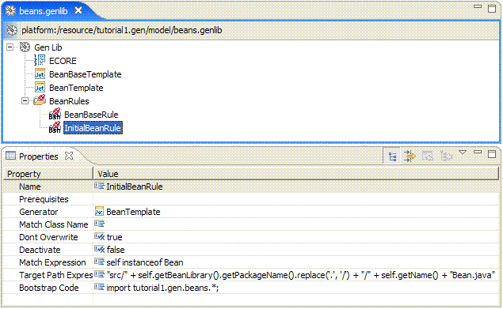

- Re-generate.
- Add the business methods to the PersonBean class and be sure that this file will never be touched again by GenFw. Note, that this might become a problem if you decide to change the templates and the relation between BeanBases and Beans!
- Finally integrate the GenFw generation into your automated build script. For this purpose there is an Ant task that you can use as follows:
<?xml version="1.0" encoding="UTF-8"?>
<project name="tutorial1.orderman" default="generate" basedir=".">

<target name="generate">
<genfw genapp="model/orderman.genapp" />
</target>

</project>

That’s it! Because during normal development you will invoke the generator as often as possible (and necessary) and because you may want to add other GenApp files there is the Eclipse view Generator Applications (category Sympedia Generation). It lists all the GenApps and GenLibs in your workspace and you can open them from here. You can run the Generate action on all or selected GenApps from here. You can even switch on a second tree level to show all the inputs (meta model instances) of the GenApps.

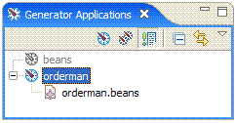

Happy generating ;-)

Eike Stepper
Berlin, Germany, 2006-01-25

Further Informations

- It is a major design issue in our generated BeanBase classes that the Listener methods take an instance of the BeanBase class as the first argument, because it prevents the callback method from calling the bean’s business methods without down-casting to the derived Bean class. With the current design it is impossible to pass a Bean-classed instance to the callbacks. A nifty solution to this problem is the introduction of generated business interfaces that are implemented by the BeanBase classes and that all clients of the bean have to use. These interfaces would have to include abstract declarations of the business methods, so that the callback method of the listener can call them directly. The only reason why I waited to mention this until page 15 is, that this design would force us to model the abstract syntax of Java methods and parameters in our beans meta model. Of course it is feasible, but soon you will recognize that existing meta models like Ecore itself, UML2 and others already provide all the necessary infrastructure to model such things. Why should we invent the wheel again? It could be easier to re-use these models.

The Density Generator, for example, currently uses Ecore to model packages, classes, methods and so on. Because Ecore is (at least compared to UML2) a rather unexpressive meta model (it closer relates to MOF than to UML2), I made extensive use of generic model annotations that are evaluated by the generator.
- GenFw never writes files that are not changed, even if a generator produced new output for that file. If the content is the same as before, the file will not get a new modification time stamp. This way there’s usually no harm in frequently using the Generate All action.

- If you are using JDT’s automatic code formatting facility (maybe even in conjunction with the FormatOnSave plugin), the physical content of a Java file might change due to generation even if the logical content is the same. Only the formatting changes, and changes, and …

For these situations GenFw provides a delegating generator called Java Formatter. This generator first invokes an arbitrary other generator on the same inpout object and target path and then formats and returns the results of the delegate generator. Unfortunately you have to add a Java Formatter for each template to be delegated to. So far I have not found another way to handle generator chains.
- Generator Modularity: You can split your GenLibs and GenApps as you like and let them refer to elements in the other files. A GenApp is a GenLib, so you can even cope with a single GenApp if you want. The only difference between the two is that Inputs can only be contained in GenApps. The reason is the possible project-relative path resolution of input files.

- If you can explain to me why you would like to deploy the generator project as an externally installed plugin, I could most probably find a way to adapt class loading to a hybrid strategy. Personally I think that the meta models, the templates and the resulting GenLib tend to change often due to new requirements or simply due to maintenance, so I leave this project in my workspace.

- If I was wrong when I said at the beginning that we don’t like to mix generated code with hand-written code, it’s most certainly because you do like it, nevertheless ;-) Don’t worry, GenFw comes with a JMerge Generator that works similar to the Java Formatter, it first delegates to another generator (assumingly a JET Template) and then merges the result. You can configure a custom merge.xml or leave the property empty to use the CodeGen default one. Of course you can even prepend this chain by a Java Formatter (as newer CodeGen versions can do, too).

- If a JET Template is too heavy in a certain situation, you can use a Static File Initializer to produce static content, line by line.

- If you want to use the original JET templates of the EMF distribution, there are currently two ways: You can use the Ecore Template generator or the EMF Generator. In both cases the generator expects a .genmodel file to be used as the Input.

- With the Ecore Template generator you can generate selected templates and choose to generate the Interface file or the Implementation file. Note, that the Ecore templates don’t expect a pure GenBase instance (the input object ) to be passed as argument! Rather it expects an Object[3] array. That’s why the Ecore Template generator is a special subclass of JET Template. Attention: Before you use an Ecore Template generator, you must patch org.eclipse.emf.codegen.ecore, see the appendix!

- With the EMF Generator you can generate a whole GenPackage. Theoretically it is possible to feed the generator with selected GenClassifiers, but unfortunately they will miss some constructs that are only generated by a GenPackage (Switch, Factory, …). Generating the GenPackage in addition is not applicable, because there doesn’t seem to be a way to prevent CodeGen from also iterating over all the contained elements. This, in turn, would prevent you from overriding selected templates! The only use for the EMF Generator that I can see at the moment, is a way to integrate normal EMF generations (without template overrides) into the GenFw user interface.

- After a while you will recognize that the more input objects you have in your models and the more Rules you have in your RuleSets the slower the generation will be. If you are using BeanShellRules, GenFw will instantiate at least one BeanShell interpreter per input object and Match Expression in the Rule. This might be subject to further optimization in the future, but for the moment of being the easiest way to speed up generation is to specify a Match Class Name. This string value is tested for equality against the fully qualified class name of the input object (self), which is ways faster. But be careful, you can’t catch inheritance with this trick! So, to let the BeanBaseRule properly match in the above example, you have to specify tutorial1.gen.beans.impl.BeanImpl as Match Class Name, not its interface tutorial1.gen.beans.Bean. In addition the Match Expression is evaluated, but only after the class names have been proven to match. Attention: If you have issues with your generator’s classpath, it can happen that you get strange ClassNotFoundExceptions or ClassCastExceptions when evaluating the Match Expression, the Target Path Expression or when template code is invoked. This is almost always a sign that your input objects have been loaded by a class loader different from the one GenFw uses. Check, that your generator (plugin) project properly references your meta model plugins!

Patching CodeGen for Use by the Ecore Templates

The current version (2.2.0 I200601190000 as of this writing) of EMF has to be slightly patched in order to let the Ecore Template generator use the original Ecore templates without invoking CodeGen. Please refer to http://www.eclipse.org/newsportal/article.php?id=14751& group=eclipse.tools.emf#14751

You can apply the following patch against the I200601190000 version of org.eclipse.emf.codegen.ecore and deploy the plugin to your install location:

Index: src/org/eclipse/emf/codegen/ecore/genmodel/impl/GenPackageImpl.java
===================================================================
RCS file: /home/tools/org.eclipse.emf/plugins/org.eclipse.emf.codegen.ecore/src/org/eclipse/emf/codegen/ecore/genmodel/impl/GenPackageImpl.java,v
retrieving revision 1.50
diff -u -r1.50 GenPackageImpl.java
--- src/org/eclipse/emf/codegen/ecore/genmodel/impl/GenPackageImpl.java 10 Jan 2006 20:22:20 -0000 1.50
+++ src/org/eclipse/emf/codegen/ecore/genmodel/impl/GenPackageImpl.java 25 Jan 2006 12:34:06 -0000
@@ -1766,22 +1766,26 @@
}
else
{
+ if (dependencyHelper == null) dependencyHelper = new DependencyHelper();
return dependencyHelper.getSimpleDependencies();
}
}

public List getPackageInterDependencies()
{
+ if (dependencyHelper == null) dependencyHelper = new DependencyHelper();
return dependencyHelper.getInterDependencies();
}

public List getPackageLoadInterDependencies()
{
+ if (dependencyHelper == null) dependencyHelper = new DependencyHelper();
return dependencyHelper.getLoadInterDependencies();
}

public List getPackageBuildInterDependencies()
{
+ if (dependencyHelper == null) dependencyHelper = new DependencyHelper();
return dependencyHelper.getBuildInterDependencies();
}

@@ -1793,6 +1797,7 @@
}
else
{
+ if (dependencyHelper == null) dependencyHelper = new DependencyHelper();
return dependencyHelper.getInitializationDependencies();
}
}
@@ -1802,6 +1807,7 @@
if (genPackage == this) return "this";
if (genPackage == ecoreGenPackage) return "ecorePackage";

+ if (dependencyHelper == null) dependencyHelper = new DependencyHelper();
return "the" + dependencyHelper.getUniqueName(genPackage);
}

