Tutorial
How to connect a TFT to the Grasshopper AVR32 Board

A picture is worth a thousand words. This sentence also applies to the world of embedded computing, embedded devices are more and more equipped with high resolution displays and GUIs.
Today displays and GUIs are almost everywhere ,from cellphones , MP3 players , digital cameras ,television remote controls to even appliances as simple as coffee machines.

In this tutorial I will show you how to connect a TFT display to the Grasshopper AVR32 board and doing the necessary steps to get it working in Linux. As sample application I chose the famous mplayer mediaplayer, especially patched to get use of the advanced features of the AT32AP7000 application processor on the Grasshopper such as the vector multiplication unit and DSP /SIMD instructions .
The performance gain from this advanced features is really impressive compared to pure software implementations on similar processor platforms such as ARM or PowerPC.

The AP7000 houses a feature rich LCD controller which is able to drive most types of displays used today. Ranging from monochrome STN displays to state of the art TFT displays with 16.7 million colors and resolutions up to SVGA.
The LCD controller uses parts of the SDRAM connected to the AT32AP7000 as frame buffer memory , similar to on board graphics on PC mainboards. On the Grasshopper this SDRAM is 32 bit wide connected and the LCD controller frame buffer data is feed from a DMA engine, so there is plenty of memory bandwidth and CPU performance available to even display PC desktop like resolutions with ergonomic refresh rates and pleasing color depths.
The LCD controllers user interface consists of nearly 300! 32 bit registers.
Luckily for us the hard part to get this LCD controller working in Linux is already done by some people from the company Atmel in Norway. We only have to set some parameters , easily to get from the displays data sheet.
So let us start with the tutorial.

Hardware implementation
At first I wanted to use the Sharp LQ043T3DX02 480x272 24bit TFT display for this tutorial.
This type of display is easily and cheap obtainable from game console spare part shops and online auctions as “PSP Display”. But mine did not arrive soon enough so I have to stay with a Hitachi TX09D70VM1CDA 240x320 18bit TFT which I used in a customer project at work. A little bit more expensive than the Sharp one , but very simple to use and extremely reliable with a MTBF of over 10k hours. It only needs a single operating voltage of 3.3V , all typical voltages required for a TFT are generated on board.
From the software point of view the two displays differ only in some parameters, so you will get a clue of how to hook up a TFT in general form this tutorial.

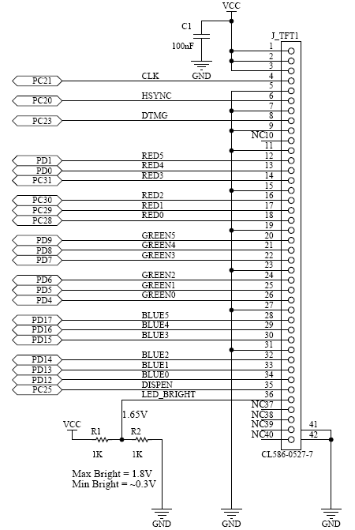

The wiring between the Grasshopper and the TFT is really simple.

Care should be taken on the CLK line, excessive ringing or jitter may result in an distorted picture or malfunction of the TFT. Adding a series termination resistor (20 to 50 Ohm) on this line can improve a lot.

Software implementation
The Linux frame buffer device is a ideal choice for embedded devices since it is easy to implement and very universal in it's use. You can run anything from plain text consoles to full blown X11 on it.
It is also available on desktop PCs , so you can develop and debug frame buffer applications on your
desktop machine.
The LCD controller on the Grasshopper is disabled by default , so we first must enable it in
the startup file of the Grasshopper and tell the Linux kernel that the LCD controller can be used as frame buffer device.

The startup file is located at :
/your_grasshopper_directory/build_avr32/linux-2.6.24-icnova/arch/avr32/boards/icnova/icnova_base.c
Open it with your favorite editor and add the following lines:

#include <linux/fb.h>
#include <video/atmel_lcdc.h>

and after

#undef ICNOVA_USB_CP2102

this lines:

static struct fb_videomode grasshopper_tft_modes[] = {
{
.name = "TX09D70 @ 60",
.refresh = 60, /* refresh rate */
.xres = 240, /* horizontal resolution */
.yres = 320, /* vertical resolution */
.pixclock = KHZ2PICOS(4965), /* pixel clock in kHz */
.left_margin = 1, /* h. front porch */
.right_margin = 33, /* h. back porch */
.upper_margin = 1, /* v. front porch */
.lower_margin = 0, /* v. back porch */
.hsync_len = 5, /* hsync length */
.vsync_len = 1, /* vsync lengt */
.sync = FB_SYNC_HOR_HIGH_ACT | FB_SYNC_VERT_HIGH_ACT,
/* Active high hsync impulse , active high vsync impulse */
.vmode = FB_VMODE_NONINTERLACED,
/* always send a full frame to the display */
},
};

static struct fb_monspecs __initdata grasshopper_default_monspecs = {
.manufacturer = "ATM", /* ATM = Atmel */
.monitor = "GENERIC", /* Generic type */
.modedb = grasshopper_tft_modes,
.modedb_len = ARRAY_SIZE(grasshopper_tft_modes),
.hfmin = 14820, /* doesn't affect the lcdc! */
.hfmax = 32000, /* doesn't affect the lcdc! */
.vfmin = 30, /* doesn't affect the lcdc! */
.vfmax = 200, /* doesn't affect the lcdc! */
.dclkmax = 30000000, /* doesn't affect the lcdc! */
};

struct atmel_lcdfb_info __initdata grasshopper_lcdc_data = {
.default_bpp = 16, /* Colur depth */
.default_dmacon = ATMEL_LCDC_DMAEN | ATMEL_LCDC_DMA2DEN,
.default_lcdcon2 = (ATMEL_LCDC_DISTYPE_TFT
| ATMEL_LCDC_CLKMOD_ALWAYSACTIVE
| ATMEL_LCDC_MEMOR_BIG),
.default_monspecs = &grasshopper_default_monspecs,
.guard_time = 2,
};
Finally, to enable the LCD Controller and make it usable as frame buffer device add this line in the static int __init icnova_init(void) function :

at32_add_device_lcdc(0, &grasshopper_lcdc_data, fbmem_start, fbmem_size);

In the next steps we configure the Linux Kernel to use the LCD controller and frame buffer.
For easy cross compiling of the kernel and applications add the Grasshopper toolchain
temporary to your path variable

export PATH=/your_grasshopper_directory/build_avr32/staging_dir/bin:$PATH

and make an alias (crossmake)

alias crossmake='ARCH=avr32 CROSS_COMPILE=avr32-linux- '

to start the kernel configuration “cd” in your grasshopper directory
to /build_avr32/linux-2.6.24-icnova/ and type :

crossmake make clean menuconfig uImage

Go to the “Device Drivers” submenu and select “Graphics support”
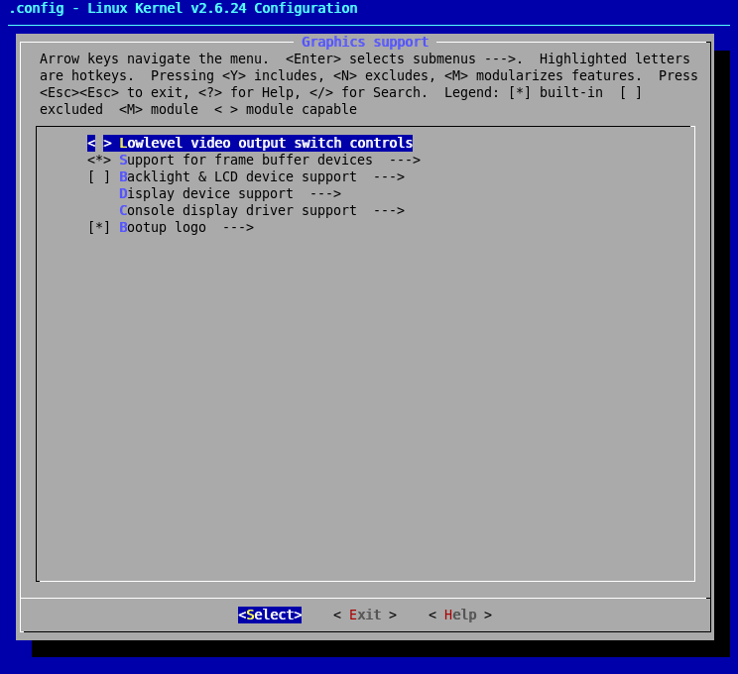
Select the options according to the screenshots.

This step enables the Linux frame buffer and the Penguin bootup logo.
In the frame buffer device submenu :

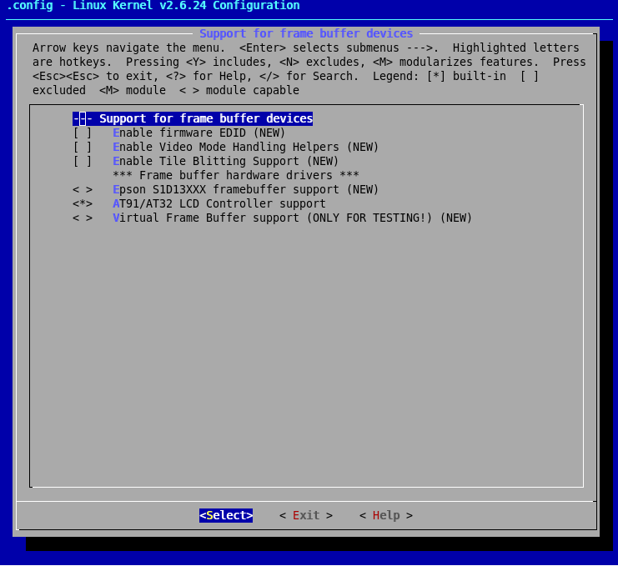
This step selects the AVR32 LCD controller .

The next step is optional , if you want a console terminal on your frame buffer
go one level up and in the “Char devices” submenu and select the options like in the screenshot. If you don't want a frame buffer terminal just leave this submenu as it is.

Optional console on frame buffer

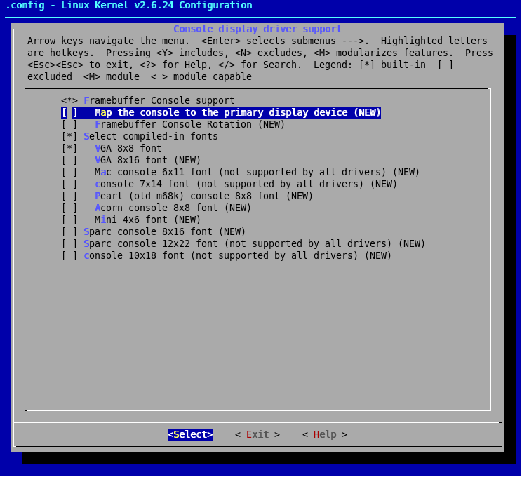
Now exit and save the kernel configuration . The build process should start and if all go well your new kernel should be in :

/your_grasshopper_directory/build_avr32/linux-2.6.24-icnova/arch/avr32/boot/images/uImage

Copy your new kernel (with nfs,ftp,tftp or whatever you like) to the board in the /boot directory . Don't forget to rename and/or backup your old kernel. I renamed mine to uImage_old , so I can
load the old kernel in U-Boot with “fsload uImage_old” in case the new kernel doesn't work as expected.

If all went good you should see something similar to this :

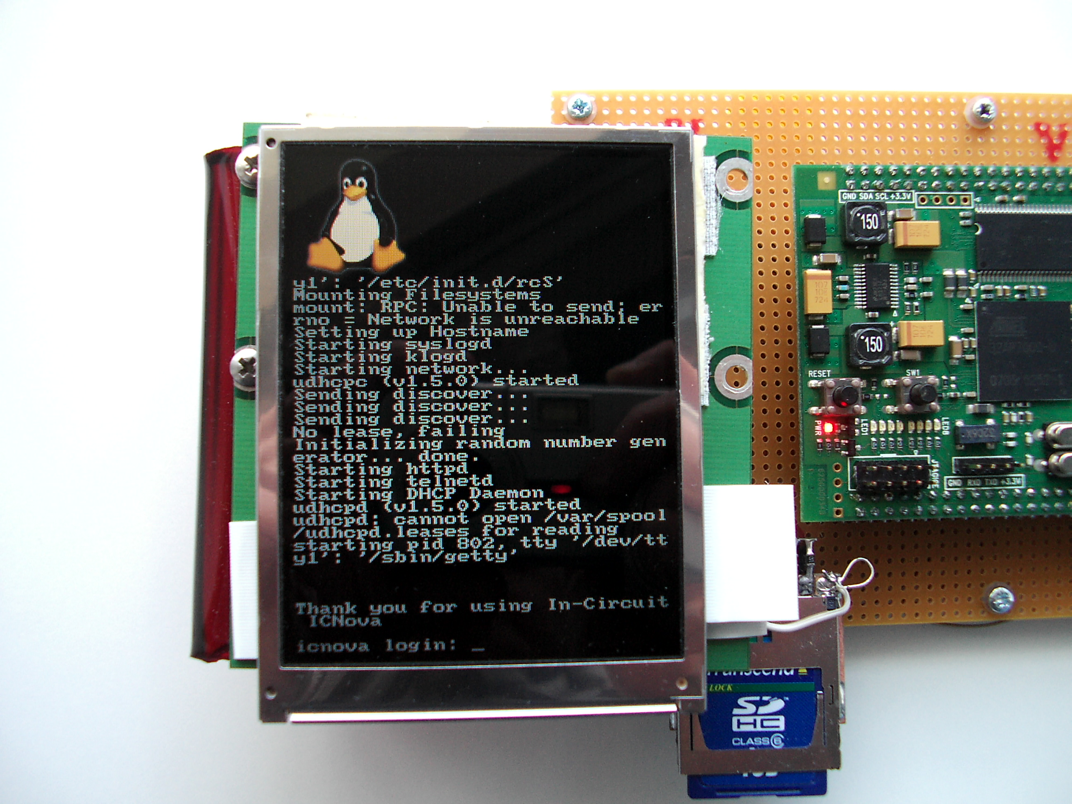

Sample application (mplayer)

Everybody who ever watched a movie in Linux knows mplayer. Atmel published a patch for mplayer
which adds support for the advanced features of the AT32AP7000 processor.
There is a nice howto for AVR32 at :

http://www.avr32linux.org/twiki/bin/view/Main/MPlayer

Since we don't have GTK , X11, some libraries and sound support at this point, follow the instructions for the command line version and edit the configuration script disabling all alsa ,sound
and libmad stuff.

Now just use the alias “crossmake” explained earlier to compile mplayer and everything should work.
Copy the resulting binary to your board , set executable permissions and type in :

./mplayer -nosound path_to_my_video_file/my_video_file.mpXX

I tested mplayer with a couple of MPEG2 , MP4 and AVI files , all of them work without problems.
Playing a fullscreen 900kbps MPEG2 @ 24fps leads in roughly 30% processor load!
A slightly higher clocked (190MHz) ARM9 hardly reaches 15fps with this file at 100% processor load.
Watching a movie trailer on the Grasshopper

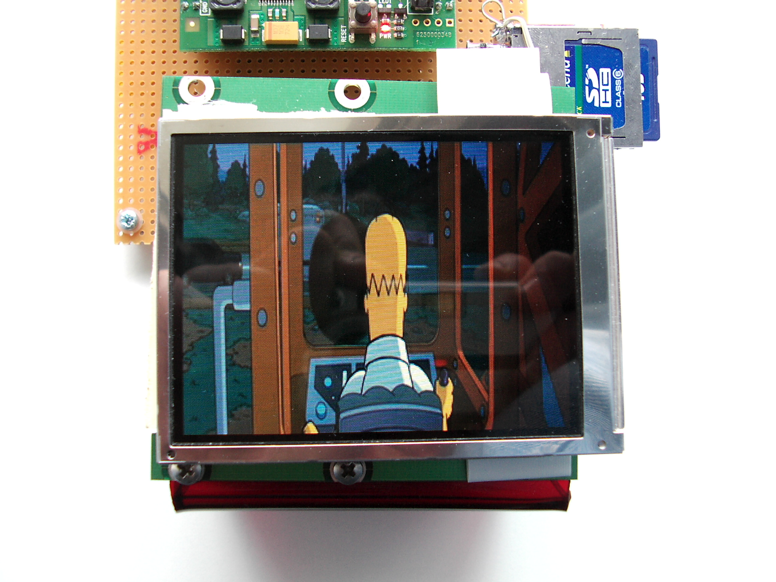
Sorry for the bad picture quality , it is difficult to take a good picture from a TFT display.
In real the picture on the screen is really sharp and vivid!

I hope this tutorial was informative for you , if you are planing to add a display to the Grasshopper
I suggest you read further documentation because this tutorial will give you just a brief overview.
Most documents of interest you will find in the /your_grasshopper_directory/build_avr32/linux-2.6.24-icnova/Documentation directory.

You can download all project files and if my Sharp display arrives ,a patched icnova_base.c for this type of displays at :
http://forum.embedded-projects.net/
just search the AVR32 forum.

