Template Method

Intent
Define the skeleton of an algorithm in an operation, deferring some steps to client subclasses. Template Method lets subclasses redefine certain steps of an algorithm without changing the algorithm's structure.

Problem
Two different components have significant similarities, but demonstrate no reuse of common interface or implementation. If a change common to both components becomes necessary, duplicate effort must be expended.

Discussion
The component designer decides which steps of an algorithm are invariant (or standard), and which are variant (or customizable). The invariant steps are implemented in an abstract base class, while the variant steps are either given a default implementation, or no implementation at all. The variant steps represent "hooks", or "placeholders", that can, or must, be supplied by the component's client in a concrete derived class.
The component designer mandates the required steps of an algorithm, and the ordering of the steps, but allows the component client to extend or replace some number of these steps.
Template Method is used prominently in frameworks. Each framework implements the invariant pieces of a domain's architecture, and defines "placeholders" for all necessary or interesting client customization options. In so doing, the framework becomes the "center of the universe", and the client customizations are simply "the third rock from the sun". This inverted control structure has been affectionately labeled "the Hollywood principle" - "don't call us, we'll call you".

Structure

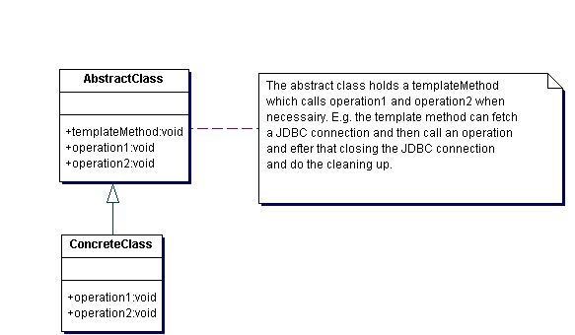

Example
The Template Method defines a skeleton of an algorithm in an operation, and defers some steps to subclasses. Home builders use the Template Method when developing a new subdivision. A typical subdivision consists of a limited number of floor plans with different variations available for each. Within a floor plan, the foundation, framing, plumbing, and wiring will be identical for each house. Variation is introduced in the later stages of construction to produce a wider variety of models. [Michael Duell, "Non-software examples of software design patterns", Object Magazine, Jul 97, p54]
In JDBC one often needs to open (or fetch from a pool) a connection and do som CRUD work. The opening, closing etc can be placed in a templated method in an abstract class. The Abstract class can the defer the actual CRUD operation to a subclass. A variant on this – with no inheritance – is to have a seperate class doing the JDBC plumbing accepting an interface. The interface has only one method – execute – which is called and in turn gives the controll back to the caller in an anonymous inner class of the calling class method.

Rules of thumb
Strategy is like Template Method except in its granularity. [Coplien, C++ Report, Mar 96, p88]
Template Method uses inheritance to vary part of an algorithm. Strategy uses delegation to vary the entire algorithm. [GOF, p330]

