GANTT Diagramm
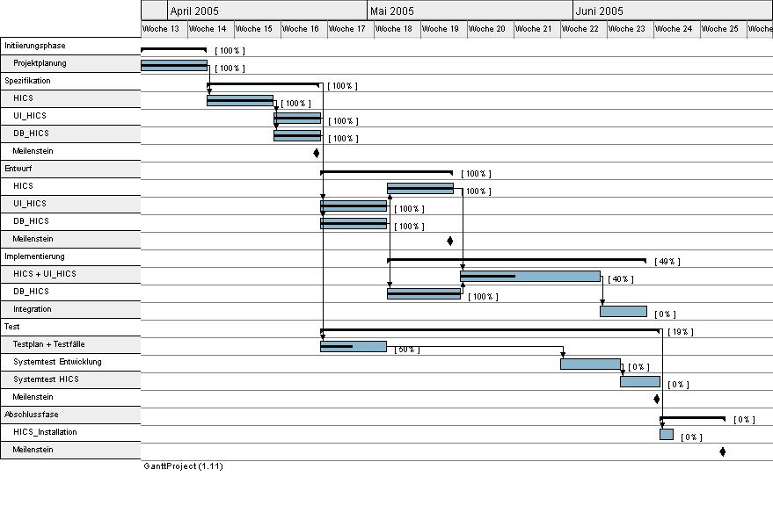Version 1.3

