DESIGN MODEL

DESIGN MODEL 1
1 Registration 2
1.1 System Sequence Diagramm 2
1.2 DCD 2
1.3 Sequenz Diagramm 3
1.4 Description 3
2 Login (User not active) 4
2.1 System Sequence Diagramm 4
2.2 DCD 4
2.3 Sequence Diagramm 5
2.4 Description 5
3 Login (User is active) 6
3.1 System sequence diagramm 6
3.2 DCD 6
3.3 Sequence diagram 7
3.4 Description 7
4 Logout 8
4.1 System sequence diagramm 8
4.2 DCD 8
4.3 Sequence diagram 9
4.4 Description 9
5 Subscribe for newsletters 10
5.1 System sequence diagramm 10
5.2 DCD 10
5.3 Sequence diagram 11
5.4 Description 11

Version | Date | Description | Author
Inception draft | 17.11.2006 | First draft. To be refined primarily during elaboration | Schnl1, Zumsr1

  - Registration
    - System Sequence Diagramm
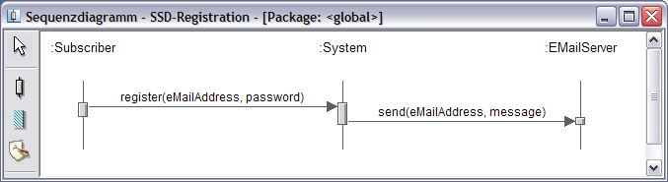

register(eMailAddress, password)
User enters email, name and password to create a new account.

sendMail(eMailAddress, message)
System generates an activation code and a message text. Email server sends mail to the subscriber.

    - DCD
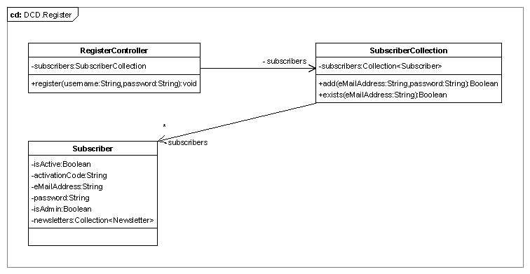

    - Sequenz Diagramm
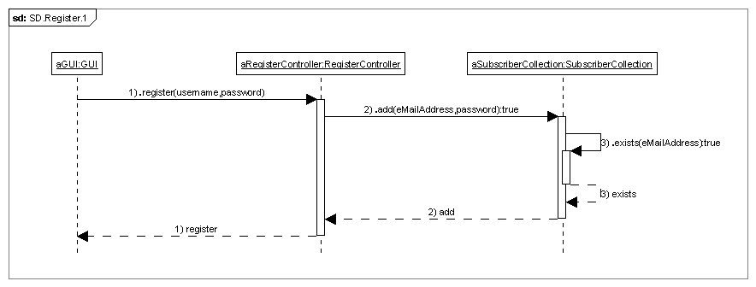

    - Description
- Subscriber inputs his email-address, name and his password (two times to confirm it)
- System tests if the email-address is well formed and the two passwords match.
- System generates a mail with an activation-code System uses the mail server to send the mail with the activation-code to the subscriber System create a non active account.
  - Login (User not active)
    - System Sequence Diagramm
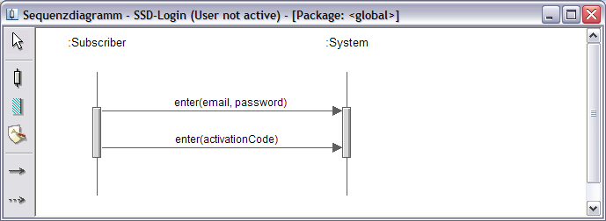

enter(email, password)
User enters email address and password to perform a login.

enter(activationCode)
User must enter his received activation code because his account isn’t active yet.

    - DCD
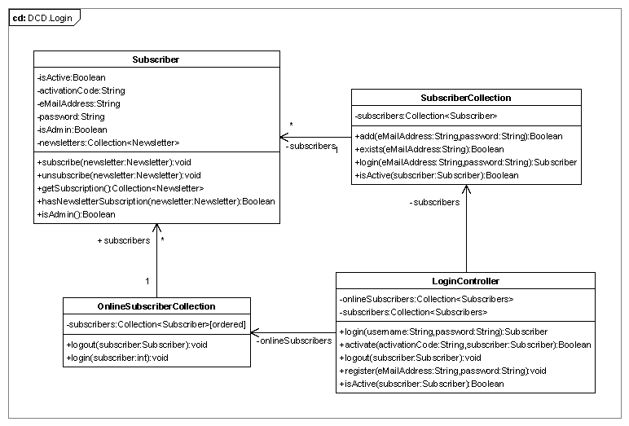

    - Sequence Diagramm
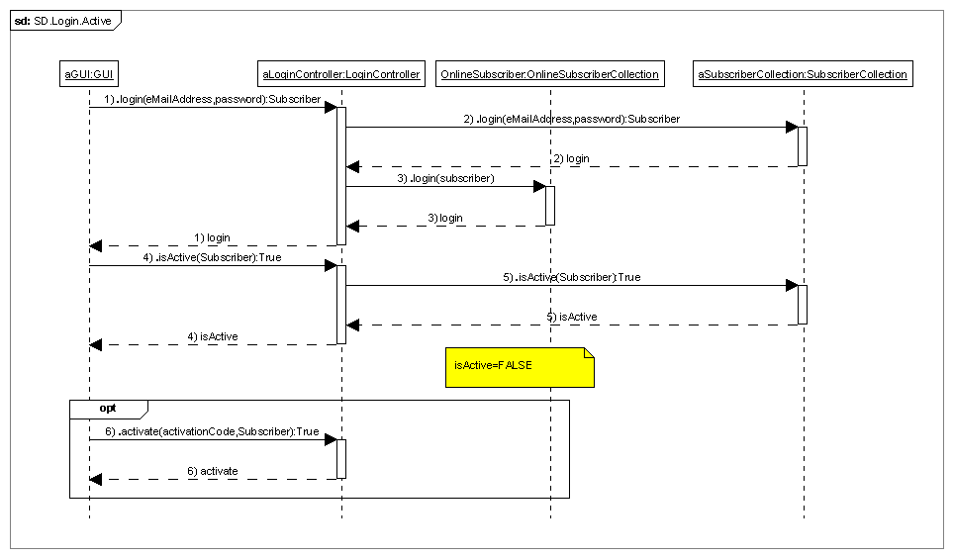

    - Description
- Subscriber inputs his mail-address and his password
- System checks the account
- GUI receives the Subscriber object or null if username does not exist or password is incorrect
- The Subscriber is added to the OnlineSubscribers collection
- If a subscriber is returned the GUI has to check if the user is activated.

  - Login (User is active)
    - System sequence diagramm

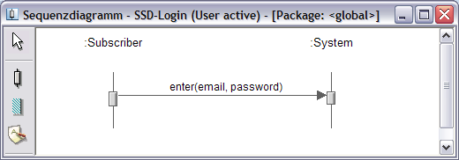

enter(email, password)
User enters email address and password to perform a login.

    - DCD

    - Sequence diagram

    - Description
- Subscriber inputs his mail-address and his password
- System checks the account
- GUI receives the Subscriber object or null if username does not exist or password is incorrect
- The Subscriber is added to the OnlineSubscribers collection
- If a subscriber is returned the GUI has to check if the user is activated.

  - Logout
    - System sequence diagramm

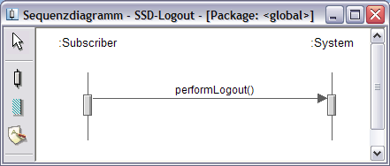

PerformLogout()
User perform logout to sign out of the application.

    - DCD
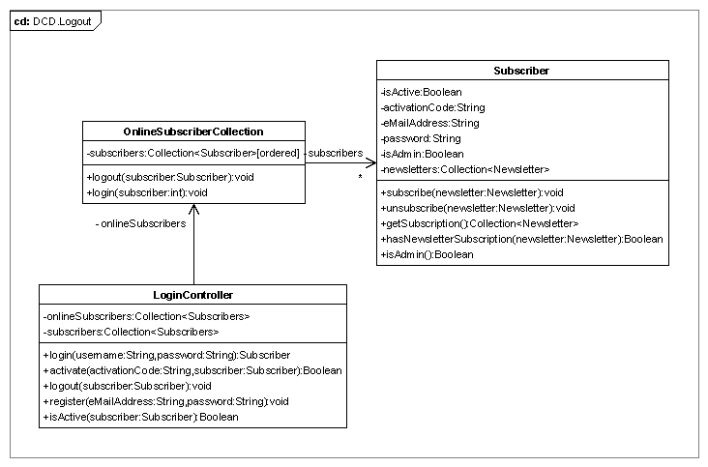

    - Sequence diagram
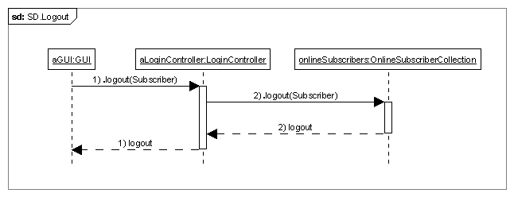

    - Description
- Subscriber performs a logout.
- System removes subscriber from onlineSubscriberCollection.

  - Subscribe for newsletters
    - System sequence diagramm

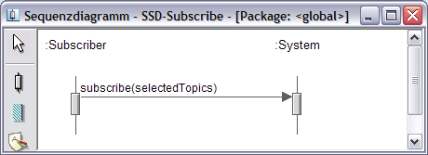

Subscribe(selectedTopics)
User subscribes to the newsletter he wants.

    - DCD
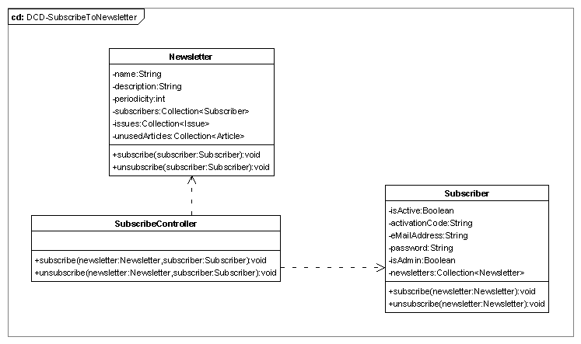

    - Sequence diagram
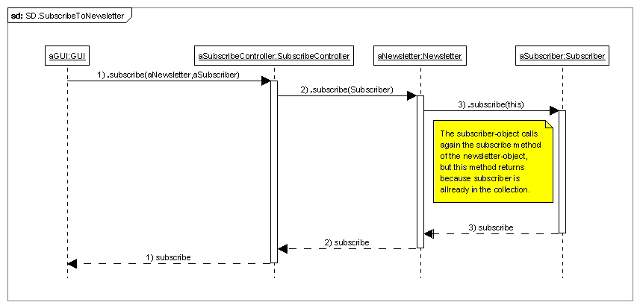

    - Description

