Google Maps Pugin |  | 
Plugin Type: | CDS-API Extension (Type 3)
Short Description: | Adds API functions for drawing Google Maps
Author: | Sven Weih, based on phoogle
Version: | 1.0
Requirements | -

Introduction
Google Maps (maps.google.com) offers you, to implement maps to your website. If you want to display the location of your company on a web, then you can use google maps to create an interactive map of the location of your company.
For using Google Maps, you need to register at Google. You will receive an API-Key by Google with which you can access Google Maps.

Setup
- Install the Plugin
- Write code to your template.

Usage
Here is an example, of how to draw a map in your template with N/X WCMS. We defined a class with the placeholders:
- Google-API-Key (label),
- Address( label),
- Address Description (text),
- ShowControls (boolean)

Based on these fields, we developed the following code in the map-template:

// Get the Google Maps API-Key
$apikey = $cds->content->get("Google-API-Key");

// Create the Maps-API. The apikey is passed as parameter.
$maps = $cds->plugins->getApi("Google Maps API", $apikey);

// add the google-js to the head of the page
$cds->layout->addToHeader($maps->printGoogleJS());
.....
Call $cds->layout->drawHeader();

.....

// add a point to the map
$maps->addAddress($cds->content->get("Address"), $cds->content->get("Address Description"));

// setup width and height and zoom factor (0-17)
$maps->setWidth(600);
$maps->setHeight(450);
$maps->zoomLevel = 2;

// setup controls
$maps->showControl = $cds->content->get("ShowControls");

// draw the map.
$maps->showMap();

The result is looking like this:
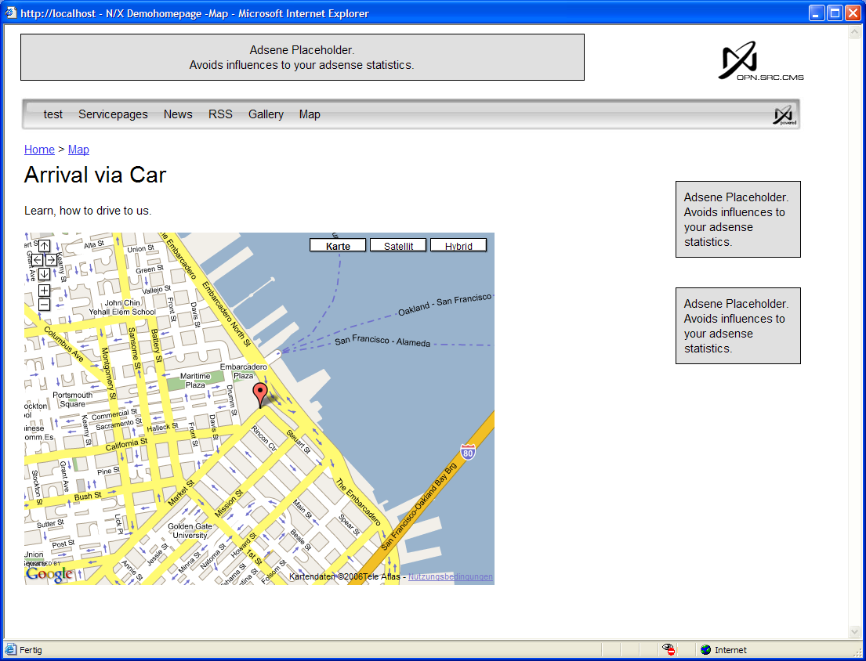

Customization
Since this plugin is based on phoogle, you can use all the customisations which are available for phoogle. The phoogle.class-file is located at cms/plugins/googlemaps.

Method Documentation.
You can download the API-documentation at:
http://www.system7designs.com/phoogle/phoogle.pdf

