Gallery Plugin |  | 
Plugin Type: | Content-Type-Extension (Type 1)
Short Description: | Helps creating HTML or Flash Image Galleries.
Author: | Sven Weih
Version: | 2.0
Requirements | N/X 4.5

Introduction
The Gallery Plugin was developed to allow one creating image galleries with just some mouse-clicks. There is almost no custom programming required.

Setup
- Install the plugin in Plugin Administration.
- Go the the library and create a new content. Select Gallery as content type or
- Go the the classes-editor and add a new content-placeholder to a class. Then define the placeholder to host a gallery.
- Edit the content and select a folder of your Content-Library. All the images in the folder are then displayed in the gallery:

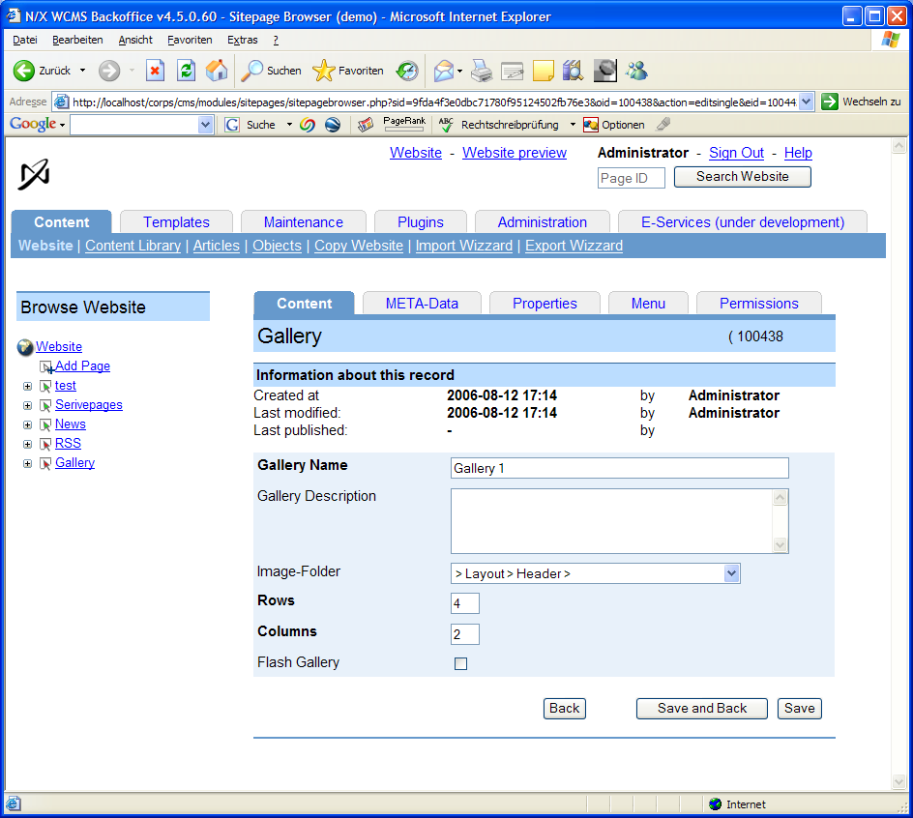
- You can setup the gallery.
  - Make it a flash gallery and setup the columns/rows you want to display in the flash gallery.
  - Make it a HTML-Gallery (unselect the flash checkbox). The columns/rows define nothing in this case!

Usage

To draw the gallery in your template, call the following function, if it is located in the library and an accesskey is set:
echo $cds->content->getByAccessKey("<accesskey>",
array("body",<width>,<height>));

If the content is a part of your object, then just call:

echo $cds->content->get("<placeholdername>",
array("body",<width>,<height>));

If you are using the HTML-Version of the plugin, you must also add some Javascript to the header of your template. Therefore call the the function:

$header = $cds->content->get("<placeholdername>",
array("HEAD",<width>,<height>));

and add it to the header of your homepage:
$cds->layout->addToHeader($header);

You must add the Javascript to the header, before you call drawHeader() !

Customisation
You can exchange the previous and the next button. Therfore just query www/sys and wwwdev/sys and copy new images with the same filename there.

