1 2 3 ontology
Seminar Economics & informatics
Date:
February, 2007
Course:
Seminar Economics and ICT (FEW 1904)
Authors:
- Hesing Kuo (292412)
- Remy Stibbe ()
- Nico Vaatstra ()
- Jasper Voskuilen (300353)
Teacher:
Dr. F. Frasincar

Table of contents

Table of contents ii
1. Introduction 3
2. Project definition 4
2.1. Problem statement and Goals 4
2.2. Scope 4
2.3. Schedule 4
3. Literature review 5
3.1. Ontology learning 5
3.2. Ontology visualization 5
4. Methodology 6
5. Results 7
6. Conclusions 8
References 9

- Introduction

Information on the Internet is growing rapidly. Nowadays billions of pages contains data which is used for the worldwide exchange of information. The pages represent mainly textual data and have no semantic annotation. Querying based on inefficient keyword matching becomes a bottleneck of the web. Semantic web based on machine understandable metadata would provide a qualitatively new level of service. Ontology’s will link together large segments of human knowledge and complement it with machine processability. However, building ontology’s for the semantic web is pretty time consuming and requires enormous human effort. With assistant of machine learning techniques, ontology construction can be (partially) automated.

- Project definition
This chapter describes the specific problems and goals that we try to solve, achieve, at the end of the seminar.
  - Problem statement and Goals
The aim of this seminar paper is to present a better method for ontology extraction from text. This means that the proposed method will take as input a variety of texts and is able to automatically generate an ontology that annotates and describes the processed texts.
In order to better understand the results produced by this seminar paper will also address the visualization of ontologies. To be more precise a visualization plugin for protégé shall be developed based on the edge bundling technique described in Holten (2006).
  - Scope
- The method that will be proposed by this seminar paper will acquire information about concepts and instances from the texts to be processed.
- The processing and creation of the ontology must be fully automatic.
- The proposed method will use an incremental approach (concept learning) to describe the processed texts
- We will try to optimize the entire ontology creation process and we will therefore not use an existing process and enhance only a part of it.
- We will focus on the economic domain and use any knowledge about that domain to guide the ontology creation process.
  - Schedule
The schedule for this seminar is given in Figure 1.
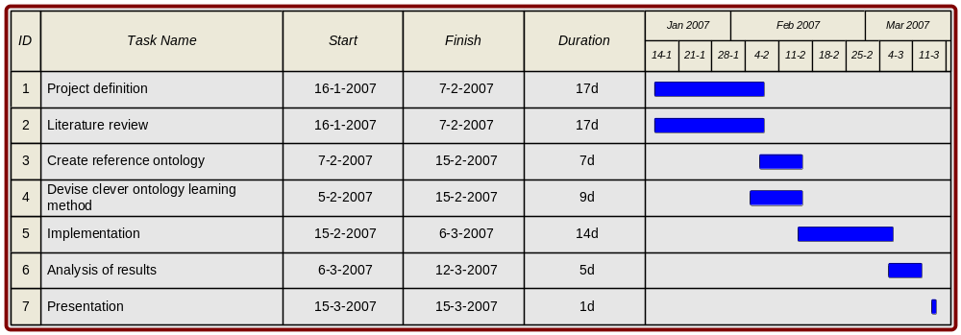
Figure 1 Schedule of activities

Literature review
  - Ontology learning
  - Ontology visualization
- Methodology

Reviewed methods and techniques:
Association rules:
With a set of data generated with POS tagging and Hearst pattern based extractor, we want to find relationships between the concepts in our dataset. All concept occurrences from documents are stored in a database table. In order to find relations between these concepts, several methods were analyzed and tested:
- WEKA: Collection of common used machine learning algorithms for data mining tasks build in JAVA. Weka contains tools for data pre-processing, classification, regression, clustering, association rules, and visualization. One algorithm we are particularly interested in is the Apriori learner for finding association rules. It does not seek rules that predict a particular class attribute, but rather look for any rules that capture strong associations between different attributes.
- Pearson’s correlation algorithm determines the level of association between concepts. It needs a co-occurrence matrix as input. What we now have is a dataset which can be seen as an occurrence matrix. Due time pressure, we could not make a co-occurrence matrix and we have not implemented the Pearson algorithm.
- KuoVaaStiVos’s approach: Each document (abstract) has some words that occur frequently. A relation between concepts is established when the same words occur in another document. For example, abstract 1 has the following words that occurs frequently: Unemployment, inflation, wage. Abstract 2 contains the concepts: inflation, unemployment and market. Both unemployment and inflation occurs in both documents. This indicates that there is a relation between these two concepts. The strength of this relation, depends on the frequency in all other documents.
- Results

- Conclusions

References

Holten D. (October 2006). Hierarchical Edge Bundles: Visualization of Adjacency Relations in Hierarchical Data. IEEE Transactions on visualization and computer graphics. Vol. 12, No. 5, pp. 741-748.
Ian H. Witten, Eibe Frank, Len Trigg, Mark Hall, Geoffry Holmes, and Sally Jo Cunningham, Department of Computer Science, University of Waikato, New Zealand. Weka: Practical Machine Learning Tools And Techniques with Java Implementations.
www.cs.waikato.ac.nz/~eibe/pubs/99IHW-EF-LT-MH-GH-SJC-Tools-Java.ps.gz
Eibe Frank, Mark A. Hall, Geoffrey Holmes, Richard Kirkby, Bernhard Pfahringer, Ian H. Witten, and Leonhard Trigg. Weka - a machine learning workbench for data mining. In Oded Maimon and Lior Rokach, editors, The Data Mining and Knowledge Discovery Handbook, pages 1305-1314. Springer, 2005.
Nees Jan van Eck, Jan van den Berg, Flavius Frasincar. Rapportage 8: Definitie TDM methode en conceptrelatie representatie data November 2005

R. Srikant and R. Agrawal, Mining generalized association rules, In Proceedings of the 21st
VLDB Conference, pages 407–419, Zurich, Swizerland, 1995.
www.cs.sfu.ca/CourseCentral/459/han/papers/srikant95.pdf
www.cs.ualberta.ca/~colinc/GenAssocNov17.ppt

A. Maedche and S. Staab, Discovering Conceptual Relations from Text, In Proceedings of
the 14th European Conference on Artificial Intellengence, pages 321–325, Berlin, Germany,
August 2000.

Association rules – Apriori algorithm
http://www.aicomponents.com/Algorithms/AssociationRules.aspx
http://en.wikipedia.org/wiki/Apriori_algorithm
http://www.cs.ualberta.ca/~zaiane/courses/cmput499/slides/Lect10/sld054.htm

