1 2 3 ontology
Seminar Economics & informatics
Date:
February, 2007
Course:
Seminar Economics and ICT (FEW 1904)
Authors:
- Hesing Kuo ()
- Remy Stibbe ()
- Nico Vaatstra ()
- Jasper Voskuilen (300353)
Teacher:
Dr. F. Frasincar

Table of contents

Table of contents ii
1. Introduction 3
2. Project definition 4
2.1. Problem statement and Goals 4
2.2. Scope 4
2.3. Schedule 4
3. Literature review 5
3.1. Ontology learning 5
3.2. Ontology visualization 5
4. Methodology 6
5. Results 7
6. Conclusions 8
References 9

- Introduction

- Project definition
This chapter describes the specific problems and goals that we try to solve, achieve, at the end of the seminar.
  - Problem statement and Goals
The aim of this seminar paper is to present a better method for ontology extraction from text. This means that the proposed method will take as input a variety of texts and is able to automatically generate an ontology that annotates and describes the processed texts.
In order to better understand the results produced by this seminar paper will also address the visualization of ontologies. To be more precise a visualization plugin for protégé shall be developed based on the edge bundling technique described in Holten (2006).
  - Scope
- The method that will be proposed by this seminar paper will acquire information about concepts and instances from the texts to be processed.
- The processing and creation of the ontology must be fully automatic.
- The proposed method will use an incremental approach (concept learning) to describe the processed texts
- We will try to optimize the entire ontology creation process and we will therefore not use an existing process and enhance only a part of it.
- We will focus on the economic domain and use any knowledge about that domain to guide the ontology creation process.
  - Schedule
The schedule for this seminar is given in Figure 1.
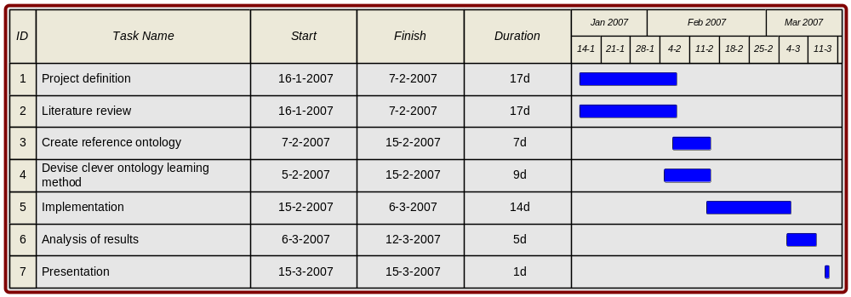
Figure 1 Schedule of activities

Literature review
  - Ontology learning
  - Ontology visualization
- Methodology

- Results

- Conclusions

References

Holten D. (October 2006). Hierarchical Edge Bundles: Visualization of Adjacency Relations in Hierarchical Data. IEEE Transactions on visualization and computer graphics. Vol. 12, No. 5, pp. 741-748.

