

**Setup-Instructions DStar-DD**

This instruction describes how to setup DStar-DD-mode for usage with the G4KLX ircDDBGateway.

**Hamnet/AmprNet**

At DB0MYK DStar-DD-mode allows users to access the “Hamnet”, which is the high speed part of the amprnet in Europe.

**The worldwide amprnet is our own closed network used for amateur radio only!  
For me it really makes sense to use it for DStar Digital Data.**

You will find more information on amprnet and Hamnet in different languages on the web:

<http://en.wikipedia.org/wiki/AMPRNet> (English language)  
<http://db0fhn-i.ampr.org/doku.php?id=projects:wlan:hamnet> (English language)  
<http://www.amateurfunk-wiki.de/index.php/Kategorie:HAMNET> (German language)  
<http://de.wikipedia.org/wiki/HamNet> (German language)

.. and many more.

**DHCP**

DB0MYK provides all necessary network information by DHCP.

The big advantage of DHCP is that users without any network knowledge may use it easily.  
It is as easy as connecting a PC to a usual DSL- or WLAN-router.  
Not all OMs are network and internet specialists.

A disadvantage of DHCP is a changing IP address which makes peer-to-peer routing more complicated.  
I personally do not think that P2P routing is the main purpose of DStar-DD. Most users do not run any services on their PC that might be connected from the net; a standard Windows installation with firewall enabled will not even answer a ping by default.  
Servers should be connected to the network by a faster link, however, they could also get fix IPs.

But anyway, I have built a little web-tool which shows the actual users from the DDMode.log of ircDDBGateway with the current IP address from DHCP-leases. Users can see on a webpage of the gateway who is on air in DD and what the actual IP address is.

There is much room for improvement at that place; dynamic IP addresses should not be an unsolvable issue!





1. **Setup of the ID1 transceiver:**

* Tune the ID1 to the frequency of your local DD-mode repeater.
* Select DD-Mode.
* Activate the correct repeater mode.  
  The ID1 offers RP+, RP- and RPS.   
  Most DD-mode repeaters work simplex, note that you have to set RPS in that case!  
  Without any repeater setting DD-mode won’t work.
* After that you need to enter your own callsign, destination, repeater 1 and repeater 2.  
  This works exactly in the same way like setting it up for digital voice:
* Set destination to “CQCQCQ”,
* Set repeater 1 to the callsign and ID that your local repeater uses for the DD-module.   
  Usually it is the ID “A” at the 8th position, like “DB0MYK_A”.
* Set repeater 2 to the gateways’ callsign.  
  Usually it is the repeaters’ callsign with the ID “G” at the 8th position, like DB0MYK_G.

If you have installed the remote control software on a PC, settings should look like this:

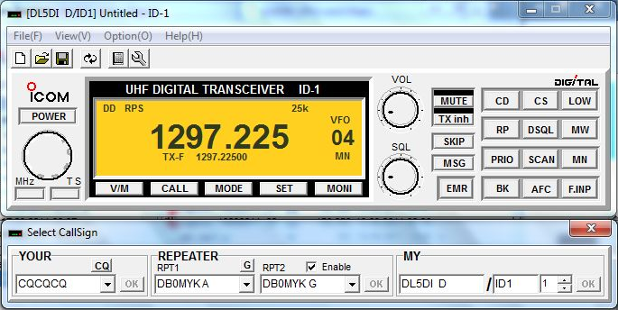





1. **Setup of the PC**

* If you are using a Windows PC and have not done any changes to the settings of the Ethernet interface yet, you have nothing to configure.
* If you did manual changes to the network settings, take care, that the Ethernet interface has to be activated and set to DHCP mode.

1. **Connect the devices and start working**

* Connect your PC and the ID1 by using a network cable.
* The transmitter of the ID1 is deactivated by default.  
  Activate your ID1 by pressing “TXinh”.

“TXinh” should now have disappeared from the display and you should immediately see some traffic going back and forth.   
Your PC will send out a DHCP request as soon as the interface gets connected.  
The gateway will supply the IP and some other necessary network settings.

You are now ready to work!

Try a ping to a known IP address. Ask your local admin for information.  
If the gateway is connected to the amprnet try 44.225.73.2!

You should see your callsign in ircDDB-live now (if VIS=on).  
It will appear only once every 2 minutes.

1. **Some samples of my local DD-repeater:**

The webpage that I get from the local gateway is the dashboard of the ircDDBGateway:

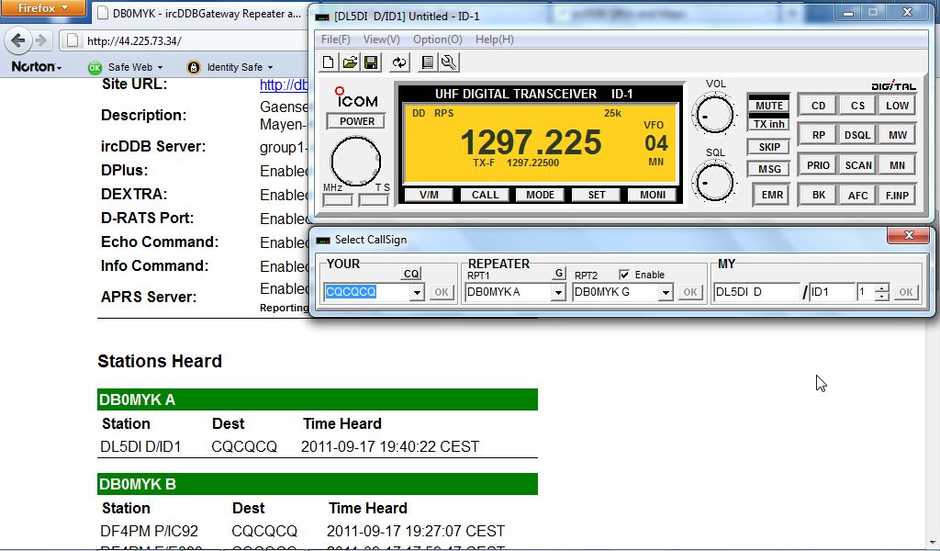

This shows a connect to the webserver 44.225.73.2:

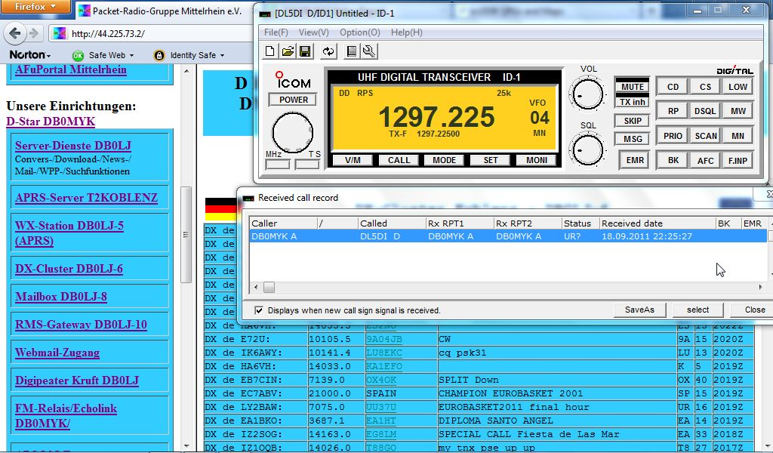

My local server 44.225.73.2 also allows to connect to the Packet-Radio network by using the feature “TCPIP-Connect” of the Windows Packet Program “WPP”.

With this I am able to connect to packet-radio stations like the DX-Cluster DB0LJ-6 in this example:

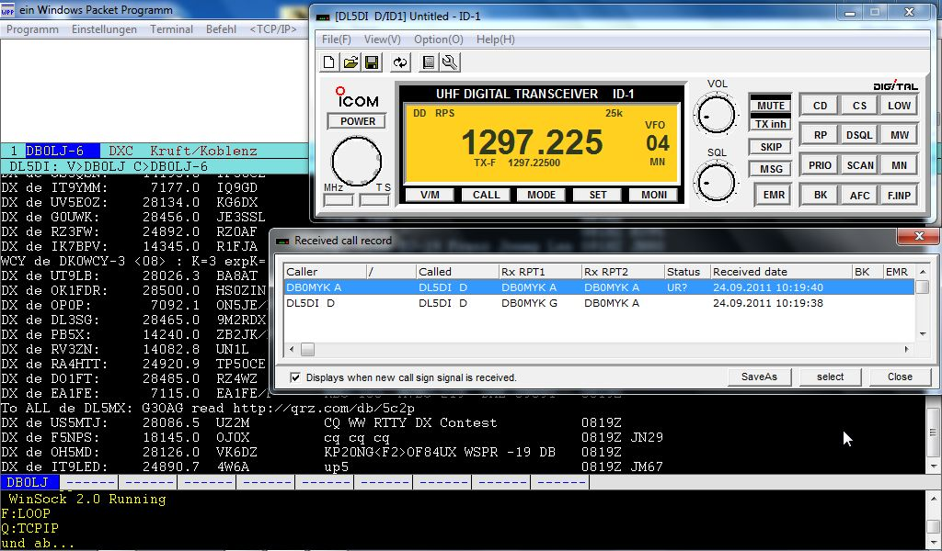

Have fun!

Hans, DL5DI