Gateway Usage

# Overview

This package consists of six software packages, the ircDDB Gateway, the ircDDB Gateway Config application, the Remote Control Application, the StarNET Digital Server, Timer Control, and the Time Server.

The ircDDB Gateway is designed to be used both with the repeaters based on non-Icom hardware that can be downloaded from the pcrepeatercontroller Yahoo! group, and also with Icom hardware. Indeed it is possible to run a system with the gateway that contains a combination of both Icom and homebrew hardware in almost any permutation.

The gateway provides access to the ircDDB network to allow for real-time callsign and repeater routing via ircDDB and CCS, as well as linking to DExtra, DCS, and D-Plus reflectors. Extra facilities include an echo server for radio testing and spoken information messages in a number of languages.

If D-Plus is enabled with the gateway then it authenticates itself with the official D-Plus server to ensure proper access to D-Plus reflectors and gateways.

The gateway can interface to the APRS network to pass on data from D-Star users who have GPS or GPS-A mode enabled on their radios, it may also be interfaced to the D-RATS software.

The gateway includes five STARnet Digital servers which run alongside the gateway functionality.

The Remote Control Application is used to control both the ircDDB Gateway and STARnet Digital Server from a remote location. If automatic control of the gateway is required then the Timer Control application can be used to create a schedule of linking and unlinking based on times and days (optionally). Both programs use strong authentication to ensure that unauthorised control of a gateway or server is not possible.

The STARnet Digital Server is a version of the gateway that does not control any repeaters, but instead makes available up to fifteen STARnet Digital groups. This would typically run at a data centre and not on a remote hill top location which is the natural domain of the ircDDB Gateway. At compile time it is possible to configure the server to link to DCS or DExtra reflectors to provide additional functionality.

Finally, the Time Server can be used to send time announcements to the gateway for transmission out of the attached repeaters.

If you run the pre-built Windows .exe version of the software then it is probable that you'll need to install a copy of the latest Visual C++ run-time libraries from Microsoft. To do this you need to download and run the Vcredist_x86.exe file which is found at <http://www.microsoft.com/downloads/details.aspx?FamilyID=9b2da534-3e03-4391-8a4d-074b9f2bc1bf&displaylang=en>. This only needs to be done once.

In order to use the ircDDB Gateway or StarNET Server fully, it needs to be registered with, and logged into, the ircDDB network. This network is only available to properly licensed repeaters, which in most countries also implies the issuing of a special permit and maybe a special callsign for the gateway also. Once this has been issued register with the ircDDB network via <http://regsrv.ircddb.net> and follow the instructions on that page. In the USA a club callsign is required for the gateway and repeaters.

If you do not have such a callsign or permit, then ircDDB may be disabled as documented in the ircDDB configuration below. Audio routing via CCS is available to all gateways and has no restrictions on its use.

# The ircDDB Gateway

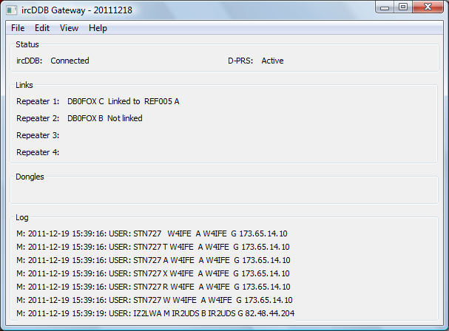

ircDDBGateway.exe [-nolog] [-gui] [-logdir directory] [-confdir directory] [config name]

ircddbgateway [-nolog] [-gui] [-logdir directory] [-confdir directory] [config name]

ircddbgatewayd [-daemon] [-nolog] [-logdir directory] [-confdir directory] [config name]

The ircDDB Gateway has all the capabilities of the Icom G2 gateway software, and much more besides. Unlike the Icom software, it is open source, works with much more than just Icom hardware, and uses a far better callsign and repeater routing systems; ircDDB and CCS. These newer system updates information about a user’s location on the network within a second as compared to the couple of minutes typically encountered on the Icom G2 system. In addition the ircDDB Gateway is able to run on almost any platform and does not require the setting up of a separate database system in order to run.

On Windows the gateway program is named ircDDBGateway.exe and is a GUI based program, as is the Linux version which is named ircddbgateway. Also on Linux is a program named ircddbgatewayd which is a command line version of the repeater and is typically used as a daemon.

The -daemon command line switch is used on the command line version to put the program into the background, and to disassociate it from the controlling terminal. The program will return immediately, but using the ps command will show that it is running in the background.

There is an optional parameter which signifies the configuration to be used, and this must be set on the command line when running as well as configuring the gateway. This name will appear on the title bar as well as affecting the name of the log file used. The location of the configuration file, which is used when running under Linux is normally found in the /etc directory. The -confdir option allows the location of the users’ home directory to be set explicitly, the –confdir option is also valid under Windows but performs no function.

If a configuration name is used, then the names of the output files of the gateway are changed to match this name, so that multiple copies of the gateway don’t interfere with each other. Typically the name is inserted after the main name, and the dot. For example:

links.log becomes links_XXX.log

where XXX is the configuration name. Within this document the original file names without the optional configuration name is used when referring to the file names.

A log of actions and errors is to be found in the file ircDDBGateway-YYYY-MM-DD.log where YYYY-MM-DD is the current date. This file is normally found in the users’ home directory under Windows and /var/log under Linux, but this location may be overridden by the -logdir command line option. The log may be disabled by giving the -nolog option on the command line. Logging is still performed, but it goes to stderr and therefore may easily be ignored, or redirected to another target. A copy of the last seven lines of the log is displayed at the bottom of the GUI screen.

From the user point of view, the commands are almost identical to that found on Icom and DVAR systems. Briefly the user commands are, assuming that the local repeater is GB7AA__C:

|  |  |  |  |  |
| --- | --- | --- | --- | --- |
| Command | UR | RPT1 | RPT2 | Comments |
| To work a station on the local repeater | CQCQCQ__ | GB7AA__C | GB7AA__C | Not routed to a reflector, even if linked. |
| To work a station on a locally connected repeater | CQCQCQ__ | GB7AA__C | GB7AA__B | Routing to GB7AA__B. Not routed to a reflector, even if linked. |
| To work a station on the currently linked reflector | CQCQCQ__ | GB7AA__C | GB7AA__G |  |
| To callsign route to a particular user | G9BF____ | GB7AA__C | GB7AA__G | To callsign route to G9BF, wherever they are. |
| To route to a particular repeater | /GB7ZZ_B | GB7AA__C | GB7AA__G | To route to the repeater GB7ZZ__B. |
| Link to a reflector | XRF999BL | GB7AA__C | GB7AA__G | Links to reflector XRF999_B. |
| Unlink from a reflector | _______U | GB7AA__C | GB7AA__G |  |
| To echo your transmission back to you | _______E | GB7AA__C | GB7AA__G | Only if enabled in the gateway. |
| To trigger a voice announcement about the link status | _______I | GB7AA__C | GB7AA__G | Only if enabled in the gateway. |
| Link to the default reflector/repeater | _______L | GB7AA__C | GB7AA__G | This only works if a default reflector or repeater has been set up by the sysop. |

Note that the underscore character is used to indicate a space character in the actual setting of the callsigns.

The controlling of linking and unlinking can also be controlled by DTMF commands, this is enabled by default but can be disabled in the configuration. These commands do not work when transmitting to a locally connected repeater as detailed above, however in all other circumstances the DTMF commands operate. These commands are:

|  |  |  |
| --- | --- | --- |
| DTMF Command | Equivalent UR Command | Comment |
| “B1A” or “B01A” or “B001A” | XRF001AL | Link to DExtra reflector XRF001 A |
| “*1C” or “*01C” or “*001C” | REF001CL | Link to D-Plus reflector REF001 C |
| “D1B” or “D102” or “D0102” or “D00102” | DCS001BL | Link to DCS reflector DCS001 B |
| “#” | _______U | Unlink |
| “0” or “00” | _______I | Trigger a voice announcement |
| “**” | _______L | Link to the default reflector/repeater if set |

As before the underscore character is used to indicate a space character in the actual setting of the callsigns. Note that DTMF commands are only registered with the gateway if the UR callsign is set to CQCQCQ.

The act of linking or unlinking to a reflector will usually cause the gateway to generate a voice announcement in the same way that issuing the I command does. These voice announcements are also generated by internal timer events that change the link status (see later) as well as by the sysop using the Remote Control application to change the link status. Therefore hearing a voice announcement for no apparent reason is not something to worry about!

On a full duplex repeater system based on homebrew repeaters, it is possible to issue link and unlink commands when the repeater is transmitting network data from a reflector (or any other source). This allows for the unlinking of a repeater from a busy reflector/repeater when there aren’t enough gaps in the conversation to allow a normal unlink command to be issued.

The use of CCS callsign and repeater routing is considerably different from that used by ircDDB which is itself based on the syntax used by Icom G2 systems. CCS originally only allowed linking by DTMF tones, but a UR call equivalent was added to allow for ease of use by system that didn’t support DTMF, for example the Dummy Repeater.

The idea behind CCS is that each user of CCS has a unique number which is allocated by the X-Reflector group in Hamburg, getting a CCS number can be done via their web pages at <http://dcs.xreflector.net/userreg.html> and a CCS number for a repeater may be obtained from <http://dcs.xreflector.net/repeaterreg.html>

Using CCS is very simple, using the CCS number of the remote station, or remote repeater, you simply enter that number into your DTMF keypad on your D-Star radio and the CCS system will map that number into a callsign. A link will be made to the repeater where the remote callsign was last heard, and the link will follow your QSO partner if they change repeaters. The gateway will respond with the standard “Linked to ….” voice message and slow data text as if linked to a reflector. If the CCS number is unknown then the gateway will report “Not linked” by voice and the slow data text will give more details of the reason.

An outgoing CCS link from a repeater will cause all existing reflector links to be ended, however an incoming CCS link to a repeater will not affect any link status but will cause a voice message to be emitted. The CCS DTMF and UR callsign commands are:

|  |  |  |  |
| --- | --- | --- | --- |
| Purpose | DTMF Command | UR Call Command | Comment |
| Link to DG1HT | “1111” | CCS1111_ | 1111 is DG1HT |
| Link to DM0HMB B | “79322” | CCS79322 | 7932 is DM0HMB and the extra 2 is for module ‘B’ |
| Disconnect CCS | “A” | CCSA____ | Works on incoming and outgoing links |

The underscore character is used to indicate a space character in the actual setting of the callsigns.

The gateway also includes miscellaneous commands that cannot be categorised. They are:

|  |  |  |  |
| --- | --- | --- | --- |
| Purpose | DTMF | UR Call Command | Comment |
| Get the gateway version |  | _______V | There is no DTMF equivalent |

The underscore character is used to indicate a space character in the actual setting of the callsigns.

The gateway has the ability to send external status data to the attached repeaters, the contents of which may be requested by the sysop via D-Star. There are up to five status messages, each of which is a maximum of twenty characters in length. These messages are held in the files status1.txt to status5.txt which are located in the users’ home directory. When a change in one of these status messages is detected, an entry will be written into the ircDDB Gateway log file and the new status data sent to all of the attached non-Icom repeaters.

The configuration of the gateway is not trivial and should be done in conjunction with the configuration of the repeater(s) which is covered in a separate document; in particular the network settings must match.

It is likely that the gateway will be running behind a firewall or router, and if this is the case you need to ensure that the correct ports are passed through the firewall/router otherwise the operation of the software will be impaired. Many of the outgoing connections, for example to ircDDB and to the APRS server, are TCP and originate at the gateway end, these will typically pass through any such firewall/router without needing to make changes to its configuration, for other services, listed below, some configuration of the firewall/router will be needed. These ports are:

|  |  |  |
| --- | --- | --- |
| Name | Type and Port Number | Description |
| DExtra | UDP, 30001 | DExtra gateway and reflector linking, also used by DEXTRA_LINK if enabled. |
| DCS | UDP, 30051-30059 | DCS gateway and reflector linking, also used by DCS_LINK if enabled. |
| D-Plus | UDP, 20001-20009 | D-Plus gateway and reflector linking |
| CCS | UDP, 30061-30065 | CCS callsign or repeater routing |
| G2 Routing | UDP, 40000 | For callsign and repeater routing |
| Remote Control | UDP, ?????? | For the remote control protocol |

All of these ports, bar UDP port 40000 for G2 routing, are optional as DExtra, DCS, D-Plus, and CCS can be disabled within the gateway, and the Remote Control protocol is disabled by default and does not have a default port number. If the Remote Control protocol is used then the appropriate UDP port number will have to be opened on the firewall/router.

The gateway allows both incoming as well as outgoing D-Plus, DExtra, DCS, and CCS links. Outgoing links are usually controlled by users, but may also be initiated by the Remote Control and Timer Control programs. Incoming links are initiated by people using client programs such as DVAR, WinDV, DExtra Gateway, DCS Client, etc and are not under the control of users of the gateway. The rules for relaying audio data in and out of the gateway via the various links are relatively straightforward. RF users of the repeater(s) will hear and be heard on all links to the gateway, incoming or outgoing. Users who have initiated links into the gateway with client programs will also hear and be heard by all other links, as well as status messages and G2 routing audio, in the same way that RF users do.

Links initiated by users of the gateway, typically to reflectors, will carry almost all of the audio with some exceptions. These exceptions are: voice status announcements, G2 callsign and repeater routing which include STARnet Digital traffic and time announcements, cross-band routing (using RPT2), and incoming network D-RATS traffic.

# The ircDDB Gateway Configuration Program

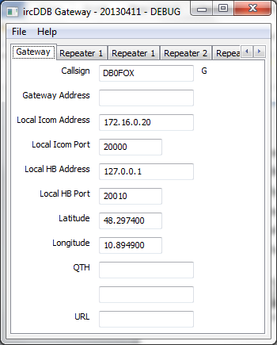

ircDDBGatewayConfig.exe [-confdir directory] [config name]

ircddbgatewayconfig [-confdir directory] [config name]

The configuration of the ircDDB Gateway is handled by an external program, previously it was handled within the gateway itself.

On Windows the gateway configuration program is named ircDDBGatewayConfig.exe and is a GUI based program, as is the Linux version which is named ircddbgatewayconfig.

There is an optional parameter which signifies the configuration to be used, and this must be set on the command line when running as well as configuring the gateway. This name will appear on the title bar. The location of the configuration file, which is used when running under Linux is normally found in the /etc directory. The -confdir option allows the location of the users’ home directory to be set explicitly, the –confdir option is also valid under Windows but performs no function.

If a configuration name is used, then the names of the output files of the gateway are changed to match this name, so that multiple copies of the gateway don’t interfere with each other. Typically the name is inserted after the main name, and the dot.

### The Gateway Tab



This is where the callsign of the gateway is set, by convention this callsign always ends with a G, and this is done for you by the program, you just need to enter the specific part of the callsign. This will typically be the same as used by the repeaters (bar the band letter) which will be attached to the gateway. The Gateway Address is an optional entry and is used to bind the gateway to a particular external IP address of the computer that it is running on, this would typically be used when there is more than one gateway running on the same PC, and each has to use a different IP address to avoid clashing. By default it is blank meaning that it the gateway will use whichever external IP address is appropriate, which is normally what is wanted.

The Local Icom Address/Port and Local HB Address/Port are to configure where the gateway will listen for the different types of repeaters. If your system does not control any Icom repeater hardware then the values for the Local Icom Address/Port may be ignored, and likewise a system that does not have any homebrew systems attached may ignore the settings of the Local HB Address/Port. If your system has both types of hardware, then it is essential that the combination of IP address and port number is different between the different types.

For a homebrew repeater (D-Star Repeater, Dummy Repeater, DV-RPTR Repeater, DVAP Node, GMSK Repeater, and Split Repeater) the values in Local HB Address and Local HB Port must match the values in the Network tabs in that software in the entries for the Gateway Address and Gateway Port. It is not recommended that Local HB Port numbers of 20001-20009, 30001, 30051-30059, 30061-30069, or 40000 are used.

The Latitude and Longitude entries are the latitude and longitude of the repeater system given in decimal degrees, with northern latitudes being positive and southern latitudes negative. Eastern longitudes are positive and western longitudes are negative. This data is reported to both the APRS network (if enabled, see later), to the ircDDB QRG & Maps feature, and to the location shown on the CCS web pages. Setting both of these values to zero disables the reporting of the gateways location to these systems.

The QTH and URL entries are for the ircDDB "QRG & Maps" feature at <http://status.ircddb.net/qam.php>, and can be used to provide further details of the location of the gateway/repeaters. The first QTH field of up to twenty characters in length, and will be included in memory channel lists and appear in the display of transceivers. It should help to uniquely identify the repeater. The second QTH field of up to twenty characters is shown in addition to the first on status pages of the ircDDB web site and allows for more details to be displayed. Special characters, HTML tags, and URLs, are not allowed in these entries.  
  
The URL will be displayed on the status page of the gateway on ircDDB web site. Links to commercial sites are **not** allowed.  
  
The field AGL (Above Ground Level) is used to provide the antenna height above ground level (in metres). This may be used for propagation calculations.  
  
These entries are optional.

### The Repeater Tab

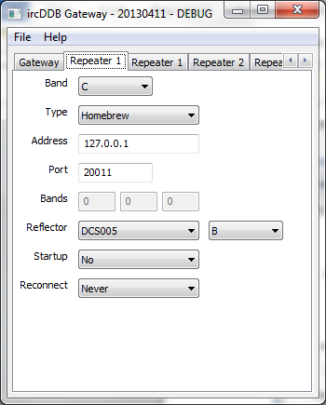 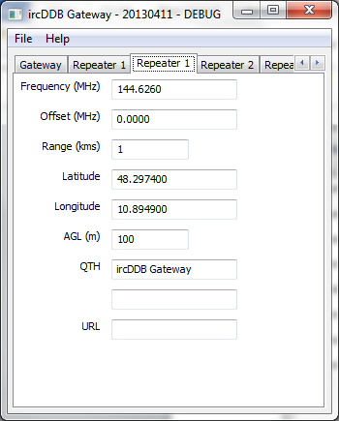

The configuration for a repeater has so many entries that it is split over two panels per repeater. They both appear under the title of Repeater N.

A single copy of the ircDDB Gateway can control up to four repeaters, typically covering up to four frequency bands. For this document, we will concentrate on the settings for only one repeater, setting the other entries is done in exactly the same way.

The first entry is the band, this is in fact the callsign of the repeater which will be based on the callsign set in the Gateway Tab above, but with the G at the end of the callsign replaced with the letter chosen from the list given for the Band. The valid entries are “None”, “A”, “B”, “C”, “D”, “E”, “AD”, “BD”, “CD”, “DD”, and “ED”. These latter four entries are for setting up DD mode repeaters and will not be covered in any more detail in this document; DD mode support is only available with Icom hardware and only when the gateway is running under Linux. The “None” entry is used when there is no repeater installed, for example a gateway controlling a single 2m band repeater would have one repeater set with a Band of “C” and the other three with Band settings of “None”.

Traditionally the bands are:

|  |  |  |
| --- | --- | --- |
| Frequency | Band Letter | DD-Mode |
| 28 MHz (10m), 50 MHz (6m) | E | ED |
| 144 MHz (2m) | C | CD |
| 430 MHz (70cms) | B | BD |
| 1296 MHz (23cms) | A | AD |

Next comes the type, the choice is either “Icom” or “Homebrew”, and describes the repeater hardware and software that is attached. It is possible to mix the different types of repeater attached to a single copy of the ircDDB Gateway. The Address and Port are the IP address and port number of the attached repeater, in the case of a homebrew repeater (D-Star Repeater, Dummy Repeater, DV-RPTR Repeater, DVAP Node, and GMSK Repeater) then these should match the settings of the Local Address and Local Port in the Network Tab of the repeater. For an Icom controller, the setting of the Address and Port will be that of the controller and will be the same for all of the bands that use the Icom hardware. It is not recommended that Port numbers of 20001-20009, 30001, 30051-30059, 30061-30069, or 40000 are used.

The Bands entries, as opposed to Band entry, is used when the hardware type has been set to Icom and is where the values of three bytes in the protocol can be set. The values for these can be found in the log file of the gateway, in a line similar to:

Repeater DB0FOX C registered with bands 0 1 2

In which case the values to be entered would be 0, 1, and 2 for the repeater entry for Band C. This is not needed for homebrew repeaters, and is optional for Icom ones, however if these values are not set or are incorrect for Icom hardware then you will need to transmit to the Icom hardware from the radio side before the gateway can send data out to RF users.

The Reflector, Startup, and Reconnect entries are to do with controlling the reflector/repeater linking behaviour of the repeater port. The Reflector entry is typically a favourite or some form of home reflector for the repeater, maybe one serving your country or state. The list of available reflector/gateways is taken from merging three files, a list of DExtra systems, a list of DCS systems, and a list of D-Plus systems. These files exist so that the system already has a knowledge of some systems before the main link to the ircDDB network is working, which may take a while. In addition the ircDDB network does not have information about DExtra, DCS, or D-Plus reflectors. The channel on the chosen reflector/repeater: “A” to “Z”, is also specified.

The default location of these files is ‘/usr/local/etc’ under Linux and ‘C:\Program Files\ircDDBGateway’ under Windows, and they are named DExtra_Hosts.txt, DCS_Hosts.txt, and DPlus_Hosts.txt. The contents of these files may be overridden by placing files with the same names in your home directory, and the gateway will use these instead. The log file includes information about where the data was read from.

The format of these files are identical, each line consists of two or three entries, or a comment line which begins with a # symbol in the first position, the rest of the line being ignored by the program. A non comment line has the callsign of the reflector or repeater/gateway as the first entry, without any trailing band or module letter, then a tab or some spaces, and then the IP address of that system. There is an optional third item which is again sperated by a tab or spaces from the IP address, which is the letter L which indicates to the gateway that the IP address of this entry is fixed and is not to be overridden by any other source. Normally entries in these files are replaced with information from external sources which may be more up-to-date, but this external information can be ignored by using this flag. Any entry in these files automatically locks the linking protocol to that of the file name, for example DCS for DCS_Hosts.txt, etc.

The Startup entry tells the gateway whether to link to the listed reflector/repeater when the gateway starts. The Reconnect entry may take on the values of “Never”, “Fixed”, “5 minutes”, “10 minutes”, “15 minutes”, “20 minutes”, “25 minutes”, “30 minutes”, “60 minutes”, “90 minutes”, “120 minutes”, and “180 minutes”, and this controls the behaviour of the gateway with respect to the reflector/repeater listed in the Reflector entry. If set to “Fixed” then the software will stay linked to the listed reflector/repeater specified in Reflector and all incoming commands to link and unlink from the repeater will be ignored. If set to one of the times then incoming link and unlink commands will be acted upon (if valid) but after the specified period of local repeater inactivity, the gateway will unlinked from the current reflector/repeater and link to the reflector/repeater specified in the Reflector entry.

A special case is when the Reflector entry is set to “None”, in which case if the Reconnect entry is set to “Fixed” then the repeater can never be linked to a reflector/repeater, likewise if the Reconnect entry is set to one of the time options, it will unlink from the current reflector/repeater after the specified period of local repeater inactivity and remain unlinked, until an incoming link command is received from the local repeater.

If Reconnect is set to “None” then all incoming commands are acted upon (if valid) and the software will not reconnect to the reflector/repeater specified in Reflector automatically.

The Frequency, Offset, Range, and AGL (Above Ground Level) parameters are used to send data to the APRS system (if enabled) and the ircDDB QRG & Maps feature about the local repeater. Note that these entries are in metric units.

The Latitude and Longitude entries here are used in two circumstances. Firstly, if the repeater is not co-located with the gateway or other repeaters then its location can be specified here so that it appears on the APRS map in the correct location. Secondly, when there are a number of co-located repeaters, this entry can be used to specify a slightly different location for the repeater so that it can be seen on the APRS map. The values specified here only override the values set on the Gateway Tab when their value is not zero, and only the entry which is not zero is used, so it is possible to override just the latitude or longitude as needed.

### The ircDDB Tab

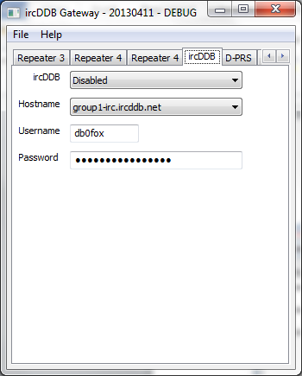

This tab is where the login information to access the ircDDB network is entered. If ircDDB is not being used then the whole ircDDB sub-system may be disabled here. If ircDDB is enabled then the Hostname is chosen from one of group1-irc.ircddb.net for European systems, group2-irc.ircddb.net for systems in North America, the other entries are test systems. The Username is usually the callsign of the gateway in lower case and the Password is allocated by the ircDDB Network administrators when registering for access to the ircDDB network.

To access the test systema, use the gateway callsign as the Username, without the trailing “G”, (as it is on the official ircDDB network) and any or no password.

### The D-PRS Tab

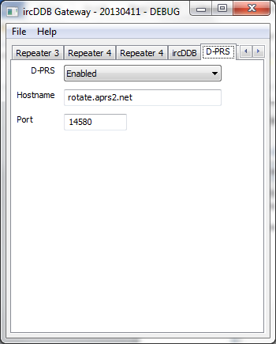

The D-PRS tab is used to control the gating of users position data to the APRS network. Both GPS or GPS-A data in the D-Star transmission are gated, but only of its checksum is valid thus ensuring that corrupt data is not sent to the APRS network.

This gating of data is controlled by setting D-PRS to “Enabled” and setting the Hostname and Port to a valid APRS server. Typically these servers use TCP port 14580 and your local APRS server should be chosen and entered into the Hostname. Leaving the Hostname blank or a zero Port will also disable gating to the APRS system.

A list of all the tier 2 APRS servers is available from <http://www.aprs2.net/serverstats.php>, and it is recommended that a local APRS server is chosen.

### The DExtra Tab

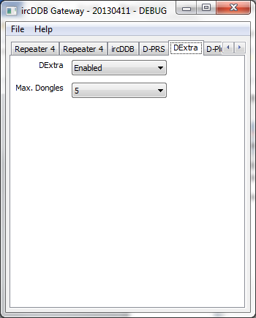

The linking to DExtra reflectors/repeaters is controlled by this tab. By default DExtra is enabled. In addition it is possible to control the number of DExtra DV-Dongle links to the gateway in order to control bandwidth usage. Note that systems using DExtra Client and DExtra Gateway count as DExtra Dongle users. The number of gateways linking to this gateway is not limited, and neither is the number of outgoing DExtra links.

### The D-Plus Tab

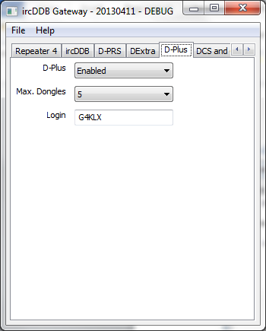

The linking to D-Plus reflectors/repeaters is controlled by this tab. By default D-Plus is enabled. It is possible to control the number of D-Plus DV-Dongle links to the gateway in order to control bandwidth usage. Software such as the official DV-Dongle and DVAP software appear as Dongle users as do DVAR systems. The number of outgoing D-Plus links is not restricted, and these appear as DV-Dongle users to D-Plus reflectors and gateways.

For the purposes of linking to D-Plus reflectors and Icom G2 based gateways the callsign used in the Login setting must be registered as a user on the Icom G2 network. If the callsign of the gateway is not registered on that network, another callsign may be substituted in the Login entry to enable those links.

### The DCS and CCS Tab

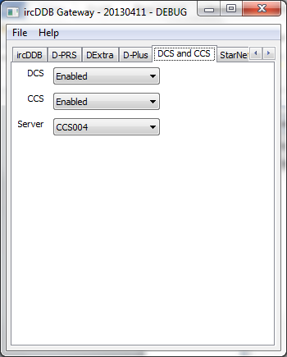

This DCS entry controls the ability of the gateway to link to DCS reflectors. Currently the gateway only uses the DCS protocol to link to DCS reflectors, and it does include the ability to handle incoming DCS links, and this tab disables both of these functions.

The CCS entry controls the CCS sub-system and therefore disables incoming and outgoing CCS links, and their associated DTMF commands. The (CCS) Server chooses which of the geographically diverse CCS servers to use, it is recommended that you choose the server closest to you in order to spread the load on the system.

### The StarNet Tab

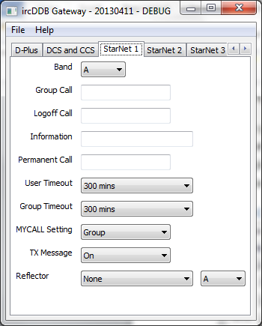 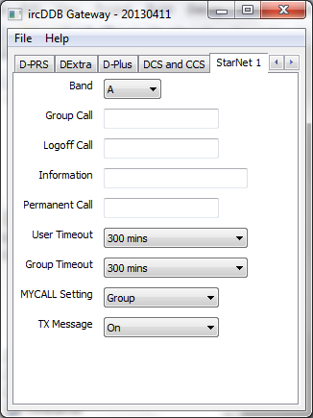

The ircDDB Gateway supports up to five STARnet Digital groups. A full discussion of STARnet Digital groups is beyond the scope of this document, and a knowledge of STARnet Digital is needed in order to make the correct choices in these dialogue boxes.

There are two versions of the dialogue box shown above, the right hand side version is the default version, however if the gateway is compiled with either the DCS_LINK or DEXTRA_LINK symbols defined, then the left hand side version will appear instead.

A STARnet Digital group has a callsign, this is used when calling into the group and for issuing commands to it, and it is this value that is set in the Group Call entry. It is also important to associate a group with a Band on the gateway, even one that isn’t in use by a real repeater. Optionally a Logoff Call can be specified which is used to log off from the group, in addition to the LOGOFF command that can be sent to the Group Call. It is important that the Group Calls and Logoff Calls are all unique, it is not possible to share the same Logoff Call across multiple STARnet Digital groups.

The User Timeout is used to remove someone who is logged into a group who hasn’t transmitted to it for the specified period of time. The values allowed are “Never”, “30 mins”, “60 mins”, “120 mins”, “180 mins”, “240 mins”, and “300 mins”, with “Never” indicating that the User Timeout is not in use. Likewise the Group Timeout is used to log off all of the users from a group after a period of inactivity in the group from any of them, the values allowed are “Never”, “30 mins”, “60 mins”, “120 mins”, “180 mins”, “240 mins”, and “300 mins”, with “Never” indicating that the Group Timeout is not in use.

When relaying audio through a STARnet Digital group, the MY callsign which is used by the group can be either the Group callsign or the original User callsign. In some countries there are issues with licensing and callsign usage, so the choice of this value may be dictated by external factors. If the Group callsign option is chosen in the MYCALL Setting then the group callsign is entered into the MY1 position and “SNET” in the MY2 position. If the User callsign option is chosen in the MYCALL setting then the original user MY1 callsign is set in the MY1 position, and a shortened version of the group callsign in the MY2 position. This shortened group callsign used is one of the following, depending on the group callsign:

|  |  |
| --- | --- |
| StarNet Group Callsign | Shortened Group Callsign |
| STN999_A | 999A |
| STN999__ | S999 |
| None of the above | SNET |

The TX Message may be on or off, if on then the gateway will insert some text data into the outgoing data stream and the contents of this message depend on the MYCALL Setting above:

|  |  |
| --- | --- |
| MYCALL Setting | Text Data |
| Group | “FROM mycallsign” |
| User | “VIA STARnet groupcallsign” |

Therefore with the TX Message set to on, the complete data about who the user is, and which group is relaying the audio is always available regardless of the MYCALL Setting.

If DEXTRA_LINK was defined at compile time, then the DExtra Link is enabled within the STARnet Digital group. This allows the group to be permanently linked to a DExtra reflector as a means of moving away from reflector usage and onto an infrastructure based on StarNET Digital groups instead. The same applies for DCS reflectors if DCS_LINK was defined at compile time.

### The Remote Tab

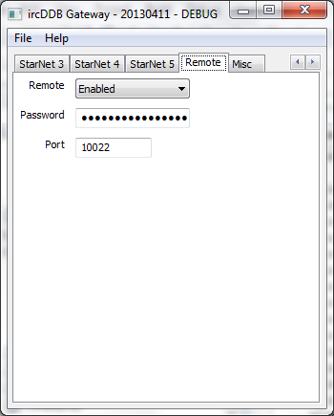

The gateway may be controlled externally by the Remote Control application. This allows for the linking and unlinking of reflectors from repeaters and the changing of the Reconnect settings also. For STARnet Digital groups it is possible to remove users from the group.

To enable remote control, the Remote must be set to enabled and a suitable Password and Port number need to be specified. By not having a default port number, a certain measure of security is added in addition to the strong authentication provided by the use of an SHA-256 hashing function and a random number. More details of the Remote Control application can be found below.

If the program accessing the remote control port is running on the same machine as the gateway, then it may use the remote control port without having to go through the authentication stage first.

### The Misc Tab

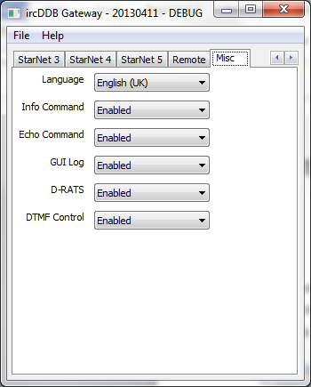

The Misc Tab contains a lot of settings that don’t belong in any other tabs, and is therefore a real combination of unrelated settings.

The Language setting controls both the text data and the spoken voice produced by the info command. The languages supported are English (UK and US), German, Danish, French, Italian, Polish, Spanish, Swedish, Dutch (Belgium and Holland), Norwegian, and Portuguese. Currently there is currently no voice file for either Dutch option, only the text data. The voice files are located in ‘/usr/local/etc’ under Linux and ‘C:\Program Files\ircDDBGateway’ under Windows, and they are named according language and country code. The contents of these files may be overridden by placing files with the same names in your home directory, and the gateway will use these instead.

The Info and Echo commands are the ones issues by users of the repeaters by using the “_______I” and “_______E” commands respectively. Normally these are enabled, however they may be disabled if so desired. Setting the Info Command to Disabled also stops the gateway from generating the voice messages in response to external events not just to commands issued by users.

The GUI Log is normally disabled, but when enabled it makes the gateway write some extra log files to the users’ home directory. These files are used by external programs to display information about the running of the gateway, for example on web pages. The format of these files is regular which makes parsing them relatively easy from languages such as PHP and ASP, as well as PERL and AWK.

The extra log files that are generated are:

|  |  |
| --- | --- |
| File Name | Contents |
| Links.log | The current incoming and outgoing DExtra, DCS, and D-Plus links, file written every two minutes. |
| STARnet.log | Write an entry for every user joining and leaving a STARnet Digital group. |
| Headers.log | Write an entry for every header received by the gateway, the source of the header is also indicated and can be any of “DExtra”, “DCS”, “DPlus”, “G2”, “Repeater”, and “StarNet”. |
| DDMode.log | Information about DD mode users. |

D-RATS is an external program that allows the slow data portion of a D-Star DV stream to be used for chatting and e-mail among other uses. There is support for this within the gateway, and by setting D-RATS to enabled, starts the D-RATS servers within the gateway. These servers listen on TCP ports for connections from the D-RATS program, in order to simplify configuration, the port number of the TCP socket for D-RATS is the same value as used for the repeater UDP port.

Finally the use of DTMF commands and the replacement of the DTMF tones with silence is controlled by the final setting. The default is to have the DTMF commands and the silence substitution enabled.

# Remote Control Application

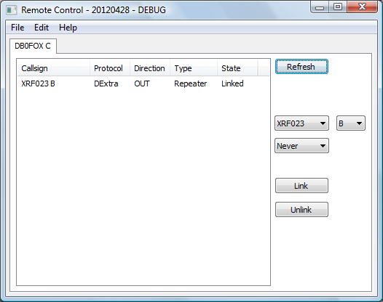

RemoteControl.exe [config name]

remotecontrol [config name]

The Remote Control application is used to control either an ircDDB Gateway or a STARnet Digital Server. It is a purely GUI program and so there is no daemon or command line version available, being named RemoteControl.exe on Windows and remotecontrol on Linux. There is an optional config name which is used to allow for more than one configuration for the application to be stored, so that more than one gateway or server may be controlled from one computer. The choice of the config name is in the hands of the sysop, but something meaningful and which doesn’t contain spaces is recommended. If a config name is given, it will appear in the title of the GUI window. If only one system is to be administered, then the config name can be left out.

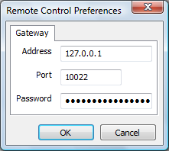

There is only one configuration panel, and that controls access to the gateway/server. In it the Address, Port, and Password are specified, and these must match the settings on the gateway/server. These settings are stored so once set correctly, need not be re-entered unless a change to the parameters is made at the far end.

In operation the application gets all the information it needs from the gateway/server and displays the appropriate panels in the GUI. There is one panel for each Repeater and STARnet Digital group running at the far end, and the callsign of each is displayed in the tab to ease selection of the correct one.

On a repeater panel, all of the DExtra, DCS, and D-Plus links are displayed, along with their direction and the type, and their status. There is a Refresh button which updates the display as needed, as well as settings for a reflector/repeater and the reconnect parameter. A full discussion of these settings can be found in the Repeater Tab documentation above, and these settings can be overridden from this application.

It is worth noting that in order to unlink the repeater you can either set the reflector/repeater to “None” and then press the “Link” button, or use the “Unlink” button.

The list of reflectors and repeaters used by the application are held in exactly the same locations as used by the gateway, and the same system of overriding the contents of these files also applies here.

On a STARnet Digital group panel the users on the particular STARnet Digital group are listed along with the value of their user timeout if active. To the right of the user list, is a Refresh button, information about the logoff callsign, group timer, and a button to Logoff All of the groups users. The purpose of this latter button is obvious. It is also possible to log off individual users of the group by left clicking on the user in the list to highlight them, and then right clicking the mouse to get the user popup menu. From this menu you can choose the Logoff option, which will log that user off the group.

# The StarNET Digital Server

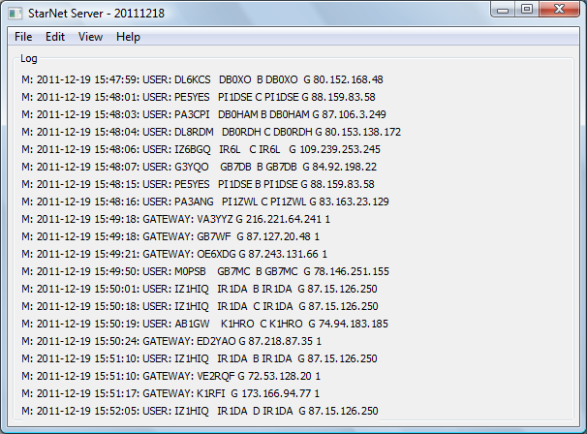

StarNetServer.exe [-nolog] [-gui] [-logdir directory] [-confdir directory]

starnetserver [-nolog] [-gui] [-logdir directory] [-confdir directory]

starnetserverd [-daemon] [-nolog] [-logdir directory] [-confdir directory]

The ircDDB Gateway includes five STARnet Digital groups, however if a dedicated STARnet Digital server is required, which includes no support for repeater hardware or software, and allows up to fifteen groups, then this is the program to use.

On Windows the gateway program is named StarNetServer.exe and is a GUI based program, as is the Linux version which is named starnetserver. Also on Linux is a program named starnetserverd which is a command line version of the repeater.

The -daemon command line switch is used on the command line version to put the program into the background, and to disassociate it from the controlling terminal. The program will return immediately, but using the ps command will show that it is running in the background.

The location of the configuration file, which is used when running under Linux is normally found in the /etc directory. The -confdir option allows the location of the configuration file’s directory to be set explicitly. This option is also available under Windows but is not used.

A log of actions and errors is to be found in the file StarNetServer-YYYY-MM-DD.log where YYYY-MM-DD is the current date. This file is normally found in the /var/log directory under Linux and the users’ home directory under Windows, but this location may be overridden by the -logdir command line option. The log may be disabled by giving the -nolog option on the command line. Logging is still performed, but it goes to stderr and therefore may easily be ignored, or redirected to another target. A copy of the last twenty lines of the log is displayed in the GUI screen.

It is likely that the gateway will be running behind a firewall or router, and if this is the case you need to ensure that the correct ports are passed through the firewall/router otherwise the operation of the software will be impaired. Many of the outgoing connections, for example to ircDDB, are TCP and originate at the gateway end, these will typically pass through any such firewall/router without needing to make changes to its configuration, for other services, listed below, some configuration of the firewall/router will be needed.

These ports are:

|  |  |  |
| --- | --- | --- |
| Name | Type and Port Number | Description |
| DExtra | UDP, 30001 | DExtra gateway and reflector linking, only used if DEXTRA_LINK is enabled. |
| DCS | UDP, 30051 | DCS gateway and reflector linking, only used if DCS_LINK is enabled. |
| G2 Routing | UDP, 40000 | For callsign and repeater routing |
| Remote Control | UDP, ?????? | For the remote control protocol |

The DCS and DExtra ports ate only used if DCS_LINK or DEXTRA_LINK are used within a group, otherwise it is not used. The Remote Control protocol is disabled by default and does not have a default port number. If the Remote Control protocol is used then the appropriate port number will have to be opened on the firewall/router.

The program is configured by choosing the Preferences option under the Edit menu entry at the top of the screen.

### The Callsign Tab

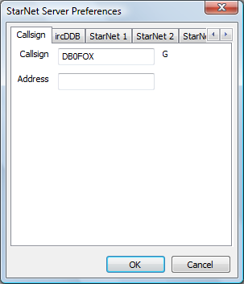

This is where the callsign of the STARnet Digital server is set, in many ways the server operates as a gateway in terms of the D-Star protocols, so therefore a gateway callsign has to be specified. Like the gateway, the G at the end of the callsign is automatically appended, so only the main part of the callsign needs to be specified.

The Address is an optional parameter and allows the server to be bound to a particular IP address, which is useful when running both the STARnet Server with DEXTRA_LINK and the XReflector run on the same machine. In this case the machine needs to have two IP addresses, and the STARnet Server needs to bind to one of the addresses and the XReflector to the other.

### The ircDDB Tab

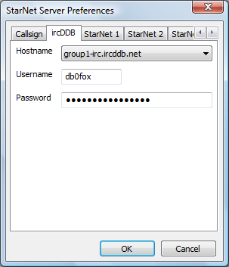

This tab is where the login information to access the ircDDB network is entered. The Hostname is chosen from one of group1-irc.ircddb.net for European systems, group2-irc.ircddb.net for systems in North America, or server1-ik2xyp.ods.org which is a test ircDDB system run by ircDDB-Italia. The Username is usually the callsign of the gateway in lower case and the Password is allocated by the ircDDB Network administrators when registering for access to the ircDDB network.

To access the ircDDB-Italia test system, use the gateway callsign as the Username, without the trailing “G”, (as it is on the official ircDDB network) and any or no password.

### The StarNet Tab

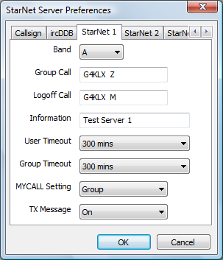 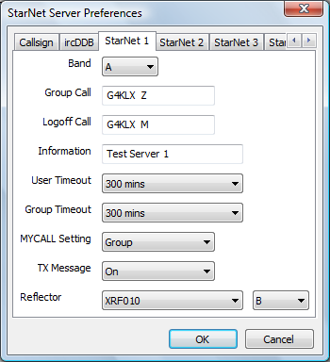

The STARnet Server supports up to fifteen STARnet Digital groups. A full discussion of STARnet Digital groups is beyond the scope of this document, and a knowledge of STARnet Digital is needed in order to make the correct choices in these dialogue boxes.

There are two versions of the dialogue box shown above, the left hand side version is the default version, however if the gateway is compiled with the DEXTRA_LINK symbol defined, then the right hand side version will appear instead.

A STARnet Digital group has a callsign, this is used when calling into the group and for issuing commands to it, and it is this value that is set in the Group Call entry. It is also important to associate a group with a Band on the gateway, even one that isn’t in use by a real repeater. Optionally a Logoff Call can be specified which is used to log off from the group, in addition to the LOGOFF command that can be sent to the Group Call. It is important that the Group Calls and Logoff Calls are all unique, it is not possible to share the same Logoff Call across multiple STARnet Digital groups.

The User Timeout is used to remove someone who is logged into a group who hasn’t transmitted to it for the specified period of time. The values allowed are “Never”, “30 mins”, “60 mins”, “120 mins”, “180 mins”, “240 mins”, and “300 mins”, with “Never” indicating that the User Timeout is not in use. Likewise the Group Timeout is used to log off all of the users from a group after a period of inactivity in the group from any of them, the values allowed are “Never”, “30 mins”, “60 mins”, “120 mins”, “180 mins”, “240 mins”, and “300 mins”, with “Never” indicating that the Group Timeout is not in use.

When relaying audio through a STARnet Digital group, the MY callsign which is used by the group can be either the Group callsign or the original User callsign. In some countries there are issues with licensing and callsign usage, so the choice of this value may be dictated by external factors. If the Group callsign option is chosen in the MYCALL Setting then the group callsign is entered into the MY1 position and “SNET” in the MY2 position. If the User callsign option is chosen in the MYCALL setting then the original user MY1 callsign is set in the MY1 position, and a shortened version of the group callsign in the MY2 position. This shortened group callsign used is one of the following, depending on the group callsign:

|  |  |
| --- | --- |
| StarNet Group Callsign | Shortened Group Callsign |
| STN999_A | 999A |
| STN999__ | S999 |
| None of the above | SNET |

The TX Message may be on or off, if on then the gateway will insert some text data into the outgoing data stream and the contents of this message depend on the MYCALL Setting above:

|  |  |
| --- | --- |
| MYCALL Setting | Text Data |
| Group | “FROM mycallsign” |
| User | “VIA STARnet groupcallsign” |

Therefore with the TX Message set to on, the complete data about who the user is, and which group is relaying the audio is always available regardless of the MYCALL Setting.

If DEXTRA_LINK was defined at compile time, then the DExtra Link is enabled within the STARnet Digital group. This allows the group to be permanently linked to a DExtra reflector as a means of moving away from reflector usage and onto an infrastructure based on STARnet Digital groups instead.

### The Remote Tab

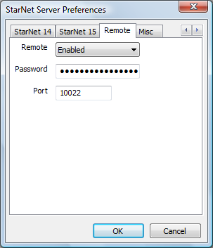

The server may be controlled externally by the Remote Control application. This allows for the remote logging off of all or some of the users from the group.

To enable remote control, the Remote must be set to enabled and a suitable Password and Port number need to be specified. By not having a default port number, a certain measure of security is added in addition to the strong authentication provided by the use of an SHA-256 hashing function and a random number. More details of the Remote Control application can be found above.

If the program accessing the remote control port is running on the same machine as the server, then it may use the remote control port without having to go through the authentication stage first.

### The Misc Tab

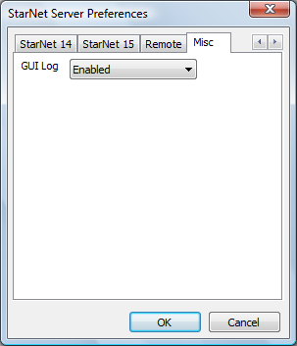

The GUI Log is normally disabled, but when enabled it makes the gateway write some extra log files to the users’ home directory. These files are used by external programs to display information about the running of the gateway, for example on web pages. The format of these files is regular which makes parsing them relatively easy from languages such as PHP and ASP, as well as PERL and AWK.

The extra log files that are generated are:

|  |  |
| --- | --- |
| File Name | Contents |
| STARnet.log | Write an entry for every user joining and leaving a STARnet group. |
| Headers.log | Write an entry for every header received by the gateway, the source of the header is also indicated and can be one of “DExtra” and “StarNet”. |

# Timer Control Application

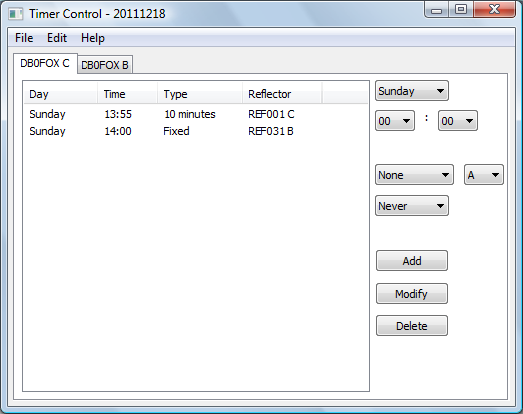

TimerControl.exe [-nolog] [-logdir directory] [config name]

timercontrol [-nolog] [-logdir directory] [config name]

timercontrold [-daemon] [-nolog] [-logdir directory] [-confdir directory] [config name]

The Timer Control application and daemon are used to control the reflector links of the ircDDB Gateway. It allows a time schedule to be entered, so that access to the various reflectors can depend on the day and time.

The GUI version of the program is named TimerControl.exe on Windows and timercontrol on Linux. On Linux is a program named timercontrold which is a command line version of the repeater.

The -daemon command line switch is used on the command line version to put the program into the background, and to disassociate it from the controlling terminal. The program will return immediately, but using the ps command will show that it is running in the background.

A log of actions and errors is to be found in the file TimerControl-YYYY-MM-DD.log where YYYY-MM-DD is the current date. This file is normally found in the users’ home directory, but this location may be overridden by the -logdir command line option. The log may be disabled by giving the -nolog option on the command line. Logging is still performed, but it goes to stderr and therefore may easily be ignored, or redirected to another target.

There is an optional config name which is used to allow for more than one configuration for the application to be stored, so that more than one gateway or server may be controlled from one computer. The choice of the config name is in the hands of the sysop, but something meaningful and which doesn’t contain spaces is recommended. If a config name is given, it will appear in the title of the GUI window. If only one system is to be administered, then the config name can be left out.

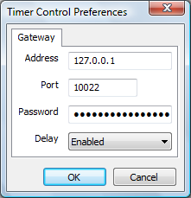

There is only one configuration panel, and that controls access to the gateway. In it the Address, Port, and Password are specified, and these must match the settings on the gateway. These settings are stored so once set correctly, need not be re-entered unless a change to the parameters is made at the far end.

The Delay allows a one minute delay to be included in the Timer Control when it starts. This is to allow the Timer Control to be started at the same time as the ircDDB Gateway, but gives the gateway enough time to start before it the program communicates with it. Without the delay enabled, the commands start almost immediately after the program is started.

In operation the application gets all the repeater callsign information it needs from the gateway and displays the appropriate panels in the GUI. There is one panel for each Repeater and the callsign of each is displayed in the tab to ease selection of the correct one.

On each repeater panel is a list of the time schedule for that repeater in day and time order, and on the right hand side are controls to add, modify, or delete schedule entries. The meanings of the reflector and reconnect settings are the same as for the gateway and will not be detailed again here. Adding or modifying an entry will cause any existing entries with the same day and time to be automatically deleted.

The schedule works by changing the settings of the reflector link of the repeater on the day and time scheduled. This setting of the reflector and reconnect will stay in force until changed by the next schedule change, unless overridden by the Remote Control application, a user command (if allowed), or by a timer expiry.

The program only accesses the gateway when it requires information or sends new link information, and in between times it is possible to use the Remote Control application without interference from the Timer Control application. If the Time Control application is not running at one of the reflector change day and time then the reflector change will not be sent to the gateway.

The list of reflectors and repeaters used by the application are held in exactly the same locations as used by the gateway, and the same system of overriding the contents of these files also applies here.

# The Time Server

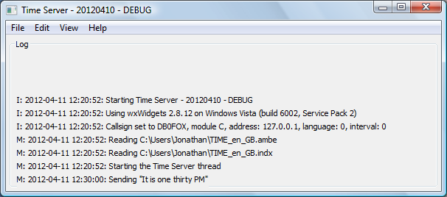

TimeServer.exe exe [-nolog] [-gui] [-logdir directory] [-confdir directory] [config name]

timeserver [-nolog] [-gui] [-logdir directory] [-confdir directory] [config name]

timeserverd [-daemon] [-nolog] [-logdir directory] [-confdir directory] [config name]

The Time Server is used with the ircDDB Gateway to add time announcements to the system.

On Windows the program is named TimeServer.exe and is a GUI based program, as is the Linux version which is named timeserver. Also on Linux is a program named timeserverd which is a command line version of the repeater.

The -daemon command line switch is used on the command line version to put the program into the background, and to disassociate it from the controlling terminal. The program will return immediately, but using the ps command will show that it is running in the background.

The location of the configuration file, which is used when running under Linux is normally found in the /etc directory. The -confdir option allows the location of the configuration file’s directory to be set explicitly. This option is available under Windows but is not used.

A log of actions and errors is to be found in the file TimeServer-YYYY-MM-DD.log where YYYY-MM-DD is the current date. This file is normally found in the users’ home directory under Windows and /var/log under Linux, but this location may be overridden by the -logdir command line option. The log may be disabled by giving the -nolog option on the command line. Logging is still performed, but it goes to stderr and therefore may easily be ignored, or redirected to another target. A copy of the last ten lines of the log is displayed in the GUI screen.

The configuration is simple, and is accessed from the Edit menu option on the main screen.

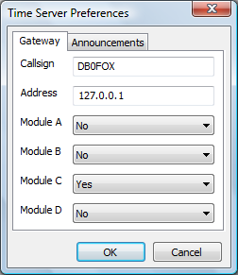

The Callsign is self explanatory, and should match the callsign of the gateway without the trailing ‘G’. The Address is the IP address of the gateway, which will be 127.0.0.1 if the Time Server is running on the same machine as the gateway. The Module A to Module D options tells the software which of the attached repeaters to send the time announcements to.

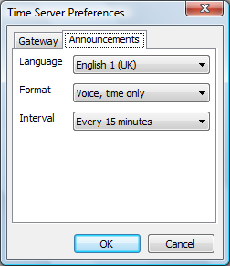

The language allows for setting not only the language of the announcements, but in some cases, a choice of announcement style. For English (US and UK) there are two styles, one slightly more formal than the other, there are also two choices for the German announcements.

The Format has three options, “Voice, time only” transmits the time as both a voice announcement with associated text data containing the time, “Voice, callsign + time” is similar to the first format but with the callsign of the repeater transmitted in voice before the time. “Text, time only” transmits silence with the time included in the associated text data.

The Interval is used to control the frequency at which the announcements are made, the default of “Every 15 minutes” means that time announcements are made on the hour, at fifteen minutes past the hour, thirty minutes past the hour, and forty-five minutes past the hour. “Every 30 minutes” means that the announcements are sent on the hour and half past the hour only, and “Every hour” means that announcements are only made on the hour.

Note that the time announcements are started when the correct minute arrives, but due to delays in the system, may not be transmitted until a second or more after that time. Therefore setting your clock using the time announcements will only be accurate to within a few seconds.

# Questions?

The Yahoo! group ircDDBGateway has hundreds of subscribers who use this software, and asking a question their will often provide an answer for anything that is not covered in this document. The group also has a search function so that you can search for someone else asking the same question earlier. If you run the ircDDB Gateway software then it is recommended that you join the group, it can be found at <http://groups.yahoo.com/group/ircDDBGateway>.

# Revision History

|  |  |  |
| --- | --- | --- |
| Date | Description | Author |
| 2012-02-07 | Updated the QRG & Maps entry. Updated the locations of the files under Linux. Added new drop-down list for selecting the ircDDB server. | Jonathan Naylor, G4KLX |
| 2012-03-10 | Added DCS details. | Jonathan Naylor, G4KLX |
| 2012-04-03 | More cleanups. | Jonathan Naylor, G4KLX |
| 2012-04-11 | Added the Time Server. | Jonathan Naylor, G4KLX |
| 2012-04-16 | Added extra information about the host files. Simplified the audio routing information. | Jonathan Naylor, G4KLX |
| 2012-04-23 | Add details of the new Bands entries, added the new configuration name, add the new address entry. Updated the entries for the Time Server and Timer Control. | Jonathan Naylor, G4KLX |
| 2012-04-28 | Updated the Remote Control GUI and document file name changes for config names. | Jonathan Naylor, G4KLX |
| 2013-04-17 | Removed XReflector, added ircDDB Gateway Config and included details of CCS. | Jonathan Naylor, G4KLX |
|  |  |  |

# Document Licence

This document is released under the Creative Commons Public Licence.



### You are free:

* **to Share** — to copy, distribute and transmit the work
* **to Remix** — to adapt the work

### Under the following conditions:

* **Attribution** — You must attribute the work in the manner specified by the author or licensor (but not in any way that suggests that they endorse you or your use of the work).
* **Non Commercial** — You may not use this work for commercial purposes.
* **Share Alike** — If you alter, transform, or build upon this work, you may distribute the resulting work only under the same or similar license to this one.

You can find further information at:

<http://creativecommons.org/licenses/by-nc-sa/3.0/>

<http://creativecommons.org/licenses/by-nc-sa/3.0/legalcode>