ircDDB-Gateway

**Online installation using YUM**

Please note that ircDDBGateway requires a DStar-repeater. This might either be a software repeater built from modules of the G4KLX PCRepeaterController package, or a typical Icom Repeater with a controller ID-RP2C and one or more Icom repeater modules. A combination of hard- and software repeater is also supported.

ircDDBGateway is available for Windows and Linux systems from the files section of the Yahoo Group “ircDDBGateway”  
<http://groups.yahoo.com/group/ircDDBGateway>

Source code is available from the SVN BerliOS (www.berlios.de , project “opendv”)

The Windows version is provided as a self installing executable, the Linux version is available in form

of source code for self compilation and installation, CentOS and Debian packages.

A comfortable way to install the ircDDBGateway software on Linux systems is to use package

managers like YUM and APT for full automated online installation.  
You do not need any development tools, no additional libraries have to be searched and installed manually, no compilation of source code, no experience with development work, neither resources on your gateway system, nor a special development system.   
  
An ircDDBGateway package is available for CentOS5 and several PC and ARM-based Debian versions.   
CentOS5 is the standard Linux distribution for DStar gateways, running on more than 70% of all gateways worldwide. This YUM package may be used to easily upgrade IcomG2 installations.  
Do not uninstall an existing IcomG2 installation, the install script will use its’ preferences and allows to keep the registration database active if required.

CentOS5 is available for download and on CDs/DVDs.  
Please check <http://www.centos.org> to find more details and mirrors for downloads.  
  
Note that we composed and tested the package with CentOS**5**, but already have got feedback that the installation also works with CentOS6 .  
Please find information on additional requirements for CentOS6 below.

**Step 1: Adding the ircDDB repository server**

At first you have to run the following command on your gateway system once:  
  
curl <http://download.prgm.org/dl5di-soft/opendv/repositories/centos5> -o /etc/yum.repos.d/opendv.repo  
  
If your gateway/repeater has access to the closed Amateur Radio amprnet, you may use this command to install a amprnet repository server:

curl <http://44.225.73.2/pub/dl5di-soft/repositories/centos5/> -o /etc/yum.repos.d/opendv.repo

Please note that this amprnet server won’t work over the internet!

Take care that you copy and execute the complete line on your system!

These commands copy a configuration file with information about the ircDDB update servers to your yum repos directory.  
You will not need to execute this command again later for any update.  
  
*(You might skip this step if you are upgrading an IcomG2 gateway with the ircDDB-add-on installed from a yum package. In that case you have already added the ircDDB repository.)*

**For CentOS6 only:**John K7VE reported that he was able to get the installation also run on CentOS**6.2** after adding another rpm source using this command:

rpm -Uvh http://download.fedoraproject.org/pub/epel/6/i386/epel-release-6-5.noarch.rpm

**Step2: Clean your expire-cache**

yum clean expire-cache  
  
 **Step3: Add Repo server***(This step might not be necessary on all systems. In case that you get an error message saying that the package is already installed continue with step 4)*

yum install rpmforge-release  
  
After this command was executed successful you need to clear the cache again to make sure that the new repo is used.  
  
 yum clean expire-cache

**Step 4: Install the ircDDBGateway package**

Use the following command to install the ircddbgateway package:

yum install ircddbgateway

Say “yes” to install the software.

The package **“ircddbgateway”** is updated regular with all beta versions which are provided in the beta folder of the ircDDBGateway Yahoo Group.

All package versions of ircDDBGateway and the G4KLX repeater share the package “g4klx_sharedfiles”. This package supplies host-lists for reflector networks and other data.   
This package is installed automatically and may be updated separate at any time when list updates may be necessary.

The former package “ircddbgateway-release” is no longer available. There was nearly no request for it. An existing installation of this package cannot be updated with “ircddbgateway”.  
YUM does not allow updating files from one package by another package.  
Please use

yum remove ircddbgateway-release

followed by

yum install ircddbgateway

to switch to the actual version of the maintained package.  
The config files in /etc will stay untouched as they are not part of the packages.

**Recommended Sequence of Installation steps:**

If you want to run **ircDDBGateway** together with one or more **G4KLX repeater** modules we recommend the following sequence of steps to get all modules easily configured and work together:

1. Install the G4KLX-Repeater package – but do not configure it!
2. Install the ircDDBGateway package.
3. Configure ircDDBGateway by using ircddbgw_conf  
   (including autostart features)  
   ircddbgw_conf automatically involves parts of repeater_conf where needed
4. Start ircDDBGateway (manually or from ircddbgw_conf)
5. Configure the autostart features of the G4KLX repeater modules using repeater_conf for each repeater module.
6. If everything works fine reboot your PC and check if all components come up properly.

**Step 5: Configure ircDDBGateway**

After the first installation you will be asked to start the command line configuration tool ircddbgw_conf. This tool will involve repeater_conf for G4KLX repeater modules automatically and make sure that all port and address parameters fit together.

**Configuration in text mode:**

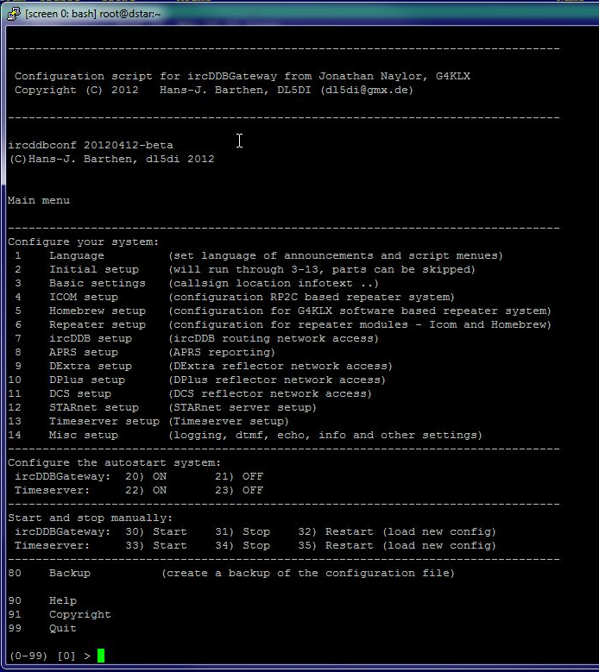

The language can be set with selection 1 of the tool. This is the language for the voice-announcements of the gateway as well as for the language of the menus of the configuration tool.  
However, most translations for the menus do not yet exist, so it defaults to English.

After that the initial setup can be started using selection “2”. This option will lead you through all preferences menus.  
The script will try to offer the best values for selection by searching other existing configurations. This is very useful when upgrading from IcomG2 software with or without ircDDB-addon.  
The script will offer to leave the registration service of IcomG2 running and only stop the gateway part. This would be useful to give registered users time to move their registration to another gateway.

Do not uninstall any IcomG2 parts before the installation of ircDDBGateway!

Settings can be corrected and changed at any time, input is stored immediate after you close the line and will be offered for default selection during next run.

**Configuration in GUI mode:**

You might configure ircDDBGateway and TimeServer in GUI mode using an X session on the gateway PC or from remote. An easy way from remote is using VNC.  
 *(You can install a VNC server with “yum install vnc-server”. After that you can access the gateway system in GUI mode from remote using a free VNC client like UltraVNC for your favorite OS).*

Open a terminal window and start “ircddbgatewayconfig”.  
If you use special locale settings in GUI mode you should start the software with the script /usr/local/bin/ircddbgatewayconfig.sh  
 **⇒ Configure ircDDBGateway and TimeServer like described in the configuration manual.  
You may find the documentation in different languages in the folder “Documentation” of the FILES section at the Yahoo Group “ircDDBGateway”.**  
<http://groups.yahoo.com/group/ircDDBGateway/files/Documentation/>

If the configuration has been finished and the system runs properly use EXIT in the File menu to stop and leave the software.

**Step 5: Start ircDDBGateway in daemon mode**

You may start the daemon from the configuration tool ircddbgw_conf with option 30, the timeserver with option 33, or with the commands:

/sbin/service ircddbgateway start  
 /sbin/service timeserver start

The start script may be activated with ircddbgw_conf option 20 and 22, deactivated with option 21 and 23 or using the following commands

activate:

/sbin/chkconfig --add ircddbgateway  
/sbin/chkconfig --add timeserver

deactivate:

/sbin/chkconfig --del ircddbgateway  
/sbin/chkconfig --del timeserver

To be sure that everything works properly you might want to reboot the server and see if everything comes up.

**Step 6: Update ircDDBGateway**

Later updates will be installed as usual by

yum update ircddbgateway

or during a normal YUM system update.   
The update process will automatically stop the gateway, install the update and restart the gateway if the start-scripts are configured for autostart on boot.

It would be wise to check the configuration for possible changes and new options after each update. You can use the text based configuration tool or start ircDDBGateway in GUI mode again. Don’t forget to stop the daemon before!

In case of an issue you may easily step back to the version installed before:

yum downgrade ircddbgateway

Use

yum remove ircddbgateway

to remove the package. The configfiles in /etc need to be removed manual.

Please find more information on the Yum features in the manpage or on the internet.

73

Hans, DL5DI

**APPENDIX 1:**

**Path-structure of your YUM installation**

**ircDDBGateway-package:**

/etc/yum.repos.d/opendv.repo

/etc/sysconfig/ircddbgateway start options of ircddbgateway  
/etc/sysconfig/timeserver start options of timeserver  
/etc/sysconfig/ircddb_conf options of configuration program

/etc/init.d/ircddbgateway startup file of ircddbgateway  
/etc/init.d/timeserver startup file of timeserver

/usr/share/ircddbgw_conf menu and help files of config program

/etc/default/ircddbgw_conf default values for configuration

/etc/ircddbgw_conf.conf settings of configuration program

/usr/local/bin/ircddbgateway ircddbgateway executable  
/usr/local/bin/ircddbgateway.sh start script for GUI mode  
/usr/local/bin/ircddbgatewayconfig ircddbgateway graphical config tool  
/usr/local/bin/ircddbgatewayconfig.sh start script for graphical config tool  
/usr/local/bin/ircddbgw_conf configuration program  
/usr/local/bin/timeserver timeserver executable

/var/www/html dashboard files

**Only if the repeater package is installed:**

/etc/sysconfig/dcsgateway / dextragateway start options of reflector gateways  
/etc/sysconfig/dvapnode start options of dvapnode  
/etc/sysconfig/*repeater (* = gmsk, dvrptr, split …) start options of repeater modules  
/etc/sysconfig/repeater_conf options of configuration program

/etc/init.d/repeater_1 … repeater_4 startup files for repeater modules  
/etc/init.d/dcsgateway /dextragateway startup file for reflector gateways

/usr/share/repeater_conf/ menu and help files of config program

/etc/default/repeater_conf default values for configuration

/etc/*repeater_1 … *repeater_4 (* = gmsk, dvrptr, split …) configuration of repeater modules

/usr/local/bin/dvapnode dvapnode executable  
/usr/local/bin/*repeater (* = gmsk, dvrptr, split …) repeater executables  
/usr/local/bin/repeaterconfig repeater configuration program (GUI)  
/usr/local/bin/repeater_conf repeater configuration program (text)  
/usr/local/bin/dcsgateway /dextragateway reflector gateway executables

and some more

**APPENDIX 2:**

**Start-Process / places where to place manual changes:**

During startup the init-process starts “/etc/init.d/ircddbgateway” with the option “start”.

This startscript is part of the distribution and should not be changed manually!

It loads parameters from the file /etc/sysconfig/ircddbgateway which may be adjusted to meet the local needs.

The content of this file looks like this:

# Defaults for ircddbgateway initscript

# sourced by /etc/init.d/ircddbgateway

# installed at /etc/sysconfig/ircddbgateway by the maintainer scripts

DAEMON_PATH=/usr/local/bin/ircddbgatewayd

DAEMON_OPTIONS="-logdir /var/log -daemon"

IRCDDBGATEWAY_DDENABLED="no"

IRCDDBGATEWAY_DDDHCP="yes"

IRCDDBGATEWAY_DDDEV="tap0"

IRCDDBGATEWAY_DDIP="192.168.0.1"

IRCDDBGATEWAY_DDMASK="255.255.255.0"

* DAEMON_PATH specifies which executable program should be started
* DAEMON_OPTIONS may also include the parameters “-nolog” and “-logdir”.  
  The values can be modified by the configuration program ircddbgw_conf. This makes sure that depending settings of add-on tools will be adjusted too (for example for the dashboard).  
  Please find more details about possible command line parameters in the general ircDDBGateway manual:  
  <http://groups.yahoo.com/group/ircDDBGateway/files/Documentation/>
* The last 5 entries are for DD-Mode settings.   
  Leave this entries unchanged unless you know what you are doing!  
  DD-Mode requires a special D-Star radio.   
  Currently only the Icom RP2D allows to run a DD-mode repeater.  
  Please find more details in the special DD-mode setup manual:

<http://groups.yahoo.com/group/ircDDBGateway/files/DD-mode/>

**APPENDIX 3:**

**Network configuration:**

**3.1 Standard installation – Gateway and Repeater on the same network:**

The necessary port forwarding and NAT entries to your router for incoming traffic depend on the services that you want to use.

Here a list of typically used ports:

|  |  |  |
| --- | --- | --- |
| Name | Type and Port Number | Description |
| Dextra (XRF) | UDP, 30001 | DExtra gateway and reflector linking, also used by DEXTRA_LINK if enabled. |
| DCS | UDP, 30051 | DCS reflector linking |
| D-Plus (REF) | UDP, 20001 | D-Plus gateway and reflector linking |
| G2 Routing | UDP, 40000 | For callsign and repeater routing |
| Remote Control | UDP, ?????? | For the remote control protocol |

**3.2 Special installation – Gateway and Repeater on different networks:**

If you install ircDDBGateway and one or more repeater modules at different locations and different networks or subnets, you may need to forward the configured gateway and repeater ports as well.   
The gateway needs to be able to contact the repeaters and the repeaters need to contact the gateway!

If you stayed with the default settings these ports are usually used:

|  |  |  |
| --- | --- | --- |
| ircDDBGateway | UDP, 20010 | incoming at the gateway /  outgoing at the repeater modules |
| Repeater  (G4KLX-Software) | UDP, 20011  UDP, 20012  UDP, 20013  UDP, 20014 | incoming at the repeater modules / outgoing at the gateway (one port for each repeater module, like configured) |

At the repeater location no other port is needed, all network connections to ircDDB and reflector systems end at the gateway location.