How to Create OpenDX Loadable Modules for Windows with Visual C++.
The OpenDX documentation explains how to build user custom modules to be added into the environment on UNIX platforms; and, VIS, Inc. even has some tools for helping build modules with the GNU Autotools in UNIX. This however does not help those who are trying to build modules directly on Microsoft Windows systems within Visual Studio. Thus, this document gives instructions how to perform this action.
After reading through the OpenDX documentation and getting an understanding how to write code for modules, follow the directions below to set up an example Visual Studio project for the custom dynamic loadable “HelloWorld” module. Once you see how this is done, you should be able to copy the directions for your own custom module.

Getting Started Writing a Module

- Start Microsoft Visual C++ 6.0.
- Select New from the File menu.
- Within the Projects tab, select Win32 dynamic link library.
- Type in the Project Name, for our case this is “HelloWorld”.
- Choose the location where to store this project and click “OK” (see Figure 1).
- In the following dialog box, select “An empty DLL project” and click Finish.
- A new dialog will pop up describing that an empty project now exists, click “OK”.
Each project will need to have some settings added to it so Visual Studio can find all of the appropriate include and library files.
- Select the Project menu option and click “Settings…”
- In the upper left hand corner, click on the Settings For drop down list and select “All Configurations”.
- Click on the C/C++ tab and click on the Category drop down list and select “Preprocessor”.
- Add the OpenDX include directory in the Additional include directories—typically this is “C:\Program Files\OpenDX\include” but it may vary.
- Click on the Link tab and add dxexec.lib to the end of the Object/library modules: list.
- Select the Input option of the Category drop down list on the link tab and add the path to the dxexec.lib in the Additional library path line. Typically the path would be C:\Program Files\OpenDX\lib_intelnt
- Click “OK” to close this dialog box.

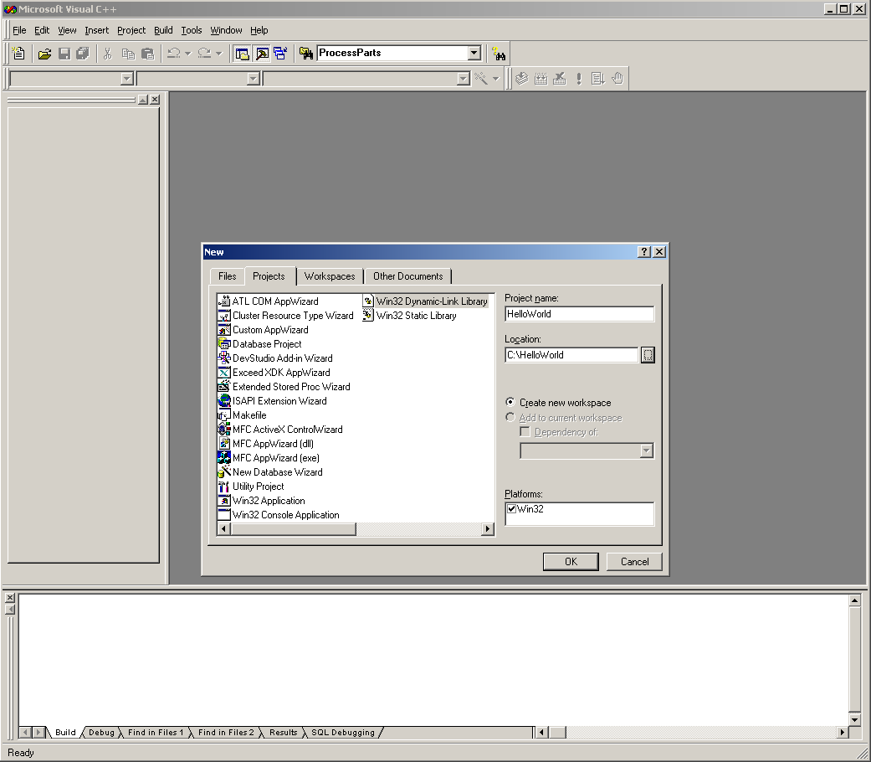
Figure 1.
For this project, two “c” files must be created and one “mdf” file. For more information on what an “mdf” file is and how to write them, refer to the DX programmer’s manual. For now, this document will guide you through the file creation step by step.
- Select New from the File menu and click on the C++ Source file option of the dialog.
- Type in HelloWorld.c as the filename and click “OK” (see Figure 2).

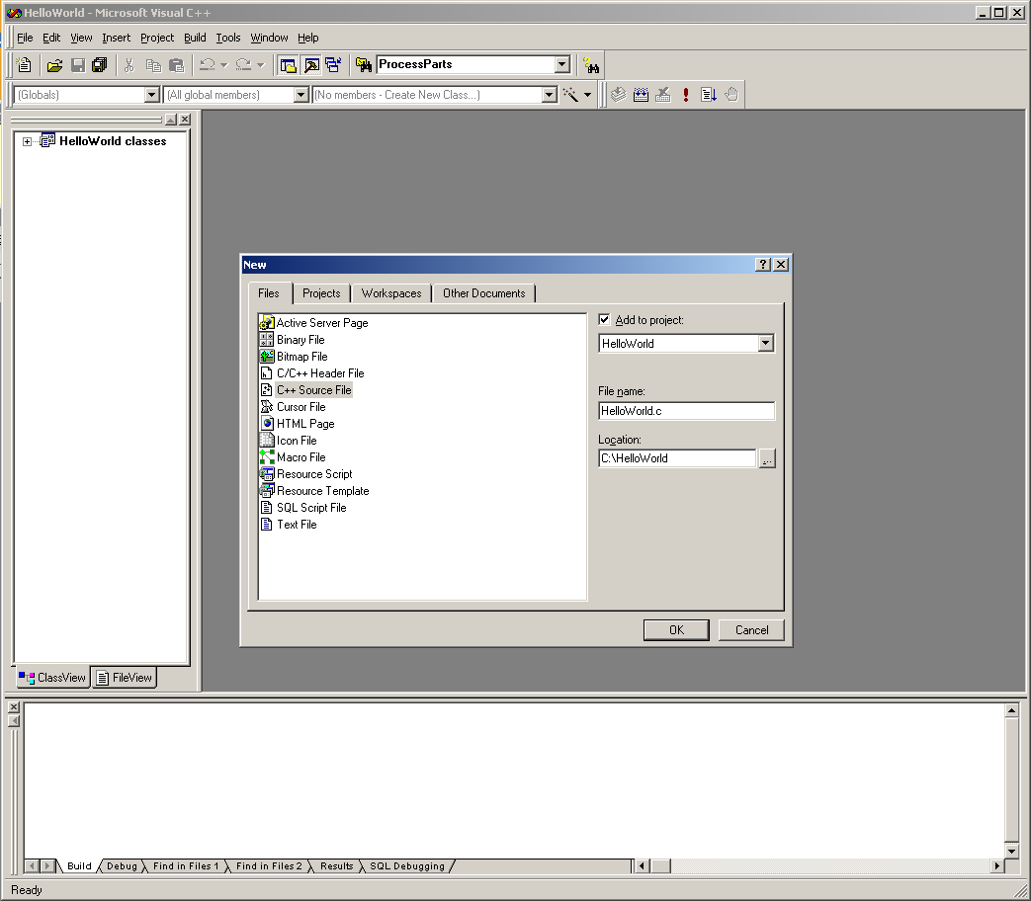
Figure 2.

- Add the code to the HelloWorld.c file. The code is as follows:

#include <dx/dx.h>

Error m_Hello(Object *in, Object *out)
{
char message[30], *greeting;

if (!in[0])
sprintf(message, "hello world");
else {
DXExtractString(in[0], &greeting);
sprintf(message, "%s %s", "hello", greeting);
}

out[0] = (Object) DXNewString(message);
return OK;
}

- Select New from the File menu and click on the Text File option of the dialog.
- Type in HelloWorld.mdf as the filename and click “OK”.
- Add the following code to the HelloWorld.mdf file and save.

MODULE Hello
CATEGORY Greetings
LOADABLE C:\HelloWorld\HelloWorld
DESCRIPTION Prefixes "hello" to the input string
INPUT value; string; "world"; input string
OUTPUT greeting; string; prefixed string

The mdf file must have an accompanying “c” file that describes inputs and outputs to the loadable part of the module. Luckily, there is an awk script that can convert an mdf file into the valid “c” file that will need to be included into the project.
Awk is a small UNIX utility that can be run under Windows. A port of this utility has been created for Windows by Brian Kernighan. Download and install awk95.exe from his web site <http://cm.bell-labs.com/cm/cs/who/bwk/awk95.exe>, put it in a directory where it can be exectued from (such as C:\WINNT), and rename it awk.exe.
- Start a “Command Prompt (DOS shell)” and use “cd” to put you in the directory where your “mdf” file is located. Using the path specified in this example, do a “cd C:\HelloWorld”.
- Now run the awk command with the mdf2c.awk file against the HelloWorld.mdf. For this example, the command, all on one line, would be:

awk -v dynamic=1 -f "C:\Program Files\OpenDX\lib\mdf2c.awk" HelloWorld.mdf > HelloWorld-mdf.c

- The previous command creates a file named “HelloWorld-mdf.c”. Back in the Visual Studio window, click on the FileView tab in the bottom left. Click on the “HelloWorld files” with the right mouse button and select “Add File to Project…”
- Click on the “HelloWorld-mdf.c” file and click “OK” to add it to the project.
In order for the correct symbols to be exported by the Microsoft linker so that OpenDX knows where to start running your function from within the dll, a DEF file must be added to the project.
- Select New from the File menu and click on the Text File option of the dialog.
- Type in HelloWorld.def as the filename and click “OK”.
- Add the following code to the HelloWorld.def file and save.

VERSION 1.0
EXPORTS
DXEntry

- Everything should be ready to go, click “Build HelloWorld.dll” in the Build menu.
If all went according to plan, you should get no warnings and no errors. If you do get errors or warnings, check to make sure that your dx include directory and dxexec.lib files can be found. You may also want to check your HelloWorld-mdf.c file and compare it to the following:
/* Automatically generated - may need to edit! */

#include <dx/dx.h>
#include <dx/modflags.h>

#if defined(intelnt) || defined(WIN32)
#include <windows.h>
#endif

extern Error DXAddModule (char *, ...);

#if defined(intelnt) || defined(WIN32)
void FAR WINAPI DXEntry()
#else
void DXEntry()
#endif
{
{
extern Error m_Hello(Object *, Object *);
DXAddModule("Hello", m_Hello, 0,
1, "value",
1, "greeting");
}
}

The module is now ready for DX to use. Copy HelloWorld.dll and HelloWorld.mdf to a directory where it will be run from, start the DX editor, click Load Module Description from the File menu, locate your mdf file, and click OK. If you get an error with respect to an invalid mdf file, you need to upgrade your version of OpenDX to a version greater than 4.2. If you get an error with regards to “Bad Parameter: cannot open file …”, the mdf file LOADABLE line must be updated to reflect the directory where the dll is located.
Follow the example using the HelloWorld module within the Programmer’s Manual to see if the module works.

