Registration and Discovery Service
Formal Service Specification, Version 1.1 (draft)

TITLE: Registration and Discovery Service Specification Version 1.1. (draft)
DATE: MAY 2002
AUTHOR: MCCONNELL, Stephen
COPYRIGHT: OSM SARL, 2000-2002
REFERENCE: OSM/2002-05-A
Copyright 2000-2002 by OSM SARL

All rights reserved.
OSM hereby grant permission to copy this document for the purpose of evaluating the technology contained herein. Publication of this document does not represent a commitment to implement any portion of this specification.
WHILE THE INFORMATION IN THIS PUBLICATION IS BELIEVED TO BE ACCURATE, OSM MAKES NO WARRANTY OF ANY KIND WITH REGARD TO THIS MATERIAL INCLUDING BUT NOT LIMITED TO THE IMPLIED WARRANTIES OF MERCHANTABILITY AND FITNESS FOR A PARTICULAR PURPOSE.
OSM shall not be liable for errors contained herein or for incidental or consequential damages in connection with the furnishing, performance or use of this material. The information contained in this document is subject to change without notice. This document contains information protected by copyright. All Rights Reserved. Except as otherwise provided herein, no part of this work may be reproduced or used in any form or by any means—graphic, electronic, or mechanical, including photocopying, recording, taping, or information storage and retrieval systems— without the permission of the copyright owner. All copies of this document must include the copyright and other information contained on this page.
RESTRICTED RIGHTS LEGEND. Use, duplication, or disclosure by government is subject to restrictions as set forth in subdivision (c) (1) (ii) of the Rights in Technical Data and Computer Software Clause at DFARS 252.227-7013.

Specification Contact Points
OSM sarl
20 rue Thibaud, Paris 75014, France
voice: + 33 1 4044 4116
Stephen J. McConnell
mailto:mcconnell@osm.net
http://www.osm.net

Trademarks
All trademarks acknowledged.

Content
Part 1 Introduction to the Specification 4
1.1 Problem Statement 4
1.2 Scope of the Specification 4
1.3 Relationship to Specifications 5
1.3.1 Related Web Service Specification 5
1.3.2 OMG Enterprise Specifications 5
Part 2 Registration and Discovery Specification 7
2.1 Introduction to the Object Model 8
2.2 Data Structures 11
2.2.1 Introduction 11
2.2.2 Selection, Selections and Selection Iterator 11
2.2.3 Artifact, Resource Description and Disclosure 12
2.2.4 Supporting types 17
2.2.5 Filter 20
2.3 Registration Interfaces 21
2.3.1 Registry 21
2.4 Discovery Interfaces 25
2.4.1 Directory Interface 25
2.4.2 Active Directories and related Interfaces 27
2.5 Processor and Abstract Processor 30
Part 3 Complete IDL 32

Introduction to the Specification

Problem Statement
Within the electronic commerce business-to-business domain there are business requirements for services supporting the creation and maintenance of repositories capable of supporting the registration and discovery of XML schema based descriptions of physical and logical resources, and the means through which referral and subsequent application of descriptions can be monitored. These requirements represent a common set of needs expressed within both the Electronic Commerce and Telecommunication domains in respect to the delivery of higher level facilities such as brokerage and resource referral applications.

Scope of the Specification
Solutions are sought for the definition of an XML schema suitable for use as a description of an information or computational resource (referred to here as a Resource Description) together with interfaces expressed in IDL supporting the registration and discovery such descriptions.
A Resource Description is an instance of XML document conformant with an XML schema capable of exposing a description of an informational or computation artifact together with commercial, marketing and legal interests of the publisher.
Features exposed by a Resource Description include:
- artifact location by URI
- artifact publisher by URI
- a textual or domain specific schema describing the artifact
- date of publication and validity
- commercial or legal terms and conditions attributed to the artifact
- deployment and/or activation constraints
Examples of information artifacts that could be described using a Resource Description include Web pages or structured industry domain specific XML documents. Examples of computational artifacts that could be described using a Resource Description include proprietary client application packages (possibly packaged as Jar files), or descriptions of access points into web and enterprise based applications.
Given the above, interfaces expressed in IDL are provided to support the registration of Resource Descriptions into a repository, and interfaces enabling the discovery and ranking of Resource Descriptions based on supplied search criteria.
As an example, a logistics service provider may wish to describe the features, benefits, and the conditions of activation of a business capability concerning goods delivery. Such a description would be expressed as an instance of a Resource Description, possibly referencing marketing information under URLs to web pages, and potentially containing supplementary industry specific XML elements. During the process of service registration, the supplier would provide a formal Resource Description possibly detailing service activation constraints and service access points. As a result of the registration of a Resource Description, the provider would receive a receipt of registration.
A client, using an implementation of the discovery interface can register transient or persistent queries. As an example, a client, using a discovery interface, could register a persistent query for Resource Descriptions specialized for the travel industry, for flight availability for a particular day. Over time, the query result would change as availability of flights fluctuated. In contrast, a transient query would be assessed against immediately available Resource Descriptions.
Service providers publishing computation or information artifacts under Resource Descriptions may choose to use a Resource Description as an input argument to a service activation operation. Such applications may require information identifying a chain of registration acts contributing to its discovery. Such a chain of registration acts may be used by higher-level applications dealing with commercial referral (such as commercial trading systems, commercial brokerage applications, and advertising management systems).

Relationship to Specifications

Related Web Service Specification

UDDI
UDDI provides an XML-based method for businesses to describe themselves and the Web-based services they offer. The UDDI Business Registry is the public database where companies register themselves.
UDDI Home
http://www.uddi.org/

WSDL
Web Services Description Language (WSDL) is an XML-based language used to define Web services and describe how to access them. The WSDL standard is maintained by the W3C (World Wide Web Consortium). The W3C defines the standard as "an XML format for describing network services as a set of endpoints operating on messages containing either document-oriented or procedure-oriented information. The operations and messages are described abstractly, and then bound to a concrete network protocol and message format to define an endpoint. Related concrete endpoints are combined into abstract endpoints (services). WSDL is extensible to allow description of endpoints and their messages regardless of what message formats or network protocols are used to communicate."
WSDL Specification
http://www.w3.org/TR/wsdl

OMG Enterprise Specifications

OMG Electronic Commerce Domain Specifications
The OMG Electronic Commerce DTF has established a set of framework specifications covering communities, agencies and collaborative business encounters based on extensions above the OMG Business Object Domain Task and Session Specifications.
Electronic Commerce Domain Specifications, Community and Collaboration Frameworks
First Edition, July 1999
http://www.omg.org/docs/dtc/99-07-03.pdf

OMG Business Object Domain Task and Session Specification
The Business Object Domain Task and Session Specifications establish the relationships between a User, Task, representing user units of work, consumed and produced resources, and application objects supporting task execution, messages and workspaces.
This submission re-uses the notions of identifiable domain consumers for general services dealing with event consumer identification. The specification introduced a directory agent that is based on the semantics of a processor as defined by the Task and Session specifications. As such, the specification ensures a complete and seamless mechanism for the integration of discovery services within frameworks based on the Task and Session business object layer.
Business Object Domain Specifications, Task and Session 2.0,
August 1999
http://www.omg.org/docs/dtc/99-08-03.pdf
CORBA Services Specification, Trading Object Service Specification Chapter
http://www.omg.org/docs/formal/98-12-09.pdf
Notification Service
http://www.omg.org/docs/telecom/98-10-01.pdf

Registration and Discovery Specification
Type | Description
Identifiable | An abstract base type to Artifact and Receipt providing URI based identification of an element.
Artifact | An abstract base type to ResourceDescription and Disclosure
Selection | A type containing an URI referencing an Artifact and a ranking of the artifact relative to a search query.
ResourceDescription | A type describing an Internet based resource.
Disclosure | A type describing an act of disclosure of an Artifact.
URI | A reference to a remotely located resource.
Key | A value type used to attribute a graph of names to a resource description enabling classification of description relative to possibly multiple ontology schemas.
Feature | A value type used to attribute a graph of named features and values to a resource description.
Receipt | A value type used to provide proof to a client of an act dealing with registration, modification, or retraction of an artifact from a Registry.
Filter | A value type used to define a search/selection criteria.
Registry | An interface through which a client can register a resource description or existing disclosure instance.
Directory | An interface through which a client can invoke requests enabling the discovery of artifact descriptions based on supplied filters.
ActiveDirectory | An interface that extends the Directory interface to enable the creation of a DirectoryAgent.
DirectoryAgent | An interface that supports the registration of a client listener and operations through which persistent queries can be registered with the agent.

Introduction to the Object Model
The Registration and Discovery Services defines two principal set of interfaces and a number of value types that facilitate the publication and subsequent discovery of description of internet resources such as web pages, XML documents or web applications. The two interfaces groups address the respective roles of registration and discovery.
The registration interface provides operations supporting the registration of resource description, an object that describes an Internet resource. The resource description contains information about the Internet resource including its URI, a textual description, URI references to legal terms and conditions, its effective date and validity, and terms and conditions concerning the disclosure of the description by a registry operator.
The discovery interfaces provide a basic set of operations enabling simple lookup of a single resource description and operations supporting general queries based on supplied filter arguments that return a set of results in the form of selections. The selection instances returned from a query are lightweight structures containing only a URI and a ranking value. A client presenting information to human user can expand the content of a particular selection by invoking an operation on a directory to resolve the value of a selection to a resource description. This approach allows the effective de-coupling of query resolution form presentation, enabling enhancement of the end-user experience.
The following illustration depicts the cycle between the creation of a resource description and the subsequent generation of a selection set by a discovery service. Firstly, a client acting in the role of a resource or capability provider, uses a proprietary application to constructs an instance of a ResourceDescription. This value is used as an argument to a register operation on the Registry. A client acting in the role of a resource or capability consumer invokes the find operation on a directory using a filter as the search criteria. The result of the operation is a sequence of ranked selections.
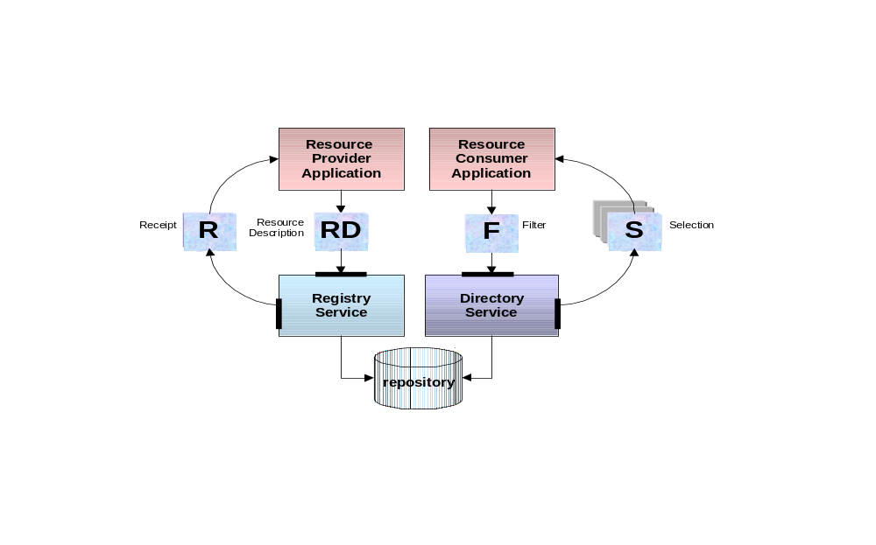
Resource Description registration, receipt creation, search and selection retrieval.
Selection instances contain a URI and a ranking of the resource description referenced by the URI. In-fact, it is more correct to say that the URI references a type called Artifact which is the base type for the two types ResourceDescription and Disclosure. A Disclosure is simply a value type that contains a resource description together with information detailing a verifiable act of registration. The decision to reference a resource description as opposed to a disclosure instance is based on policy of the resource provider, together with the internal policy of the registration and directory services.
Given a selection instance, the client invokes a resolve operation against the directory, enabling the conversation of the selection value to an associated resource description. The following illustration depicts the simple case of a selection directly referencing a resource description. Once the client has the resource description it can present this information as part of a web page or other client application context.
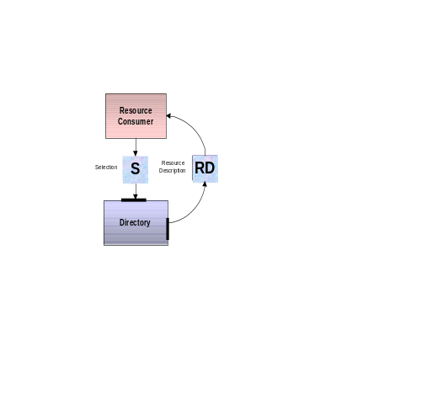
Conversion of a selection instance to a resource description.
The next illustration depicts the exposure of a Disclosure instance. In the case of a Disclosure, the instance contains as part of its structure a instance derived from Artifact – meaning that it can contain anther disclosure, which itself can contain other disclosure, leading eventually to a base resource description. In effect, a disclosure instance is potentially a container of an arbitrarily long chain of registration events. A resource description registered under registry R1 can be discovered under directory D2 as an instance of disclosure, subsequently registered again under another registry (possibly an registry supporting aggregated offers in a particular domain) and finally discovered by another consumer. The resulting disclosure instance maintains an internal record of its passage of registration through R1 and R2. This information is particularly relevant to supplier organizations in terms of tracking of advertising and channels management. Supplier organizations can take advantage of this chain information by structuring server applications to take disclosure instances as input arguments.
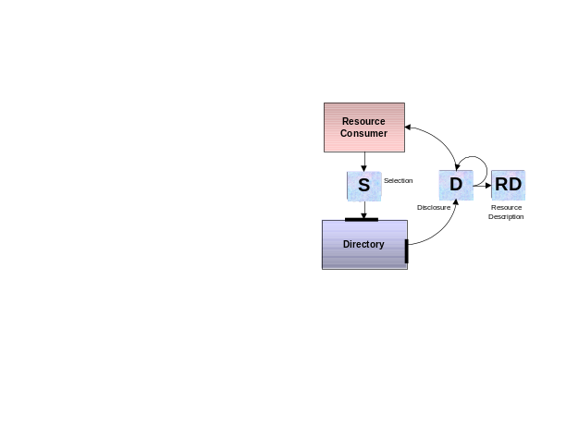

Conversion of a selection instance to a disclosure chain and resource description.
The following illustration depicts a possible business cycle of a resource description used as an argument to a server:
- Creation of the resource description, containing a description of the a supplier capability and URI reference to the server;
- registration of the resource description under a general marketplace registry;
- discovery of the capability under a general market directory in the form of a disclosure instance;
- subsequent referral of the description to vertical domain marketplace;
- discovery of the disclosure under the vertical marketplace;
- application of the resulting disclosure instance as an argument to a server
Server applications (processors) can take advantage of referral information in Disclosure chains as part of sophisticated applications supporting referral reward schemes and market site value assessment.
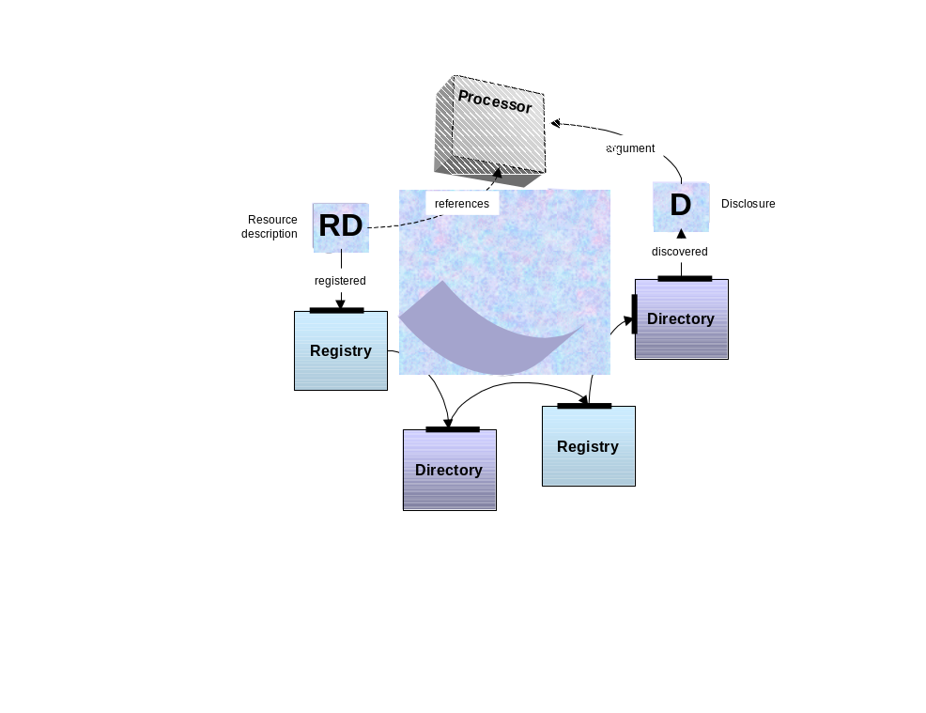
Service referral across marketplace systems.
This specification does not attempt to protect resource descriptions or disclosure instances from physical destruction or potential decomposition of referral actions. However, implementations may supplement the model by using underlying CORBASec services to authenticate clients and ensure exchange of resource descriptions and disclosure instances within trusted communities.

Data Structures

Introduction
From the perspective of resource discovery, an Artifact is disclosed to a client in the form of a Selection instance. A Selection instance contains a URI that references an Artifact instance together with a ranking of the artifact relative to an initial query. Concrete types derived from Artifact include ResourceDescription and Disclosure. A Disclosure is a type containing another Artifact. A ResourceDescription is a type that exposes information about the location, provider, and validity of an Internet resource.
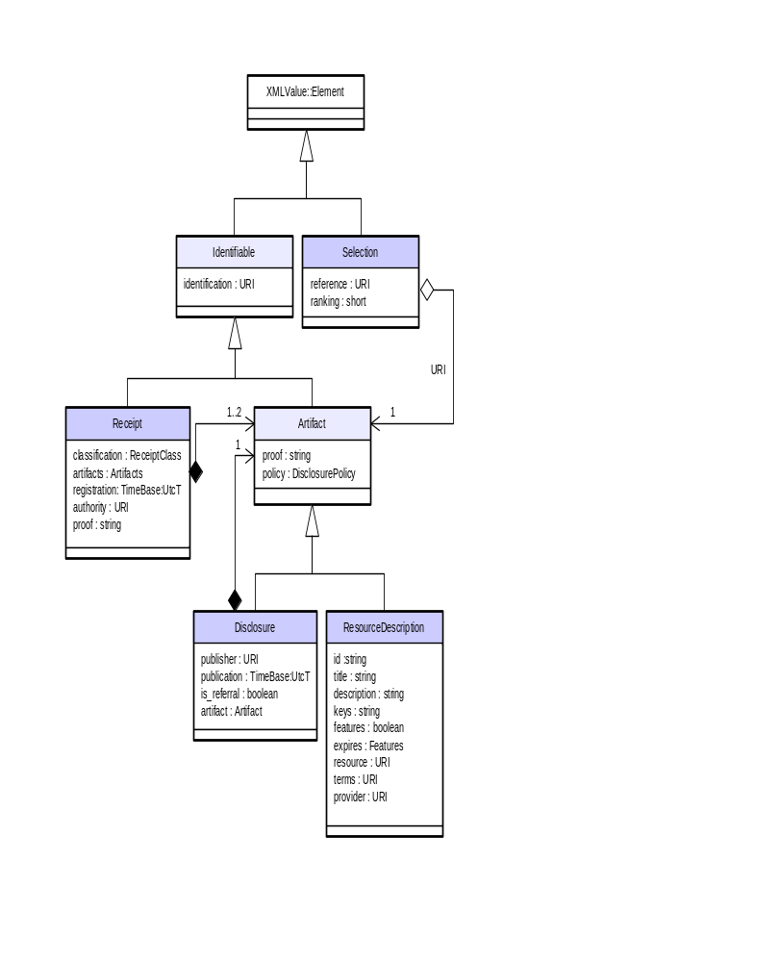
Principal Data Structure Types

Selection, Selections and Selection Iterator
A URI based reference to a resource together with ranking information are presented to client in the form of Selection instances. Selection is a type that combines an Artifact URI and a ranking of the associated artifact reference relative to a query. Selection instances are created and exposed by the Directory interface as a result of quires invoked by clients. The ranking of a Selection instance provides a mechanism for the prioritization of relevance of a particular artifact reference relative to the supplied filter argument (where the filter argument corresponds to the search criteria).

IDL Specification
valuetype Selection : XMLValue::Element
{
private URI reference;
private short ranking;
};
typedef sequence<Selection> SelectionSequence;
interface SelectionIterator: CosCollection :: Iterator
{
};

Attributes
Name | Type | Purpose
reference | URI | URI referencing an identifiable ResourceDescription or a Disclosure instance (type derived from Artifact). The value of URI many be relative to a particular Directory instance.
ranking | short | A value between 0 and 100 used by a client to establish the prioritization of one selection relative to another selection. A value of 0 indicates that no ranking is inferred. A ranking of 100 implies the highest possible ranking of the disclosure. The higher the ranking, the higher the relevance of the artifact relative to the query against which the Selection was established.

Artifact, Resource Description and Disclosure

Identifiable
The Identifiable value type is an abstract base type to Artifact and Receipt. It contains the single attribute identifier that returns a URI that uniquely identifies the instance.

IDL Specification
valuetype Identifiable : XMLValue::Element
{
private URI identifier;
};

Attributes
Name | Type | Purpose
identifier | URI | Unique identifier of the instance.

Artifact
Artifact is an abstract base type to ResourceDescription and Disclosure. The Artifact type exposes the DisclosurePolicy (an enumeration of either ARTIFACT or REFERRAL) used during disclosure of the Artifact under the Discovery services, and a attribute used to expose proof on data integrity.

IDL Specification
valuetype Artifact : Identifiable
{
private string proof;
enum DisclosurePolicy
{
ARTIFACT, // expose as a ResourceDescription
REFERRAL // expose as a Disclosure
};
private DisclosurePolicy policy;
private string proof;
};
typedef sequence<Artifact> ArtifactSequence;

Attributes
Name | Type | Purpose
policy | DisclosurePolicy | An enumerated value of ARTIFACT or REFERRAL. Artifacts published under the referral policy (using Registry and Discovery services) shall be exposed as instance of Disclosure. Resource descriptions published under the artifact policy may be exposed as supplied.
proof | string | Pending resolution.  The intention is to use this attribute to hold proof of integrity of the content of the instance. Resolution of this attribute is dependant of validation of XML externalized form of a resource description and Disclosure type which are linked in part to the resolution of the XML value type definition.

Resource Description
A ResourceDescription is a value type that may be registered with a Registry, and potentially disclosed by a Directory. A resource description provides a common way to describe an arbitrary Internet resource such as a web page, XML document or application entry point.

Information Artifact Example
The following table summarizes a possible resource description of this document. The title and description attributes correspond to the document title and description of this document. The document is classified under three keyword chains, two corresponding to an ontology potentially maintained by the OMG, a third maintained by OSM, and the forth corresponding to a example public repository of electronic commerce related resources. The feature list includes named value applicable to this document and potentially constructed automatically by a client application. The resource attribute contains a URL of the submission and the provider attribute contains a reference to the URL of OSM (the original publisher of the document).

Name | Value
Title | A Registration and Discovery Service
description | Initial submission by OSM to the Object Management Group Registration and Discovery RFP
key_list | omg.ecdtf.rfp.discovery.subissions.osm  omg.org.omg.doc.dtc.2000-05-09  net.osm.public.discovery.submission.R1  ec.services.discovery
feature_list | author: McConnell  copyright: OSM SARL, 2000  status: DRAFT  release: 1.0  date: 23-MAY-2000
expires | -
resource | http://www.omg.org/pub/docs/dtc/2000-05-09.pdf
terms | -
provider | http://www.osm.net

Computational Artifact Example
The following example resource description presents a profile of an available collaboration process, hosted by the OMG supporting the voting on a motion to recommend adoption of this specification. The resource reference is an iiopname referencing an object under a naming service. In this example the object type is a Collaboration instance defined by the EC Domain Specifications. The subject of the collaboration would be document resource containing the motion. To assist client identification of the type of resource identified by the resource statement, a feature called type has been included into the description. The description has an expiry date set following which the provider will no longer be hosting the particular process instance referenced by the description.

Name | Value
title | A Registration and Discovery Service adoption vote
description | Motion to recommend adoption the proposed specification.
key_list | org.omg.ecdtf.rfp.discovery  net.osm.public.discovery.submission
feature_list | type: org.omg.CollaborationFramework.Collaboration
expires | 23 September 2000
resource | iiopname://gateway.org.omg/ecdtf/recommendations/P101
terms | http://www.omg.org/pp/membership_terms.html
provider | http://www.omg.org

IDL Specification
valuetype ResourceDescription :
Artifact
{
private string title;
private string description;
private Discovery::Keys keys;
private Discovery::Features features;
private TimeBase::UtcT expires;
private URI resource;
private URI terms;
private URI provider;
};
typedef sequence<ResourceDescription> ResourceDescriptions;
interface ResourceDescriptionIterator:
CosCollection :: Iterator {
};
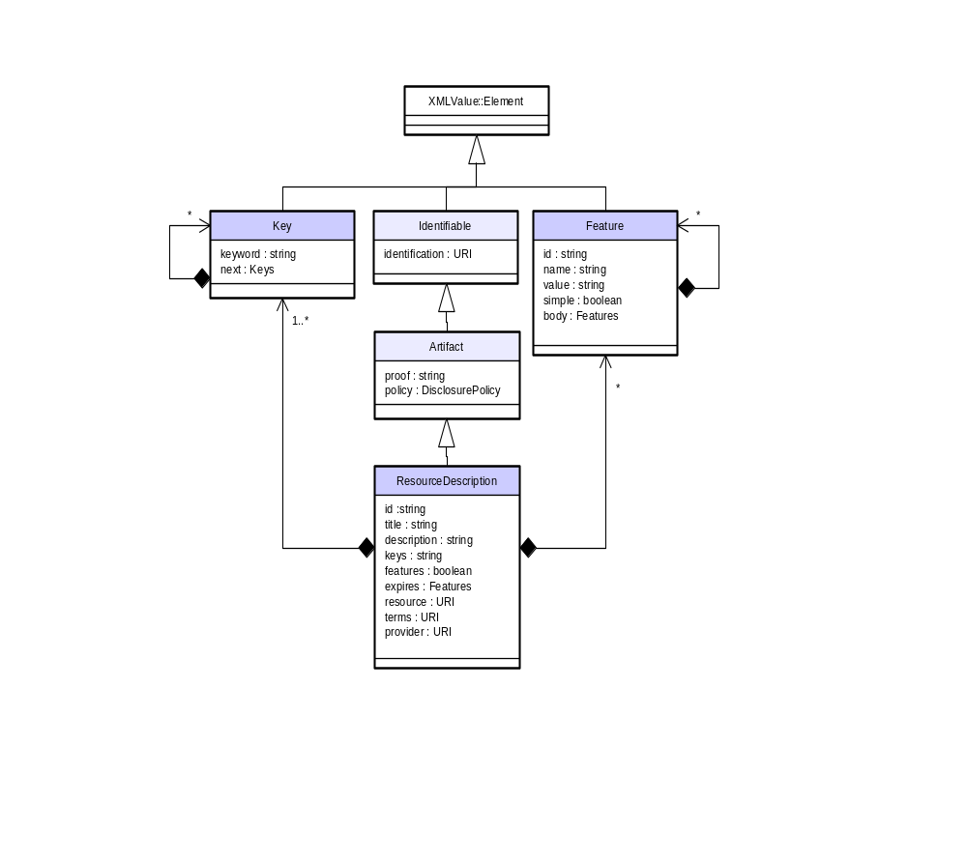
ResourceDescription and composite types – Feature and Key

Attributes
Name | Type | Purpose
title | string | A string representing the title of the resource description.
description | string | A string representing a textual description.
keys | Keys | A sequence of key declarations, used to classify the resource description.
features | Features | A sequence of features that describe the resource.
expires | TimeBase::UtcT | The expiry date of the resource. Expiry implies that the information contained within a resource description may not longer be considered as valid by the supply of the description.
resource | URI | A URI referencing the resource in question. Examples of URI include web page URLs and iiopname URL.
terms | URI | A URI referencing the terms and conditions of service access by a supplier.
provider | URI | A URI referencing the suppler. Examples of supplier URI include home page URLS or iiopname URL to objects such as an Agency (refer EC Community specifications).

Disclosure
A Disclosure is a value type that contains a disclosed artifact, details and proof of the registration act proceeding disclosure. An instance of Disclosure is exposed to a client as an attribute of a Selection instance, or possibly as a result of a lookup operation invoked against a directory.
If a Disclosure is_referral attribute returns true, the artifact attribute contains a pre-existing instance of Disclosure, otherwise the artifact attribute references a ResourceDescription. Based on the value of is_referral, a client can narrow the value returned by artifact to either the Disclosure or ResourceDescription type.
Because an instance of Disclosure can contain another instance of Disclosure, the type is in-effect a chain of disclosures. This characteristic enables the reconstruction of the path or acts of disclosure that led to the discovery of a resource description by a client.

IDL Specification
valuetype Disclosure :
Artifact
{
private URI publisher;
private TimeBase::UtcT registration;
private boolean is_referral;
private Discovery::Artifact artifact;
};
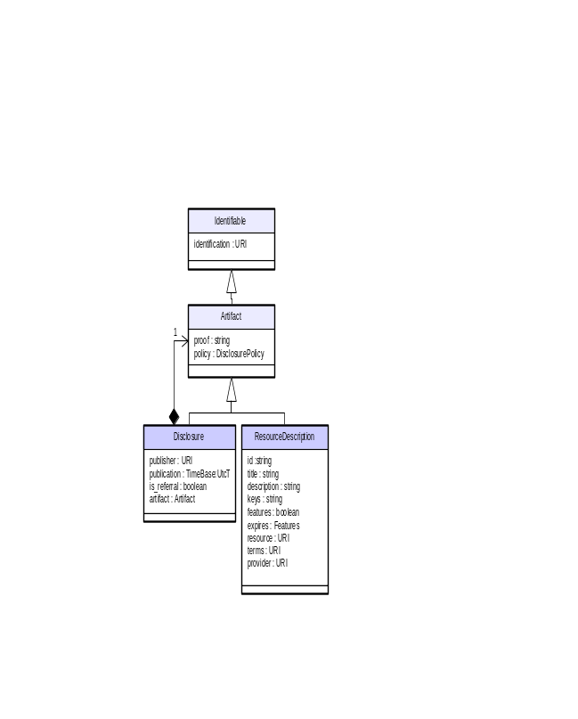
Disclosure Object Model

Attributes
Name | Type | Purpose
publisher | URI | The URI of the publisher of the Disclosure.
registration | TimeBase::UtcT | The date and time of registration of the Artifact.
is_referral | bolean | An instance of Disclosure can be published as a referral by setting the is_referral attribute to true. In such a case the artifact attribute contains a pre-existing instance of Disclosure, otherwise the artifact references a ResourceDescription. Based on the value of is_referral, a client can narrow the value returned by artifact to either the Disclosure or ResourceDescription type.
artifact | Artifact | If the value of is_referral is true, this is an instance of Disclosure, otherwise it is an instance of ResourceDescription.

Supporting types

URI
A URI (Uniform Resource Identifier) is either a URN (Uniform Resource Name) or URL (Uniform Resource Locator). URI expressions shall be conformant with the following specification:
Uniform Resource Identifiers (URI): Generic Syntax
http://www.ietf.org/rfc/rfc2396.txt

IDL Specification
typedef string URI;

Keys
A Key is a value type that supports the declaration of a graph of key values. Key values are used to describe the classification of a resource description. For example, the following three sequence of keys (separated by periods for the purpose of illustration) are possible classifications of this document:
net.osm.public.discovery.specifciation.R1
org.omg.doc.ec.2000-05-09
ec.services.discovery
The expression of the above chains is achieved through the exposure of a graph of key value types and key sequences. A resources description can expose multiple key graphs. Each key graph has a root key. Every key has 0 to * qualifying keys accessible through the next attribute. The next attribute returns a sequence of Key instances (refereed to as Keys).

IDL Specification
valuetype Key : XMLValue::Element {
private string keyword;
private Keys next;
};
typedef sequence<Key> Keys;

Attributes
Name | Type | Purpose
keyword | URI | A keyword is a string used to declare a particular context within the scope of ontology (where ontology implies a publisher independent ordered structure of key words).
next | Keys | A key may contain subsequent key values. These values are accessible through the next attribute. Subsequent keys are interpreted by query implementations relative to their parent key.

Construction of a keyword graph
Graphs of keywords may be automatically constructed by an applications based on supplied information resources or object references. Automation of the construction of a keyword graph and the potential end-user annotation is implementation dependent.
Resource descriptions can contain multiple classifications through the exposure of multiple key graphs. This enables the construction of cross-references that spans multiple ontology schemes.

Features
Feature instances are used to supplement a resource description with domain specific property values. Features has a unique identifier within the scope of the resource description it is contained within, a name that can be used by a client when presenting a feature in a human interface, and a string value. Features can be used to supplement queries by referring to a feature name and possible feature values as a selection criterion.

IDL Specification
valuetype Feature :
XMLValue::Element
{
private string id;
private string name;
private string value;
};
typedef sequence<Feature> Features;

Attributes
Name | Type | Purpose
id | string | An identifier of the feature unique within the scope of the containing resource description.
name | string | A string representing the name of the feature.
value | string | A string corresponding to the value of the feature.

Receipt
A Receipt value type is a type returned from an act of registration of a resource description with a Registry. A receipt contains a sequence of related artifacts, the date and rime of a registration, replacement or retraction, a URI to the publisher issuing the receipt, a unique receipt identifier, and a string containing proof of registration.

IDL Specification
valuetype Receipt :
Identifiable
{
enum ReceiptType {
REGISTRATION,
REPLACEMENT,
RETRACTION
};
private ReceiptAction action;
private Discovery::Artifacts artifacts;
private TimeBase::UtcT registration;
private URI authority;
private string proof;
};
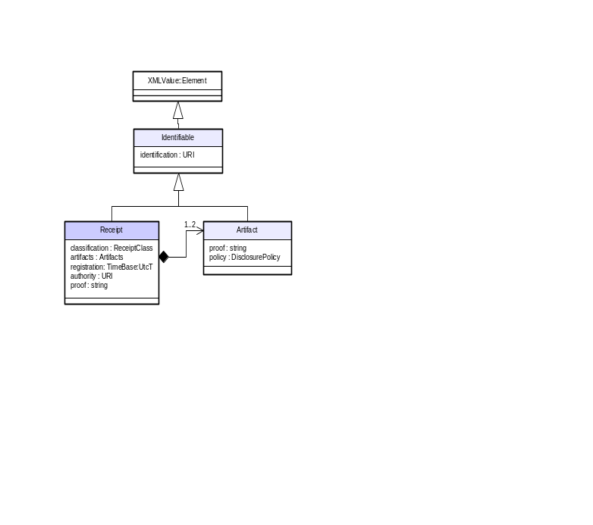
Receipt Object Model

Attributes
Name | Type | Purpose
action | ReceiptAction | An enumerated value corresponding to the type of receipt. May be one of the values REGISTRATION, REPLACEMENT or RETRACTION. Refer Registry interface for descriptions of actions that generate receipts.
artifacts | Artifacts | The value of the artifacts attribute is a function of the type of action against which a receipt is created (refer Registry interface). A REGISTRATION receipt holds a sequence of one artifact corresponding to the artifact of registration. A REPLACEMENT receipt contains a sequence of two artifacts, the original and the replacement. A RETRACTION receipt holds a sequence of one artifact corresponding to the artifact previously held by the registry.
registration | TimeBase::UtcT | The date and time of receipt creation.
publisher | URI | URI to the publishing entity, possibly an iiopname URL to a Registry interface.
proof | string | A signed hash of the description, registration date and time, publisher URI, and identifier.

Filter
Filter is a value type that describes a selection argument passed to or registered with a directory. A filter is composed of composed of conditional arguments against which an implementation of a discovery interface can establish a rankled order selection set.
FILTER VALUE TYPE PENDING SPECIFICATION

IDL Specification
valuetype Filter :
XMLValue::Element
{
private string value;
};

Registration Interfaces

Registry
A registry is an interface that provides an operation supporting registration of an Artifact (the base type for ResourceDescription and Disclosure), verification of Artifacts based on supplied receipts, replacement of exiting Artifacts based on a supplied registration receipt and new Artifact.

IDL Specification
interface Registry
{
exception ExistingArtifact{
string reason;
};
exception RegistrationDenied{
string reason;
};
exception RetractionDenied{
string reason;
};
exception UnknownReceipt{
string problem;
};
exception MallformedReceipt{
string problem;
};
exception MallformedArtifact{
string problem;
};
exception ArtifactUnavailable{
string reason;
};

Receipt register(
in Discovery::Artifact artifact
) raises (
ExistingArtifact,
RegistrationDenied,
MallformedArtifact
);

Artifact verify(
in Discovery::Receipt receipt
) raises (
UnknownReceipt,
MallformedReceipt,
ArtifactUnavailable
);

Receipt replace(
in Discovery::Receipt receipt,
in Discovery::Artifact artifact
) raises (
RegistrationDenied,
UnknownReceipt,
MallformedReceipt,
MallformedArtifact
);

Receipt retract(
in Discovery::Receipt receipt
) raises (
UnknownReceipt,
MallformedReceipt,
RetractionDenied
);
};
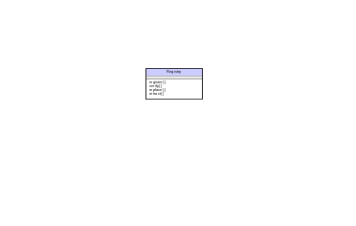
Registry Object Model

Registration of an Artifact
A client, using a proprietary application constructs an instance of ResourceDescription. This description instance can be passed to the register operation as the artifact argument. The register operation returns a Receipt that serves as the client’s proof of registration. Alternatively, a client having discovered an instance of Disclosure (possibly using the Discovery services) can re-register this instance using the register operation. The returned receipt may be used as an identifier for subsequent verification, updating or retraction of the related artifact.
The general purpose of the register operation is to provide the access point towards a client for the purpose of declaring an artifact to the Registry. The Artifact DisclosurePolicy effects the semantics of the register operation. If the value of policy is ARTIFACT, the artifact passed into the register operation can be exposes under a Directory service as supplied. If the value of policy is REFERRAL, the artifact must be packaged within an enclosing Disclosure instance and attributed with details concerning the time and date of registration, URI of the registry and proof of registration.
Receipt register(
in Discovery::Artifact artifact
) raises (
ExistingArtifact,
RegistrationDenied,
MallformedArtifact
);

Exception | Description
ExistingArtifact | Raised following an attempt to register an artifact that is previously registered with the registry. An implementation is not required to throw this exception and may choose to accept the registration.
RegistrationDenied | Raised for an implementation independent reason, detailed under the exception reason field.
MallformedArtifact | The artifact supplied to the register operation is invalid or badly formed.

Verification of a registered Artifact
A client having obtained a receipt against registration may invoke the verify operation in order to retrieve an Artifact corresponding to a prior act of registration. An implementation is not required to return the same artifact and in fact may return a variant of the original artifact. An implementation is required to return the artifact in the form of a Disclosure instance.
Disclosure verify(
in Discovery::Receipt receipt
) raises (
UnknownReceipt,
MallformedReceipt,
ArtifactUnavailable
);

Exception | Description
UnknownReceipt | Raised when a Receipt supplied to the registry is unknown by the registry (possibly as a result of supplying a receipt to a registry which was not the creator of the receipt).
MallformedReceipt | The receipt supplied to the verify operation is badly formed.
ArtifactUnavailable | For internal implementation reasons the artifact related to the receipt cannot be supplied.

Updating of a registered Artifact
A client having previously registered an artifact with a registry may attempt to replace the artifact using the replace operation. The replace operation takes an existing Receipt and a new Artifact as an argument and returns a new Receipt instance.
Receipt replace(
in Discovery::Receipt receipt,
in Discovery::Artifact artifact
) raises (
RegistrationDenied,
UnknownReceipt,
MallformedReceipt,
MallformedArtifact
);

Exception | Description
RegistrationDenied | Raised for an implementation independent reason, detailed under the exception reason field.
UnknownReceipt | Raised when a Receipt supplied to the registry is unknown by the registry (possibly as a result of supplying a receipt to a registry which was not the creator of the receipt).
MallformedReceipt | The receipt supplied to the replace operation is badly formed or an invalid receipt type.
MallformedArtifact | The artifact supplied to the replace operation is badly formed.

Retraction of a registered Artifact
A client, holding a valid receipt of registration of an Artifact may attempt to retract the registration using the retract operation. The operation takes a receipt of registration or replacement, and returns a Receipt of retraction.
Receipt retract(
in Discovery::Receipt receipt
) raises (
UnknownReceipt,
MallformedReceipt,
RetractionDenied
);

Exception | Description
UnknownReceipt | Raised when a Receipt supplied to the registry is unknown by the registry (possibly as a result of supplying a receipt to a registry which was not the creator of the receipt).
MallformedReceipt | The receipt supplied to the replace operation is badly formed or an invalid receipt type.
RetractionDenied | Raised for an implementation independent reason, detailed under the exception reason field.

Discovery Interfaces

Directory Interface
Directory provides support for the invocation of queries enabling the discovery of Artifact instances, either directly or by reference through exposed Selection instances. The Directory interface can be used in conjunction with Registry interface to establish catalogue services, brokerage, and referral trading systems.
The Directory interface provides operations supporting the location of a single artifact based on a supplied filter argument, a find operation supporting the creation of an iterator of Selection instances, and a resolve operation supporting translation of Selection instances to and Artifact instances.

IDL Specification
interface Directory
{
Artifact locate(
in Discovery::Filter filter
) raises (
NoMatch,
InvalidFilter
);
SelectionSequence find(
in Discovery::Filter filter,
in short first,
in short last
) raises (
NoMatch,
InvalidFilter
);
ArtifactSequence resolve(
in SelectionSequence selection
);
};

Locating a single resource description
The locate operation provides a convenient operation to get a single value of Artifact (the base type for Disclosure and ResourceDescription). Applications can hand over selection responsibility to a Directory implementation on the basis of a Filter argument. Example include applications that which to dynamically connect to a system service or other on-line resource. The locate operation will raise the NoMatch exception if no Artifact instance can be returned. The operation raises the InvalidFilter exception if the Filter is invalid or badly formed.
Artifact locate(
in Discovery::Filter filter
) raises (
NoMatch,
InvalidFilter
);

Establishing a selection set from a query
The find operation enables retrieval of a sequence of Selection instances based on a supplied filter, sequence size and sequence starting position. The value of start corresponds to the nth logical artifact from a ranked order selection result. The value of size corresponds to the maximum number of Selection entries to include in the sequence that is returned to the client. If the number of matching selection is zero, an implementation will raise the NoMatch exception. The InvalidFilter exception will be raised if the filter structure is invalid. Client can use this operation to retrieve batches of selection results such as the next 10 Selection instances from position 10 and onwards.
SelectionSequence find(
in Discovery::Filter filter,
in short start,
in short size
) raises (
NoMatch,
InvalidFilter
);

Converstion of a SelectionSequence to an ArtifactSequence
The resolve operation supports the translation of a sequence of Selection instance to a correspondingly ordered sequence of ArtifactInstances.
ArtifactSequence resolve(
in SelectionSequence selection
);

Active Directories and related Interfaces
The ActiveDirectory is an extension to the Directory interface that supports the creation of instances of DirectoryAgent based on a supplied IndetifableDomainConsumer (a interfaces based on CosNotification::StructuredPushConsumer). A DirectoryAgent provides support for the registration of a persistent Filter and process centric behavior that enables client control over the subscription process.
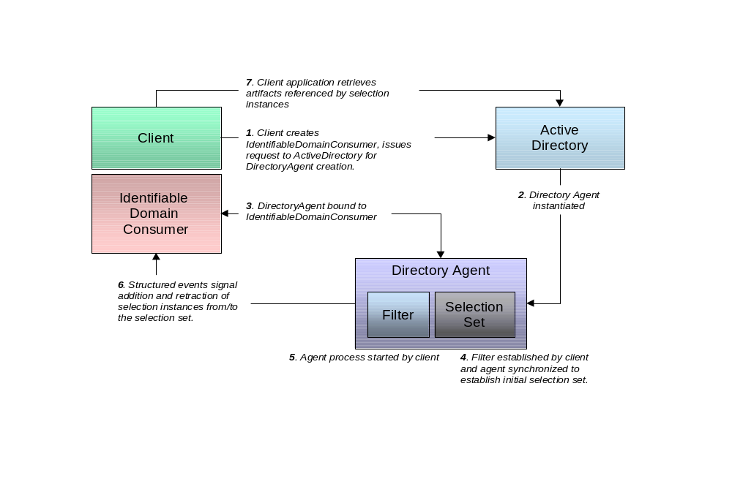
ActiveDirectory, DirectoryAgent, IdentifableDomainConsumer and Client interaction

Active Directory
An ActiveDirectory is an extension to the Directory interface that provides support operations through which a client can establish persistent queries. ActiveDirectory exposes the operation create_directory_agent that returns an instance of DirectoryAgent based on an instance of IdentifiableDomainConsumer supplied by a client.

IDL Specification
interface ActiveDirectory :
Directory
{
DirectoryAgent create_directory_agent(
in Session::IdentifiableDomainConsumer consumer
);
};
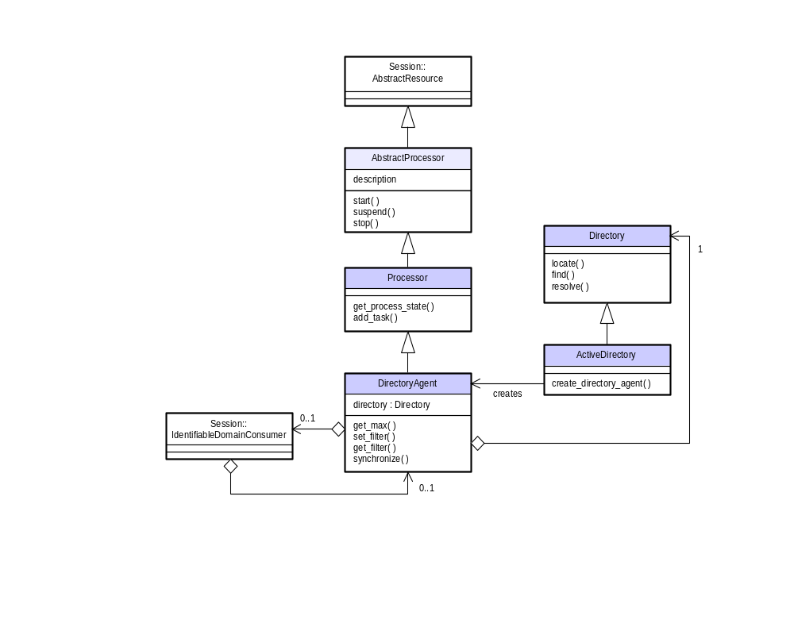
Directory, ActiveDirectory and Directory Object Model

Directory Agent
DirectoryAgent exposes operations enabling the registration and modification of a single search criterion, and the maintenance of an active view corresponding to potentially changing search results. The DirectoryAgent interface leverages the Task and Session processor semantics by packaging a directory as a process that can be associated to Task assigned to Users.

IDL Specification
interface DirectoryAgent :
Process::Processor
{
exception NoFilter{ };
exception ProcessRunning{ };
readonly attribute Discovery::Directory directory;
short get_max( );
void set_filter(
in Discovery::Filter filter
) raises (
InvalidFilter,
ProcessRunning
);
Filter get_filter(
) raises (
NoFilter
);
SelectionSequenceIterator synchronize(
in short size,
in short max
) raises (
NoFilter,
ProcessRunning
);
};

Attributes
Name | Type | Purpose
directory | Directory | The Directory to which the DirectoryAgent is associated during instantiation. A client application uses this directory to translate Selection values into Artifact descriptions.

Setting and Modifying filter criteria
The DirectoryAgent interface provides explicit support for the registration of “sticky” filters – i.e. filters that are persistently associated with the DirectoryAgent. An implementation is responsible for the maintenance of a Selection result set, established through the synchronize operation and the associated Filter. The max argument establishes the maximum number of Selection instances to return. The size argument restricts the length of each SelectionSequence returned from a SelectionSequenceIterator. The synchronize returns an iterator of SelectionSequence based on the filter registered with the agent. This allows a client to cycle through the initial selection result set independently of the potential extent of the set. Changes to the result set are propagated to the associated IdentifiableDomainConsumer as structured events detailing retractions and addition of Selection instance to the result set.
During execution a client may have to re-synchronize an active selection relative to the delivery of structured events. This can be achieved through invocation of the synchronize operation.
SelectionSequenceIterator synchronize(
in short size,
in short max
) raises (
NoFilter,
ProcessRunning
);

Setting and Modifying filter criteria
A Filter is initially established and modified using the set_filter operation. Before invoking this operation, a client must suspend the process (refer Task and Session specification). Using set_filter, the client can establish the filter criteria that will be used by an implementation to establish the result set and subsequent notification events. Once a Filter has been established (corresponding to the search criteria), an implementation is responsible for the propagation of structured events detailing the addition or retraction of Selection instance that match the Filter criteria.
void set_filter(
in Discovery::Filter filter
) raises (
InvalidFilter,
ProcessRunning
);
Filter get_filter(
) raises (
NoFilter
);

Structured Events
The following table details the structured event fields used to notify the addition and retraction of a Selection from a selection set.
Event Table
Event: | Description
addition | Notification of the addition of a sequence of Selection instances.
 | Supplementary properties:
 | selection | SelectionSequence | Sequence of selection instance added to the search result.
retraction | Notification of the retraction of a sequence of Selection instances.
 | Supplementary properties:
 | Supplementary properties:
 | selection | SelectionSequence | Sequence of selection instance added to the search result.

Processor and Abstract Processor
The Process module contains the definition of two interface, AbstractProcessor and Processor. Processor semantics are based on the Task and Session specification. Namely, a user’s task (unit of work) is associated with a processor. A processor can support many tasks. Version 2.1 of the Task and Session specification defines a processor as the type AbstractResource. This definition is insufficient for the purposes of the Registration and Discovery services and as such, the following IDL has been prepared as a supplement to this specification. It is expected that resolution of processor semantics will be addressed under a future Task and Session RTF precluding the necessity for inclusion under a revised or final specification.

IDL Specification
module Process {
enum process_state {
open, not_running, notstarted, running,
suspended, terminated, completed, closed
};

interface AbstractProcessor :
Session::AbstractResource
{

exception CannotStart {};
exception AlreadyRunning {};
exception CannotSuspend {};
exception CurrentlySuspended {};
exception CannotStop {};
exception NotRunning {};

readonly attribute string description;

void start ( ) raises (CannotStart, AlreadyRunning);
void suspend ( ) raises (CannotSuspend, CurrentlySuspended);
void stop ( ) raises (CannotStop, NotRunning);

};

interface Processor :
AbstractProcessor
{
process_state get_process_state( in Session::Task task );
void add_task( in Session::Task task );
};
};

AbstractProcessor Operations and Exceptions
All exceptions defined under the Process module are equivalent to the corresponding exceptions within the Task and Session Task definition. Operations supporting start, suspend and stop of a process are operationally equivalent to the Task and Session Task variant.

Process State Enumeration
The process_state enumeration is equivalent to the task_state enumeration defined under the Task and Session specification.

Task Association
The add_task operation provides a convenience mechanisms through which a Task may be associated to a processor.

Complete IDL
// File: Discovery.idl

#ifndef _DISCOVERY_IDL_
#define _DISCOVERY_IDL_
#include <Process.idl>
#include <xmlcore.idl>
#pragma prefix "omg.org"

module Discovery{

interface Registry;
interface Directory;
interface ActiveDirectory;
interface DirectoryAgent;
valuetype Key;
valuetype Feature;

typedef string URI;

typedef sequence<Key> Keys;
valuetype Key : XMLValue::Element {
private string keyword;
private Keys next;
};

typedef sequence<Feature> Features;
valuetype Feature : XMLValue::Element {
private string id;
private string name;
private string value;
private boolean simple;
private Features body;
};

valuetype Identifiable :
XMLValue::Element
{
private URI Identifier;
};

valuetype Artifact :
Identifiable
{
private string proof;
enum DisclosurePolicy {
ARTIFACT, // expose as a ResourceDescription
REFERRAL // expose as a Disclosure
};
private DisclosurePolicy policy;
private string proof;
};
typedef sequence<Artifact> ArtifactSequence;

valuetype ResourceDescription :
Artifact
{
private string title;
private string description;
private Discovery::Keys keys;
private Discovery::Features features;
private TimeBase::UtcT expires;
private URI resource;
private URI terms;
private URI provider;
};

valuetype Disclosure :
Artifact
{
private URI publisher;
private string identifier;
private TimeBase::UtcT publication;
private boolean is_referral;
private Discovery::Artifact artifact;
};

interface ResourceDescriptionIterator :
CosCollection :: Iterator {
};

valuetype Receipt :
Identifiable
{
enum ReceiptClass {
REGISTRATION,
REPLACEMENT,
RETRACTION
};
private ReceiptClass classification;
private Discovery::ArtifactSequence artifacts;
private TimeBase::UtcT registration;
private URI authority;
private string proof;
};
typedef sequence<Receipt> Receipts;

valuetype Selection :
XMLValue::Element
{
private URI identifier;
private short ranking;
};
typedef sequence<Selection> SelectionSequence;
interface SelectionSequenceIterator : CosCollection :: Iterator { };

valuetype Filter :
XMLValue::Element
{
private string value;
};

interface Registry
{
exception ExistingArtifact{
string reason;
};
exception RegistrationDenied{
string reason;
};
exception RetractionDenied{
string reason;
};
exception UnknownReceipt{
string problem;
};
exception MallformedReceipt{
string problem;
};
exception MallformedArtifact{
string problem;
};
exception ArtifactUnavailable{
string reason;
};

Receipt register(
in Discovery::Artifact artifact
) raises (
ExistingArtifact,
RegistrationDenied,
MallformedArtifact
);

Disclosure verify(
in Discovery::Receipt receipt
) raises (
UnknownReceipt,
MallformedReceipt,
ArtifactUnavailable
);

Receipt replace(
in Discovery::Receipt receipt,
in Discovery::Artifact artifact
) raises (
RegistrationDenied,
UnknownReceipt,
MallformedReceipt,
MallformedArtifact
);

Receipt retract(
in Discovery::Receipt receipt
) raises (
UnknownReceipt,
MallformedReceipt,
RetractionDenied
);
};

exception NoMatch{ };
exception InvalidFilter{
Filter filter;
string reason;
};

interface Directory
{
Artifact locate(
in Discovery::Filter filter
) raises (
NoMatch,
InvalidFilter
);
SelectionSequence find(
in Discovery::Filter filter,
in short start,
in short size
) raises (
NoMatch,
InvalidFilter
);
ArtifactSequence resolve(
in SelectionSequence selection
);
};

interface ActiveDirectory :
Directory
{
DirectoryAgent create_directory_agent(
in Session::IdentifiableDomainConsumer consumer
);
};

interface DirectoryAgent :
Process::Processor
{
exception NoFilter{ };
exception ProcessRunning{ };
readonly attribute Discovery::Directory directory;
short get_max( );
void set_filter(
in Discovery::Filter filter
) raises (
InvalidFilter,
ProcessRunning
);
Filter get_filter(
) raises (
NoFilter
);
SelectionSequenceIterator synchronize(
in short size,
in short max
) raises (
NoFilter,
ProcessRunning
);
};
};
#endif // _DISCOVERY_IDL_

// File: Process.idl
#ifndef _PROCESS_
#define _PROCESS_
#include <Session.idl>
#pragma prefix "omg.org"

module Process {

enum process_state {
open, not_running, notstarted, running,
suspended, terminated, completed, closed
};
interface AbstractProcessor :
Session::AbstractResource
{
exception CannotStart {};
exception AlreadyRunning {};
exception CannotSuspend {};
exception CurrentlySuspended {};
exception CannotStop {};
exception NotRunning {};
readonly attribute string description;
void start ( ) raises (CannotStart, AlreadyRunning);
void suspend ( ) raises (CannotSuspend, CurrentlySuspended);
void stop ( ) raises (CannotStop, NotRunning);
};
interface Processor :
AbstractProcessor
{
process_state get_process_state( in Session::Task task );
void add_task( in Session::Task task );
};
};
#endif /* _PROCESS_ */

