System Architecture
The Plantlore system consists of three main parts which are the Plantlore Java client, the Plantlore Java server and the BioCASE-based Plantlore web client.

The big picture
As already introduced in the User Manual, Plantlore is expected to be run in a coordinated enviroment using a central authority. The central authority runs the main central database that is exposed to the world using the Plantlore server and the Plantlore-BioCASE web client. Clients, usually botanists, can access the data using the Plantlore client or the Plantlore web client. Other way to access the data would be using some global BioCASE search tool. The Plantlore web client is based upon the BioCASE Provider software which makes it possible for Plantlore to take part in the BioCASE network as a data provider node.
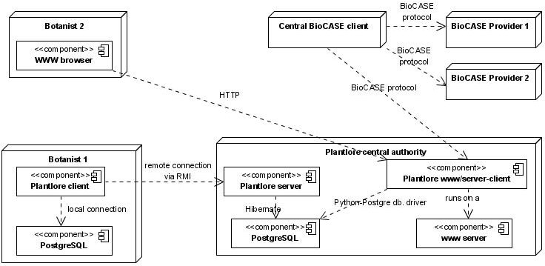Ilustrace 1: Plantlore deployment diagram
Standalone chapters are devoted to each of these Plantlore components, refer to them for furhter details. Next chapter introduces the core Plantlore system – the Plantlore server and Plantlore client.

