Printing and Scheda
One of requirements on Plantlore was to be able to create schedas - cards that were usually used in old-fashioned card indexes. From the technical point of view it is just a kind of report generation problem for data from the database. And for such a task there are many available tools for programmers. We have chosen the JasperReports library for being very flexible and reliable and we already had some experience with this library before. It also solves the printing because it offers a printing dialog if desired.

JasperReports
„JasperReports is a powerful open source Java reporting tool that has the ability to deliver rich content onto the screen, to the printer or into PDF, HTML, XLS, CSV and XML files.“ - a quote from the http://jasperforge.org/ website. There are several ways to use the JasperReports library. It is always necessary to create a report. If you have a report you have to obtain a data source from which to get the data to fill the report with. JasperReports supports various datasources: direct JDBC connection using predefined SQL statements, XML datasource, arbitrary data source after implementing the JRDataSource interface.
To leverage JasperReports the best we have created a JasperDataSource which is a class implementing the JRDataSource interface. The implementation is quite straightforward except the exception handling which we will describe furhter in the text. The JasperDataSource is created initializing it with a current DBLayer and a Selection object containing a set of Occurrences to be printed (or created schedas from). In the JasperDataSource.next() method we iterate over the Occurrences. Specific values of the records are retrieved by the JasperReports engine using the JRDataSource.getFieldValue() method.
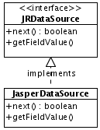

The Exception Handling
It is only possible to throw a JRException from the interface. The problem is that we have to deal with DBLayer which can throw DBLayerException and RemoteException. This would be fine if we didn't have to deal with these exceptions carefully in a uniform way. Therefore we catch these two exception and pack them as a Throwable cause of a newly created JRException. Higher in the AppCoreCtrl or PrintCtrl / Print we extract the cause (Throwable.getCause())and throw it again to be handled further in Plantlore using the DefaultExceptionHandler.handle() method.
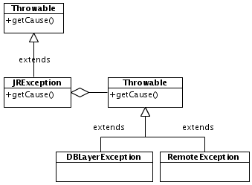

The Reports
The reports can be either written manually in an XML file format or using existing GUI tools for rapid report creation. For Plantlore we used the iReport software to create the reports for Scheda and Printing. The reports are XML code combined with Java code. That is a source of great power in creating complex reports. These reports have to be then compiled to a so called compiled report. This could be done on the fly using the JasperReports engine but it has two drawbacks. One is that the user has to have a JDK installed and the second are possible security issues – it could be then possible to create malicious harmful reports. Therefore Plantlore contains already compiled reports packed into the application jar file. The reports are then loaded dynamically as a resource from the net.sf.plantlore.client.resources package.

