PLANTLORE



Database Layer

Charles University in Prague
Faculty of Mathematics and Physics

Author: Tomáš Kovařík, tkovarik@gmail.com

Plantlore version 1.0

Database Layer

Introduction
This section describes the role of database layer in Plantlore and how this database layer is implemented and should be used in Plantlore. The purpose of this section is to provide detailed explanation of the implementation of different aspects of database management in Plantlore. Basic knowledge of the Hibernate ORM system is expected. Refer to hibernate documentation at www.hibernate.org if necessary.
Database layer in Plantlore is used to cover the Hibernate API and provide other layers the API for working with database. This layer is necessary because we do not want to call Hibernate directly from the rest of the sources and we need to do additional data processing before persisting data (such as access rights checks, saving history etc.)
In this section we will use the following terms when describing the database layer and the API it provides.
- DBLayer – is used for the database layer as a whole (includes several classes listed below)
- Client – In this document client is a user of DBLayer - classes using DBLayer interface.
- User – is a person using Plantlore
- Plantlore user – entity in Plantlore identified by a username with the given privileges
- Database user – User of the underlying database management system.

Participants
Database layer in Plantlore is implemented in the following classes and interfaces. We will go through the most important functions of the DBLayer in the following paragraphs.
- net.sf.plantlore.middleware.DBLayer – Interface defining API for working with database.
- net.sf.plantlore.server.HibernateDBLayer – Implementation of the DBLayer interface using Hibernate. Currently only this implementation is provided, however different implementations (e.g. for direct database access using JDBC) should be possible.
- net.sf.plantlore.middleware.SelectQuery – Interface defining API for buidling SELECT queries.
- net.sf.plantlore.server.SelectQueryImplementation – Implementation of SelectQuery interface using Hibernate criteria queries..
- net.sf.plantlore.server.SubQueryImplementation – Implementation of SelectQuery interface for executing subqueries (subselects). Reasons for this implementation are explained later in this document.

Initializing database connection
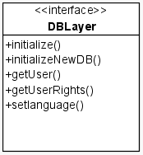
Initialization of database connection occurrs in the initialize() method. Connection parameters are partially loaded from the hibernate.cfg.xml resource file (database mapping documents) and partialy created dynamically from the supplied data (database to connect to, login and password). Initialization includes database user authentication and plantlore user authentication (against data in the tUser table). Later during the application execution it is possible to get the connected user and its rights using getUser() and getUserRights() methods.
In the initialization phase Hibernate SessionFactory is created which is then used for opening database sessions for executing SQL statements. Existence of this SessionFactory object determines whether the DBLayer is connected to a database and every method in the database layer working with database has to check the existence of SessionFactory before executing anything. Information about the logged user are stored as well and are used to check user privileges when executing database operations.

Transaction management support
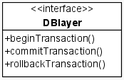
Hibernate ORM makes the JDBC transaction support available via its interface which is sufficient for the short database transactions and clients do not need to care about this. In case we need to execute multiple SQL queries (such as importing multiple records to the database), we have to provide interface to open transaction, commit and rollback it so that clients have control over the transaction. This is also neccesary since we work remotely using RMI mechanism and therefore clients only have access to methods exported by DBLayer.
When the transaction is started clients can use special methods for executing SQL queries using this transaction. Only one such long running transaction is allowed at a time.

Application transactions and optimistic row level locking
In many cases we have to deal with application transactions often including user input which might be problematic from the database point of view. One of the approaches known as pesimistic locking is to lock database rows when they are requested for updating and unlocking them after the update. Firstly, this requires a lot of additional work by the database system and brings number of problems. Secondly, the support for this on the database level is not universal (not all database systems implement SELECT FOR UPDATE statement) and Hibernate support is even worse.
Therefore plantlore uses optimistic locking strategy, which on the other hand is offered and implemented by Hibernate and is very easy to use. This is implemented by record versioning where each record has its version stored in the database and updated on every UPDATE operation. When two concurrent updates occurr, it is easy to determine (using the version numbers) that another transaction already updated the data and that the second transacion has to rollback.
The downside of the optimistic approach is that updates made in the second transaction are lost. Since we don't expect Plantlore to run in highlyconcurrent environment, using this method is feasible.

Executing INSERT/UPDATE/DELETE statements
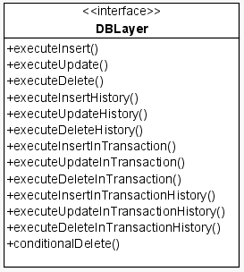
When executing database updates most of the work is done by Hibernate. DBLayer receives holder objects (which are object representation of database rows) with data to be inserted/updated and provides them to Hibernate layer for the actual operation. The role of the DBLayer in this case is to implement operations that cannot be done on the client side. These operations include:
- Modifying received data prior to persisting them
- Checking user priviliges
- Saving history of database modifications

Modifying data prior to persisting
In order to keep the database in a consistent state and protect it from unauthorized or malicios changes, DBLayer modifies received records. The following modifications are performed:
- Storing the author of the record – to be able to track the ownership of the records and
- Storing the time of modifications - so that we can order the changes and allow the “undo to specific date” operation for example.
- Storing unique identifiers of records – This modification is in place so that we prevent data corruption when records are replicated and merged together.

Checking user privileges
Although user privileges should be verified before calling DBLayer, in order to rule out any unwanted modifications of the database (by someone modifying the client code) the privileges must be also verified on the level of DBLayer. Exact rules for table access are explained in the User documentation provided with Plantlore and their exact specification is not important for us.

Saving history of database modifications
Since the goal of Plantlore is to offer best possible data mangement to the user we implement saving history of database modifications. This allows users to undo unwanted changes to data and keep track of intentional changes.
From the nature of this feature, it is reasonable to implement it on a DBLayer level so that we have complete control over the database. Detailed rules for saving history records are explained in a separate document included in Plantlore documentation.
Only selected modifications for a selected types of records are saved to history. Therefore DBLayer also providesmethods which do not modify the history. Refer to JavaDoc documentation for details.

Deleting records
When client wishes to delete selected record from the database the delete itself is not executed (there are exceptions described later). Since we want to store history of the modifications, records are only marked as deleted (by setting “deleted” parameter of the record) and are not made available to the user. In case we want to undo some of the changes it is just a matter of reviving selected records.
The only situation when we have to physically delete records from the database is when the user requests to clean the database and remove all records marked as deleted .

Executing SELECT queries
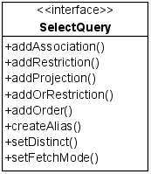
Selecting data from the database is a little bit more complicated. In order to be able to construct general SELECT queries without writing the SQL or HQL queries themselves, we decided to use so called criteria queries offered by Hibernate. We have created our own interface for constructing and executing these queries so that clients are completely shielded from the underlying Hibernate API. Therefore we suggest to consult Hibernate documentation concerning criteria queries since DBLayer API is very similar. However, since SELECT queries are the most common operation, the following paragraphs describe the creation and execution of SELECT query in more detail.

Constructing a query
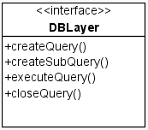
Construction of a SELECT query is started by calling createQuery() method defined by the DBLayer interface. An argument of this method is a Class object representing one of the holder objects. This holder object is a primary record we want to select from the database. Of course records of other types can be associated and joined into the query.
createQuery() method returns an instance of SelectQuery object which is later used for query construction and finally for the execution of the query.
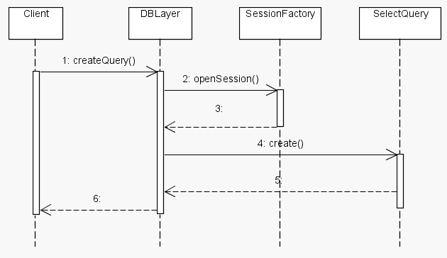

Implementing projections
Projections allow us to select columns we want to have in the result after query execution. When no projections are set, all the columns of the selected table(s) are returned.
Projections can be added to the query by means of addProjection() method defined in the SelectQuery interface. Parameters of this method are type of projection and name of the projected column. Names of the columns are available as constants stored in the respective holder objects.

Restrictions
Restrictions give us a way how to limit the selection of records to those satisfying certain constraints. In SQL, restrictions are expressed as the WHERE clause of the SELECT query.
Restrictions can be added to a query using addRestriction() method defined in the SelectQuery interface. This method takes up to 5 parameters:
- Type of restriction – defines which SQL operator should be used. Available types are defined in net.sf.plantlore.common.PlantloreConstants. Please consult this file for more information.
- First property name – name of the column used for operators which accept one or two columns as arguments.
- Second property name – name of the column used for operators which accept two columns as arguments. If the restriction works with only one column, this parameter can be null.
- Value – Any value we want to use as an argument to the selected operator.
- Values – Certain operators (e.g. operator IN) work with collection of values. For these operators, tha last argument is a collection of values we want to use with the given operator. If you use operator which doesn't accept collection of values, this parameter can be null.
In case no restrictions are defined for a query, all the records from the selected table are returned.

Aliases and joining
In order to select data from more tables, SelectQuery API makes it possible to define aliases. Alias is just another name for the associated table which can be used to access columns of this table. To assign an alias, use createAlias() method. The first parameter of this method is the column of the main table which associates it with another table. The second is the name of the alias, which can be any reasonable string (such that it can be used as an alias in the SQL query – e.g. cannot contain spaces). When the alias is defined, we can access the fields of associated table using the dot notation (<alias_name>.<field_name>).

/*****************************************************************
* We want to select a history record for a given occurrence. *
* Table tHistory is associated with table tHistoryChange and *
* this table is associated with tOccurrences table (via foreign *
* keys). The primary table we want to select from is tHistory, *
* we need to create aliases for tables tHistoryChange and *
* tOccurences. *
*****************************************************************/
// Select data from tHistory table
query = database.createQuery(HistoryRecord.class);
// Create aliases for other tables. See how the dot notation is used
query.createAlias("historyChange", "hc");
query.createAlias("hc.occurrence", "occ");
// Add restriction to CUNITVALUE column of tOccurence table
query.addRestriction(PlantloreConstants.RESTR_EQ,
"occ.unitValue", null, "unitValue", null);

Ordering the results
Ordering results is possible using addOrder() method defined in the SelectQuery interface. addOrder() method takes two arguments, the direction of ordering and the column to be used for ordering the results. Direction can be either ascending or descending.

Running a query
When the query is constructed, we can proceed to the execution. Query is executed by calling executeQuery() method defined in the DBLayer interface which takes an instance of SelectQuery we want to execute as an argument.
executeQuery() method returns unique id of result which is used for reading the results. This is necessary because more query results can be opened at the same time.

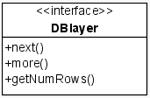
Working with the query results
Executing query doesn't fetch any data from the database. To get the selected data, either next() or more() method has to be used. These methods are defined in the DBLayer interface.
Method next() fetches next record from the result of the query. The only parameter of this method is the id of the result we want to read. next() returns an array of records read from the database. Although we are selecting a single row (record), very often associated records are fetched. For example, when selecting User record from tUser table, associated Right record (table tRight) is fetched. When retrieving results of a query, you have to know which records were fetched and cast the items in the returned array accordingly.
Method more() is used for retrieving an array of records from the result. (equivalent to multiple next() calls). Parameters of this method are the indexes of the first and last record to retrieve and of course an identifier of the result we want to read. The return value is a two dimensional array containg records in the same way as with the next() method.
To get the number of records returned by the query, getNumRows() method is available. The only parameter is the identifier of the result we are interested in. If the result is empty, value zero is returned.
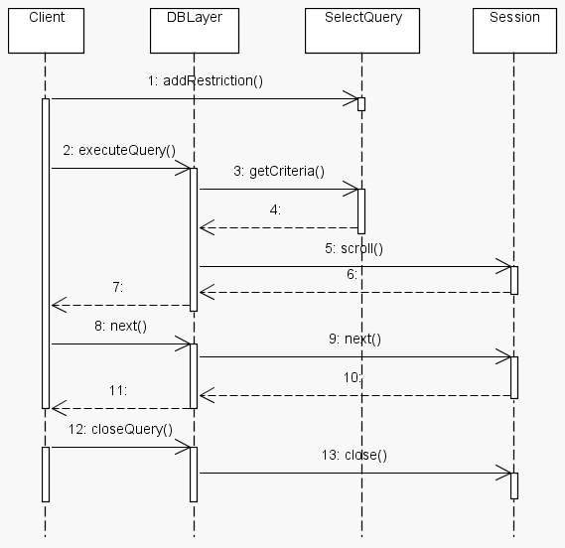

Subqueries
In case you need to execute nested SELECT query (also known as subselect), DBLayer provides special implementation of SelectQuery interface for this purpose called SubQuery. SubQuery cannot be implemented as a regular SelectQuery since underlying Hibernate implementation requires you to use DetachedCriteria objects for subqueries and this is not possible to achiev using the SelectQueryImplementation class..
Subquery is created by calling createSubQuery() method from the DBlayer interface. Obtained SelectQuery can then be attached to another SelectQuery using a special restriction type (see documentation of SelectQuery.addRestriction() method)

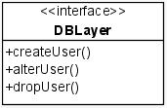
Managing database users
In order to provide complete set of operations we must be able to manage users on the database level. This is not a very standardized part of the SQL standard and is left to individual database systems to implement how they choose. Therefore there is also no support for these operations in Hibernate.
To deal with this, DBLayer provides its own implementation of these operations using JDBC interface (The general layer structure is violated in this case). Currently, these operations are implemented only for PostgreSQL database system, but implementation for different systems should also be possible.

Roles of the users
There can be three types of users in Plantlore (details can be found in the documentation of the database schema):
- Administrators – with almost complete access to data
- Common users – with limited access to data
- Special type for accessing the database from the web interface – with very limited access to data.
Implementation of this user structure is done via different roles for different types of users. These roles are granted or revoked from users upon their creation or modification. There are 3 roles:
- Plantlore_Role_Admin – for users with administrative privileges
- Plantlore_Role_User – for common Plantlore users
- Plantlore_Role_www – for users accessing data through web interface

Names of database user
When user is created in Plantlore we create new database user as well. Name of this user consists of the prefix with database name (database this user can access) and the login name itself. If a person wants to access more databases on one database system, we create separate database user for each database. (they are differentiated by the prefix with the name of the database). This way person using plantlore can use one username for multiple databases since when logging in to a database, username provided by the user is combined with the database prefix and then used to for database system authentication.

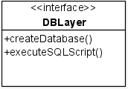
Creating new database
Creating new database is another operation where direct usage of JDBC API is required. Currently it is implemented only for PostgreSQL database system. Creating new database constists of creating the database itself (CREATE DATABASE statement), creating appropriate database user and database roles and creating database tables. SQL statements for creating users, roles and tables are stored and loaded from files located in net.sf.plantlore.config.database package. See the following methods in the HibernateDBLayer for more details:
- createDatabase() - creating new database
- executeSQLScript() - executing SQL script. This method has to be called for script for creating database users and roles and script for creating database tables.

