PLANTLORE



Analysis of the System

Usecases

Version from 15. 02. 2006

Charles University
Faculty of Mathematics and Physics
Prague, Czech Republic

Supervisor: RNDr. Antonín Říha, CSc.
Lada Oberreiterová | ladaob@seznam.cz
Jakub Kotowski | fraktalek@gmx.net
Tomáš Kovařík | tkovarik@gmail.com
Erik Kratochvíl | krater@seznam.cz

Table of contents
PLANTLORE 1
Analysis of the System 1
Usecases 1
Preliminary Analysis 3
Choosing the DB 4
Managing the Database 7
Help and Tooltips 9
The Data Overview 10
Importing the Data 14
Exporting the Data 15
Adding and Editing the Data 16
Available Plant Names 18
Accessing the System via an Internet Browser 19

Preliminary Analysis
Only one instance of the System can run. The User is not expected to work with two database connections at the same time.

Choosing the DB

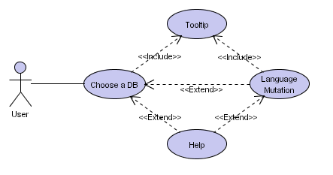
Choose a DB. The System displays a list of triplets <Alias, Server Name, Database Name>. An Alias is a string that helps the User to remember the data resource easier, such as “My Local Database” or “The Main Database at the Facility”. The Server name is a unique identifier consisting of the hostname (or IP) and a port. The Database name is a unique identifier of the database on the server. This list is unique for each user of the operating system.
The User performs one of this actions:
- switch the Language Mutation,
- invoke Help,
- select one triplet from the list and Delete it from the list or Rename it,
- Add a new triplet (ie. record describing an existing database),
- select one triplet from the list and perform Authentication,
- enter a manage-regime to Manage the properties of an Existing DB.

Language mutation. The System displays the list of supported languages and the User chooses one of them. The System switches to the selected language mutation and communicates with the User in this language for the rest of Her session (i.e. Until She's logged off). The System must support Czech and English; other languages are optional.

Help, Tooltip. Section Help and Tooltips.

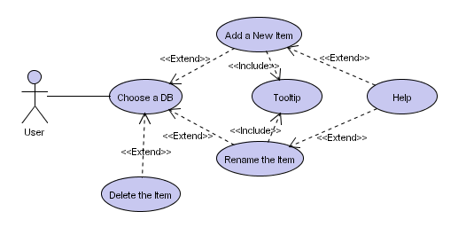
Delete the Item (triplet). The System shows a warning “The [ITEM] will be deleted (this will not remove the database).”, waits for the User to confirm it, and removes the selected triplet from the list (no database is actually deleted).

Add a New Item (triplet). The User fills in the alias, hostname of the server, and the database identificator. The meaning of the fields is the same as in the Choose a DB. The User confirms the data, and the System creates a new item in the list of triplets.

Rename the Item (triplet). The User changes the alias, or the hostname of the server, or the database identificator, which the System filled with current values. The User confirms the changes, and the System saves them.

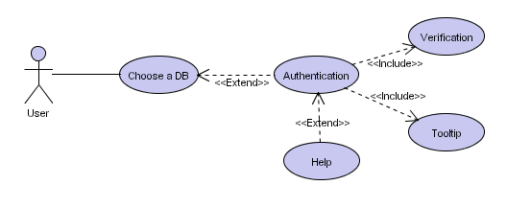
Authentication. The User inserts a username and password. The System stores five usernames for each triplet in the list and fills the username with the value used last time. The User either selects one of the usernames the System remembers or types in a new one. The System does not store passwords. After the User confirms the input, the System performs the Verification.

Verification. The System attempts to connect to the selected server and open the database using the information obtained from the User during the Authentication. If the attempt fails, the System shows a short description of the reason. The User accounts management is described in the Manage the DB usecase.
If the connection is established (the User is logged in), the System displays the Data Overview (section The Data Overview).

Add (create) a DB. The Database Manager provides: alias for the triplet and the name of the DB. The System creates a new database on the local database server (it is not possible to create a new DB on a remote server because of the security reasons). The System creates a new triplet in the list using the information obtained from the User. The System invokes Manage the DB for the newly added DB.

Managing the Database

Manage the DB. The Database Manager enters the password to gain the access to the settings of the selected database. The System displayes detail information about the database: server name, name of the database; and list of all user accounts that have been granted access to the database.
The Database Manager performs one of this actions:
- Change the Password protecting the settings,
- Add an Account to the list of accounts,
- select an account and Delete the Account,
- select an account and Edit the Account,
- Remove this database for good,
- create Backup of the database,
- Restore the state of the database from a backup copy.

Change the Password. The Database Manager inputs the new password and confirms the new password by typing it again. If both passwords match, the System changes the old password protecting the database settings to the new one. If the passwords in those two fields do not match, the System shows a warning and doesn't change the old password. The password may stay empty meaning no password is required. This password prevents users from unauthorized access to the database settings and prevents the database from being deleted by other users.

Remove the DB. The System displays the message “This database will be removed from the System, all data will be lost beyond recovery.” The Database Manager confirms this warning, and the System deletes the database from the db server.

Backup. The System creates a backup copy of this database. The System displays the progress bar so that the Database Manager can monitor the state of the operation. The process can be canceled – the System gets rid of the incomplete backup copy in this case.

Restore. The System displays a list of all available backup copies of the database – those backup copies are identified by the time and date they were created. The Database Manager selects one of them, the System displays the warning: “The database will be replaced with the backup copy [date&time_of_the_backup_copy].”. The Database Manager confirms the warning, and the System restores the state of the database from the selected backup. The System displays a progress bar so that the Database Manager can monitor the state of the operation. This process cannot be canceled.

Add an Account. The Database Manager inputs the username of the new user, the password for this account and the real name of the user. The username and password are the data the User will use to gain the access to the database, the real name of the user helps to identify the person for whom the account was created.
The Database Manager confirms the data, and the System adds the record to the list of user accounts.
There is one special account: www. If an account of this particular name is created, it means the database can be accessed via the Internet using an internet browser. The password and the real name doesn't matter. For further details consult the section Accessing the System via the Web Browser.

Edit the Account. The System displays detail information of the selected user account containing:
- set of columns visible (accessible) to the user logged with this username when browsing the data,
- set of user rights: to add new records, edit all existing records, edit Her own records only (i.e. records added by this user), delete all existing records, delete Her own records only, import records, and export records.
The Database Manager can change all those information above – She can specify which columns are visible (accessible) to the user, and modify the user rights.
The user account www is special – only the set of visible (accessible) columns can be changed. The user www has the right only to browse the data.
The Database Manager confirms the changes, and the System stores them.

Delete the Account. The System deletes the selected account from the list of user accounts. By doing so, the username is no longer accepted by the System to provide the access to the database.

Help and Tooltips

Help. The System displays a complete description of the current form.

Tooltips. The System shows a brief description for an item if the mouse pointer is hovering over it for a short period of time (~2 seconds). The tooltip disappears when the mouse moves.

The Data Overview

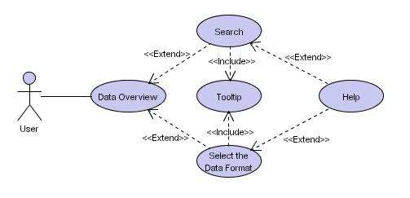
Data Overview. The System displays list of records of the database matching the last query (search request). The form of the list is determined by the data format (usecase Select Data Format).
Columns, that are set to be inaccessible to the User, are left blank.
The User can easily browse through the data. The browsing means the ability to move to the next and previous item in the list and to move among the pages. To learn more about formats, see the Select Data Format usecase.
The User performs one of these actions:
- Search in the database (ie. generate a new query),
- Select the Data Format,
- Print the listed data,
- invoke Help,
- Log Off,
- Edit the records,
- Add new record(s),
- Delete the records,
- Import new records from a file,
- Export records to a file,
- switch to the Plant Overview,
- Change the Account Password protecting Her account,
- or Undo previous operations.
The User can also Mark (check off) records of the list. These marks determine which records will be deleted, printed, or exported from the list – the User may not wish to delete/print/export all displayed records.

Search. The System displays either the Simplified or the Extended Searching Form or the SQL console (described below). The User can switch between these three searching styles.
The simplified searching form allows the User to search by the name of the taxon, accepted plant name or its synonym, the name of the person who discovered it, and the nearest bigger seat.
The extended searching form allows the User to search by the author of the discovery, name of the plant, year of the discovery or range of the years, habitat, the nearest bigger seat, fytochorion, region, quadrant, altitude, longitude, latitude.
The SQL console allows the User to write the query by Herself. This searching method is safe (preventing the User from entering malicious SQL queries).
The User confirms the data (or the SQL query) and the System performs the search. If more than one field is filled, the System returns records matching all fields (AND-semantics). The result is displayed in the Data Overview.

Select Data Format. The User selects one of this three alternatives (“how the records will be visualized to the User”):
- Simple tabular. The System displays the records of the database in a traditional table containing these columns: accepted plant name or its synonym, the name of the person who discovered it, and the nearest bigger seat. If some of those columns are not visible to this User, they are blank.
- Extended tabular: The System displayes the records of the database in a the same way as in the Simple tabular variant. The only difference is that the table has all columns: author of the discovery, name of the plant, year of the discovery or range of the years, habitat, the nearest bigger seat, fytochorion, region, quadrant, altitude, longitude, latitude.
- Herbal (Scheds): The System displayes the records in the form of a sched:

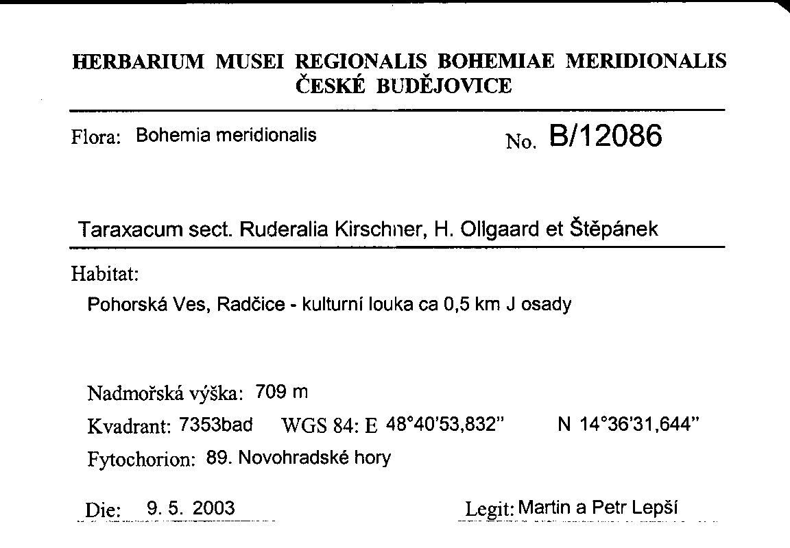
The User picks one of these alternatives. She can specify the number of records per page for the simple and extended tabular form.

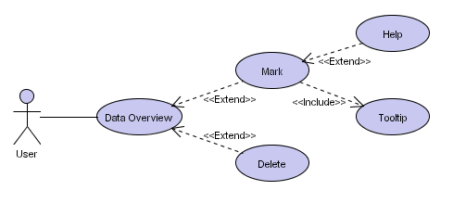
Mark. The User can either mark (one-by-one) the records of the list, or unmark all records in the list, or invert the marks, i.e. marked records become unmarked and vice versa.

Delete. The System shows the warning “All marked records will be permanently removed from the database.” that the User must confirm. Then, the System permanently removes all marked records from the database.

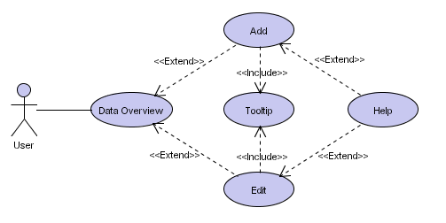
Edit. Section Adding and Editing the Data.

Add. Section Adding and Editing the Data.

Export. Section Exporting the Data.

Import. Section Importing the Data.

Print. First, the User picks columns She wishes to export. Then, the User selects the printer. The System prints all marked records of the list; the System prints them in the same format they are displayed. The System prints only those of the selected columns, that are set to be visible to the Username.

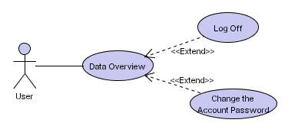
Log Off. If there is any operation in progres (in the background), the System displays a warning that the premature shutdown may result in an unwanted data loss. The User either confirms the warning, then the System stops all operations, logs off the User from the current server/DB by closing the connection, and terminates itself; or the User discards the warning, in that case the System takes no action.

Change the Account Password. The User enters the new password and confirms it by typing the password again. If both entries match, the System changes the old password protecting the account to the new one. The password may stay empty meaning no password is required.

Undo. The System displays a list with last few operations, that changed the state of the database. The System keeps track of these changes: add, edit, delete, import (which is in fact a series of adds). The amount of those changes is limited – the oldest changes are removed from history, if the size reaches a certain point. The User selects a certain point, and the System performs a rollback of all operations preceding that point.

Importing the Data

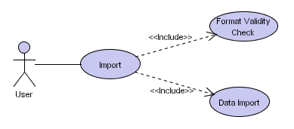
Import. The User specifies the name of the file containing the data. The User confirms the file name and the System performs the Format Validity Check. If the Format Validity Check indicates no error, the System performs the Data Import.

Format Validity Check. The System verifies the validity of the format and checks whether the data stored within are
- correct (i.e. the file has the right structure),
- consistent with its internal DB scheme,
- provide sufficient information.
The supported DB formats are: MS Excel datasheets (XLS), CSV (comma separated values format) and XML.

Data Import. The System merges the data in the file with the existing database. The System displays a progress bar so that the User can monitor the state of the operation. The System will reject any record whose plant name is not in the list of all available plant names – a warning is displayed in that case: “The [INVALID_RECORD] cannot be imported – the name of the plant is unknown.”

Exporting the Data

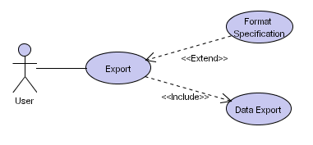
Export. First, the User picks columns She wishes to export. Then, the User specifies the name of the file where the marked records will be exported. The User confirms the name and the System performs the Data Export.

Format specification. The User selects one of the formats from the list of the supported formats. The System supports these formats: DMAP (see http://dmap.co.uk), XML, CSV (comma separated value format). The default format is XML.

Data Export. The System exports selected columns of all marked records of the list into the specified file using the specified format. It respects the access rights – those columns, that are set to be invisible to the Username, are left blank. The System displays progress bar so that the User can monitor the state of the operation.

Adding and Editing the Data

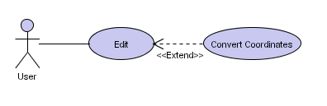
Edit. The User must have the right to modify records. The User edits the currently selected record of the list.
The System offers an interactive assistance to the User; this means the System provides an automatic word completion for following items: the name of the author, the name of the plant, the nearest bigger seat. The System will not allow the User to enter a name of a plant that is not in the list of all available plant names (section Available Plant Names).

Convert Coordinates. The User selects the format (that the coordinates will be converted to) from the list of supported formats: WGS84, S-42, S-JTSK. The System performs the conversion from the current format to the selected one.

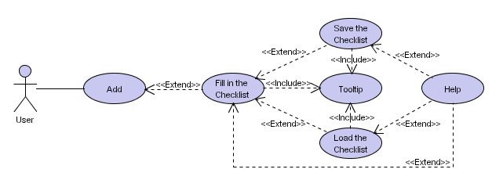
Add. The System provides two “adding modes” (described below): the User is presented with the previously used mode (or with the Simplified Adding Mode by default). She can switch to the other mode.
In The Simplified Adding Mode the System shows only these columns: taxon, author, year of discovery, place and the neraest bigger seat. The User fills in the data while the System assists Her offering the automatic word completion for following fields: the name of the author, the name of the plant and the nearest bigger seat. In the name-of-the-plant item the User can specify more than one plant (separated by commas), in that case the System creates a separate record in the database for each plant (the rest of the record is the same). This simplifies adding of multiple plants occuring in one habitat. The User can also Fill in the Checklist to specify the plants – the System fills the name-of-the-plant item with names marked in the Checklist.
In The Extended Mode the System shows all columns. The User fills in the data and the System assists Her with automatic word completion for the same columns as in the Simplified Mode. As in the simplified adding mode the User can specify more plants, the System behaves exactly the same way.
In both modes: before the User can proceed to add other information, She must instruct the System to merge the data with the database.

Fill in the Checklist. The System displays a list containing all plant names available to this database, all initially unmarked. The User marks one or more items of the list and confirms it. The System copies the marked items to the name-of-the-plant field. The User can Save the Checklist or Load the Checklist.
The User can switch to an alternative mode of the checklist: The System displays a list containing names of plants, initially empty. The User can add items to the list from the list of all available plant names (section Available Plant Names). The System copies the marked items to the name-of-the-plant field. The User can Save the Checklist or Load the Checklist.

Save the Checklist. The User inputs a file name. The System saves the state of the Checklist to that file, i.e. which items of the list were marked.

Load the Checklist. The User inputs the file where the state of the Checklist is stored. The System revives the state of the Checklist from that file.

Available Plant Names

Every database has its own list of plant names. This list is edited by a special person (“central authority”) responsible for the list of plant names. Common users should get the latest copy of this list and import it to their databases.
The list of the plant names is used by the checklist.

Import Plant Names. The User selects a file, and the System replaces its current list of plant names with the list in the file.

Export Plant Names. The User enters the name of the file, and the System exports all plant names from its database into that file. The file format must be simple so that the human user can easily modify it.

Accessing the System via an Internet Browser

The User can access the System via the web browser. She types in the URL of the desired web server. The System displays list of all databases on this server. The User selects one of the databases. The System looks for the www account (see Manage the DB – Add an Account). If there is no such account for this database, the System generates an announcement “This database is not accessible via the web browser.” In case the www account exists, the System will use it to derive the access rights granted to the User www, because the access via the web provides only a limited functionality – the User will be able to
- browse data (usecase Data Overview),
- search records (usecase Search),
- change the format in which data are displayed (usecase Select Data Format).

The User may wish to work with more databases, to which She has different access rights.

