Plantlore Server and The Communication Layer
Plantlore Server and the Communication Layer [CL] are very tightly coupled. The Communication Layer mediates the connection between the Database Layer [DBL] and the Presentation Layer [PL]. The PL and the DBL may be running in different Java Virtual Machines [JVM] but do not necessarily have to. The CL can be disengaged during the local connection and save the overhead that comes with it.
The role of the Server is important only when establishing a new remote connection, and after that the Server just provides some necessary system resources, but is no longer of vital importance and doesn't play almost any role anymore.

The Technology
The technology used to achieve the desired level of transparency, simplicity and elegance is RMI. RMI stands for the Remote Method Invocation and it is a standard part of every JVM. The greatest advantage of RMI is that to the caller everything appears to be the same as if the calls he makes to remote objects were local. The only difference is that remote calls may throw RemoteException. If handled properly, it will pose no problem.

RMI Overview and Terminology
The Remote Method Invocation allows us to invoke methods of objects, that do not live in the same JVM as if they were only local objects. The RMI machinery is quite complex and it will not be covered here.
The use of this mechanism is simple and involves five steps:
- A program P creates an object O in its JVM.
- The RMI must become aware of existence of this objects, so that it can accept remote calls. The program P must export it = make RMI aware of it. If the object O is exported, it is called a remote object.
- The program P should bind the remote objects to a Naming service, that is easily accessible, so that anyone can obtain the remote references. If an object is exported, a remote reference (or stub) is created. The stub is a proxy that contains information about the exported object and allows its owner to invoke calls on the remote object. Stubs can be passed via the network and can be available at different JVM, while the remote object never leaves the JVM in which it was created.
- Clients that wish to call methods of the remote object O must obtain their stubs first. This is done by asking the Naming service (lookup), which returns the appropriate stub for the remote object.
- Clients can call methods of the object via the stub.
The Client always has a stub and can use it to invoke methods of the remote object. Each method call is handled by the RMI – parameters are marshalled (packed, serialized) and send to the remote RMI, which must recreate those objects (unmarshall, deserialize) and fill them with sent values, perform the method call, marshall the result, send it back to the other RMI, which unmarshalls them and returns them as a result of the method call.

The Naming Service
The Naming service is a remote object, that is capable of storing pairs (Name, Stub) and returning the stub when asked for it by the associated name.

The Stub
A stub is generated for each remote object. Stubs are objects, they have their own classes. If we use the default Naming service, the stub's class is automatically (by RMI) downloaded, so that the stub (object) can be created on the local client.
If we for some reason do not wish to use the Naming service and have our own way of handing over the stub to the client, we must also ensure, that the client has an appropriate class, to be able to re-create the stub.

The Price
The price we have to pay is surprisingly low. First, everything that is passed as an argument of a remote call, must be serializable. Almost all objects that are available at java.lang and java.util are serializable. Making your own object serializable requires you to implement the "marker" interface Serializable. The interface is empty. And second, every method, that accepts a remote call, must throw a RemoteException. This way the RMI mechanism lets us know that something went wrong during the remote call. After all we work with the network.

The Idea
The PL and the DBL are connected. The PL calls methods of the DBL and DBL returns some values to the PL. This is how common work with the DBL would look like. Let's suppose we would be able to create a DBL in a different JVM than the PL. If we use the RMI in a clever way, PL may think that it works with a common object while the DBL will be in fact in a remote JVM operating with a remote database.
All we need is to create a mechanism, that will be able to create Database Layers in remote JVMs and return their stubs to Presentation Layers that will work with them remotely without knowing it. This mechanism together with the RMI can be called the Communication Layer.

Participants
Since the creation of the DBL will be complicated, we will create a DatabaseLayerFactory that will shield us from the creation of the DBL completely and just return either the local DBL or the stub that will allow the PL to make remote calls. The PL will not be able to tell the difference. The DatabaseLayerFactory must have its counterpart running in the remote JVM that will create the DBL for there and then pass its stub back to the DatabaseLayerFactory. We will denote the counterpart as RemoteDatabaseLayerFactory.

The DatabaseLayerFactory
The interface of the DatabaseLayerFactory is simple.
interface DBLayerFactory {
DBLayer create(DBInfo settings);
void destroy(DBLayer db);
}
In the create() method the DatabaseLayerFactory will decide whether the User wants a local connection or a remote connection - this will be clear from the parameter DBInfo.
- If the User wants only a local connection, the new DBL is created in the local JVM, thus leaving the RMI out of the picture and saving the overhead that is connected with this technology.
- If the User wants a remote connection, the RemoteDatabaseFactory is contacted, asked to create the new DBL in the remote JVM and then the stub of the remote DBL is returned.
In order to secure a careful destruction of the DBL we provide the destroy() method. The principle is the same.
- If the destroyed DBL is local its destruction is local - only a method ensuring the proper cleanup of the database connection is called.
- If the destroyed DBL is remote, ie. if we have only the stub, we must contact the RemoteDatabaseLayerFactory which can destroy it properly. This is why the DatabaseLayerFactory must keep a list of all DBL it has created (or at least helped to create) in order to know which of them can destroy by itself and which must be destroyed by the RemoteDatabaseLayerFactory that created it.

The RemoteDatabaseLayerFactory
The interface of the RemoteDatabaseLayerFactory.
interface RemoteDBLayerFactory {
DBLayer create();
void destroy(DBLayer stub);
}
The purpose of the RemoteDatabaseLayerFactory is to
- create new Database Layers, make them accessible to the RMI so that they can accept remote calls and then return their stubs,
- unexport Database Layers, thus disabling the ability to receive remote calls, and to ensure the proper cleanup of the database connection.
Note that the DBL is not made available in the Naming service to anyone - it is export and becomes a remote object, but the stub is passed only to the caller. No one else will have access to it. Every caller will have its own DBL. In order to monitor the number of Database Layers currently created, the RemoteDatabaseLayerFactory may implement some policy and reject creation of new Database Layers if the policy would be violated.

The Server
The Server has the following interface.
public interface Server
void start();
void stop();
ConnectionInfo[] getClients();
void disconnect(ConnectionInfo client);
}
The purpose of the server is to
- create and export the RemoteDatabaseLayerFactory, so that it can accept remote calls, and bind it to the Naming service, so that it can be contacted by anyone,
- unbind the RemoteDatabaseLayerFactory from the Naming service rendering it inaccessible, unexport it, thus preventing it from receiving remote calls, and instruct it to destroy all DatabaseLayers it has created,
- return a list describing all currently created Database Layers, which may be perceived as a list of currently connected clients,
- disconnect a client from the server, ie. instruct the RemoteDatabaseLayerFactory to destroy the DBL although the client does not wish it.

The Interaction of the Participants
The interaction during the Server startup and the new Database Layer creation.

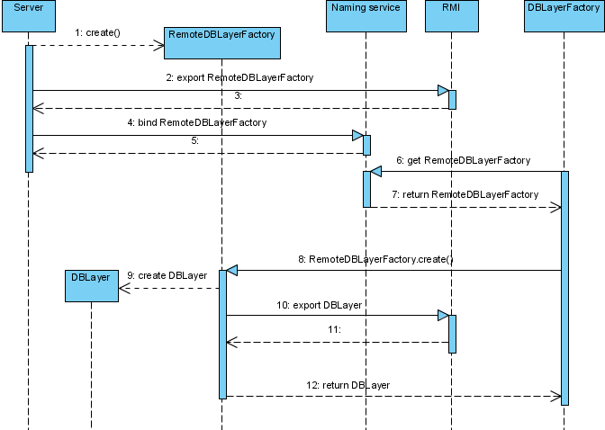
The Guard
The Server must be accessible for others to control. The Server in fact exports itself, making itself a remote object, but it doesn't bind itself to the Naming service which means its stub will not be easily accessible.
Then the server creates another remote object, the Guard, that is exported and bound to the Naming service. The Guard contains the stub of the Server and if the Guard is asked, it can return the stub of the Server, thus efectivelly allowing the caller to control the Server by invoking its remote methods.
The interface of the Guard is:
interface Guard {
Server certify(String authorizationInfo);
}
This is how even a remote administration of the Server is achieved. Anyone who wishes to control the Server, contacts the Guard, that is publicly available in the Naming service, calls its certify() method and passes the authorization information. If the information is valid, the stub of the Server is returned.

The Database Layer
It has been mentioned already that while the whole process is completely transparent to the PL, the DBL knows about it and must be prepared to take some extra measures. Since the DBL cannot allow the object SelectQuery to leave the JVM where the DBL lives, because if it did, then anyone could modify it and supply a malicious SelectQuery which would completely undermine the system of access rights. Therefore the SelectQuery is another remote object that is exported by the Database Layer, every time the DBL is asked to create it. The DBL must also destroy (unexport) the SelectQuery. This is what the DBL's methods createQuery() and closeQuery() do. The caller works in fact with stubs.

The Undertaker
The RMI allows the remote object to monitor the state of its remote references. If there are no remote references to the remote object left (either because clients discarded them properly or because they crashed), the method unreferenced() of the Unreferenced interface is called.
This mechanism is used to ensure a proper cleanup of the DBL even if the client crashes. Every remote DBL monitors the number of remote references and is equiped with an object that can destroy it properly if no stubs are left. This object is called the Undertaker.

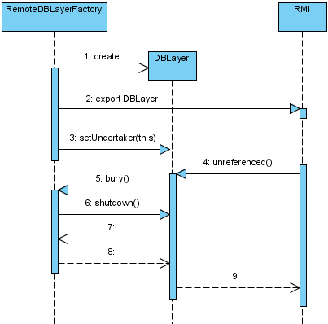
The Destruction
Very similar actions must be taken if the DBL is to be destroyed, but in the inverse order. The DBL is unexported and its shutdown() method is called. The same goes for the RemoteDatabaseLayerFactory which is unbound from the Naming service, unexported and destroy() is called for every DBL that has not been destroyed yet.

Settings of the Server
The Server is configurable and it is possible to store the configuration in a file. The configuration is restored next time the Server is started. In case the configuration file is missing, the default hardwired configuration will be used.
The format of the file is based on XML. The file can be found in the Plantlore configuration directory under the name plantlore.server.xml.
Most of these settings can be set using the GUI except the number of connections per ip and the total number of connections. These settings are not documented in the User manual because they were not required to be part of the Server.
The format of the configuration file:
<config>
<server>
<port>1099</port>
<connections>20</connections>
<perip>3</perip>
<database>
<engine>postgresql</engine>
<port>5432</port>
<parameter></parameter>
</database>
</server>
</config>

