Export
Export is one part of the Presentation Layer. Export is used to "take" the data from the database and store them in a file. This raises the need to be able to handle several different file formats, each of which has its special requirements. Therefore the Export framework follows the Builder Design Pattern.

The Technique
The Export allows the User to select the list of records that are to be exported and specify which attributes of the Occurrences are important. The list of selected records is represented by a simple wrapper of a set called the Selection - the records are identified by their unique database identifier, there is no need to store the whole records. The list of selected attributes is represented by another wrapper of a set called the Projection. The Projection allows us to quickly determine, whether certain attribute of the record was selected or not. Their names correspond with their purpose in the database language.
Export also makes use of the last select query that was executed by the User in the Search. If the User selected the records from a smaller subset, it is convenient to use this subset as a frame for the Selection. The last search query is also required in order to achieve the proclaimed functionality: nothing means everything i.e. if the User didn't select any record, everyting from the last Search will be exported.
After all information needed to start the export are gathered, they are supplied to an Export Task Factory, that can create Export tasks (Directors of the Builder Pattern), and appropriate Builders according to the selected file format.

The Participants
There are three participants that will be described below.

Builder
The interface contains several methods that are used to decompose the Occurrence data fetched from the database and build the output appropriately.
interface Builder {
void header();
void footer();
void startRecord();
void part(Record arg);
void finishRecord();
}
The Occurrence record is quite complicated and there are M:N relations in the database model. In order to process the Occurrence properly, it must be supplied to the Builder in parts. Those parts could be easily identified using the Java's reflection API, therefore it is not necessary to have several methods for each part of the record.
The Builder usually takes the Projections in order to know which attributes should be exported and which should not.
A typical Builder implements the header(), footer(), startRecord() and finishRecord() methods in its own specific way, but the implementation of part() is usualy the same. In this method the whole record is decomposed and sent to the ouptput.

ExportTask
The Export task is the Director that manages the whole export. Export task requires a query that will be used to iterate over the last search query, the Selection that contains the selected records from the query (if any), and the Builder that constructs the output.
Builder build
Selection selection

run()
build.header()
for each record R in the last search query do
if not selection contains R continue

build.startRecord()
build.part( R )

if R is Occurrence then
for each AuthorOccurrence AO associated with R do
build.part( AO )

build.finishRecord()
done
build.footer()
The pseudo-code above shows how exactly are methods of the Builder called.

ExportTaskManager
The ExportTaskManager is the Export Task factory. It is used to store the partial information about the future Export task and once all the information required is supplied, it can create a new Builder, that will be used to form the final output, and the Export task that will manage the whole export.

The Interaction
The creation of all participants and their interaction during Export.

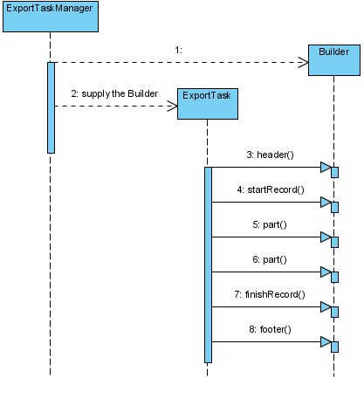
ConcreteBuilder
The Application currently contains four different ConcreteBuilders, three of the are XML based. The last one is a comma-separated-values format.

XMLBased Builders
All XMLbased builders use the DOM4J to construct parts of the output. It is not possible to use the DOM4J to build the whole output, because the XML tree is kept in memory and it could result in extreme memory requirements.
A combined solution was introduced. Only one record is constructed using the DOM4J at a time. If another record is received, the previous one is written to the output. This way it is possible to handle virtually any number of records and still use the greatest advantage of the DOM4J - XML tree construction for Occurrence records.

Comma Separated Values Builder
The CSV Builder places each Occurrence record on a separate line. If there is more than one Author associated with the Occurrence record, the Occurrence is repeated for every Author. That is: an Occurrence having n authors will be repeated three times, each time with a different Author.

