MVC and the GUI communication layer
The graphical user interface of Plantlore is built upon a variation to the Model View Controller architecture. Each bigger dialog in Plantlore is built using at least one MVC class tripple.

The problem
Plantlore client is already quite a rich client from the view of the amount of dialogs and the complexity of communication between them. Most of the dialogs are quite large and writing all the code of one dialog into one class would result in a hard to understand unmaintainable code. On the other hand Plantlore is not so big to leverage all the flexibility of more advanced MVC based architectures like the Recursive MVC architecture for example. There however is a strong need to mediate information from one MVC triad to another.

MVCs
As opposed to for example the Java Swing we decided to implement every time all the three classes individually. This helps solve the problem of very long and complex source files and it is possible to tell quickly where to look for example for code that's responsible for handling user actions or for code that presents the GUI or for the code that does the actual computation and stores the application state.
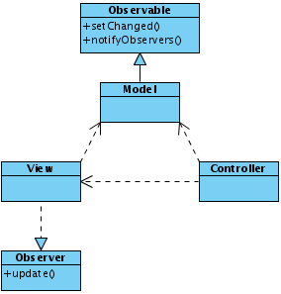

Quick overview of MVC
MVC is usually denoted an architecture as opposed to a „simple“ design pattern. It is possible to find several design patterns in a single MVC. The most important one in Plantlore is the Observer design pattern. Model always extends the standard Java Observable class that is responsible for informing all interested Observers about any change to the model which the model wishes to expose. View on the other hand implements the standard Java Observable interface which practically means implementing an update() method. The update method is called each time the Model extending the Observable notifies the Observers using the Observable.notifyObservers() method. Usually it calles the Observable.setChanged() method right before so that it is sure that the Observers really are notified.
The model usually does the computation and stores all information needed, the view usually presents the information fluently as it is notified from the model that it has changed and the controller's responsibility is to handle interaction with the user.
Another nice feature of MVC, apart from the code separation, is that it is easy to create different views of the same problem (model). Plantlore doesn't leverage this feature.

Problem using MVC
MVC was originally desinged to be one MVC for the whole application. This strategy doesn't suit any modern application any more. Therefore many variations of MVC exist that try to solve distinct problems of modern GUI application. For Plantlore client the main bottleneck was information exchange between the various MVC throughout the whole application.

The „GUI communication layer“
The communication problem is solved in Plantlore using the Observer design pattern leveraging the fact that the models are Observables. Plantlore uses special Observers internally (with one exception) called bridges that work as information mediators from one MVC to the rest of the application.

Bridges
All the bridges live inside the main AppCoreCtrl controller. For example a change a user made in the Settings MVC is stored in the Settings model which notifies all Observers about that change. Usually there would only be one observer, the SettingsView. However, in Plantlore there is another called the SettingsBridge. The SettingsBridge observes the Setting model and propagates any information further to the application whenever needed. This is the only responsibility of the *Bridge classes – to propagate information from MVCs to the rest of the application.

Diagram of Bridge <-> model dependencies
