PSU Chapter – Mars Society

Mars Rover Software (Glove inclusive)

A large portion of the work necessary to produce a functional rover is the software. Our goals of autonomous navigation increase the amount of work necessary for the software system at least two orders of magnitude.
To create a cleaner, and more focused software system we have decided to abandon the former software project which had been worked on in previous semesters. In our current attempt, learning from past shortcomings, we have decided to be aggressive about documentation, standardization, and keeping the system as modular and as simple as possible. In this way, we will produce software that is maintainable in future semesters, and allow new members to be able to contribute with the least overhead learning costs, as well as minimize program errors.
Structure:

The basic structure will modular thread based components. Information will be passed via extern global variables, as if there were some blackboard somewhere which was being watched by independent agents. Each module will provide locking mechanisms for data that that module is responsible for.
The basic structure is as follows:

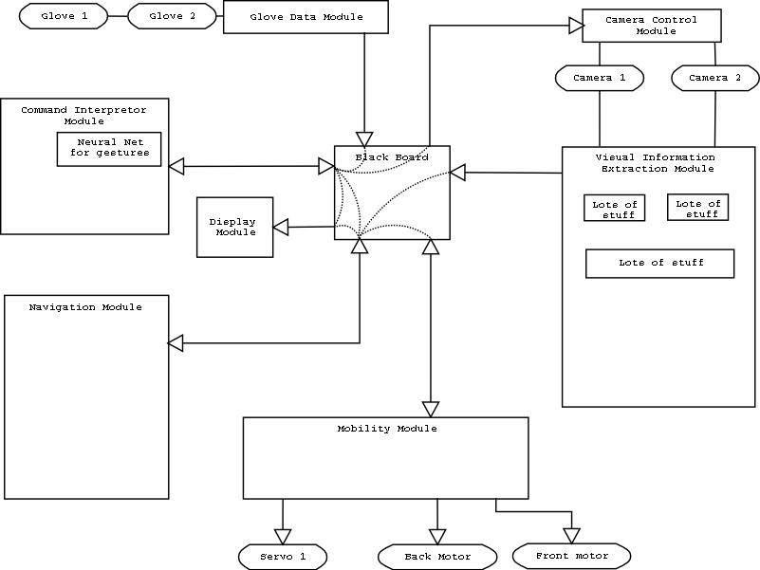
Command Interpreter:

Most of the work with the glove will be done through the command interpreter. It is in fact the command interpreters sole job to interpret information coming from the gloves (until/unless we have other input devices in the future). The command interpreter will be watching the glove data, and use a neural network to classify the gestures from the gloves as commands. Whether it is for direct control of the rover, navigation of menus, or “hot gestures” that initiate semi-autonomous features of the rover. The navigation module will be the biggest consumer of the command modules output.

Navigation:

The navigation module is the center of the autonomous control. It will poll information from all observation input devices and make decisions based on information gathered and the goals it has been directed to achieve. This module will be one of the two most difficult (and interesting) to complete, rivaled only by the vision module. As this type of module has the propensity to be come quite complex, as well as being the module which will the most changing needs, it will likely be subdivided into several sub-modules which may be complex themselves.

Vision:

As one of the major areas of AI, vision and visual information extraction is a difficult task. Like the Navigation module the Vision module will be broken into many smaller sub-modules.

Mobility, Glove, Camera Control:

These modules are simply modules to abstract away the details of the hardware. The most complex of these modules will probably be the mobility module as there is not already a driver available for the HC12. Also the mobility module will also be responsible for several motors as well as the possibility of several servos.
Documentation:

The following is an outline of the protocol that we will use to produce all of our documentation:

- High-level
  - Pictorial representation of the entire project.
  - Design and purpose descriptions for each major module
- Mid-level
  - Source Code file list for each module
  - Source Code beginning comments
    - Beginning comments
      - Filename
      - Module name
      - Date Created
      - Last Modified in which version
      - Author/Modifier list
      - Description
  - Function Usage comments in all header files
    - Brief description of what the function does
    - Brief description of what each of the arguments do
    - “ “ ... return value
  - Algorithm/Psudo-code for all non trivial functions.
    - Place within a comment block before the function definition
    - Leave the details for your code
  - Comment all non obvious lines of code
- Low-level
  - Library/Dependency listing
  - Compile Instructions
  - Makefiles
  - Install Instructions

