**Experiment: Conduction Velocity – How fast is a neuron?**

*Background*

Up to this point we have been studying spikes emitted from crickets and cockroaches, mostly by monitoring the “spike rate” and “spike presence” in response to certain stimuli or conditions. We now will study “spike speed.”

You probably think the nervous system is pretty fast. You seem to hear the spikes immediately when you touch the leg of the cockroach or blow on the cerci of the crickets. But is it instantaneous? Of course not! Not even light, the fastest signal in the universe, travels instantaneously. But how fast is a nervous system? Is it faster than a car, faster than a jetplane, or faster than a cell phone? And how can we measure it?

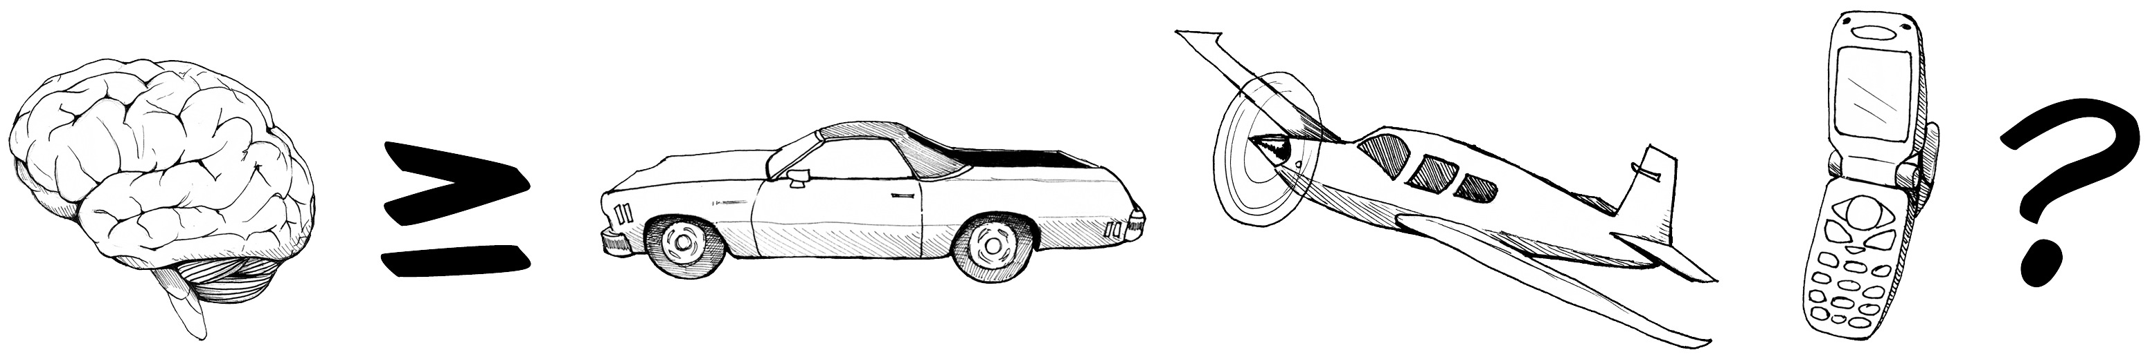

In all previous experiments, we’ve only recorded our neurons using one channel (meaning we use only one recording electrode and one ground). To measure speed (velocity) though, you need to measure both time (when a spike occurred) and distance (how far a spike has travelled down a nerve).

Take the analogy of a car on a highway. If you were looking out of a small observation hut by the road, you could tell what whether you saw a car, what kind of car it was, and the time that you saw it.

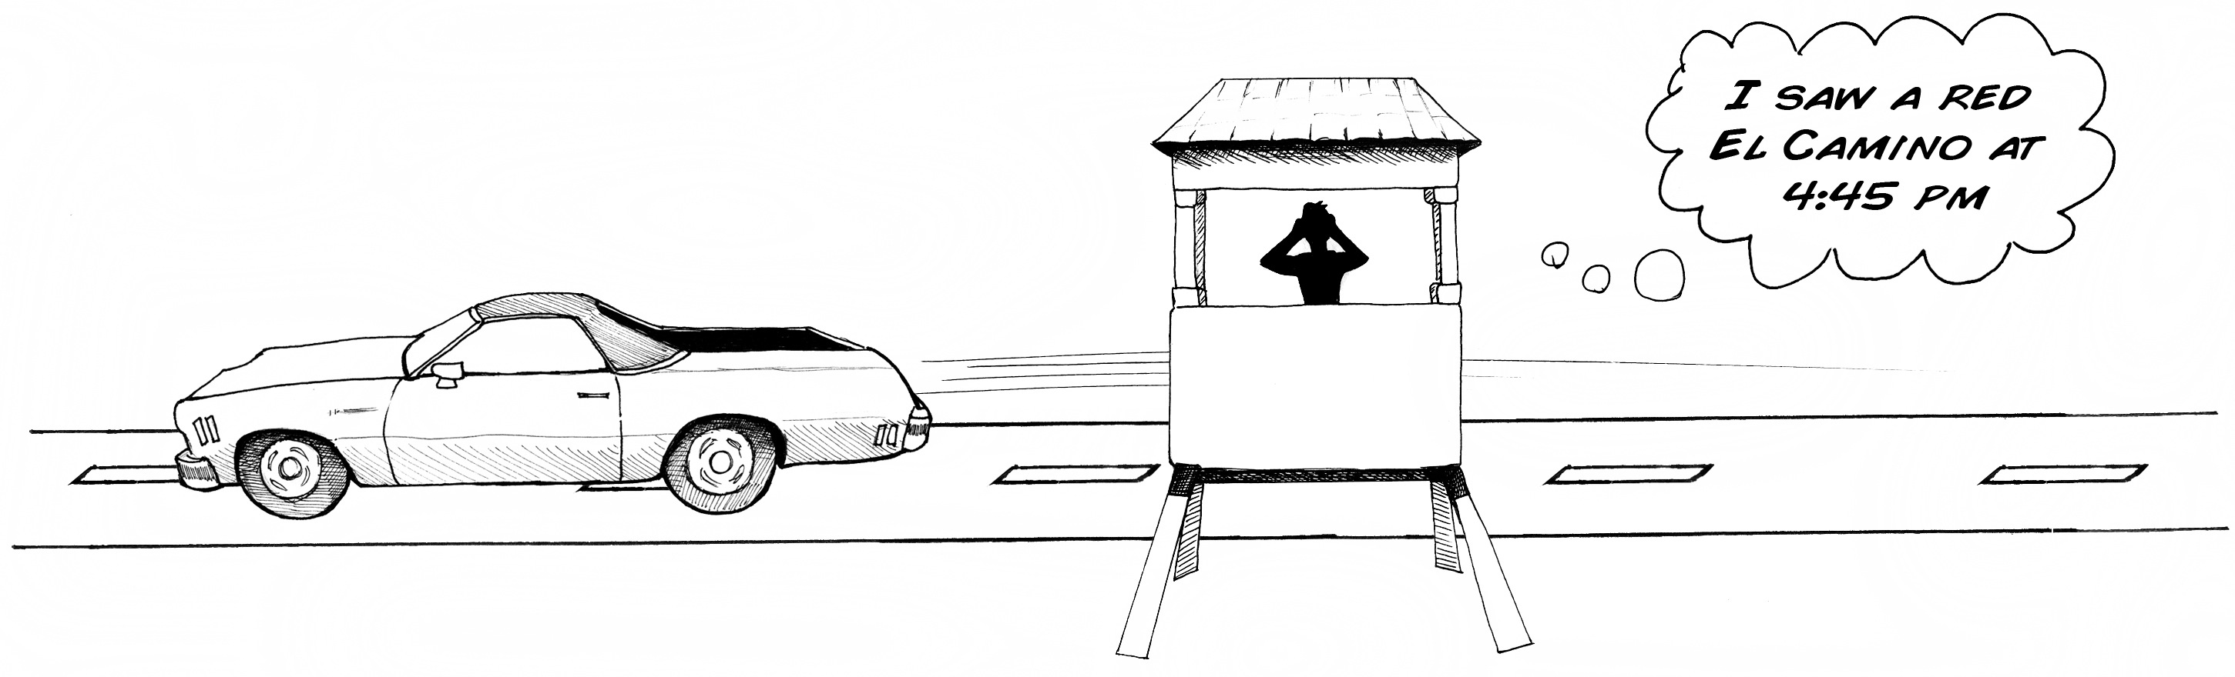

Similarly with your SpikerBox, you can currently tell if you saw a spike, perhaps what kind of neuron generated that spike (we will discuss this in a later experiment), and the time you saw the spike, but you can’t tell how fast the spike was travelling down the nerve.

Let’s go back to the car on the highway. Suppose you had a friend ½ mile down the road in a similar hut:

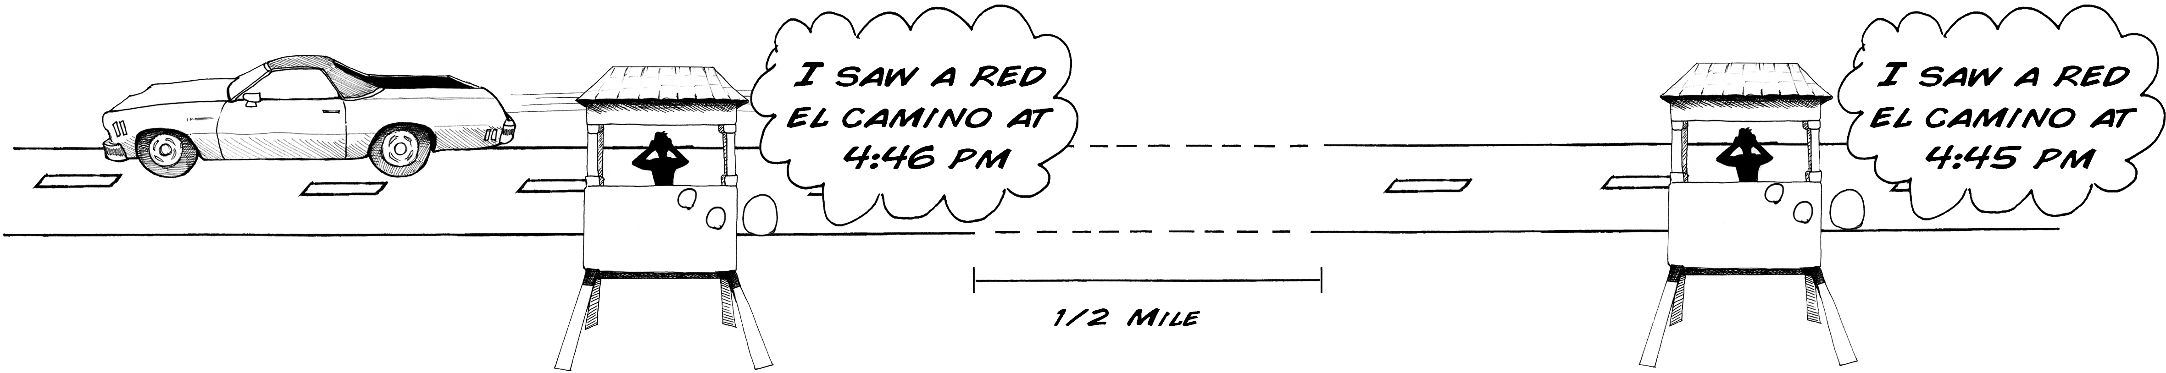

Later, you two could compare notes to determine the speed of the car. 1 minute = 0.016 hours. Dividing ½ mile by 0.016 hours = 31.25 mph.

[illustration]

So, why don’t we take our two-channel SpikerBox with our two electrodes and ground, put it in the cockroach, and measure the spike output of the two channels? You will notice immediately that there are a lot of spikes happening, in fact, way too many to keep track of it all.

Let’s go back to our analog of the road. Imagine a very busy, fast moving street with many similar looking cars, say, Lakeshore Drive in Chicago, and you and your friend can only set up stations very close to each other.



You can see the problem, There are a lot of spikes occurring in the cockroach leg, and identifying unique ones with two observers is very tricky. The femur of cockroach leg has 2 nerves inside, and inside each nerve is about 100-200 neurons, all firing many spikes. We are also limited by how far we can place our electrodes from each other in the cockroach leg, as the leg is only about 8 mm long.

Ideally, given our limited tools, we’d want to measure spikes on a longer nerve, a nerve with only 1-3 large axons in it, and axons that do not fire many spikes.

Is there any creature in the animal kingdom that meets these qualifications? Yes! and it is probably right now under your feet and in your backyard.

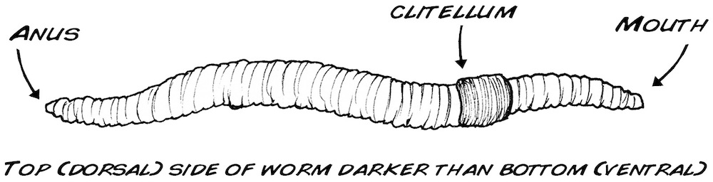

We have been studying arthropods (insects), but we now move to a new class of invertebrate: annelids! Or more commonly, worms! Enter our newest preparation: the common earthworm, *Lumbricus terristrius*. It’s a simpler animal than what we’ve studied before, and the earthworm contains three large axons that run its length, the “medial giant” and the two “lateral giant” fibers. The medial giant fiber transmits information about the front of the worm (the part closest to the clitellum), and the lateral giant fiber transmits information from the skin cells of the posterior end of the worm[1].

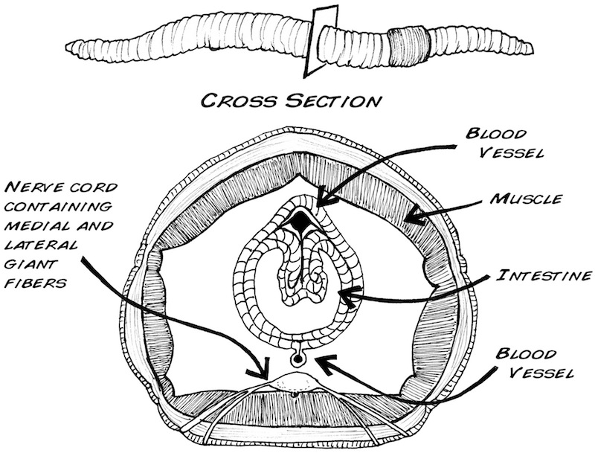

In addition to the earthworm’s long length, which allows us to place our recording electrodes far apart, the earthworm also exhibits what is known as



What is spare coding? Let’s turn back to our cockroach and the “rate coding” you have previously studied. In rate-coding, the intensity of a stimulus is encoded by the rate of spikes. If the cockroach leg used a sparse coding scheme, the leg nerves would only fire 1-2 times when you touched the barb with a toothpick, and 1-2 times more when you removed the toothpick.

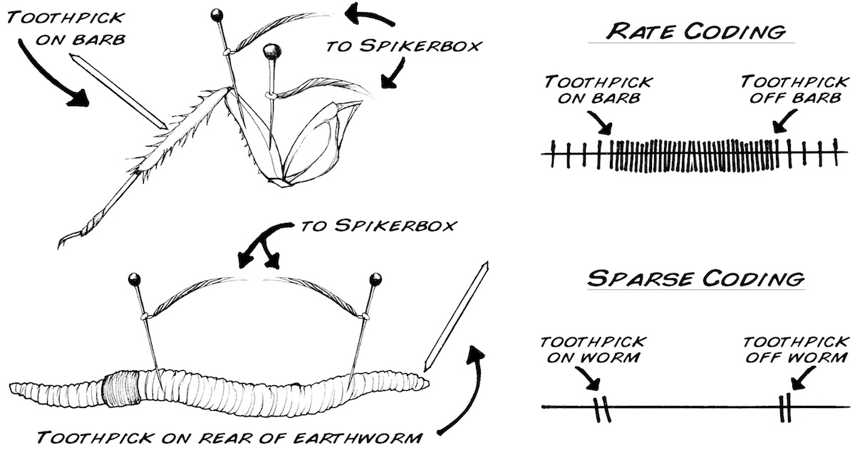

This sparse coding scheme is what we will see in the earthworm experiment below, and we will exploit to measure the conduction velocity (or speed) or the spikes.

*Procedure:*

1. Go to your nearest pet store, sporting goods store, or gas station and purchase a box of earthworms (they are typically used to feed lizards, turtles, and fish. Fishermen use them as bait). They should be around $3-$4 for 12 worms. The Earthworm box should stay in the refrigerator (not the freezer) when not being used. The worms can last approximately 1-2 months.

2. Prepare a 10% ethanol solution. The easiest way to do this is to use vodka (which is normally 80 proof, or 40% ethanol). Since vodka is not much more than watered down pure ethanol, dilute it further to 1 part vodka, 3 parts water. For example, we mix 10 milliliters of alcohol with 30 milliliters of tap water. Ask your teacher to prepare this for you. **Note:** You can also use sugar-free carbonated water (also called club soda or sparkling water) as an anesthetic if ethanol is not available. The CO2 in the water serves as an anesthetic agent.

3. Place a healthy earthworm in the alcohol mixture and wait seven minutes. Do not wait too long; as with human anesthesia, the delicate balance between too little anesthesia and too much is tricky. To little anesthesia and the earthworm will move around during the experiment, the resulting muscle electrical activity (electromyogram) will drown out the small neural electrical signals you are interested in. Too much anesthesia and the nerves will not fire. We’ve found 7-10 minutes is a good range.

4. Place the Earthworm on a piece of balsawood or thick cork, and put your three electrodes of your two-channel SpikerBox in the posterior end of the worm, like this:

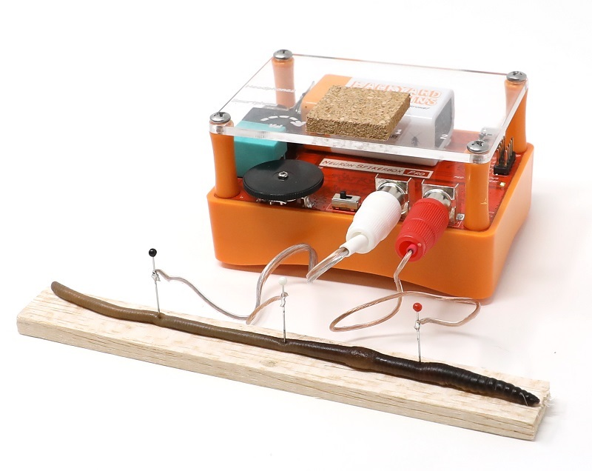

5) Plug the electrodes into your Neuron SpikerBox Pro and the USB cable into your PC.

6) Open our Spike Recorder software, and click on the USB symbol to pair with the Neuron SpikerBox Pro.

7)Press the record button on your Spike Recorder software, and, using a plastic or glass probe, tap the posterior end of the worm. You should hear the evoked spikes caused by the tap. Interestingly, the neurons in the earthworm are myelinated (covered in insulating fat), and you will notice the spikes are much quieter than you are used to.[2] Many nerve diseases, such as Multiple sclerosis, are caused by a degeneration of this fatty covering.

8) Make 3-4 taps, separated by about 3-4 seconds each.

9) Measure the time delay between the two channels by clicking at the beginning of one spike, then dragging to the start of the next. In the corner of the screen you should see the amount of time you have selected.

10) Using a ruler with divisions in the mm range, measure the distance between the electrode one and electrode two.

11) Divide the distance by the time. Viola! You have just measured conduction velocity. Repeat 4-5 times on other spikes, using the table on the following page.

12) Remove the electrodes from the worm, dip the worm briefly in water to remoisturize it, and return the worm to its Styrofoam container. It can tolerate the needle placement and be used for another experiment another day, or you can return it to the environment where you found if you live in wet climates where Earthworms can be harvested in your backyard.

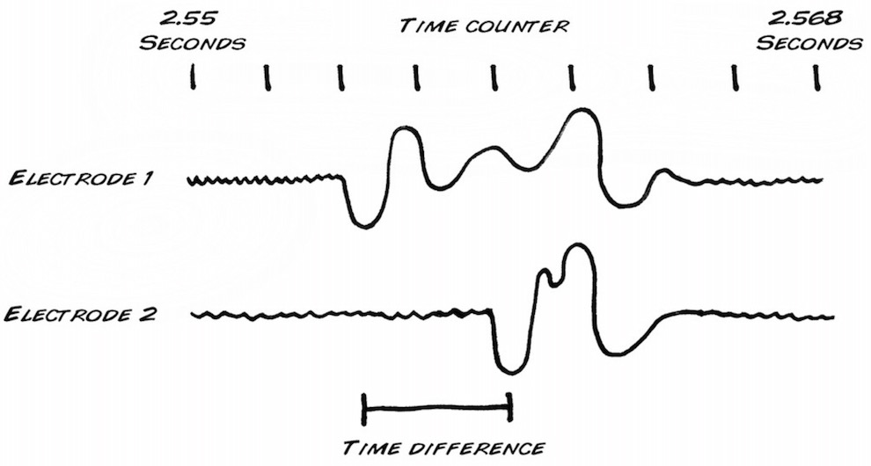



Now start exploring. For example, does this measurement change from spike to spike? Does it change from earthworm to earthworm? Are smaller earthworms faster or slower then large earthworms? Is this speed sensitive to depth of anesthesia? These are all questions we would like to know, and you do to! Let us know what new discoveries you make. To help you learn how to identify Earthworm Spikes, here is an Earthworm Recoding sample audio file.[3]

*Next Steps*

Have you ever wondered, when you stub your toe, how you manage to feel the impact almost instantaneously, but the throbbing pain takes about 1-2 seconds to reach your consciousness? This is because these two signals (touch vs. damage/pain) travel via two different fiber systems that have very different speeds. Below is a teaser as to why - want to dive deeper? Proceed to the next experiment: - **Comparing Speeds of Two Different Fibers**.

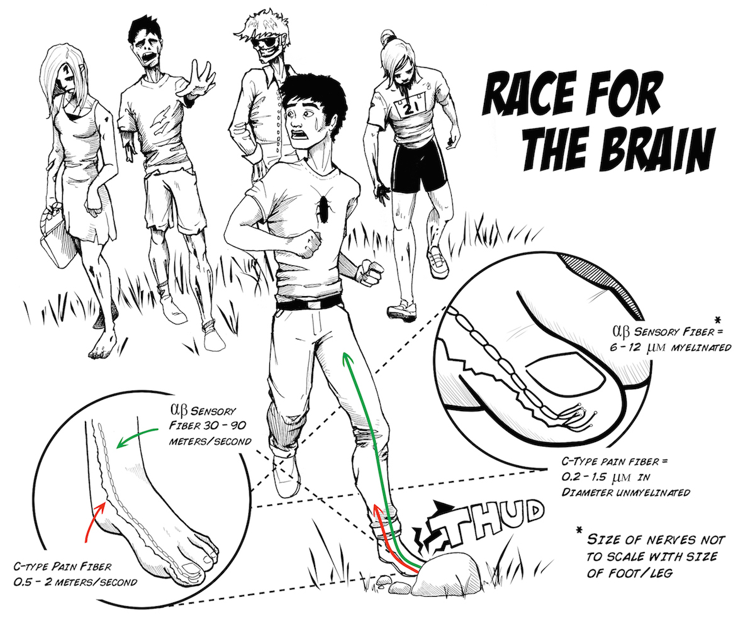

*Trouble-shooting:*

If your earthworm is not healthy (not moving around the soil and not resisting/squirming when you try to pick it up), you will not get good recordings.

*Discussion Questions:*

1) Why are we using alcohol to anesthetize the earthworm instead of ice water?

2) What happens if you reverse the ground and recording electrode 1?

3) What happens if you touch the anterior part of the worm (the mouth).

4) What are some advantages and disadvantages of sparse coding vs rate coding?

1. Kladt N, Hanslik U, Heinzel HG. Teaching basic neurophysiology using intact earthworms. J Undergrad Neurosci Educ. 2010 Fall;9(1):A20-35. Epub 2010 Oct 15.
2. Hartline DK, Colman DR. Rapid conduction and the evolution of giant axons and myelinated fibers. Curr Biol. 2007 Jan 9;17(1):R29-35.
3. http://www.backyardbrains.com/experiments/files/recordings/Earthworm_Double_Recording.mp3