**Plant structure:**

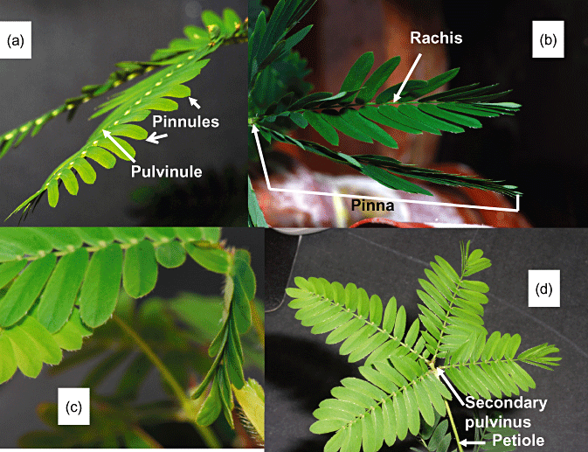

**Kinetics of pinnules closing, mechanically stimulated (MS) by a touch of the midrib**

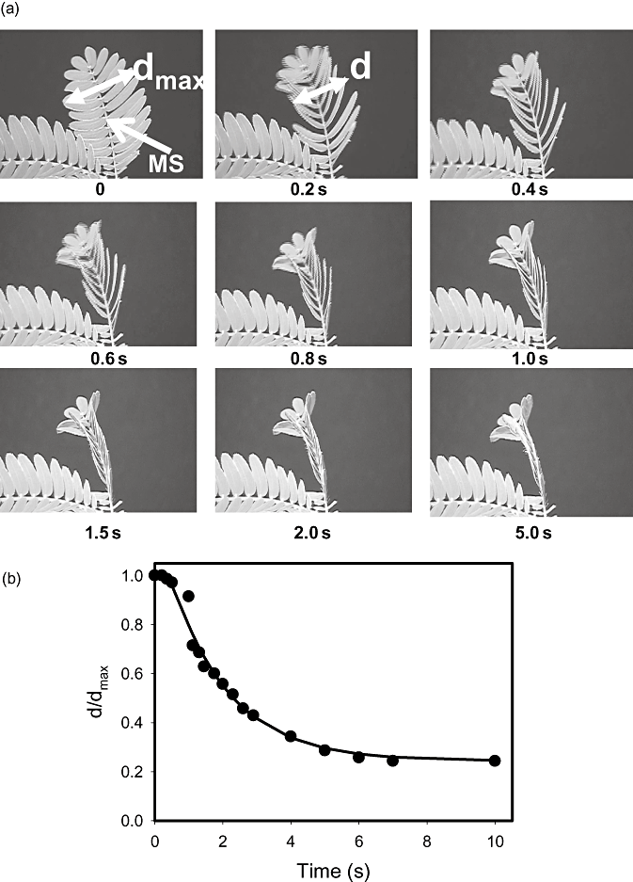

**Kinetics of pinnules opening, after mechanically stimulated (MS) by a touch of the midrib**

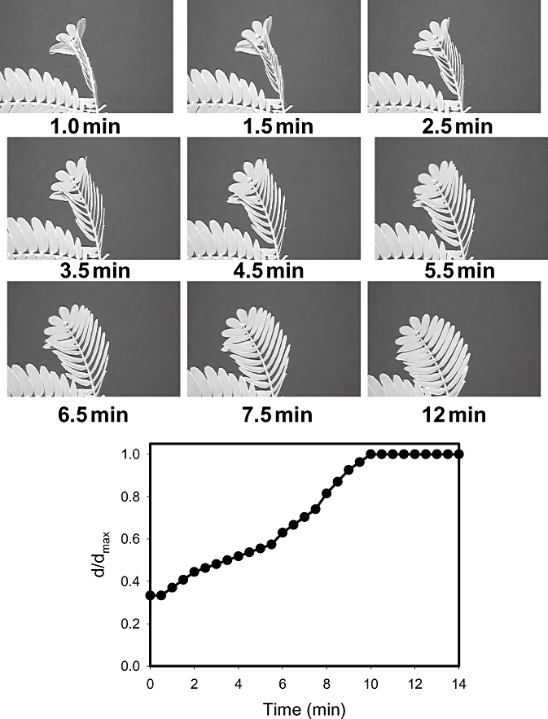

**Time dependence of the petiole relaxation (time it takes for the fallen petiole to rise back to normal).**

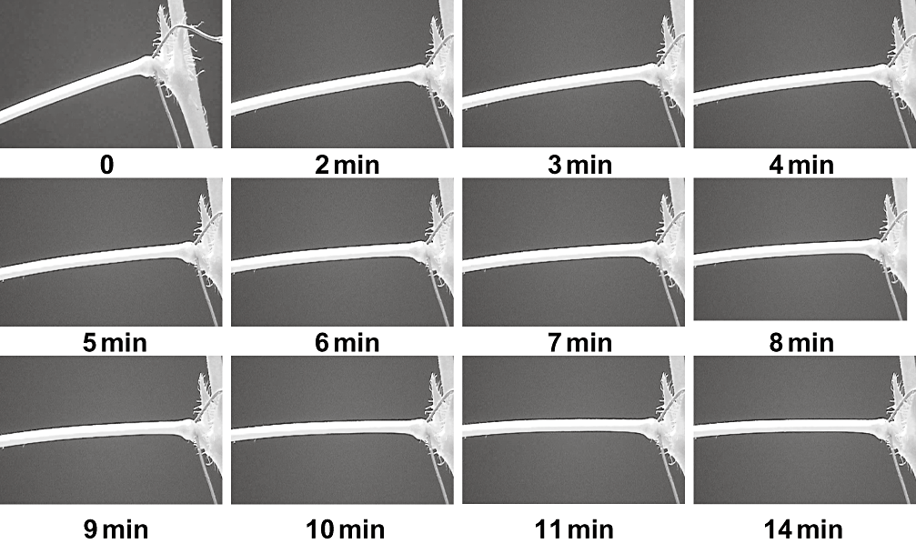

About this process of the plant movement, my favorite quote from the article that published these pictures is the following:

" Looking at [Figs 4b, 9 and 10](http://onlinelibrary.wiley.com/doi/10.1111/j.1365-3040.2009.02066.x/full#f4), one can notice that the movement of *M. pudica* after triggering also consists of three stages: a mechanically silent period with no observable movement of the plant (*τ*s), the movement with acceleration (*τ*a) and the third period of relaxation to the new equilibrium state (*τ*r)."

You can find the full article here: <http://onlinelibrary.wiley.com/doi/10.1111/j.1365-3040.2009.02066.x/full#f4>

**Images and short notes on Pulvinus movement in Mimosa Pudica, extracted from** [**nature magazine article**](http://www.nature.com/srep/2014/140925/srep06466/full/srep06466.html) **:**

Wrinkles in pulvinus that makes it flexible

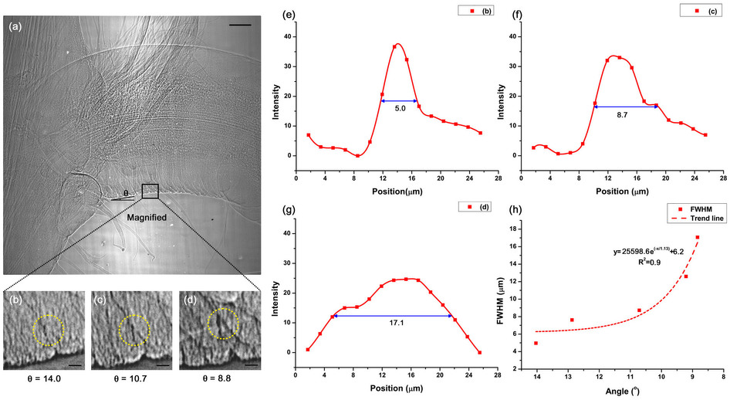

Article Image description: Wrinkles can considerably increase the surface area; thus, human fingers and elbows have numerous wrinkles[23](http://www.nature.com/srep/2014/140925/srep06466/full/srep06466.html#ref23),[24](http://www.nature.com/srep/2014/140925/srep06466/full/srep06466.html#ref24). Likewise, the pulvinus surface has plenty of tiny wrinkles ([Fig. 4a](http://www.nature.com/srep/2014/140925/srep06466/full/srep06466.html#f4)). This rugose structure provides extra surface area for expansion or contraction.

**Contraction and expansion of the pulvinus surface during a descending motion**

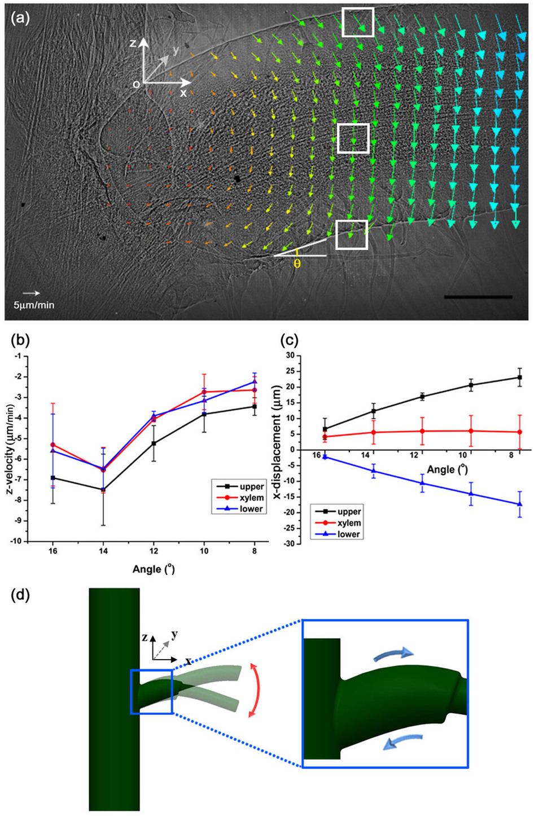

Article Image description: Structural variations of the moving pulvinus were observed via X-ray microscopy ([Fig. 3](http://www.nature.com/srep/2014/140925/srep06466/full/srep06466.html#f3)). The bending angle (θ) of the pulvinus decreased from 16.0° (0.3 mm−1) to 8.0° (0.1 mm−1). We analyzed displacement of the three parts of the pulvinus, including the upper epidermis, lower epidermis and xylem, during the descending motion in a 3D Cartesian coordinate system

**X-ray Bending pulvinus:**

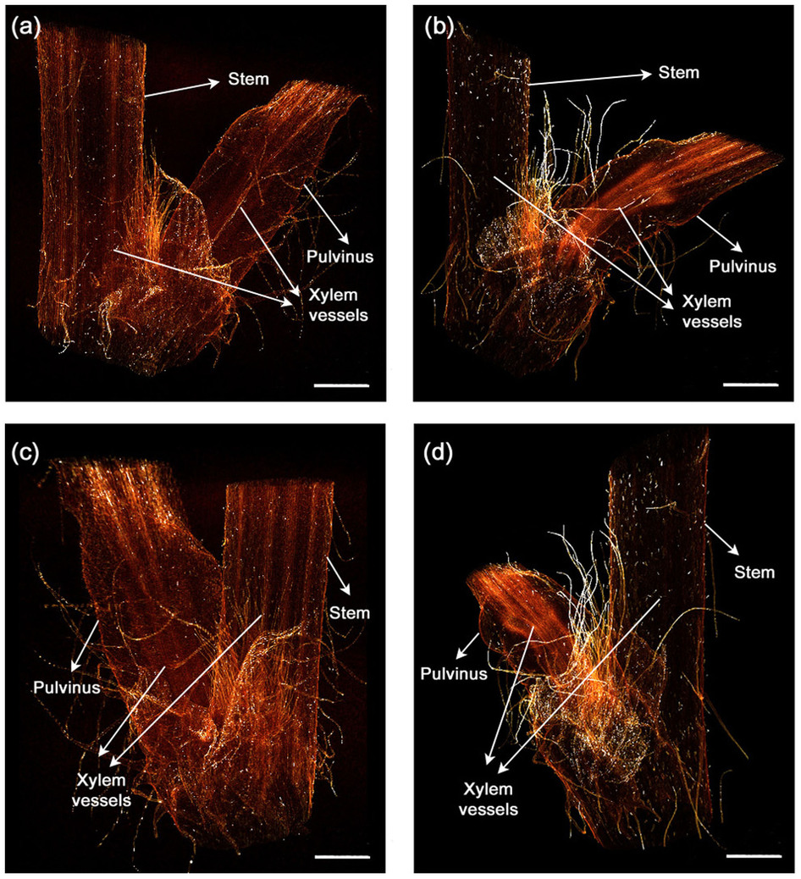

Image description in article:

"Two distinguishable X-ray tomograms were compared (see [Fig. 2](http://www.nature.com/srep/2014/140925/srep06466/full/srep06466.html#f2)) to investigate the morphological changes in the *M. pudica* bending xylem vessels. In all tomograms, the xylem vessels in the stem are straight. The xylem vessels in the straight pulvinus are upright and parallel to one another ([Figs. 2a and 2c](http://www.nature.com/srep/2014/140925/srep06466/full/srep06466.html#f2)). However, they are bent in accordance with the pulvinus bending ([Figs. 2b and 2d](http://www.nature.com/srep/2014/140925/srep06466/full/srep06466.html#f2)). These results demonstrate that the xylem vessels in the motile pulvinus have flexible structural properties that allow them to bend in all directions".

**Water transportation in mimosa pudica cells after stimulation**

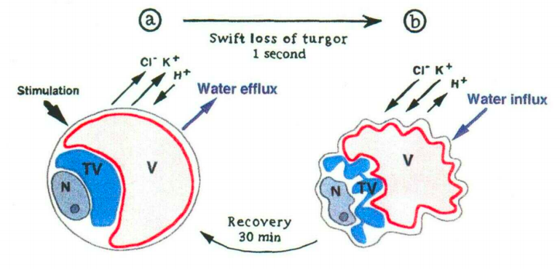

Image above from

[Fleurat-Lessard P, Frangne N, Maeshima M, Ratajczak R, Bonnemain JL, Martinoia E. Increased Expression of Vacuolar Aquaporin and H+-ATPase Related to Motor Cell Function in Mimosa pudica L. Plant Physiol. 1997 Jul;114(3):827-834.](http://www.ncbi.nlm.nih.gov/pubmed/12223745)