**Sensor in mimosa pudica**

In contrast to D. muscipula, where all the major tissues of trap lobes (sensory cells of trigger hairs, upper, and lower epidermis, mesophyll cells) are excitable with similar resting potentials (150–160 mV, Hodick and Sievers 1988), excitable cells in Mimosa are found in vascular bundles and pulvinus (Sibaoka 1962; Samejima and Sibaoka 1983; Fromm and Eschrich 1988b). In Mimosa, the phloem and pulvinus is surrounded by sclerenchyma and collenchyma sheath to restrict electrical signaling to phloem and lateral propagation

*Reference: The Effect of Electrical Signals on Photosynthesis and Respiration (in plant elecrtrophysiology book).*

**Action Potential in plants explained (difference from animals)**

"While the ionic mechanism of APs in animals depends on inward-flowing Na+ (depolarization) and outward-flowing K+ ions (repolarization), excitation of plant cells depends on Ca2+, Cl-, and K+ ions (Fromm and Lautner 2007). After perception of external stimulus, Ca2+ flow into the cell. The elevation of Ca2+ concentration in the cytoplasm activates the anion channel and Cl- efflux depolarizes the plasma membrane. Then outward rectifying K+ channel would repolarize the membrane" (Yan et al. 2009).

*Reference: The Effect of Electrical Signals on Photosynthesis and Respiration (in plant elecrtrophysiology book).*

"In plants the most important ions in this process are Ca2+ and Cl−.[29](http://www.ncbi.nlm.nih.gov/pmc/articles/PMC2634336/#R29) After arrival of the stimulus, free Ca2+ concentration in the cytoplasm increases. This Ca2+ originates from extracellular and intracellular spaces, through voltage dependent ion channels and from vacuoles via secondary transduction pathways. Depolarisation occurs due to Ca2+ activation of Ca2+-dependent anion channels and massive efflux of Cl−. Depolarization leads to opening of K+-channels, and the K+ efflux repolarizes the plasma membrane.[30](http://www.ncbi.nlm.nih.gov/pmc/articles/PMC2634336/#R30) The characteristics of action potential can be modified by changing of Cl− or K+ concentration.[31](http://www.ncbi.nlm.nih.gov/pmc/articles/PMC2634336/#R31)Electrical signals may pass through gap junctions (electrical synapses) at speed of 2 to 500 mm/s in animals. In plants, most cells have cell-to-cell conduction through plasmodesmata, and this connection has high solute permeability and electrical conductivity. Plasmodesmata are nearly identical to gap junctions of animal tissues.[32](http://www.ncbi.nlm.nih.gov/pmc/articles/PMC2634336/#R32) Plasmodesmata can be “synapses of plants,” and from a special point of view auxin can be the mediator/neurotransmitter".

*Reference:*[*http://www.ncbi.nlm.nih.gov/pmc/articles/PMC2634336/*](http://www.ncbi.nlm.nih.gov/pmc/articles/PMC2634336/)

**Action potential in Mimosa pudica**

In case of mimosa, the action potential passes in the phloem tubes.[17](http://www.ncbi.nlm.nih.gov/pmc/articles/PMC2634336/#R17),[19](http://www.ncbi.nlm.nih.gov/pmc/articles/PMC2634336/#R19),[44](http://www.ncbi.nlm.nih.gov/pmc/articles/PMC2634336/#R44) When the action potential arrives to the motor cells, the impulse can control motor cell movements through voltage dependent ion channels, and the aquaporins, and blockage of the proton ATPase.[18](http://www.ncbi.nlm.nih.gov/pmc/articles/PMC2634336/#R18),[45](http://www.ncbi.nlm.nih.gov/pmc/articles/PMC2634336/#R45) The potential change and its characteristic is one of the most important factors in the control of motor cells. The membrane potential changes are generated in unidentified mechanoreceptor cells as a receptor potential. This electrical stimulus spreads and coordinates the movements of motor cells in mimosa. The mechanoreceptors responsible for the receptor potential in mimosa are unknown. However, stretch activated ion channels in*Chara* cells have been identified as mechanoreceptors.[46](http://www.ncbi.nlm.nih.gov/pmc/articles/PMC2634336/#R46)

*Reference:*[*http://www.ncbi.nlm.nih.gov/pmc/articles/PMC2634336/*](http://www.ncbi.nlm.nih.gov/pmc/articles/PMC2634336/)

**Mechanoreceptor cells in mimosa Pudica**

The presence of red stomatal guard cells on the adaxial part of the tertiary pulvini was very strange. (...)  These red cells seemed to be good candidates for the unknown mechanoreceptor cells.

To produce fine, direct mechanical stimuli different types of epidermal cells (trichome, epidermis cells and the specialised red cells) were stimulated with a micromanipulator needle. When trichomes or epidermis cells were touched, there was no reaction, but when the red cells were stimulated, the leaflet closed.

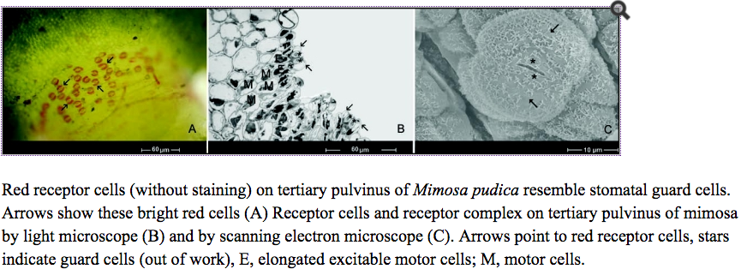

One of the most important questions was whether the red receptor cells can produce a receptor potential that can pass down to motor cells. As our electrophysiological measurements demonstrated, after mechanical stimulus a receptor potential is generated in these cells. **This receptor potential can pass through plasmodesmata**, which are able to control the movements of motor cells.[18](http://www.ncbi.nlm.nih.gov/pmc/articles/PMC2634336/#R18),[45](http://www.ncbi.nlm.nih.gov/pmc/articles/PMC2634336/#R45) These results supported our original hypothesis that the red cells on the adaxial part of the tertiary pulvini in *Mimosa pudica* L. are real receptor cells. They sense the mechanical stimuli and operate the closure mechanism of leaflets.

*Reference article:*[*http://www.ncbi.nlm.nih.gov/pmc/articles/PMC2634336/*](http://www.ncbi.nlm.nih.gov/pmc/articles/PMC2634336/)

**Action potential and water efflux in MImosa pudica**

A classic example of the conductance of APs in higher plants is the sensitive plant, M. pudica, where the propagated folding of leaflets is associated with the transmission of an AP. Rapid cooling of the apical end of a leaf pinna evokes a rapidly moving AP with a duration of 5 s transmitted basipetally within the rhachis at a rate of up to 20–30 mm s−1(Fig. 2a). This is similar to the speed of an AP in the nerves of Anodonta (45 mm s−1), but much slower than in Octopus (3 m s−1) and mammalian nerves (up to 100 m s−1,Lüttge, Kluge & Bauer 2005). The Mimosa AP becomes immediately evident as the bending tertiary pulvini cause impressive movements of the paired leaflets. When an AP reaches a pulvinus, **it is transmitted laterally via plasmodesmata into the cells of the motor cortex**. They respond to the signal by ion efflux associated with water efflux, which leads to leaf movements (Fromm & Eschrich 1988b,c; Fromm 1991). In addition, in Mimosa, the depolarizing phase is accompanied by a membrane conductance increase and the appearance of Cl- ions in the extracellular medium, and the signal height decreases when Cl- ions are added to the medium (Samejima & Sibaoka 1982). Interestingly, the transmission of an AP induced by touch or cold shock stops at the base of the single pinna and no further transmission occurs, leaving leaflets from neighbouring pinna unfolded. Concerning refractory periods, that is, the period following an AP when the cells are not excitable, they were much longer in plants than in animal systems. Absolute refractory periods last 0.0005 s in mammalian nerves, but 4–40 s in the Characeae and 2–4 min in Conocephalum, while relative refractory periods are 0.001–0.01 s in mammalian nerves, 60–150 s in the Characeae and 6–8 min in Conocephalum (Dziubinska et al. 1983, Lüttge et al. 2005).

Reference article: <http://onlinelibrary.wiley.com/doi/10.1111/j.1365-3040.2006.01614.x/full#b17>