Jessica Spinney/Swanson
Dr. Calabrese
January 25-February 11, 2015
Lab #1 - Wireshark
ITEC 2081 T/TH

Abstract

In this lab, I used WireShark to capture packets. I filtered the captured packets so that only HTTP packets would appear. I isolated individual packets using various filters. I found that I needed to research how to utilize several of the search options, but was able to succeed in most attempts.

Method
Lab Information:
This lab is about the exploration of protocols using Wireshark. Here, Wireshark is used to capture packets from an active interface (one that is communicating with the Internet) whether it is wireless or wired. The Wireshark color coding is used to help differentiate between packet types.

As the user navigates various web pages on the Internet, Wireshark captures the packets that are generated in real time. AutoScroll can be used to keep up with the latest incoming packets, or to be able to hover over specific areas of interest without losing the location.

Filtering this quickly accumulating pile of data can be accomplished using the Filter Toolbar near the top of the screen. In this lab, only the HTTP traffic is examined. This can be accomplished by typing “http” into the toolbar, or by clicking the Expression... button to its immediate right and looking for the desired term and style of use. Multiple expressions can be combined using the “&&” operator. The filters can be removed by clicking the nearby Clear button.

There are many types of packets, including GET requests, Host, User-Agent, Accepts, and cookies. These have different parts and data viewable beneath the list of packets.

Lab Environment:
- IP Address (unknown)
- MAC address: 40-25-C2-53-97-48
- Hardware type: HP Pavilion dv7-6135dx Entertainment PC
- Internet Source: Johnson & Wales University’s Academic Center Computer Lab, Room 403

Tools:
- Wireshark
- Settings - Captures, Filter Toolbar
- Snipping Tool
  - Settings - New
- Web Browsers
  - Opera
  - Firefox
  - Internet Explorer

How I Obtained Packets:

I obtained packets by surfing the Internet. I used three browsers, Opera, Mozilla Firefox, and Internet Explorer. The pages I visited included my home pages (including a Wikipedia article), several search engines (including Bing and a search for frog pictures), and several sites I visit frequently (including Etsy). I did various searches and clicked around within all of them.

Data

Capture #1
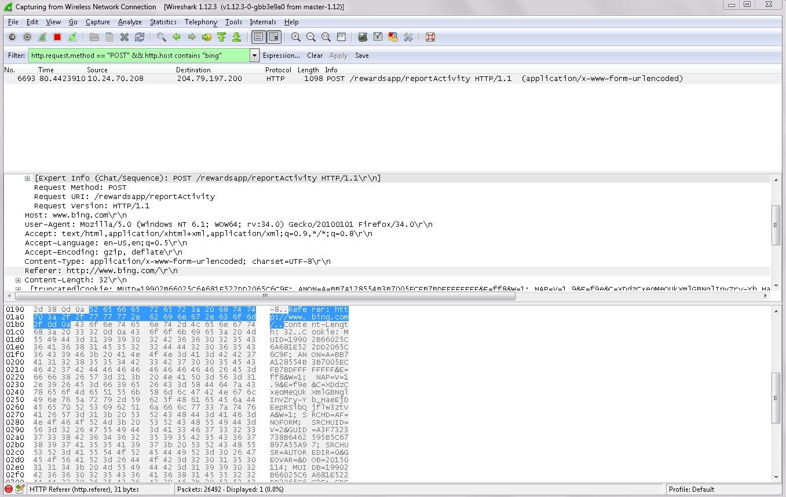

Capture #2
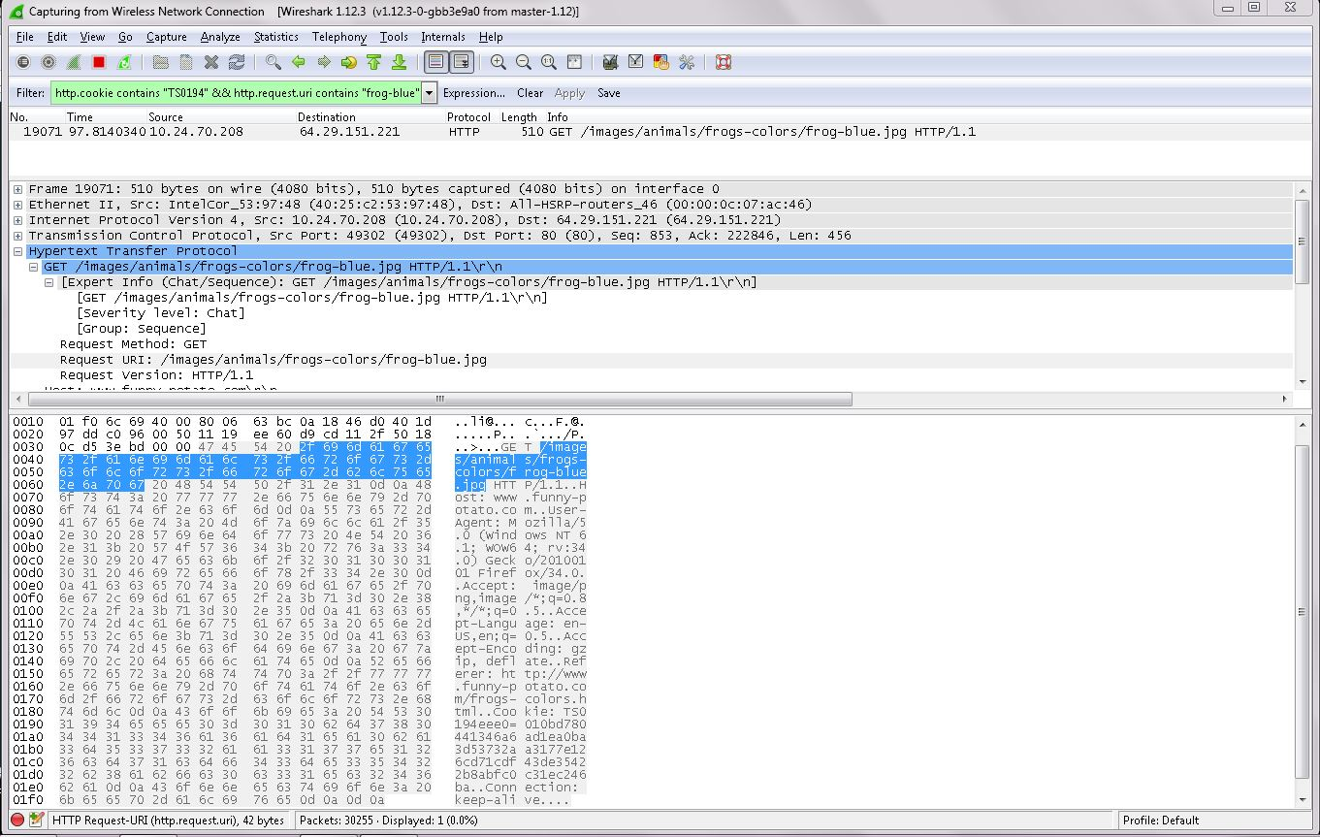

Capture #3

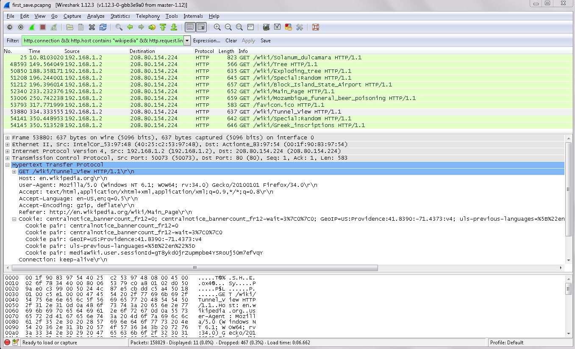

*I was unable to filter this down to one packet, and no text seemed to be highlighted along the bottom for this selection.
Capture #4

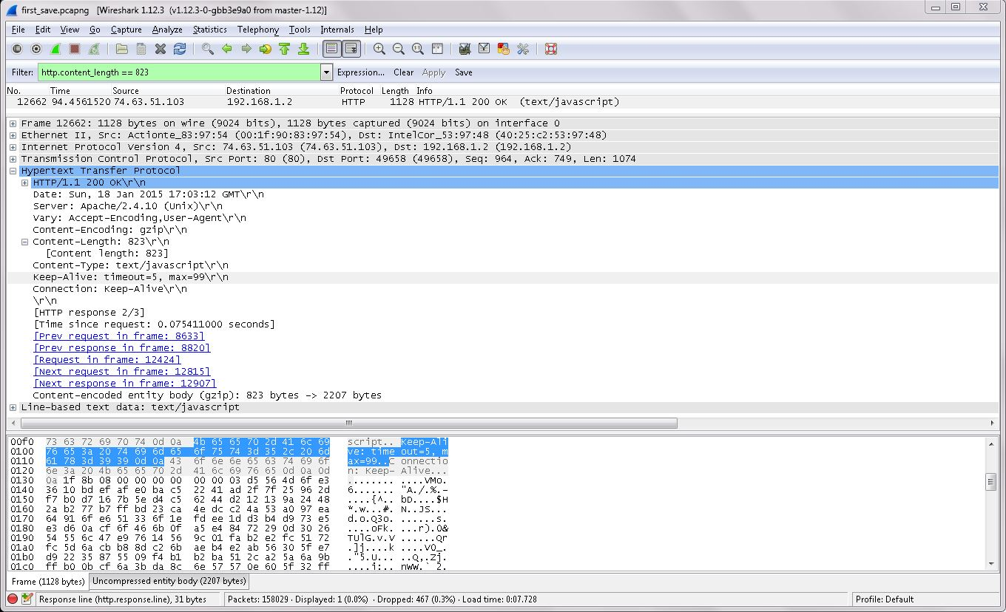

Capture #5

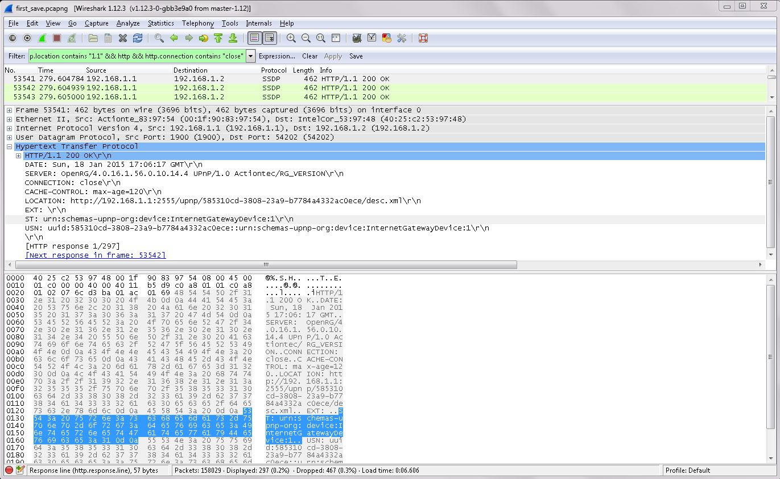

Capture #6

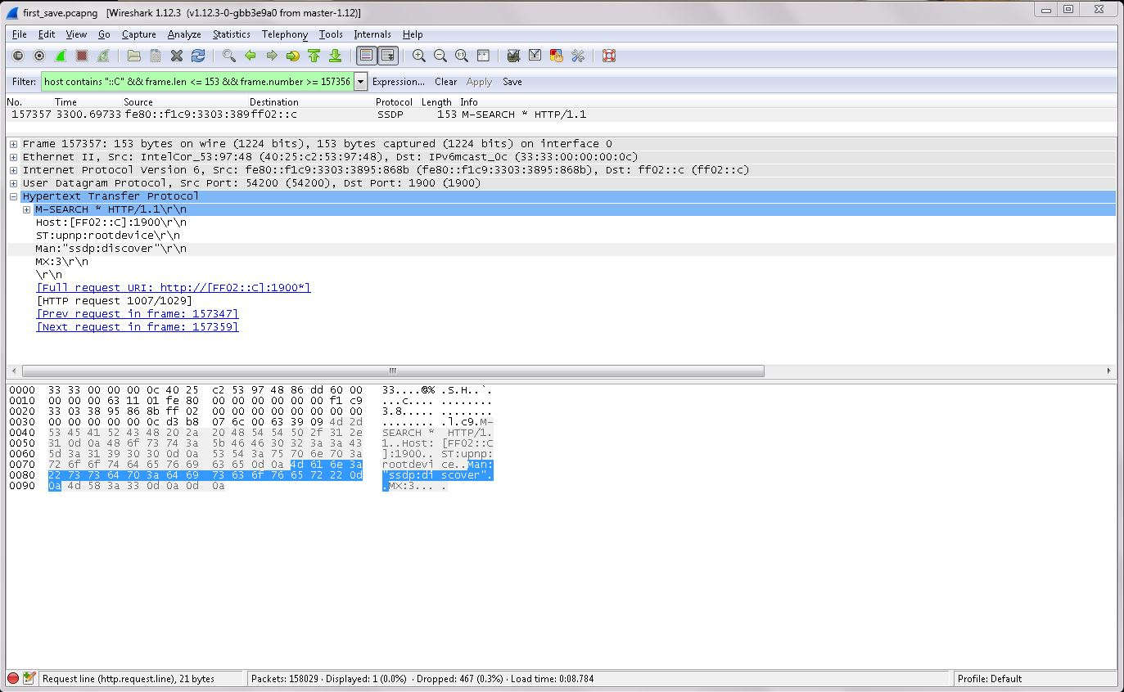

Capture #7

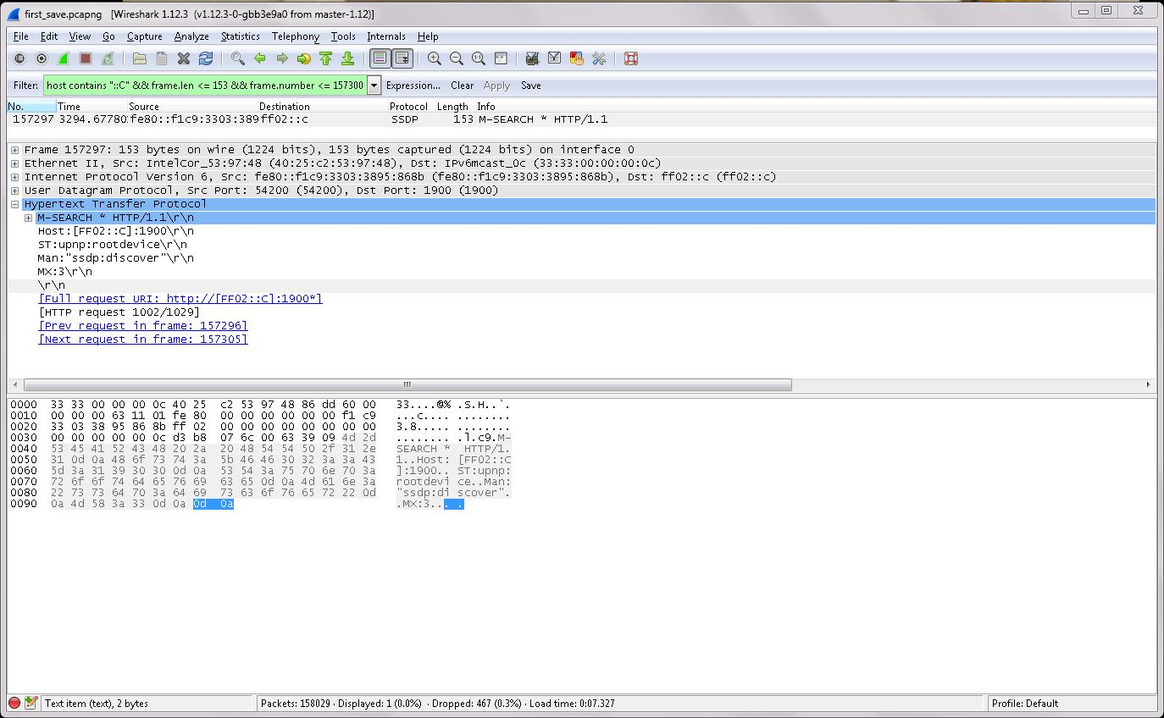

Capture #8

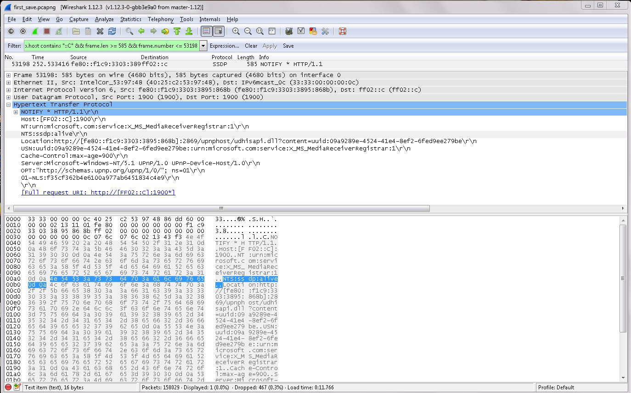

Capture #9

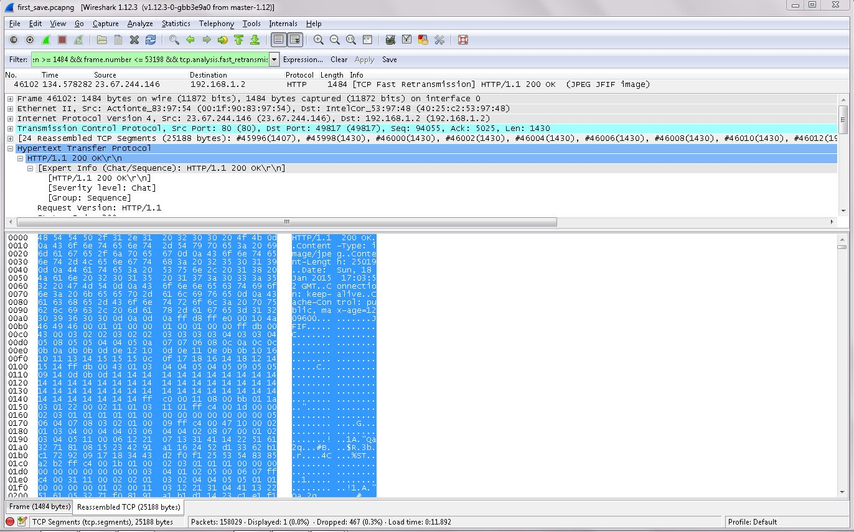

Capture #10

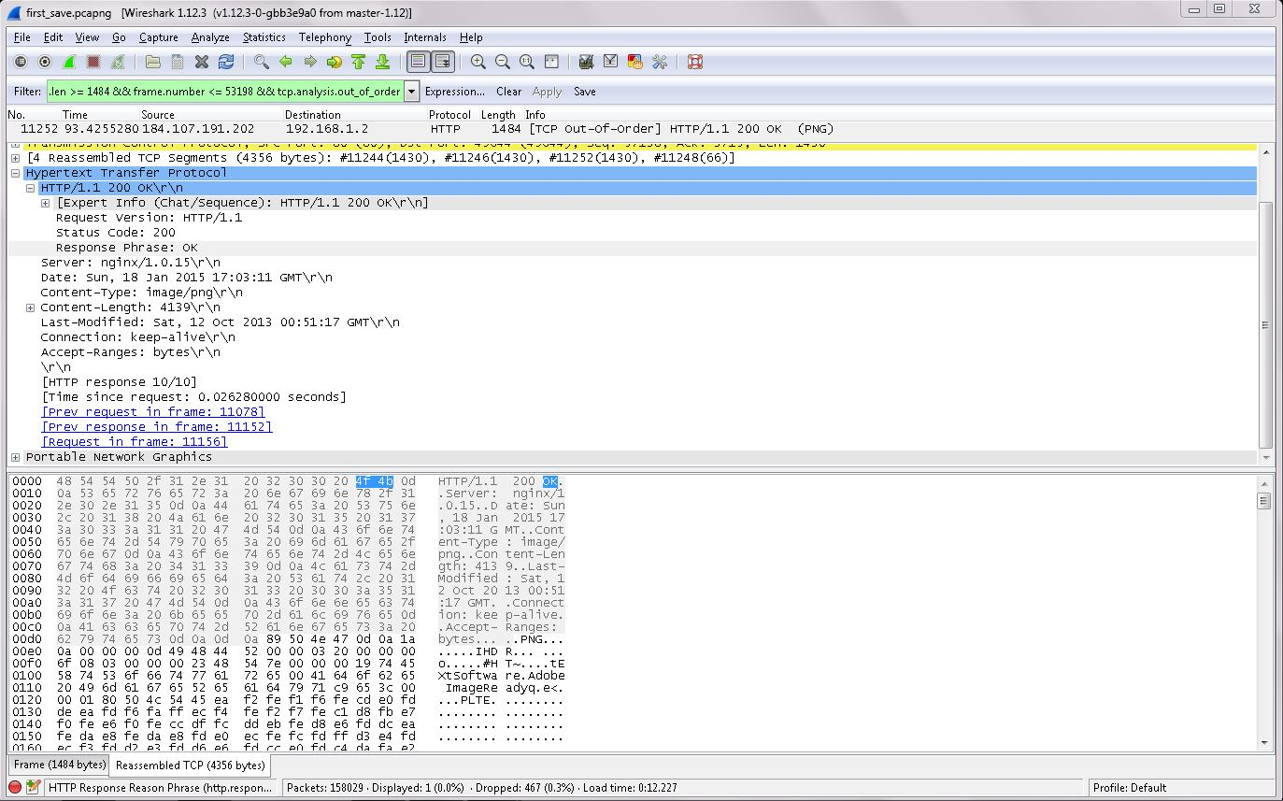

Analysis

Filtering:

Capture #1
This was an attempt to filter by the name of a website I had visited. I reduced it by filtering for ‘POST,’ which appeared in the info section.
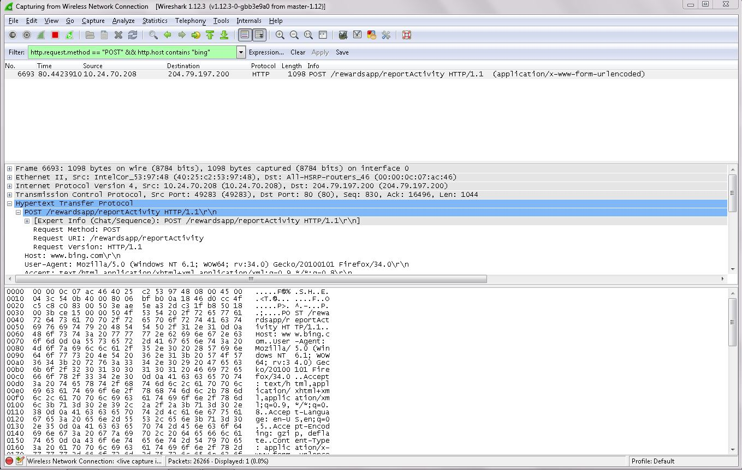
This resulted in this one packet.

Capture #3
This was an attempt to filer based upon a different website I had visited. I managed to filter the list until only ‘GET’ packets were remaining, but as shown directly below, I could not figure out how to reduce the list to only one packet. There were 11 packets at the end of this filtering process.

Capture #6
This is another search based upon the host site, this time also filtered by frame length. This was not specific enough, so an exact frame number was chosen and filtered for, as well.
This one packet resulted.

Capture #4
Here is a filter based solely on content length.
This is the packet that resulted from the filtering.

Data Correlations:

Capture #9
This is a large packet that has been reassembled from 24 TCP segments. Selecting ‘HTTP/1.1 200 OK\r\n’ under ‘Hypertext Transfer Protocol’ has highlighted all of the data. This means that HTTP/1.1 200 OK \r\n must reference the entire packet.

Capture #10
Selecting ‘[Expert Info (Chat/Sequence): HTTP/1.1 200 OK\r\n]’ under the two headings listed for Capture #9 resulted in a very short segment of data being highlighted. Only ‘OK’ and the matching hexadecimal code, ‘4f 4B’ were a part of this data.

Capture #4

Selecting ‘Keep-Alive: timeout=5, max=99\r\n’ under the same headings as Capture #9 resulted in essentially the same data appearing in the ASCII window, with matching code in the hexadecimal window.

Capture #2

Under ‘Hypertext Transfer Protocol,’ selecting [Expert Info (Chat/Sequence): GET /images/animals/frogs-colors/frog-blue.jpg HTTP/1.1\r\n]’ and then ‘Request URI: /images/animals/frogs-colors/frog-blue.jpg’ highlighted again, a nearly identical segment of data at the bottom and the corresponding hexadecimal code.

Discussion & Questions

Beginner’s Issues:
- I failed to record the IP address of the device used at the time.
- In Capture #3, I failed to discover how to further narrow down the results list before moving ahead to attempt more filters. I now know that I could have filtered for many things, including packet length, packet number, and possibly the time.

Dr. Calabrese’s Questions:
- What is the importance of a tool such as Wireshark to students learning network protocols? How would you think this tool could be used to isolate a network protocol problem?
  - I think Wireshark is a very important tool for students who are learning network protocols. It allows them to practice using the various parts of a packet to glean real results, instead of memorizing the information from a table. It also allows them to view a wide variety of formats that packets may take, and personalize the experience by being able to identify elements from their own web browsing sessions.
  - I think this tool could be used to isolate a network protocol problem because it can be used for specific errors within very specific ranges. It is also able to isolate a specific time frame if the details of the error are uncertain. Here is a minor error (out of order) I found in Capture #10 that the network seems to have corrected on its own.

- What is the correlation between the hexadecimal numbers at the bottom of the Wireshark display and the rest of the Wireshark display? Why is seeing these numbers important - give an example of how they are used in connection with 802.3 (specifically the type codes)? Give me a list of the top type codes used in industry.
  - The hexadecimal numbers at the bottom of the screen give the same data as the rest of the screen does. Computers communicate in binary. Hexadecimal is a way to condense binary into more manageable chunks. The ASCII characters to the right of the hexadecimal characters either are, or may as well be the translation of the hexadecimal code. The information along the top of the screen has all been extracted or inferred from the same binary that the hexadecimal code is from.
  - Seeing these numbers is important because it can be used to garner specific details, such as whether a packet is an ARP packet or an IP packet, simply by looking at the correct chunk of code without having to know much about Wireshark’s layout.
  - The top type codes used in the industry are IP 0800 and ARP 0806.

