# Before to start

CAPRIP is a user-friendly tool implemented in java but use Perl to parse and filter blast results and MySQL to store them. Consequently, before to start to use CAPRIB a minimal Ram 4 Gb, Internet access and the installation of additional open source software are required. Choose a location in your computer and unzip caprib.zip

## Java

<https://www.java.com/fr/download/manual.jsp>

Choose your platform (e.g. Windows 10, Ubuntu, Mac OSX).

For Mac you need to install additionally JDK file from:

<https://www.oracle.com/technetwork/java/javase/downloads/index.html>

Follow instructions.

## XAMPP

<https://www.apachefriends.org/index.html>

Figure 1 XAMPP Installation options for Windows

* 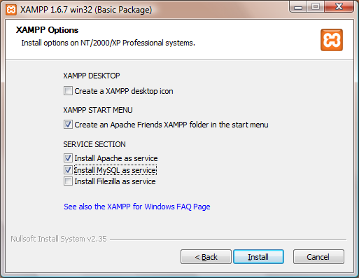Choose operating system platform (e.g. Windows, Linux, OS X)
* For Windows and Linux download Xampp version 7.3.0-0
* For OS X download Xampp version 5.6.39
* Download and follow instructions
* Choose install XAMPP and Apache as shown in Figure 1

Start Xampp form the executable.

To install Xampp in linux, open a terminal in the download folder and type:

*sudo su*

Then enter your password and finally type:

./xampp-li./xampp-linux-x64-7.3.0-0-installer.run-installer.run (Figure 2 )

Figure Xampp installation in Ubuntu

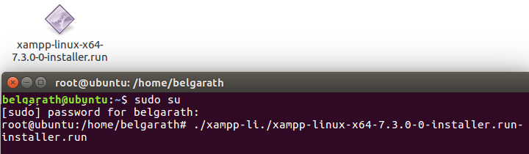

To start Xampp from console: */opt/lampp/lampp start*

To stop Xampp from console*: /opt/lampp/lampp stop*l

## Perl

<https://www.activestate.com/activeperl/downloads>

Choose your platform (e.g. Windows 10, Ubuntu, Mac OSX) and follow instructions. Normally Ubuntu and Mac OSX have perl in their operative system, you can check its version in your terminal typing:

*perl -v*

## Blast+

CAPRIP use Blast+ version 2.8.1 to compare protein fasta files with a nucleotides database, you can install it in Windows following instructions in:

<https://www.ncbi.nlm.nih.gov/books/NBK52637/>

In Linux by using this command line:

Sudo apt install ncbi-blast+

In Mac:

Click the link to download installer from:

<ftp://ftp.ncbi.nih.gov/blast/executables/blast+/2.8.1/>

# Start Caprib

Windows: double click in the Caprib2018.jar

Linux/Mac: type in the terminal: java -jar Caprib2018.jar

# Troubleshooting

Sometimes the SSL Certificate Location on UNIX/Linux is required when you do CDD NCBI queries. In order to fixed you must type:

sudo cpan Mozilla::CA