# Welcome to My Recipe Collection

## Your go-to place for delicious recipes

* Breakfast
* Lunch
* Dinner

## About This Website

Discover a curated collection of recipes from all around the world, perfect for any occasion!

## Featured Recipe

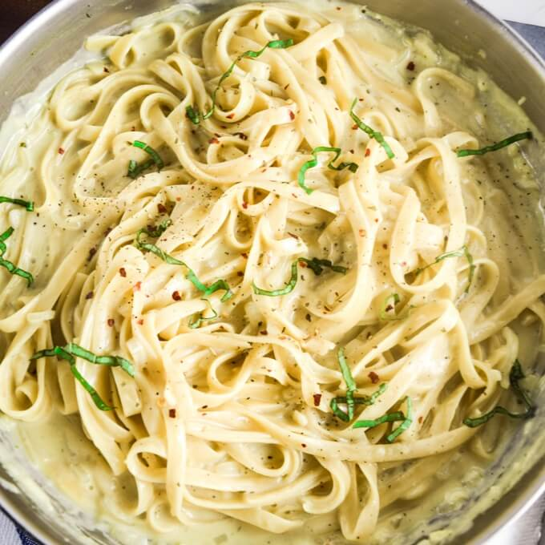This week’s favorite: Creamy Garlic Pasta! A quick and easy recipe for busy weeknights.

## Recipe Gallery

* Spaghetti Bolognese
* Classic Pancakes
* Grilled Chicken Salad

## Contact Me

Email: [myrecipes@example.com](mailto:myrecipes@example.com)

Follow me on [Instagram](https://instagram.com)

© 2025 My Recipe Collection. All rights reserved.