WeighArc App Launch Plan
Ken Custer
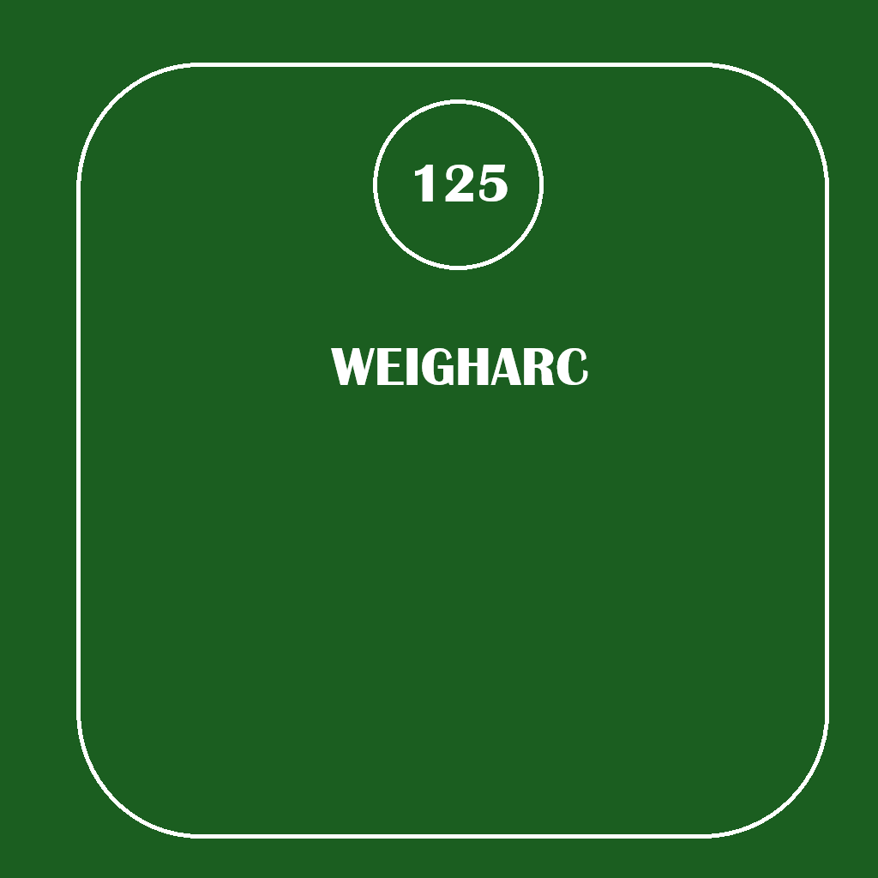
App Description and Icon
WeighArc is a weight-tracking application that gives users a simple way to record their weight and see how it changes over time. Users can create an account, log in, add new weight entries, edit older entries, and delete entries they no longer need. The information is stored in a local SQLite database, so it is still there when the app is closed and reopened. Users can also save a goal weight and turn on SMS notifications if they want a text message when they reach that goal.
The weight history was designed to be easy to read without making the screen complicated. Weight loss is shown in green, weight gain is shown in red, and no change is shown in black. The newest weight is displayed at the top of the list. I liked this better than making the user compare every number manually or scroll through older entries to find the most recent one.
For the launcher icon, I made my own design in Microsoft Paint. I used a dark green background with a white scale, a reading of 125, and the WeighArc name underneath it. I kept it fairly simple because the icon becomes much smaller when it is displayed on an Android home screen. After adding it to Android Studio, I tested it in the emulator to make sure it still looked right at the normal launcher size. In retrospect, I would most likely redo the icon, keeping the same idea, but making the text bigger.
Android Version Support
The current version of WeighArc uses a minimum SDK of 34 and targets SDK 37. That works for the project because I built and tested the app on a newer Android emulator. It also kept me from having to deal with a lot of compatibility differences between much older Android versions while I was still developing the main features.
If WeighArc were going to be released publicly, I would look at supporting more Android versions. Lowering the minimum version could make the app available to more users, but I would not do that without testing it first. The database, layouts, login screen, SMS permission handling, and other features would all need to be checked on the additional versions.
Most of my testing was done in the Android emulator. I tested creating an account, logging in, entering weights, editing and deleting entries, saving a goal weight, using the color coding, changing SMS settings, logging out, and reopening the app to make sure information was still saved. A public release would need more testing on actual Android phones because different screen sizes and manufacturers can sometimes behave differently than the emulator.
Required Permissions
The main permission used by WeighArc is SEND_SMS. The app needs that permission only if the user wants a text message after reaching a saved goal weight. The permission is included in the Android manifest, but the user is still asked for permission before using it.
I did not want someone to lose access to the weight tracker just because they did not want to allow SMS permission. If permission is denied, the user can still log in, add weights, edit or delete them, save a goal, and use the rest of the app normally. SMS notifications can also be turned back off later. The app does not ask for access to the camera, microphone, contacts, or location because none of those are needed. Telephone hardware is also marked as optional.
Monetization
If I released WeighArc outside of this project, I would start with a free basic version. The main reason someone would download the app is to keep track of their weight, so I would not charge people just to add, edit, or delete weight entries.
There are features that could make sense as paid extras later. Progress charts, longer-term statistics, exporting data, backups, syncing between devices, and more notification choices are a few examples. Those would add something beyond the basic weight tracker instead of taking away features that are already part of the main app.
I would also stay away from filling the app with advertisements. Weight information can be personal, and I think too many ads would make the app feel cluttered. A simple free version with optional premium features makes more sense for the kind of app WeighArc is.
At this point, the app has the features I wanted for the project: account creation and login, saved weight history, editing and deleting entries, goal tracking, color-coded changes, SMS notifications, and a custom launcher icon. If I kept developing it, I would spend more time testing it on different Android devices before worrying about adding a large number of new features.

