LED Luminaire measurement system

Instruction manual

Version: 2.0

May 2019

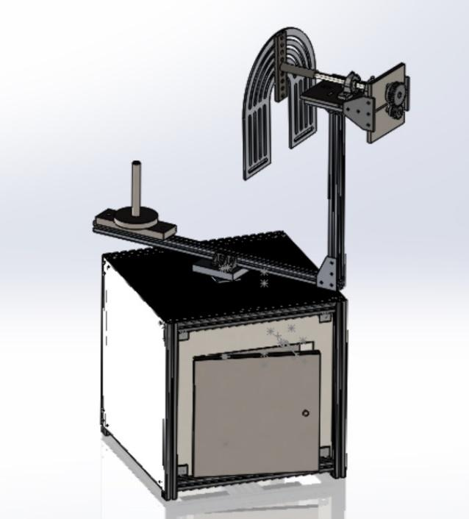

TABLE OF CONTENTS

**1** **Introduction 3**

1.1 Purpose of The Product 3

**2** **Setup 3**

2.1 Mounting Light fixture 3

2.2 Power and accessories 3

2.3 Starting application 4

**3** **Operation** 5

3.1 Running program 5

**4** **Mechanical** 5

4.1 upper horizontal drive 5

4.2 Lower Vertical Drive 5

4.3 Enclosure 5

**5** **Electrical** 6

5.1 Raspberry pi io 6

5.2 Wiring

# Introduction

## Purpose of The Product

### The purpose of this document is to provide the user with step-by-step instructions for running the device as well as an assembly/disassembly and troubleshooting guide. This product was developed by a Boise State senior design team and is designed to assist SimplyLEDs with taking light intensity measurements for new prototypes. The ideal setup for tests with this device is in a space with matte black walls and will allow at least 20 feet of separation between the sensor and mounted light.

# Setup

## Mounting Light fixture

## Power and accessories

Install a disposal cord on to the luminaire. After the luminaire is installed onto the machine, plug the cord into the receptacle marked luminaire.

System power is applied by turning the switch marked system to the on position. This will start the Raspberry Pi. To turn on the luminaire, turn the switch marker luminaire to the on position.

Incase of an emergency, the red emergency stop button can be hit to shut power off to the drive motors and the luminaire.

## Software Dependencies

The program requires certain libraries to be installed for proper operation. The current SD card installed on the raspberry pi has these dependencies already installed. However, if another SD card is used or the current one is formatted the necessary libraries will need to be installed again. The list below contains the name of the required library and how to install.

First, ensure a proper OS is installed. Currently, Raspbian is installed, but another OS may work just as well. Raspbian has Python included with the installation which, in turn, has PIP installed. PIP is a built-in library installer and will be used to install the necessary dependencies.

**IMPORTANT NOTE:** Must be connected to internet to download libraries.

1. Open a terminal by clicking on the icon as show in the figure below or use shortcut (Ctrl+Alt+T).

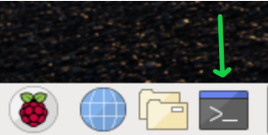

1. Once a terminal is opened these commands can be entered in succession as each one completes download and installation.
   1. PYQT5 – This library is used to create the GUI.
      1. Command– “pip install pyqt5”
   2. Pandas – This library is used for the various data collection and calculations.
      1. Command – “pip install pandas”

**Note:** Other installation options are available online if these commands fail

## Starting application

### The current program is not complete and does not yet have a single executable to run the program. To start the program in its current state, use the following directions.

### Open a terminal by clicking terminal icon in the bottom of screen or use shortcut (Ctrl+Alt+T)

### 

### Type the following commands

### cd Desktop/LED19/newcode

### Press *Enter*

### python3 mainMenu.py

### Press *Enter*

### The application should now be running. Refer to section 3.1 Running Programming for further instruction.

# Operation

## Running program

### The current application is not complete. However, the user interface for the application is complete and has all necessary components once the backend of the program is complete.

### To start a test, use the following instructions and image below as a guide.

### 

### Before a test can be started, the motor controls must return to their home position. Click the “Initialize Controls” button to accomplish this.

### The user inputs are test specific and are optional except for the “Input Wattage” and “Input Distance”. These inputs must be a number that can be converted to a float…i.e. integer, decimal, etc. If an improper value is entered an error will trigger requiring the user to input another value into these fields.

### The test mode uses a drop-down list to select the desired test to be performed. Prior to starting a test ensure the correct “Test Mode” is selected.

### If the above steps have been completed correctly the “Begin Selected Test” button should be enabled. Press this button to begin test.

### Once a test is started, the program is completely automated from this point. A “Pause Test” button is available to pause the program during a test and will be replaced by a “Continue Test” to continue the program.

### When the program is complete a file will be created using the “IESNA” input field as the file name. A blank “IESNA” field will default to the current date and time as the file name.

### If another test is desired, use the “Restart Module” button to restart the program with default settings.

# Mechanical

## upper horizontal drive

## Lower Vertical Drive

## Enclosure

# Electrical

## Raspberry pi io

### Current Raspberry Pi GPIO connections are set up for testing purposes and are not finalized.

### Image result for raspberry pi 3b pinout

## Wiring