Company Name: AtliQ Hardware

It is a hardware company which has many branches all over the country of India

Purpose: To unlock sales insights that aren’t visible to the sales team for decision, support and to automate them to reduce manual time spent on data gathering.

Stake holder: Sales Director, Marketing Team, Customer Service Team, Data & Analytics Team, IT guys

End Result: An automated dashboard providing quick and latest insights in order to support data driven decision making.

Success Criteria:

1. Dashboards uncovering sales order insights with latest data available
2. Sales team able to make better decisions
3. Sales analysts stop manual data gathering in order to save 20% of business time and reinvest in more productive activities

What did I learn?

1. Questions to ask the client so as to get reasonable insights
2. AIMS grid:

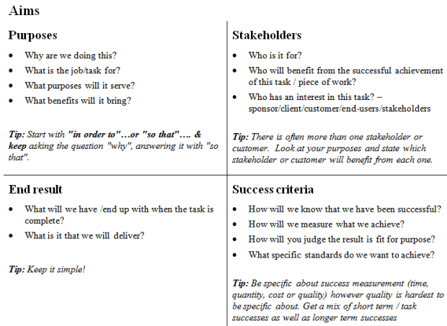

1. I learnt how to connect mysql server to PowerBI
2. Learnt how to write DAX language
3. I learnt what it feels like to work in a corporate environment