An Online Quiz Management Application

[Summer Internship]

**Participants**

20MCA010 – Badalkumar Chaudhari

20MCA016 – Sohil Ganatra

**Guided By**

Dr. Smita Agarwal

Dr. Lata Gohil

* **Definition**

To Build An Online Quiz Application for Multi-Purpose use like to conduct School/College Online Exams, Other Competitive Exams, quiz game etc.

* **Purpose**

The Purpose of this document is to build An Online Quiz Management Application which can be used to create, conduct, manage, evaluate and analyze real time Online Web Based Quizzes. (having Multiple Choice Questions)

* **Project Scope**

This Project will consist of developing An Online Quiz Management Application. The Modules included in the system will be Creating Quizzes by Adding Multiple Choice Questions, Managing Quizzes by Updating/Deleting/Displaying added questions, Deleting unwanted questions, View Score of each individuals for each Quiz etc.

* **Requirements**

[A] Hardware and Software Requirements:-

1. Tools:- Python IDLE

2. Hardware:- 64 Bit Machine

3. OS:- Windows

4. Database:- MySQL

[B] Client End Requirements:-

1. RAM:- 500MB RAM

2. System Connected to:- Internet

* **Entity Relationship Diagram**

|  |  |
| --- | --- |
| **Table Name:- Quiz_Master**  One To Many Relationship | |
| Primary Key | q_id |
|  | question |
|  | option_1 |
|  | option_2 |
|  | option_3 |
|  | option_4 |
|  | answer |

|  |  |
| --- | --- |
| **Table Name:- Candidate_Master** | |
| Primary Key | s_id |
|  | roll_no. |
|  | name |
|  | email |
|  | password |

One To Many Relationship

|  |  |
| --- | --- |
| **Table Name:- Candidate Result** | |
| Primary Key | r_id |
| Foreign Key | roll_no. |
|  | marks |
|  | date_of_exam |

* **Use Case Diagram**

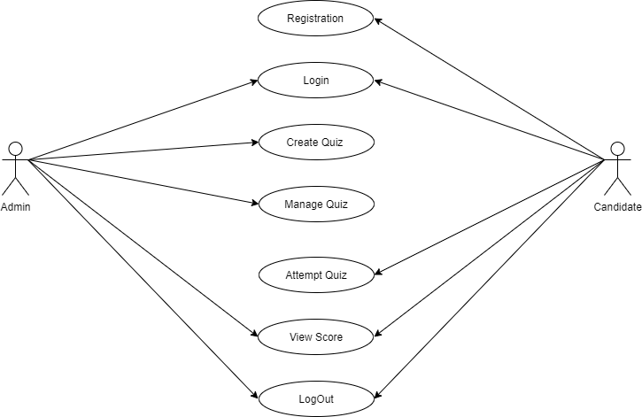

* **Data Dictionary**

1.**Quiz_Master**

|  |  |  |  |  |  |  |  |
| --- | --- | --- | --- | --- | --- | --- | --- |
| **Field Name** | **Data Type** | **Size** | |  |  | | --- | --- | | **Size** | **Constraints** | | **Valid input values** | **Description of the field** |
| q_id | int | 11 | Primary key and not null | 1 | This field represents the unique ID of a Multiple Choice Question |
| question | varchar | 200 | Not null | Who is ……? | This field represents the unique Multiple Choice Question |
| option_1 | varchar | 25 | Not null | 123Abc | This field represents the unique Option/Choice of Multiple Choice Question |
| option_2 | varchar | 25 | Not null | 456xyz | Same as above |
| option_3 | varchar | 25 | Not null | “” | Same as above |
| option_4 | varchar | 25 | Not null | “” | Same as above |
| answer | varchar | 25 | Not null | “” | This field represents the Correct Option/Choice of Multiple Choice Question |

2.**Candidate_Master**

|  |  |  |  |  |  |  |  |
| --- | --- | --- | --- | --- | --- | --- | --- |
| **Field Name** | **Data Type** | **Size** | |  |  | | --- | --- | | **Size** | **Constraints** | | **Valid input values** | **Description of the field** |
| s_id | Int | 11 | Primary key and not null | 1 | This field represents the unique ID of an Student |
| roll_no | Varchar | 10 | Not null | 20MCA010 | This field represents the unique ID of an Student roll no |
| name | Varchar | 25 | Not null | Badal | This field represents the unique ID of an Student |
| email | Varchar | 25 | Not null | [20MCA010@nirmauni.ac.in](mailto:20MCA010@nirmauni.ac.in) | This field represent the email id of a student  And username |
| password | Varchar | 25 | Not null | Badal@010 | This field represent student password |

3.**Candidate_result**

|  |  |  |  |  |  |  |  |
| --- | --- | --- | --- | --- | --- | --- | --- |
| **Field Name** | **Data Type** | **Size** | |  |  | | --- | --- | | **Size** | **Constraints** | | **Valid input values** | **Description of the field** |
| r_id | Int | 11 | Not Null | 123456 | Registration ID |
| roll_no | Varchar | 10 | Not Null | 123456 | Roll Number |
| mark | Int | 11 | Not Null | 123456 | Score achieved by the Candidate |
| date | varchar | 10 | Not Null | 123 / - | Date of the Quiz |

* **Screenshots**

**1.Welcome Page**

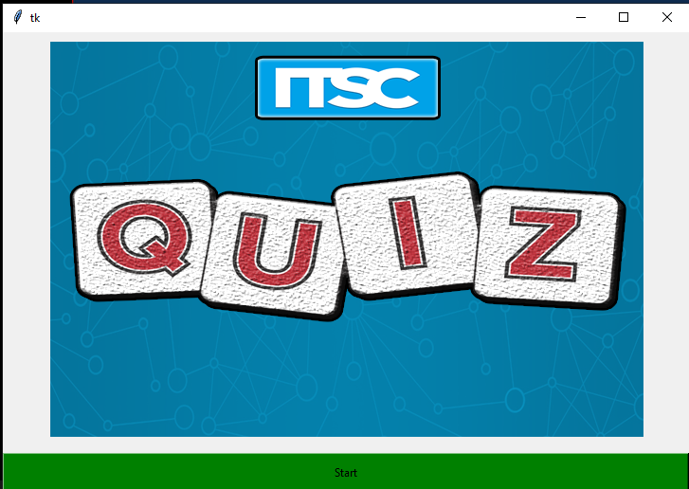

Figure 1.Welcome Page

* **Description**

|  |  |
| --- | --- |
| Description | This is the foremost screen, any user visit the website sees it and  can comprehend by it that what the website it means to do. |
| Data From | - |
| Data To | Login_page |

**2.Loginpage**

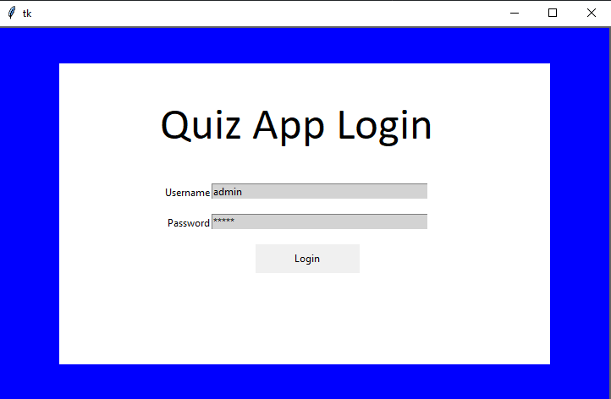

Figure 2. Login Page

* **Description**

|  |  |
| --- | --- |
| Description | This is a login screen where every user can login through it and  can perform their task. |
| Data From | Welcome page |
| Data To | Admin_Dashboard,Candidate_Dashboard |

3.**Admin dashboard**

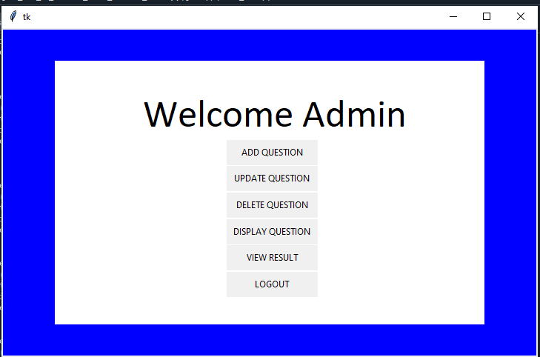

Figure 3. Admin dashboard

* **Description**

|  |  |
| --- | --- |
| Description | This is the foremost screen, admin visit the website sees it and can  comprehend by it that what the dashboard means to do. |
| Data From | Login_Page |
| Data To | - |

**4.Add question Page**

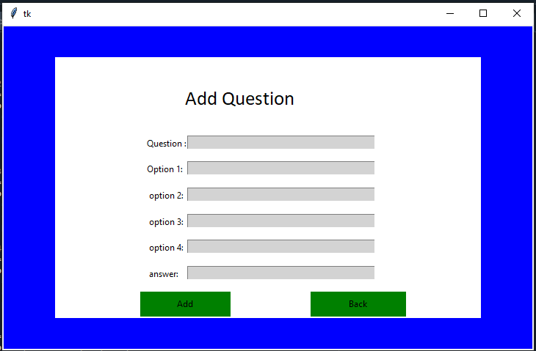

Figure 4. Add question Page

* **Description**

|  |  |
| --- | --- |
| Description | This is the page where admin will add the Question on the basis of required input fields like question, options and answer. |
| Data From | Admin_Dashboard |
| Data To | Quiz_Master |

**5.Update question Page**

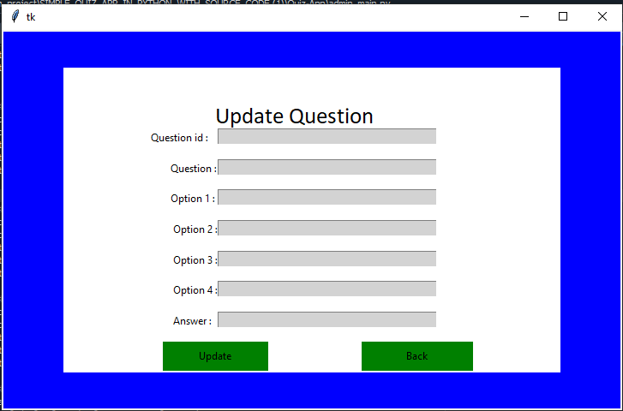

Figure 5. Update question Page

* **Description**

|  |  |
| --- | --- |
| Description | This is the page where admin will update the Question on the basis of required input fields like question,options and answer. |
| Data From | Quiz_Master |
| Data To | Quiz_Master |

**6.Delete Question Page**

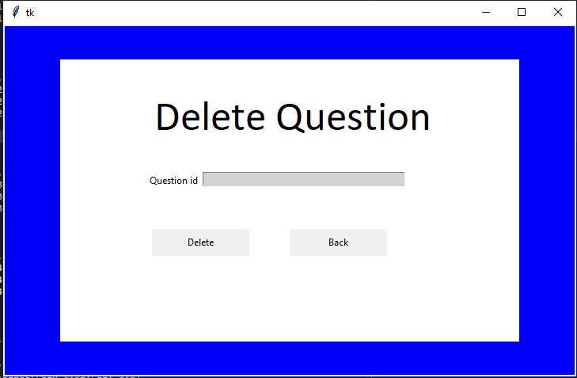

Figure 6. Delete Question page

* **Description**

|  |  |
| --- | --- |
| Description | This is the page where admin will delete the Question on the basis of required input field question id. |
| Data From | Quiz_Master |
| Data To | Quiz_Master |

**7.View Candidate mark page**

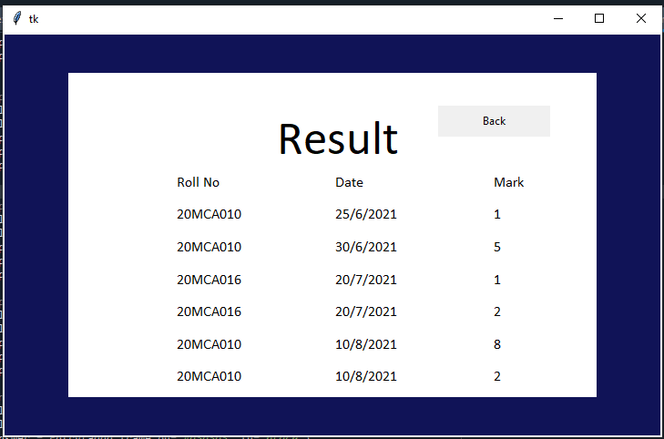

Figure 7. View candidate mark page

* **Description**

|  |  |
| --- | --- |
| Description | This is the show all candidate marks. |
| Data From | Candidate_Master |
| Data To | - |

**8.Display Question page**

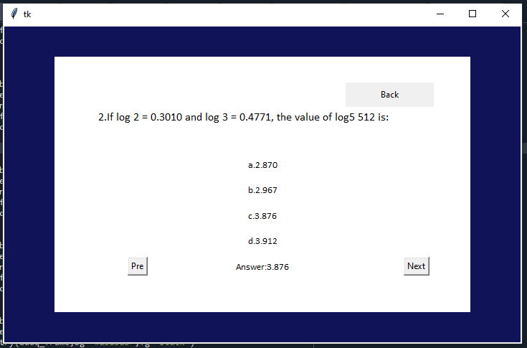

Figure 8. Display question Page

* **Description**

|  |  |
| --- | --- |
| Description | This is the show all question, options and answer. |
| Data From | Quiz_Master |
| Data To | - |

**9.Registration Page**

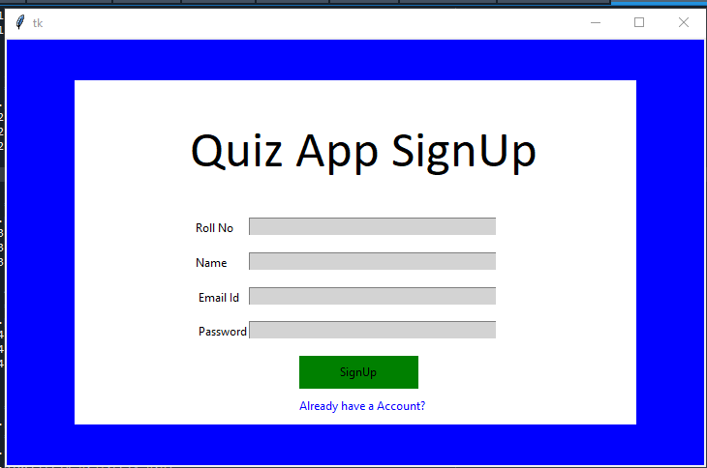

Figure 9. Registration Page

* **Description**

|  |  |
| --- | --- |
| Description | Registration forms on landing pages are very important and should be optimized in order to encourage the users to sign up for your email list, product, subscription or service. |
| Data From | - |
| Data To | Candidate_Master |

**10.Candidate Dashboard**

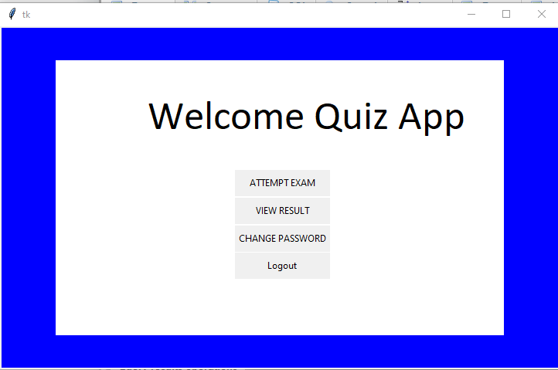

Figure 10. Candidate Dashboard

* **Description**

|  |  |
| --- | --- |
| Description | This is the foremost screen candidate visit the website sees it and can  comprehend by it that what the dashboard means to do. |
| Data From | Login_Page |
| Data To | - |

**11.Attempt Exam Page**

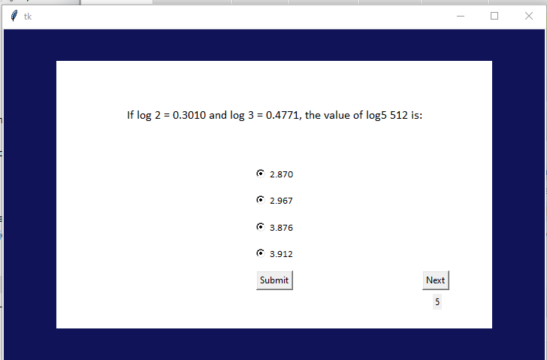

Figure 11. Attempt Exam Page

* **Description**

|  |  |
| --- | --- |
| Description | This is the candidate can attempt quiz . |
| Data From | Quiz_Master |
| Data To | Candidate_result |

**12.View Candidate page**

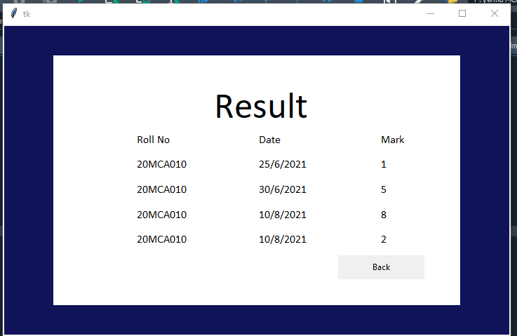

Figure 12. View Candidate Page

* **Description**

|  |  |
| --- | --- |
| Description | This is the show individual candidate marks. |
| Data From | Candidate_result |
| Data To | - |

**13.Change password page**

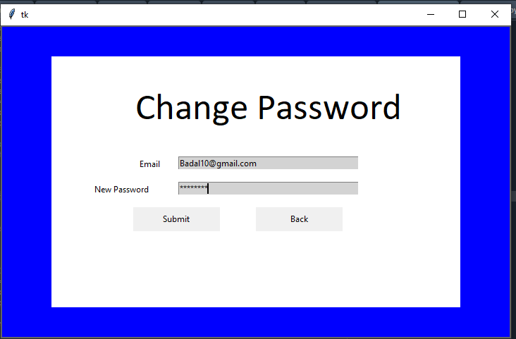

Figure 13. Change Password

* **Description**

|  |  |
| --- | --- |
| Description | This is the page where candidate can change the password. |
| Data From | Candidate_Master |
| Data To | Candidate_Master |