***Result 1:*** *This bar graph of job Industry Category versus Sum of bicycle selling in past 3 years.*

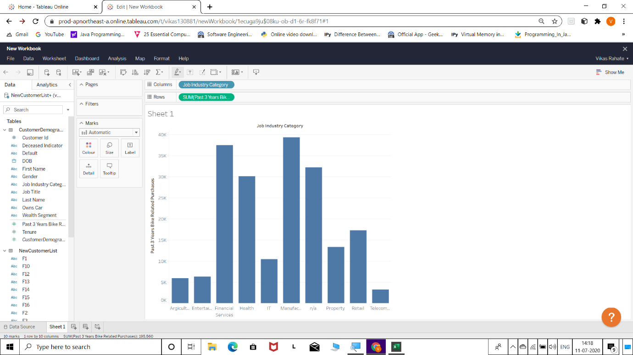

*Plot for Job Industry Category vs Sum of past 3 years bicycle selling*

*From this graph we can conclude that manufacturing industry category gives the maximum profit of something Rs. 39k and the telecom industry gives minimum profit of something Rs. 3k . Interpreted that most of the buyers are from manufacturing sectors so we can give them preference to show advertisement first and also new features and also to see that most of the Records are N/A so we have to get their data also. In this graph, we can see that we have to increase the production of Telecom, Agriculture, Entertainment and IT Sectors, then we have to know what are the needs of the people of this sector and what they want and we have to produce them keeping in mind those things.*

***Result 2:*** *This graph of sum of profit versus sum of standard cost.*

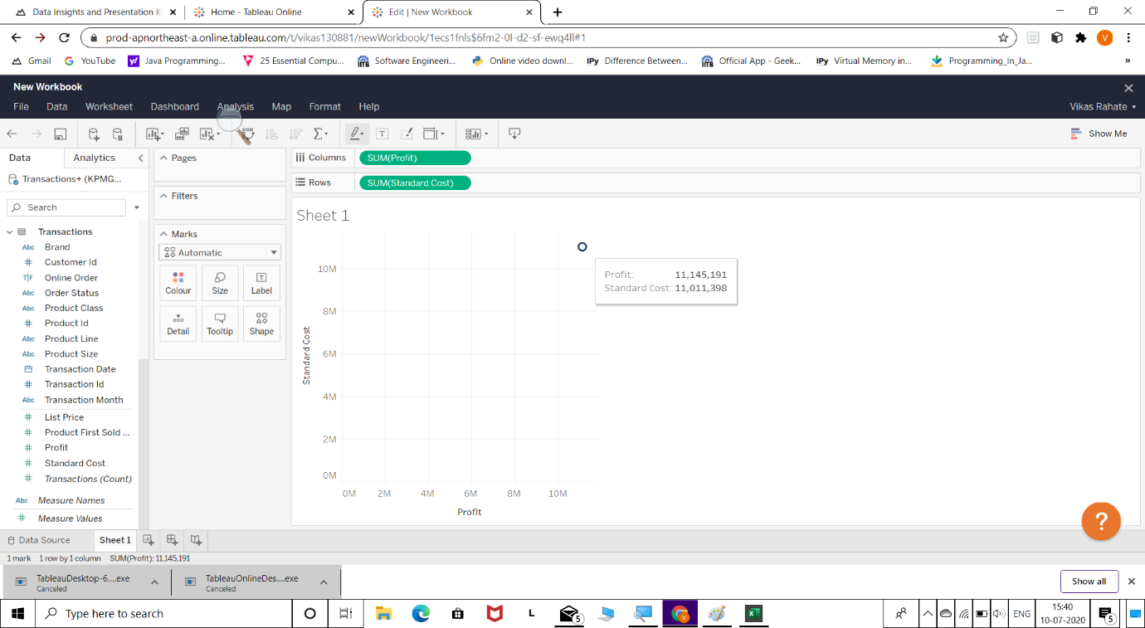

*Graph plot of SUM of profit and SUM of standard cost*

*From this graph we could concluding that sum of standard cost and profit are not having difference so, there must be either an increase in profit made so as to run industry with a better Growth Rate or reduce the Standard cost by degrading the quality though would be risky but would hardly be played with it. Now we have to think how to minimize the standard cost and do a little quality work or replace some expensive things in the Products.*

***Result 3:*** *This bar graph of job industry category versus evaluation work.*

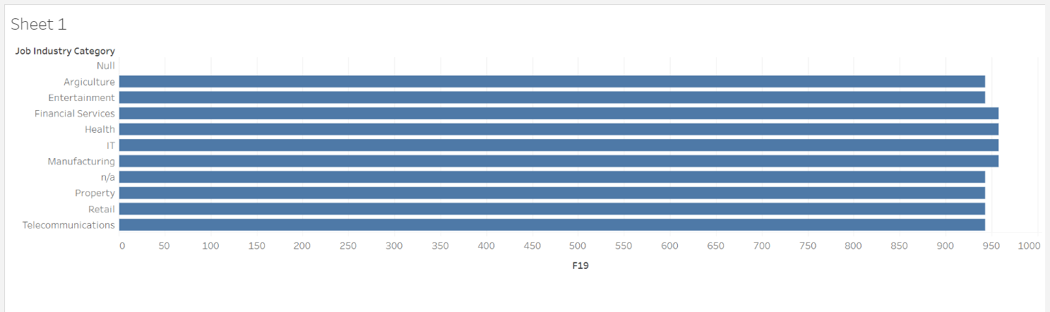

*Plot of job industry category and evaluation work*

*From this graph we could conclude that most of the evaluation work is maximized by four sectors i.e., Health ,IT, Financial services and Manufacturing sector. And Slightly less evaluation work is done in other six sectors i.e., Agriculture, Entertainment, N/A, Property, Retail and Telecommunication. Now, we have to increase the evaluation work to increase our profit and production and if the development work is right then our profit and production will increase automatically.*

***Result 4:*** *This bar graph of Month and Profit.*

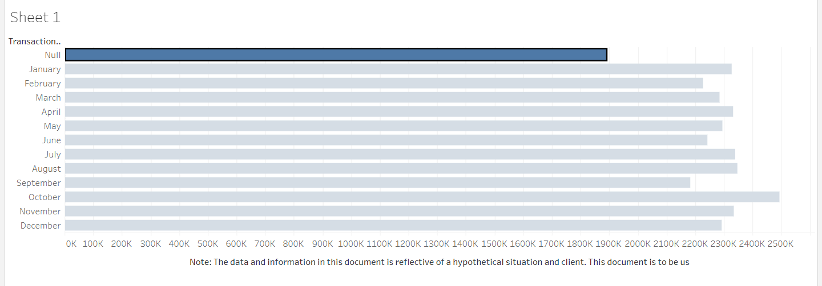

*Plot of Month and Profit*

*From this bar graph we need to focus on selling the Bicycles in September, may and February and June because the profit is lower in these months and we had higher profits in October month. In a few months we have had lower profits but we have to know why there has been less profit and what is the reason behind it and also to see why there has been more profit in month or October to increase the profit in each month.*

***Result 5:*** *This bar graph of Brands versus Profit.*

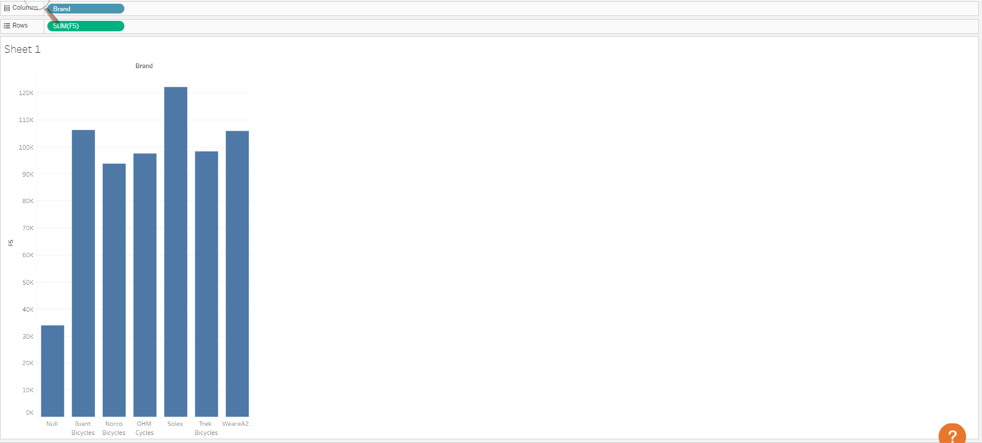

*Plot of Brands and Profit*

*From this bar graph we see that we have benefited from the Solex Brand Bicycle more than any other brand and now we have to know why Solex bicycles has been more profitable than the other brands of bicycles and the Narco Brand of Bicycles has given the lowest profit. Now we have to know why the other Brands of Bicycle are not selling and We also have to know what is the reason behind the brands of bicycle which are not being sold and what we can do to increase their sales.*

***Result 6:*** *This is the bar graph of Brands versus Sum of Standard Cost.*

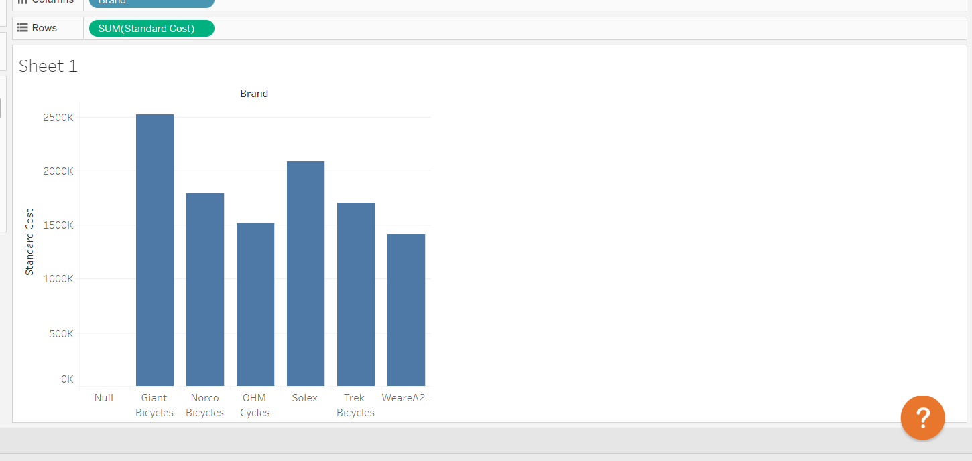

*Plot of Brands vs Sum of Standard Cost*

*From this graph we can see that the Sum of Standard Cost of Giant Bicycle is highest and Sum of Standard Cost of WeareA2 Bicycles is lowest. Now we have to see whether we are getting profit from the bicycle which has higher sum of standard cost or if we are not getting the profit then we have to work on that brand of bicycle and reduce sum of standard cost and know how we can get more profit from it.*