**A Project Report on**

**LIBRARY MANAGEMENT SYSTEM**

***Submitted in partial fulfilment of B.C.A 4h semester***



***~~~~~~~~~~~~~~~~~~~~~~~~~~~~~~~~~~~~~~~~~~~~~~~~~~~~~~~~***

*Submitted by*

Badal Mishra

CODE 16032, ROLL NO: 231

&

Shivam Debnath

CODE 16032, ROLL NO:263

**DEPARTMENT CERTIFICATE**

This is to certify that the Project entitled “**COLLEGE ADMISSION SYSTEM**” is submitted by **Badal Mishra**, Code 16032, Roll No: 231&**Shibam debnath**, Code 16032, Roll No: 263 in partial fulfilment of **B.C.A**, Minor Project of Guwahati University during the year 2017-18. This work has been found satisfactory and is approved for submission.

NAYAN MAHANTA

Asst. Professor & H.O.D

Dept of BCA

Pragjyotish College

**EXAMINATION CERTIFICATE**

This is to certify that Badal Mishra, Code 16032, Roll No: 231&Shibam Debnath, Code 16032, Roll No:263studentsof B.C.A, Department has successfully completed their Minor Project Work entitled “**LIBRARY MANAGEMENT SYSTEM**” and also defended successfully.

I wish him all the success in their future endeavours.

Examiners:

1. External Examiner:
2. Internal Examiner:

Declaration

We hereby declare that the project work entitled **“LIBRARY MANAGEMENT SYSTEM**” is an authentic work carried out by me in partial fulfilment of the requirement for the award of the degree of **B.C.A**. This project has not been submitted anywhere else.

It is Developed by us i.e Badal Mishra, Code 16032, Roll No: 231 & Shibam Debnath, Code 16032, Roll No:263students of B.C.A Department completely.

It full all Basic required that were mentioned in the project proposal.

**ACKNOWLEDGEMENT**

We truly resolve to acknowledge the opportunity provided to us by the Institution, respected teachers and family.

We intend to show our gratitude for all the support and guidance we got from our teachers, classmates, and all individuals who helped us at any point of this project.

This whole process we went through in bringing out this project was great source of knowledge and valuable experience, which would for sure, came handy for us in any future we will have to bring out another such project.

This has been a period of time over which we learnt about technological and logical aspects of the field where we are going to land soon, we feel indebt for being so well equipped with all the knowledge and experience we gathered here.

Badal Mishra Shivam Debnath

Code 16032, Roll No: 0231 Code 16032, Roll No: 0263

**CONTENTS**

The Contents of the project are –

1. Cover Page

2. Certificate

3. Acknowledgement

4. Declaration

5.Contents

6. Introduction

7. Objective

8. about Existing System

9. Drawbacks of the existing system

10. Propose System

11. Feasibility study

12. Hardware and Software information

13. Context Diagram

14. Data Flow Diagram

15. ER Diagram

16. Data Dictionary

17. Basic Code of the Project

18. Some important Snapshot of web pages

19. Conclusion

20.Reference

**Introduction**

***Surface details:***

Our project entitled as “Library Management System” is designed to bring ease to both the library staff and the students seeking for issuing books.

It is designed with features which reduce effort for the staff and increases convenience for the readers, Being a Web Based application, it is easy to Run and adapt in almost all conventional environments.

Any moderate user can easy learn and operate this system

Scope:

This System can work fine for all most every Libraries, where desired,

This cuts off a lot of human resource required to maintain the library, hence save money too.

It has fluid UI and UX which can be learnt and adapted quite quickly by any category of user.

This system extends its use outside library with is easy to adapt interfaces for readers

Objective

The Objective of this System is to reduce effort and increase convenience in the management of libraries.

It allows users to hold a book for 24 hours, so that no one can get it issued before they reach the library.

It will save time in calculation of fine

Students will be always stay notified about generated fine via their online accounts which they can access from anywhere.

* It will make it easier to search books.
* It will help keep track of book holders.
* It will keep Libraries less crowded.
* It will save money as less human resource will be required.

**About the existing system**

Currently libraries need to maintain bulky files to record of books and the individuals occupying them.

Fines are calculated manually by going through bundles of records.

Need to manually check for availability of books in the library

The process of issuing a book involves designated official making entry in registers manually, which takes plenty of time.

Disadvantages of Present System:

The current system is full of flaws as:

* A lot of Human Resource is required to maintain such a system much cost and hard to operate and maintain.
* A lot of money is wasted in maintaining these records
* Paper is wasted
* A lot of time is consumed in the process of searching a book, making its entry and retrieving any previous record.
* Availability of book cannot be assured without physically searching the library
* People need to travel to the library to know whether a book is available.

**Proposed System**

The System we developed comes with all solutions to the drawback of previous system.

Some of them are listed below:

* Search books from anywhere.
* Put book on hold for 24 hours so that no one else can take it before you
* Release book if you don’t want to hold it anymore
* A panel for users to check their hold and issued books
* Easy login and registration System.
* Automated Fine System
* One click book Issue
* Easily return book
* List of **trending books**.

**Feasibility Study**

This document enables proper decision to be made over progress of project, by studying various aspects of feasibility associated with it

Such are listed below:

* Cost: as it is a web based project it needs to be hosted over server to be accessed by users, but the efficiency which comes with the product shadows this cost, as it reduces money being spent on human resources
* Time: The time invested in this project is also justifiable as keeping the yield in consideration.
* Technical: All technological tools used to make this project are conventional easy to use one, they are easy to maintain too.

This project can be easily upgraded and maintained as it is designed in standard manner and is easy to understand.

***Hardware and software information***

**HARDWARE CONFIGURATION**

* System: Multimedia PC
* Processor:  Pentium 4 or above
* Memory: 512MB RAM or above
* Hard Disk:  500GB
* Keyboard: 104 standards

**Monitor: SVGA**

* **5.8 SOFTWARE CONFIGURATION**
* Front end:HTML,CSS,JavaScript
* Back end: SQL, PHP
* Operating System: Windows/Linux

Context Diagram

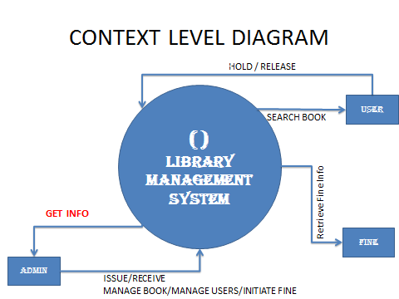

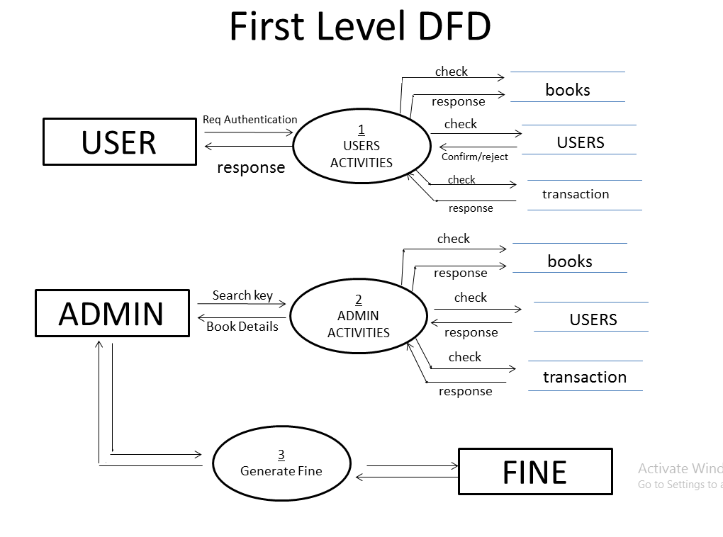

Second level for user (Process 1):

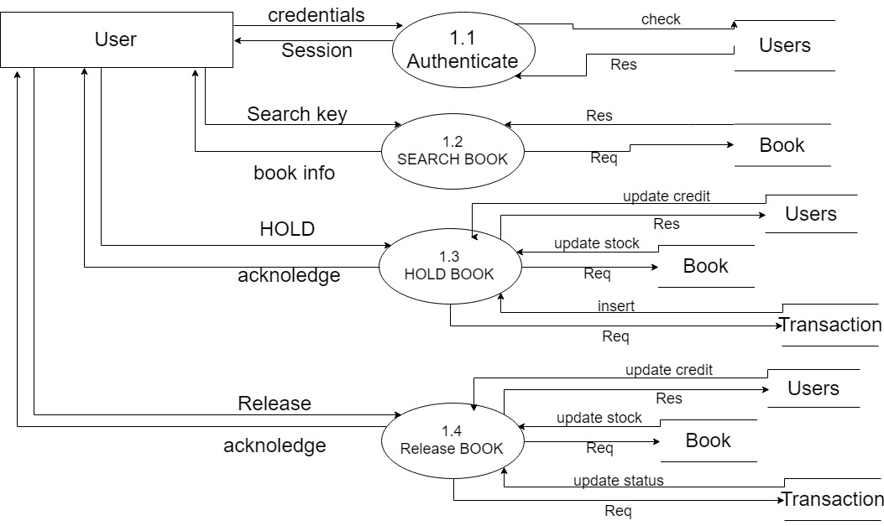

Second level for Admin (Process 2):

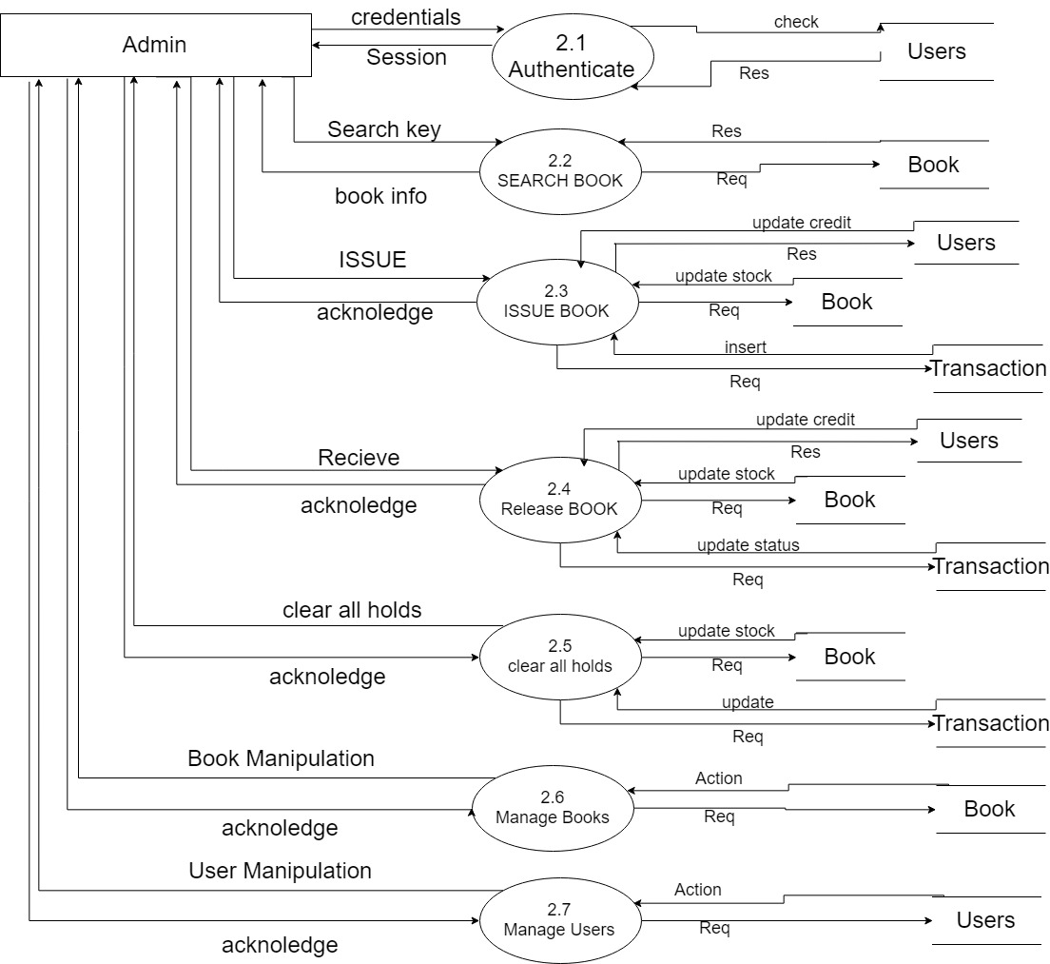

­­­

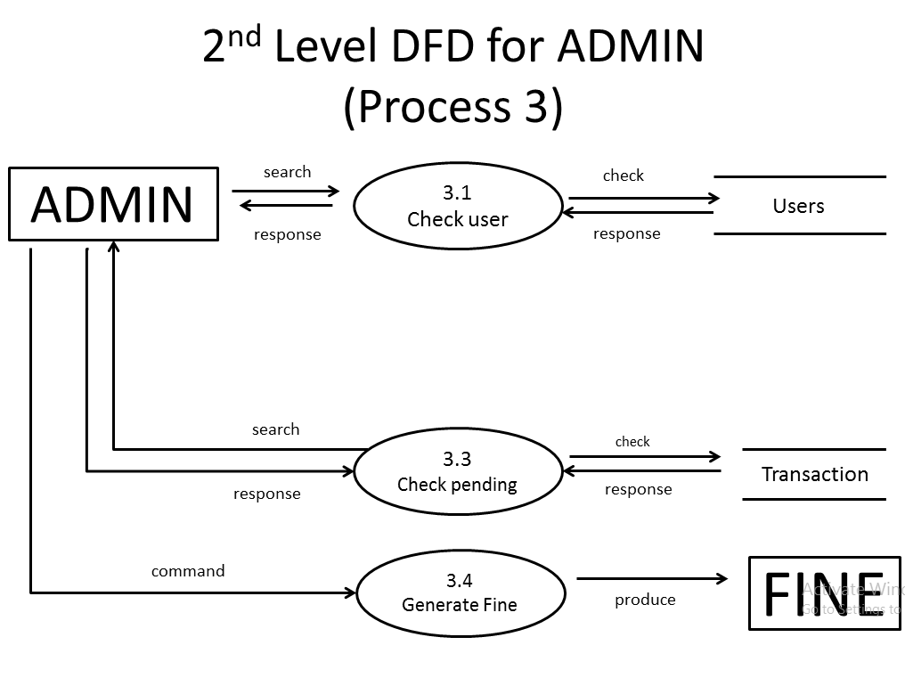

_____________________________

~~~~~~~~~~~~~~~~~~~~~~~~~~~~~

**ER Diagram:**

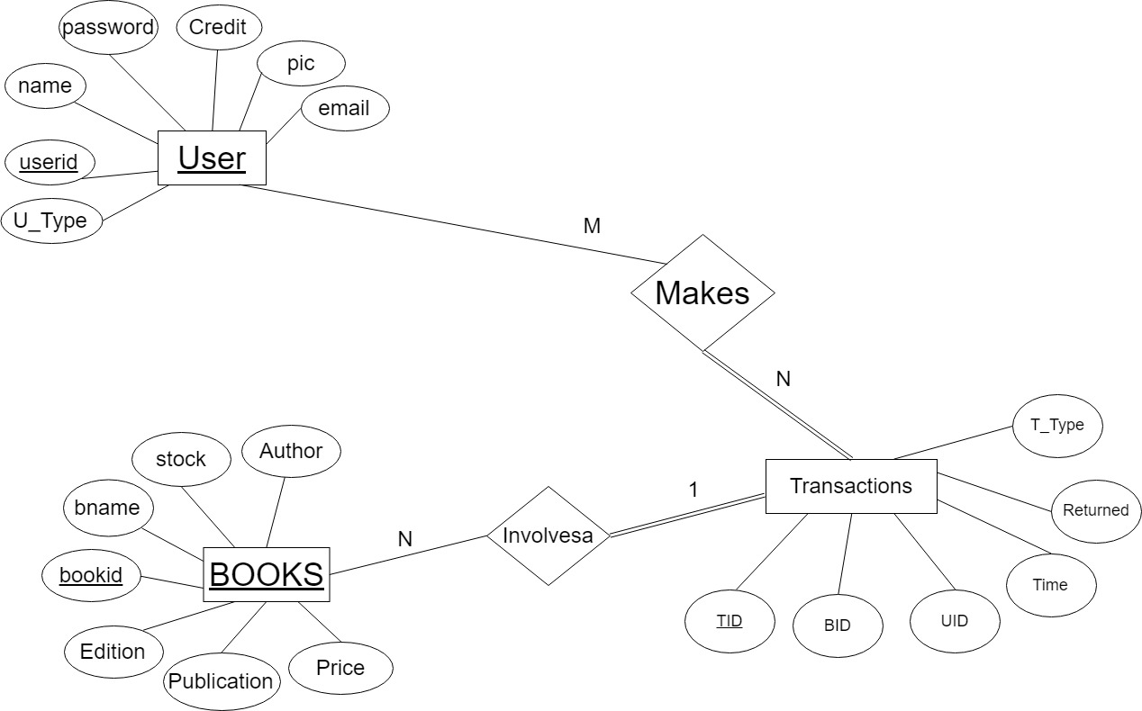

**DATA DICTIONARY**

**Users**

|  |  |  |  |  |
| --- | --- | --- | --- | --- |
| **Name** | **Type** | **Field-Size** | **Description** | **Example** |
| **Uid** | **INT** | **100** | **Unique ID for Users** | **0** |
| **name** | **VARCHAR** | **100** | **Name of user** | **xyz** |
| **password** | **varchar** | **100** | **Password** | **xyz** |
| **credit** | **INT** | **100** | **No.of book currently Occupied** | **0-5** |
| **U_type** | **varchar** | **100** | **Reader/admin** | **admin** |
| **Pic** | **varchar** | **100** | **photograph** | **Xyx.jpg** |
| **Email** | **Varchar** | **100** | **Email for identification** | **a@b.com** |

**Books**

|  |  |  |  |  |
| --- | --- | --- | --- | --- |
| **Name** | **Type** | **Field-Size** | **Description** | **Example** |
| **bookid** | **INT** | **100** | **Unique id of book** | **1** |
| **bname** | **Varchar** | **100** | **Name of book** | **Life of pie** |
| **stock** | **INT** | **100** | **Available copies** | **66** |
| **Author** | **Varchar** | **100** | **Name of author** | **abc** |
| **Publication** | **Varchar** | **100** | **Publication name** | **bbc** |
| **Edition** | **Varchar** | **100** | **Year of publication** | **2013** |
| **Price** | **Int** | **100** | **Price of the book** | **2000** |

**Transactions**

|  |  |  |  |  |
| --- | --- | --- | --- | --- |
| **Name** | **Type** | **Field-Size** | **Description** | **Example** |
| **Tid** | **INT** | **100** | **Unique id of transaction** | **1** |
| **bid** | **INT** | **100** | **ID of User Involved** | **1** |
| **uid** | **INT** | **100** | **ID of Book Involved** | **1** |
| **Time** | **timestamp** | **100** | **Time of transaction** | **2018-07-02 19:55:11** |
| **Returned** | **INT** | **100** | **State(returned or not)** | **0** |
| **T_type** | **Varchar** | **100** | **Hold or issue** | **issued** |