Olist Brazilian E-Commerce ETL Project
Supporting Documentation for GitHub

1. Dataset Source
Dataset: Brazilian E-Commerce Public Dataset by Olist
Kaggle link: https://www.kaggle.com/datasets/olistbr/brazilian-ecommerce
The original Olist dataset contains multiple related CSV files, including orders, customers, order items, payments, reviews, products, sellers, geolocation, and product category translation data. For the main assignment notebook, the ETL scope focuses on three core tables: orders, customers, and order items. This scope is enough to demonstrate joins, missing-value handling, derived columns, SQL aggregation, Delta table creation, and dashboarding.

2. Original Dataset Schema
The schema below shows how the full Olist dataset tables are connected through keys such as order_id, customer_id, product_id, seller_id, and zip_code_prefix.
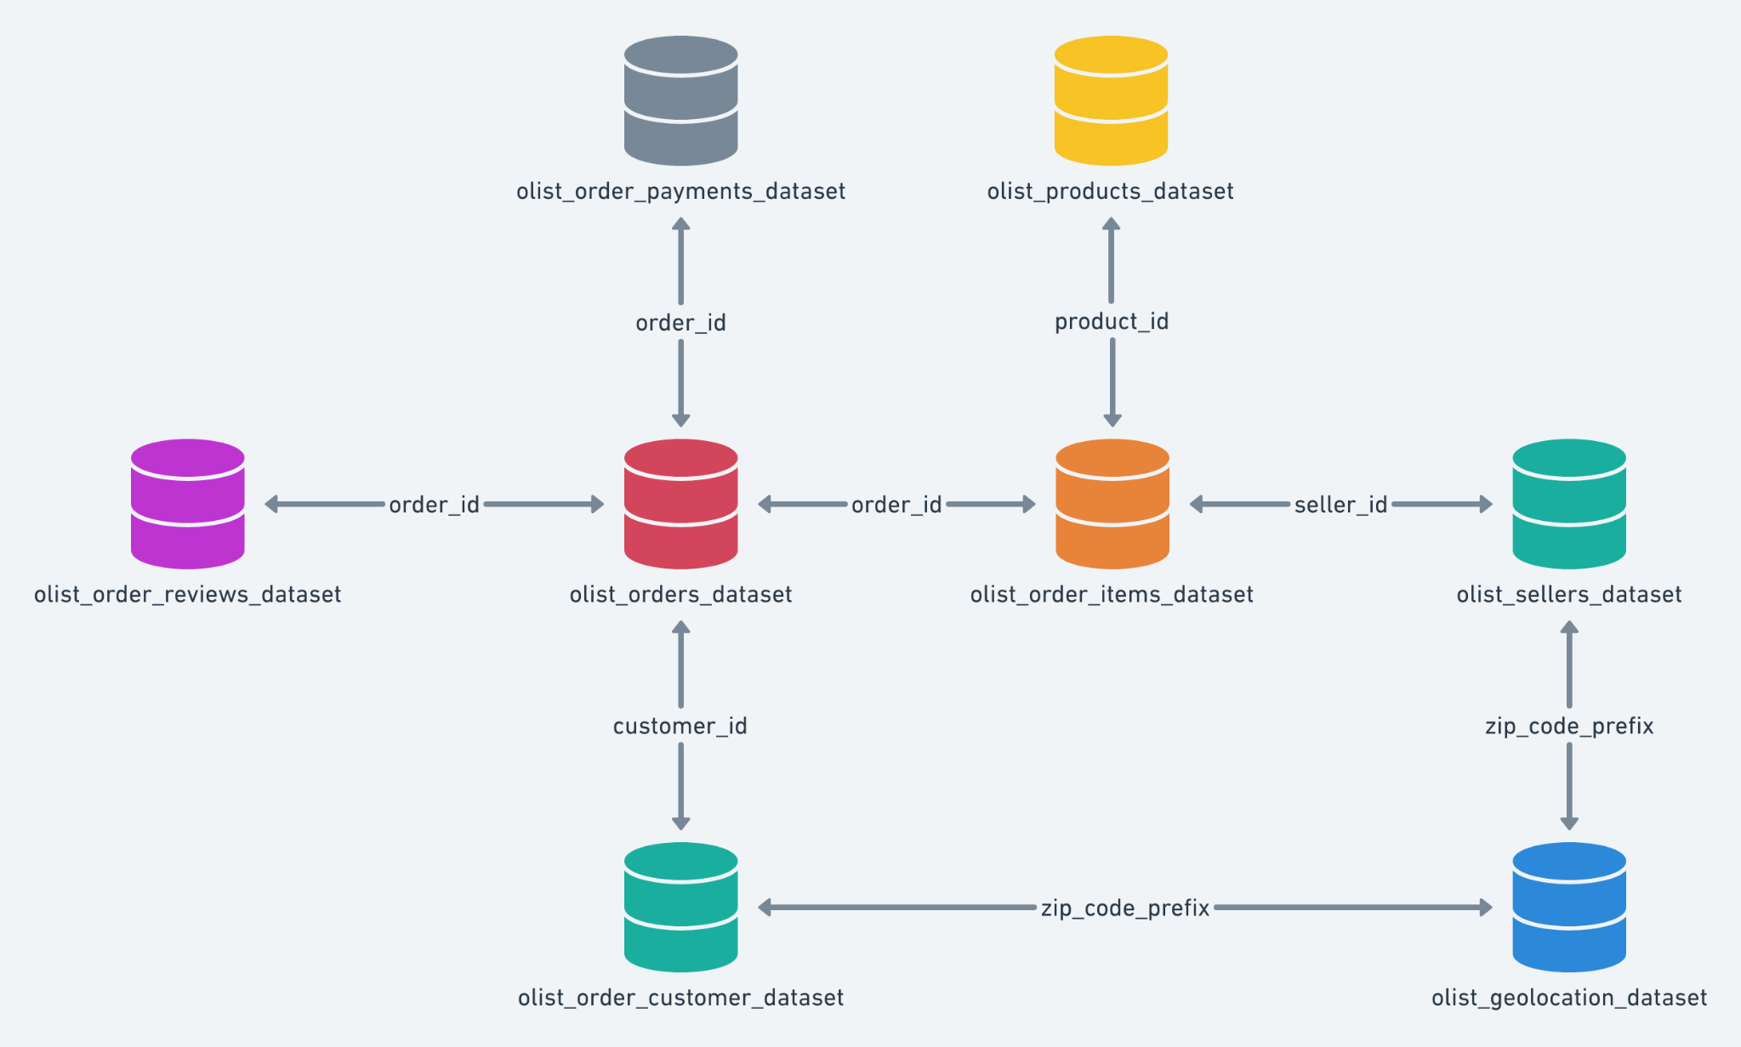
Figure 1. Original Olist dataset schema and key relationships.

3. Databricks Lakeflow Pipeline
The Lakeflow pipeline was created for learning purposes. It uses a Python transformation file to create Bronze, Silver, and Gold tables. The Bronze layer loads the raw Olist CSV files, the Silver layer creates a cleaned and joined table, and the Gold layer creates aggregated business tables for reporting.
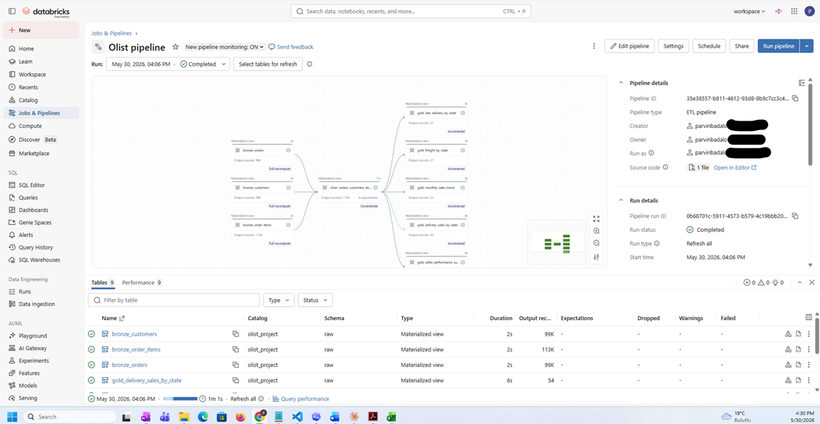
Figure 2. Databricks Lakeflow pipeline graph.

4. Databricks Job Orchestration
The Databricks Job uses a Pipeline task to run the Lakeflow pipeline. This is different from a normal Notebook task: Lakeflow pipeline code should be executed as a Pipeline task, while the analysis notebook can be run as a normal notebook or exported as a DBC archive for submission.
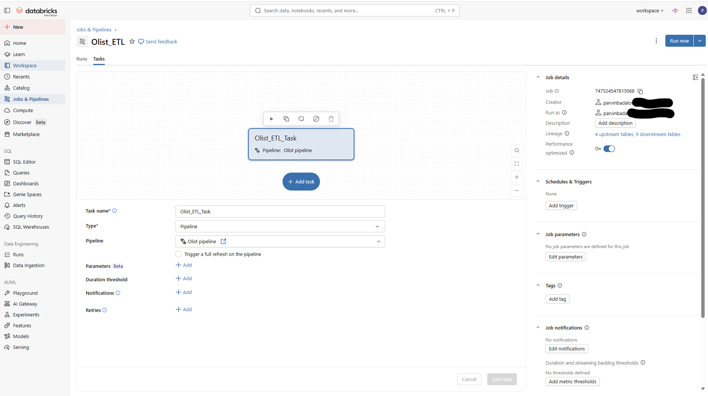
Figure 3. Databricks Job configured with a Pipeline task.

5. Project Outputs
- Catalog: olist_project
- Schemas: raw, bronze, silver, gold, and optional pipeline_demo
- Volume: olist_project.raw.olist_volume
- Bronze tables: orders, customers, order_items
- Silver table: orders_customers_items_clean
- Gold tables: delivery_sales_by_state, monthly_sales_trend, late_delivery_by_state, freight_by_state, and seller_performance_summary

