**Class diagram**

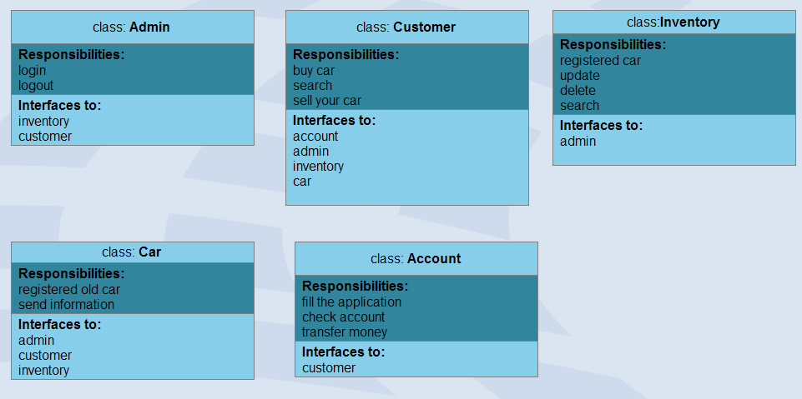

If customer buy car you have must the account. Customer transaction transmit using him account.