DATA 5322 Statistical Machine Learning 2
Badamgarav Battushig
May 17, 2026

Neural Networks for Seattle-Area Bird Call Classification

Abstract
This study considers whether spectrograms of sounds produced by birds are suitable for predicting bird species common in Seattle. A binary neural network was constructed to differentiate between an American Robin and a Song Sparrow, while three CNNs were evaluated on the 12- species classification problem. The binary classifier reached 79.2% accuracy in 13 epochs, while the best multiclass model, the wider CNN, reached 29.6% accuracy in 12 epochs. The study suggests that neural networks are capable of learning useful patterns from spectrograms. However, the classification problem is difficult because several species have similar sound patterns, including short high-frequency segments or sparrow-like calls.

Introduction
Bird vocalizations serve as a valuable source of ecological information. Many bird species are more likely to be heard than seen in dense environments or during early morning surveys. The present study aims at determining whether it is feasible to build a neural network model for classification of bird species based on their spectrograms, which show the image of sound frequencies, time, and intensity. In case such a classifier is successfully built, it can have great applied value, as the automatic detection of bird vocalizations may facilitate the biodiversity monitoring and surveys, as well as citizen science projects with no opportunity to listen to recordings.
The data used in this task include the images of the spectrograms of 12 bird species: American Crow, American Robin, Bewick's Wren, Black-capped Chickadee, Dark-eyed Junco, House Finch, House Sparrow, Northern Flicker, Red-winged Blackbird, Song Sparrow, Spotted Towhee, and White-crowned Sparrow. For this task, 1,163 images were chosen, with no more than 120 images per class in order to balance data. The following research questions should be addressed: (1) Is it possible for the CNN classifier to discriminate two very similar local songbirds using binary? (2) What is the effectiveness of different CNNs for the 12-class problem? (3) Which bird species will be misclassified frequently?
In order to solve this problem, a binary CNN was trained for American Robin versus Song Sparrow. Three multiclass CNNs were then compared: a small baseline CNN, a deeper CNN, and a wider CNN with more filters. Performance was assessed using held-out test accuracy, cross-entropy loss, confusion matrices, precision recall, F1-score, and training time.

Code | Species | Available | Used
amecro | American Crow | 66 | 66
amerob | American Robin | 172 | 120
bewwre | Bewick's Wren | 144 | 120
bkcchi | Black-capped Chickadee | 45 | 45
daejun | Dark-eyed Junco | 125 | 120
houfin | House Finch | 84 | 84
houspa | House Sparrow | 630 | 120
norfli | Northern Flicker | 37 | 37
rewbla | Red-winged Blackbird | 187 | 120
sonspa | Song Sparrow | 263 | 120
spotow | Spotted Towhee | 137 | 120
whcspa | White-crowned Sparrow | 91 | 91
Table 1. Species represented in the data and the number of spectrograms used after capping large classes at 120 samples.

Theoretical Background
A spectrogram represents an audio signal as an image such that time is mapped along the horizontal axis, frequency along the vertical axis, and the color or brightness of the pixel shows the signal energy. Such a representation makes the bird call suitable for analysis using image-learning techniques, as features like repeated notes, frequency sweeps, silence periods, and harmonics appear as visible patterns within the image. Mel spectrograms are an alternative kind of spectrogram where frequency is represented on an auditory-perception scale, and librosa library offers support for calculating mel spectrograms
A feed-forward neural network learns a series of weighted transformations from the feature vector of input to probabilities for the various classes. The algorithm makes a prediction, compares its result with the true labels through the loss function, and uses backpropagation to update the model parameters. For classification, either the sigmoid or the softmax function can be used in the output layer as appropriate to perform binary or multi-class prediction, respectively. The model is tuned by changing architecture, number of epochs, batch size, learning rate, and regularization choices, then evaluated on examples not used for training.
The convolutional neural network is especially well-suited for working with image spectrograms due to convolutional filters learn local visual motifs. In a CNN performing image classification tasks, the earliest filters could detect edges or colored bands, whereas deeper filters might combine those visual features into larger structures. For bird audio signals, those "objects" would include syllables, abrupt calls, frequency sweeps, or broadband bursts. Local-filter operation for two-dimensional inputs is provided by the Keras Conv2D layers.

It is important to consider model performance from several angles. While accuracy is relatively easy to interpret, it does not tell much about the specific problems that could arise from class imbalance. A confusion matrix is useful to find out what true classes are mispredicted as what else [6]. Precision tells us how much we can trust the predicted class; recall shows how well the true examples of a class are captured, and the F1 score combines precision and recall [7]. Early stopping and learning rate reduction helps tuning tools because they reduce unnecessary training and respond when validation performance stops improving.

Methodology
The input data were provided in as spectrogram arrays in HDF5 file. Each spectrogram was scaled to a numeric range suitable for neural-network training, rescaled to have 64 x 160 pixels, and transformed to consist of single image channel. The split between training, validation, and test data was stratified making sure that each species is included in the evaluation data. The random seed 42 was used to make train-test split and model comparison results reproducible.
In the case of the binary classification problem, only the American Robin and Song Sparrow examples were used. In the multiclass classification problem, all 12 classes of birds were included. The multiclass models were compared by changing network capacity: the small CNN served as a compact baseline, the deeper CNN added additional convolutional depth, and the wide CNN used a broader set of filters to capture more spectrogram patterns. Training was conducted for 20 epochs using a batch size of 16; however, early stopping ended training sooner when validation performance stopped improving. Learning-rate reduction was also used when validation loss plateaued.

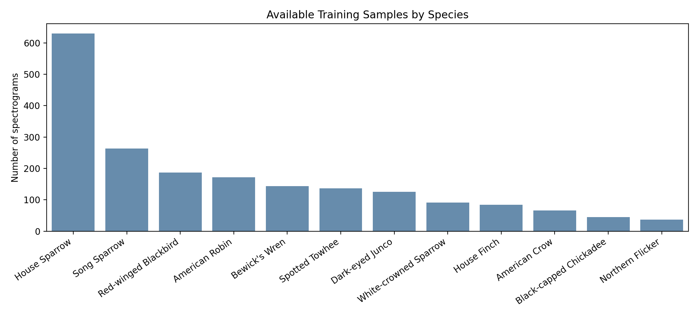
Figure 1. Available and used spectrogram samples by species.
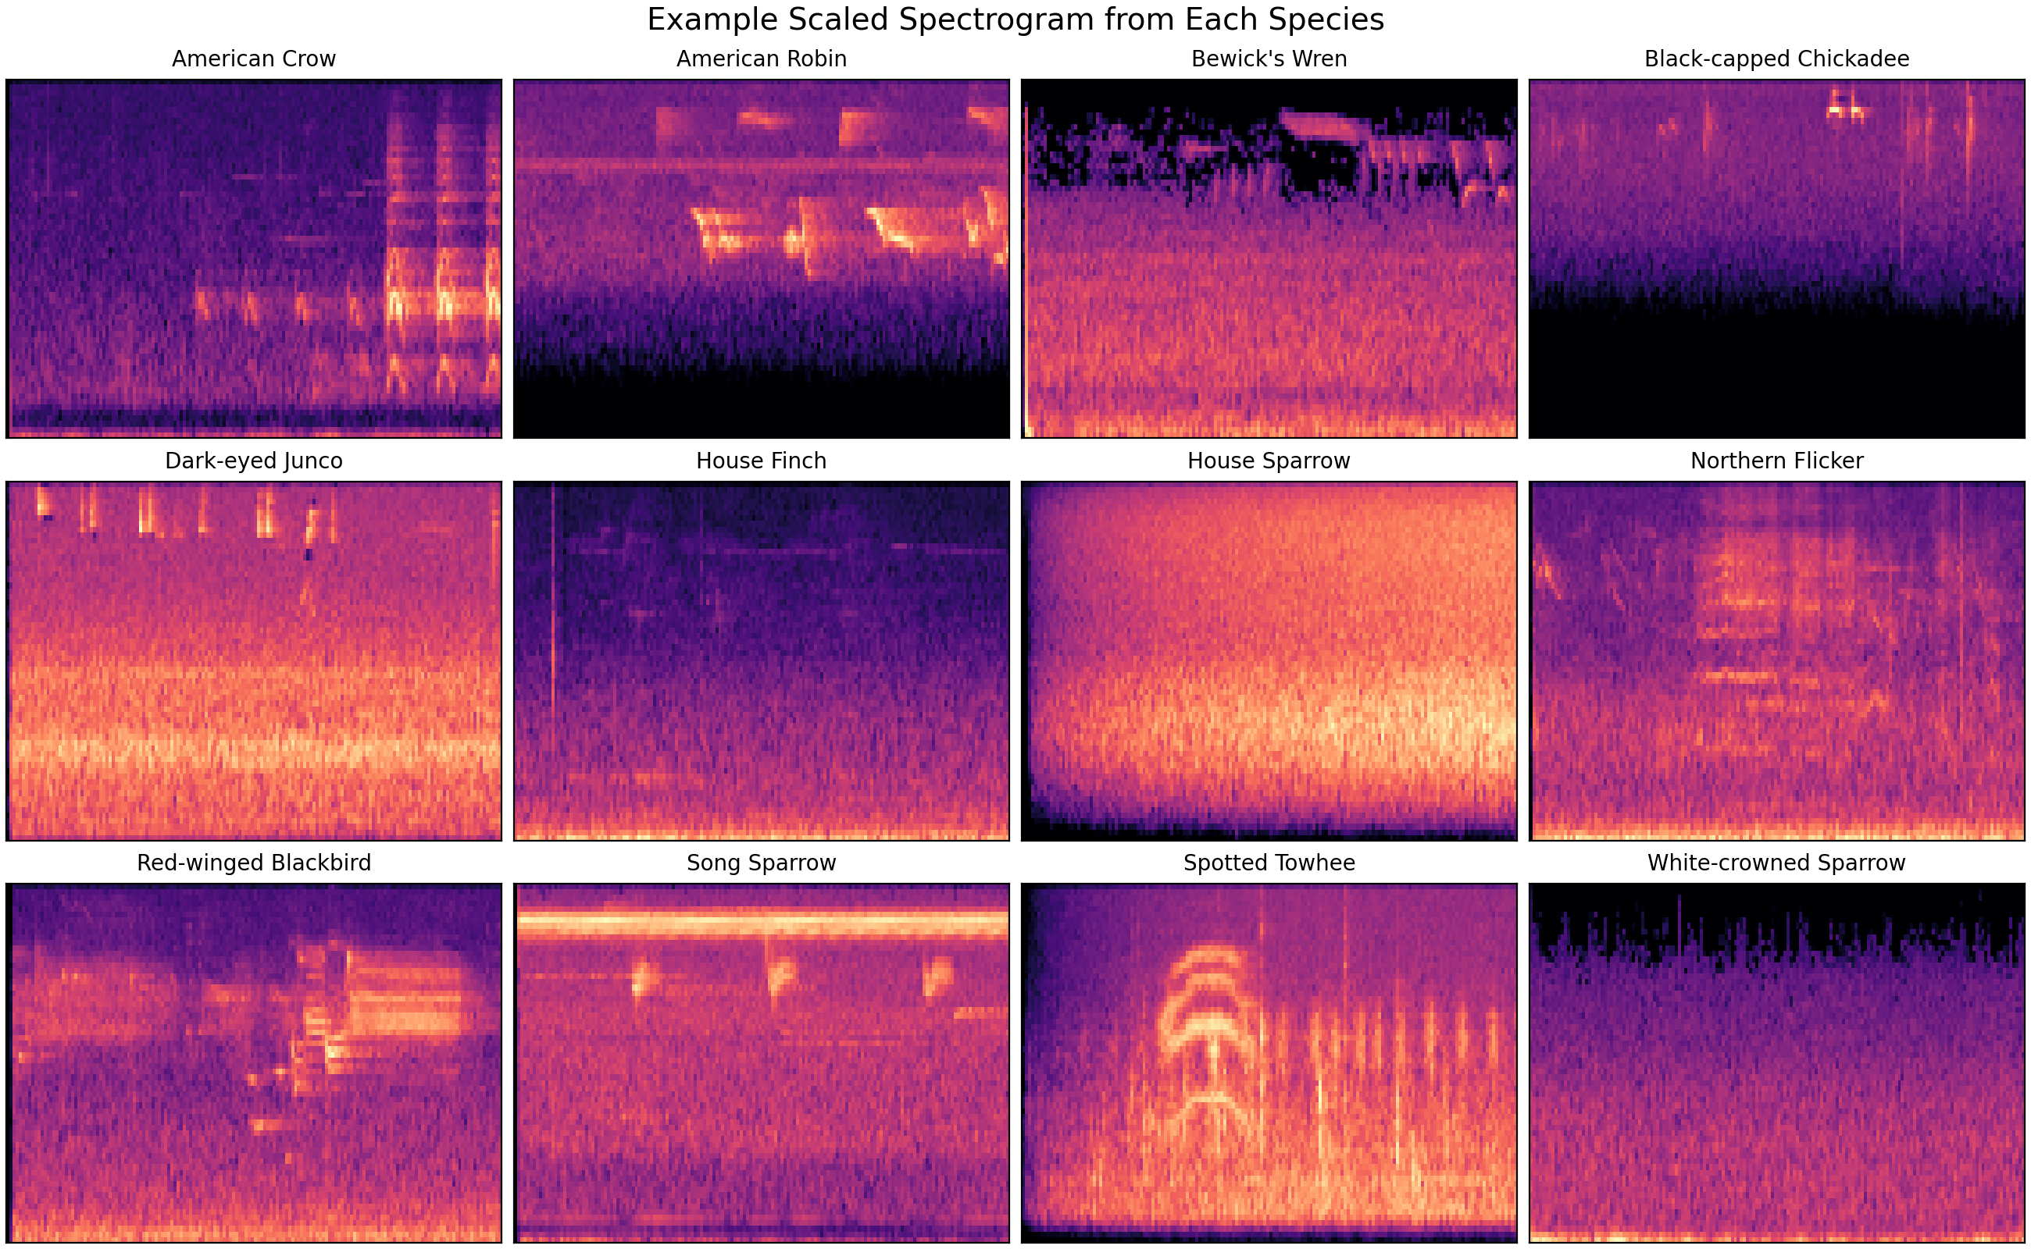
Figure 2. Example scaled spectrogram from each species in the data set.

Results
Binary classification proved significantly more effective compared to the 12-species classification . Binary classifier had an accuracy of 79.2%, a test loss of 0.390, and training time of 3.7 seconds. Wide CNN produced the most accurate results. It reached 29.6% of correct classifications, after 12 training epochs. Small CNN gave 27.5% of correct classifications while deep CNN scored only 10.3%. The findings suggest that increase of width provided more benefits than increase in the depth for the selected set of data.
Model | Task | Epochs | Test loss | Test accuracy | Training time
Binary CNN: American Robin vs Song Sparrow | Binary | 13 | 0.390 | 79.2% | 3.7 s
Wide CNN: 12 species | Multiclass | 12 | 2.065 | 29.6% | 36.8 s
Small CNN: 12 species | Multiclass | 11 | 2.179 | 27.5% | 8.2 s
Deeper CNN: 12 species | Multiclass | 5 | 3.889 | 10.3% | 11.4 s
Table 2. Neural network model comparison on the held-out test set. The best 12-species model is shaded.
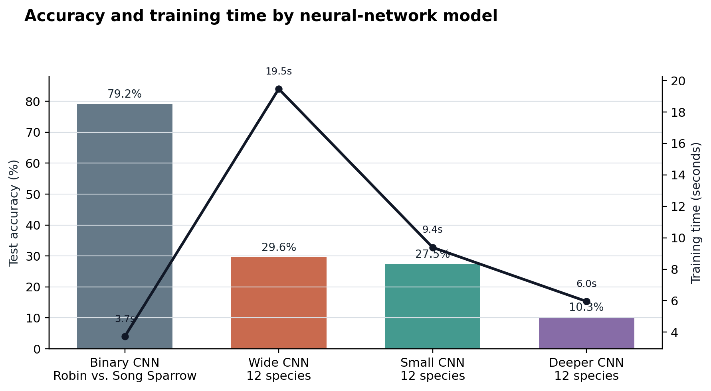
Figure 3. Test accuracy and training time by model.
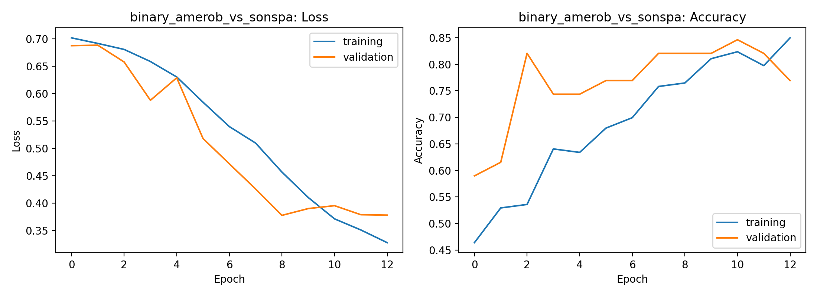
Figure 4. Binary CNN training and validation history.
As seen from the binary confusion matrix, the model recognized 17 American Robins and 21 Song Sparrows correctly, while 7 American Robins and 3 Song Sparrows were misclassified. It means that there were substantial distinctions between two bird species but robins were not recognized properly in the test split.
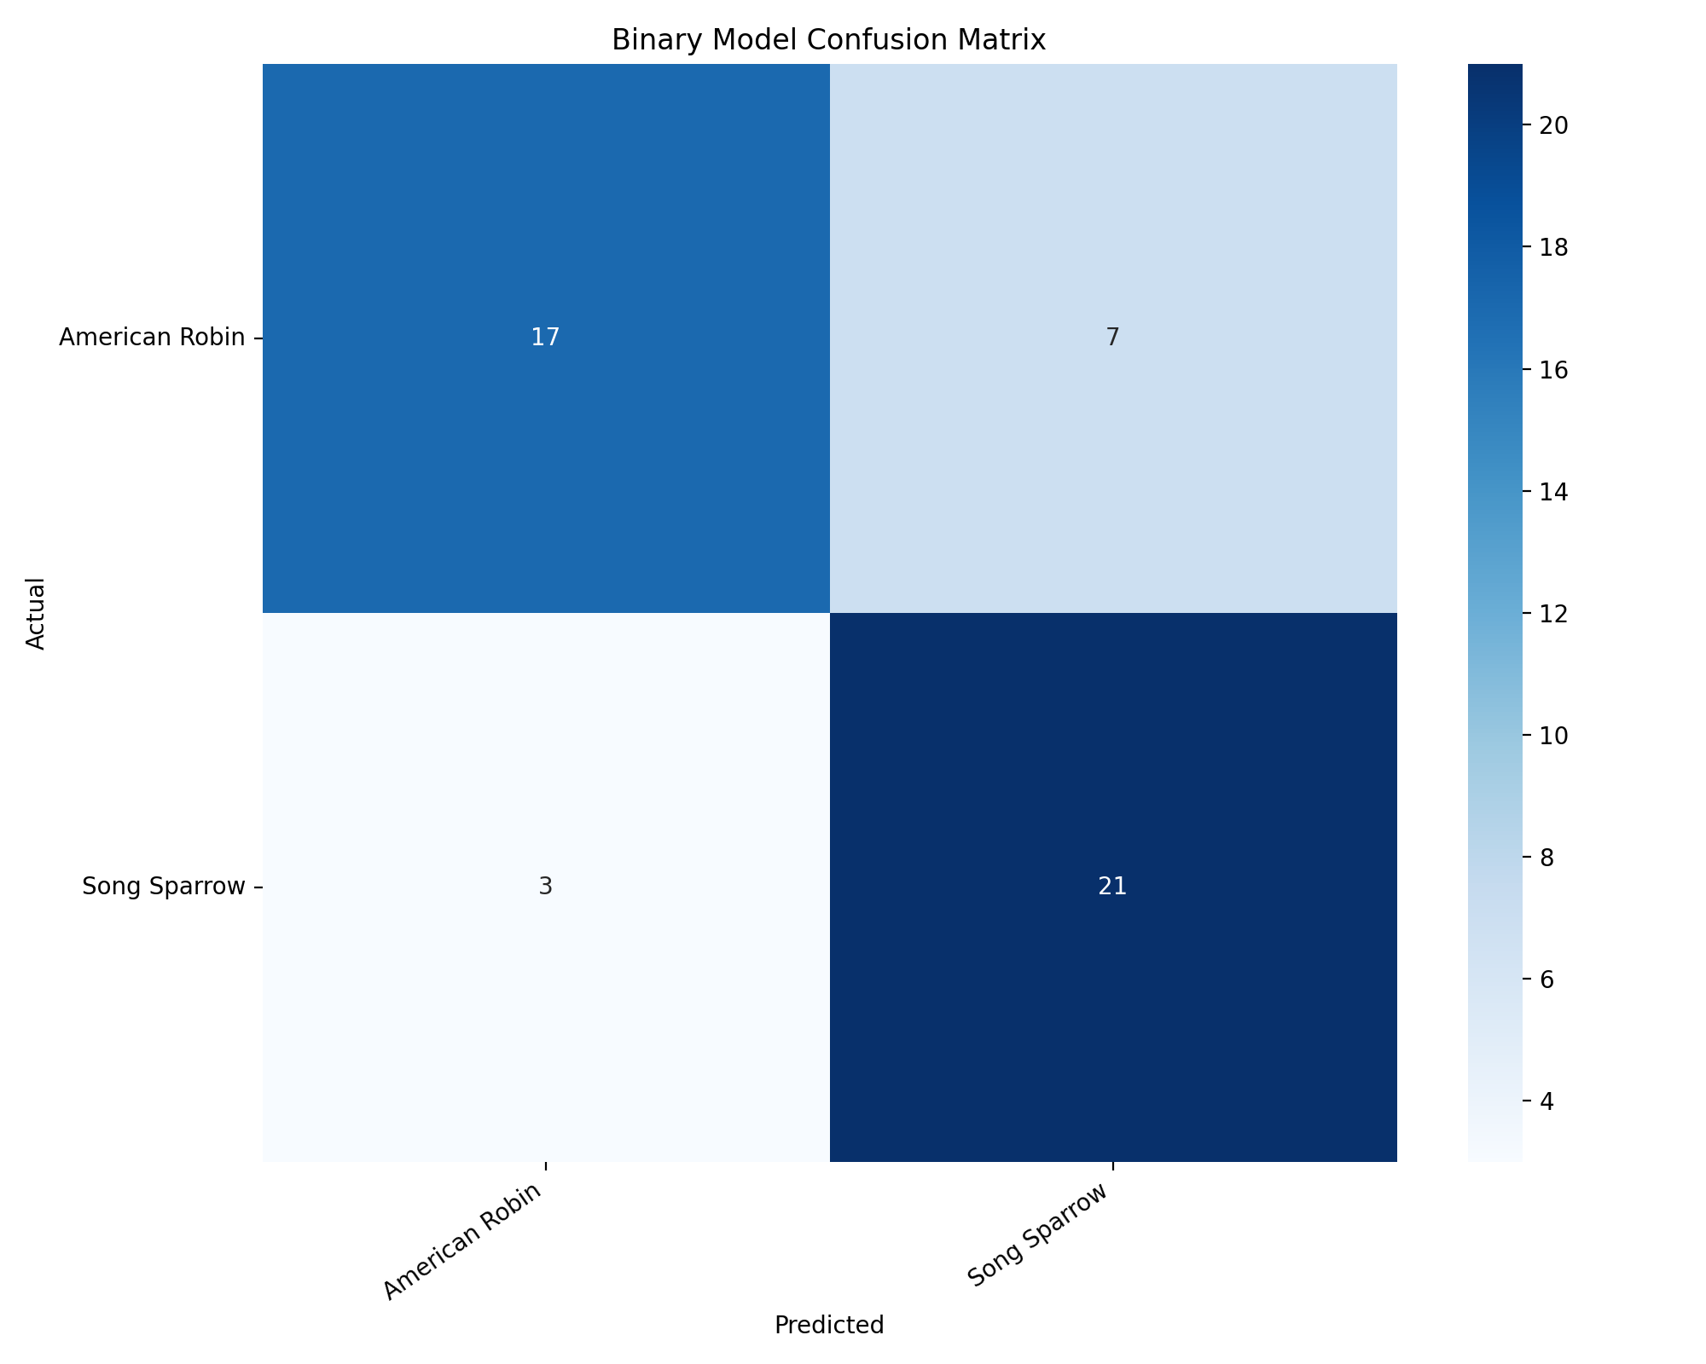
Figure 5. Binary confusion matrix for American Robin and Song Sparrow.
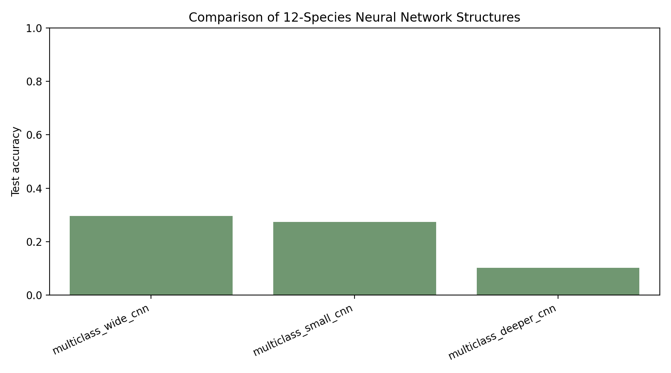
Figure 6. Multiclass CNN comparison across the three architectures.
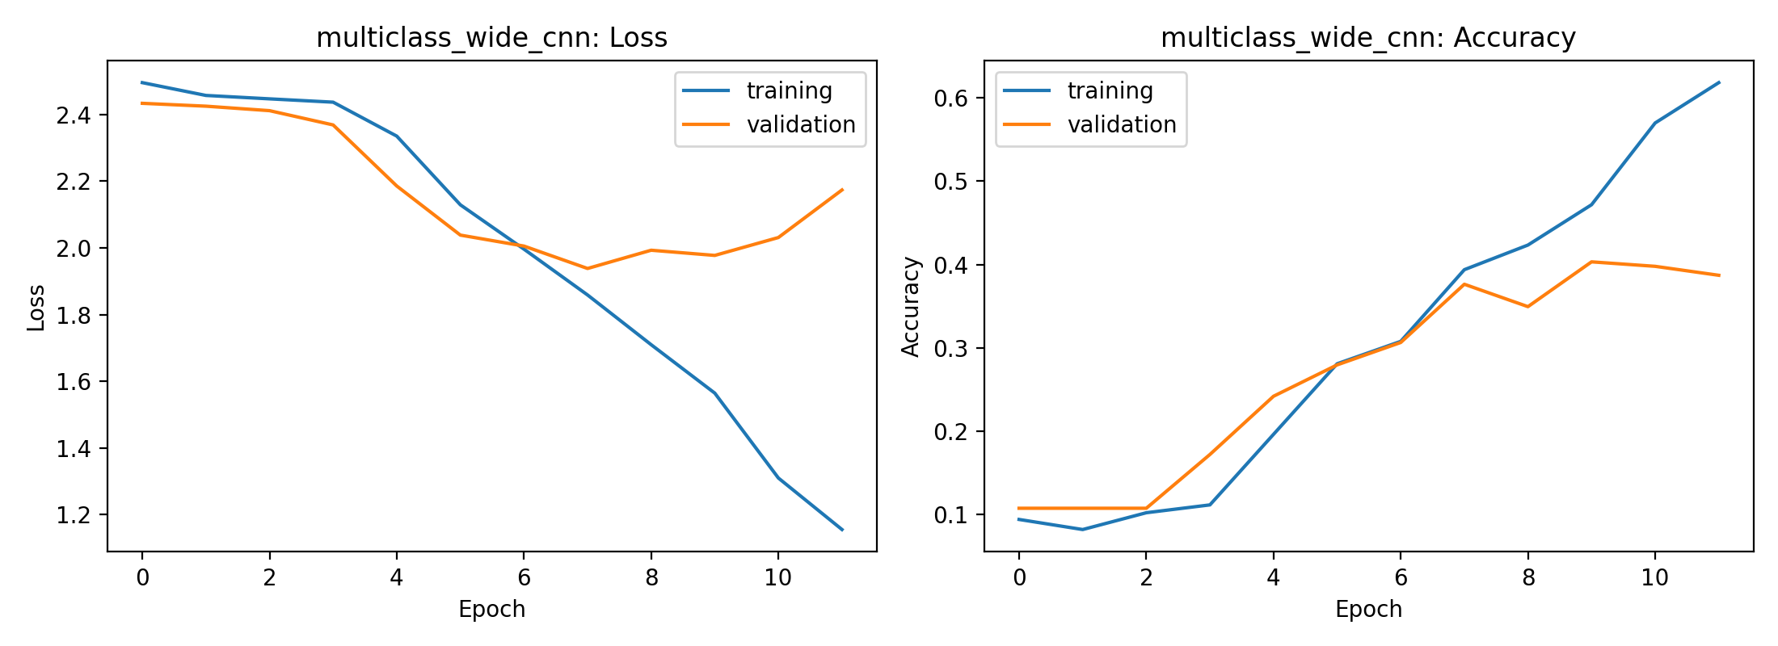
Figure 7. Training history for the best multiclass model, the wide CNN.
Among all multiclass models, Wide CNN gave the most promising result. However, the analysis of its confusion matrix shows that there are some species that have been systematically confused. House Sparrow was classified correctly in 15 out of 24 cases. American Crow also showed relatively good results: 7 out of 13 were recognized correctly. On the other hand, Northern Flicker resulted in no correct classification whatsoever. The same applies to Bewick's Wren; out of 24 cases in test split, only one example was classified correctly. Many errors were related to House Sparrow, Song Sparrow, Dark-eyed Junco, and White-crowned Sparrow. Thus, model often collapsed acoustically similar or visually similar spectrograms into a few common songbird classes.
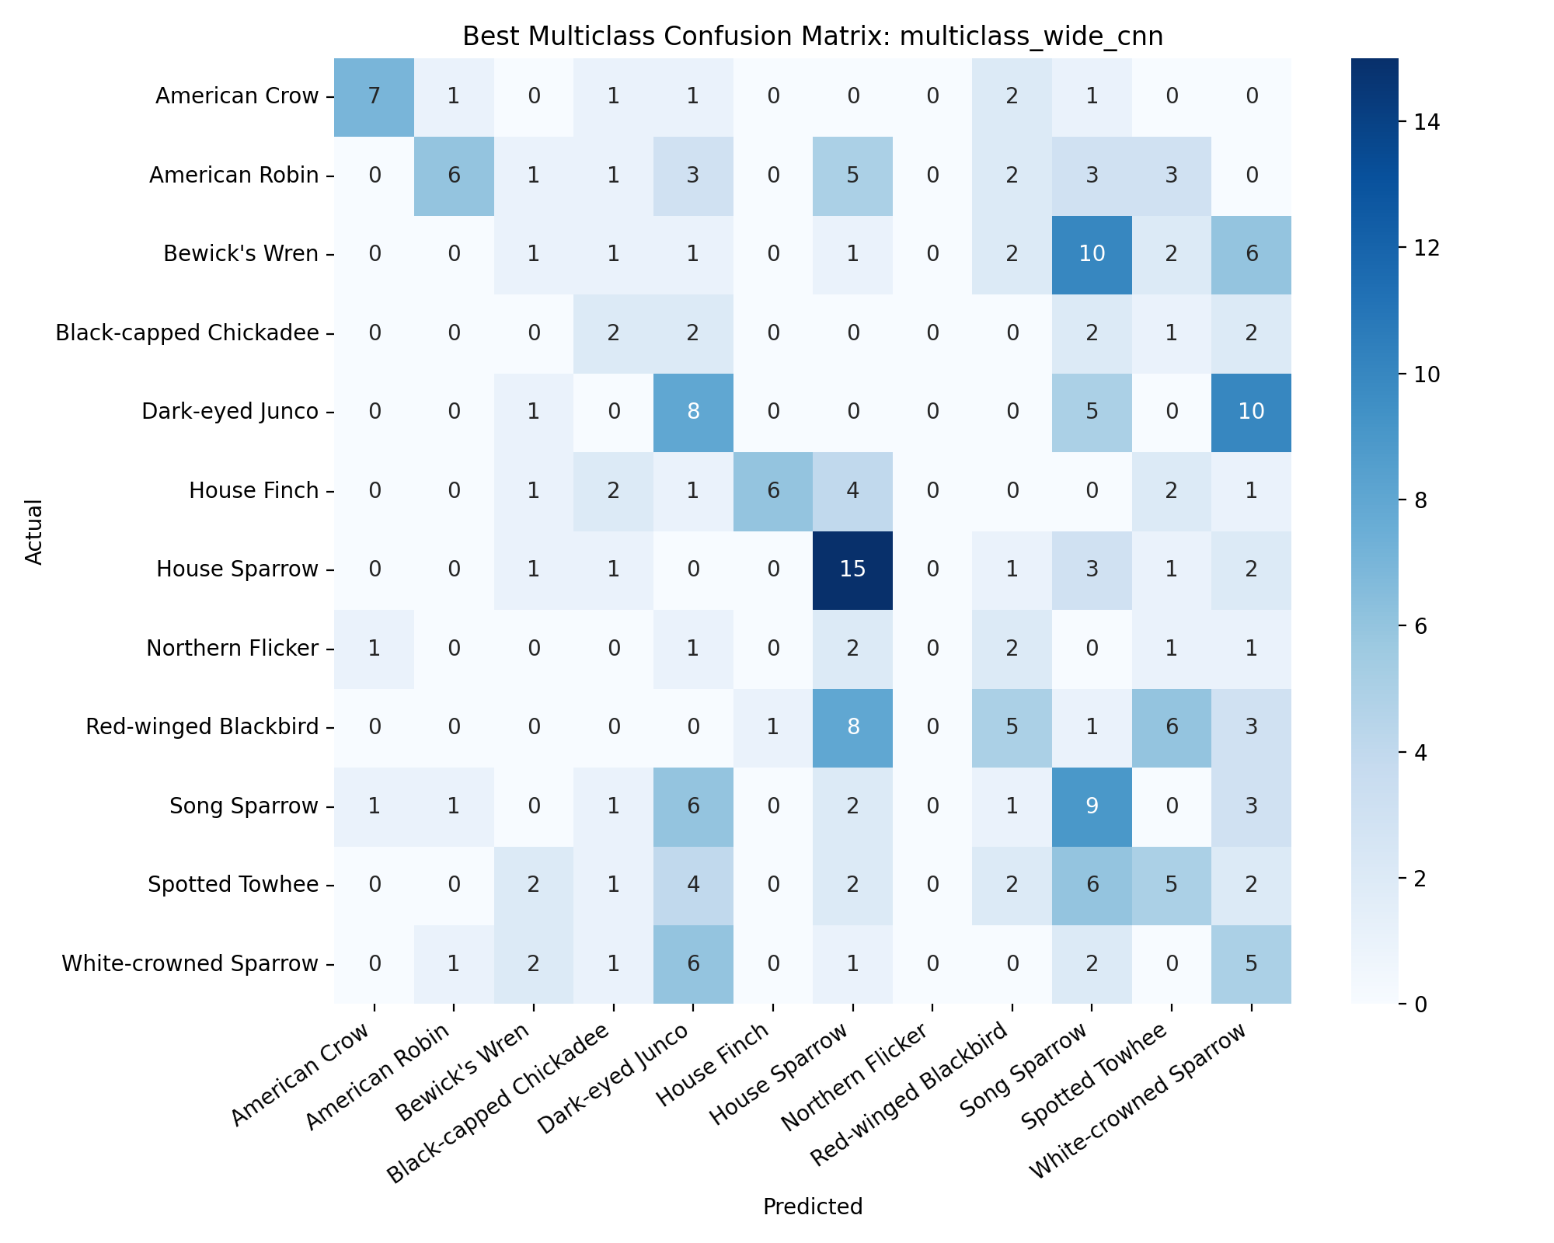
Figure 8. Confusion matrix for the best 12-species CNN.
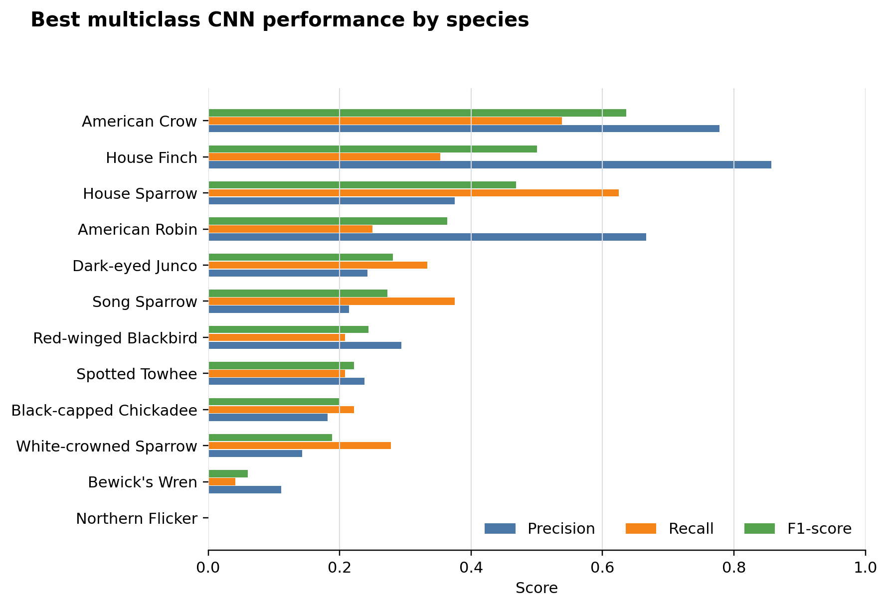
Figure 9. Precision, recall, and F1-score by species for the best multiclass CNN.
Species | Precision | Recall | F1-score | Support
Northern Flicker | 0.00 | 0.00 | 0.00 | 8
Bewick's Wren | 0.11 | 0.04 | 0.06 | 24
White-crowned Sparrow | 0.14 | 0.28 | 0.19 | 18
Black-capped Chickadee | 0.18 | 0.22 | 0.20 | 9
Spotted Towhee | 0.24 | 0.21 | 0.22 | 24
Red-winged Blackbird | 0.29 | 0.21 | 0.24 | 24
Song Sparrow | 0.21 | 0.38 | 0.27 | 24
Dark-eyed Junco | 0.24 | 0.33 | 0.28 | 24
American Robin | 0.67 | 0.25 | 0.36 | 24
House Sparrow | 0.38 | 0.62 | 0.47 | 24
House Finch | 0.86 | 0.35 | 0.50 | 17
American Crow | 0.78 | 0.54 | 0.64 | 13
Table 3. Classification report for the best 12-species CNN, sorted from lowest to highest F1-score.

External Test Clip Predictions
The trained 12-species CNN was also applied to the three external mystery clips required for the homework. The clip-level predictions are summarized below.
Clip | Top predicted species | Top probability | Second predicted species | Second probability | More than one bird? | Reason
test1 | House Sparrow | 0.153 | Song Sparrow | 0.140 | Yes | Top prediction changes across windows.
test2 | Red-winged Blackbird | 0.337 | American Robin | 0.156 | No | One species dominates the windows.
test3 | Black-capped Chickadee | 0.160 | White-crowned Sparrow | 0.154 | Yes | Top prediction changes across windows.
Table 4. External test clip predictions from the best 12-species CNN.
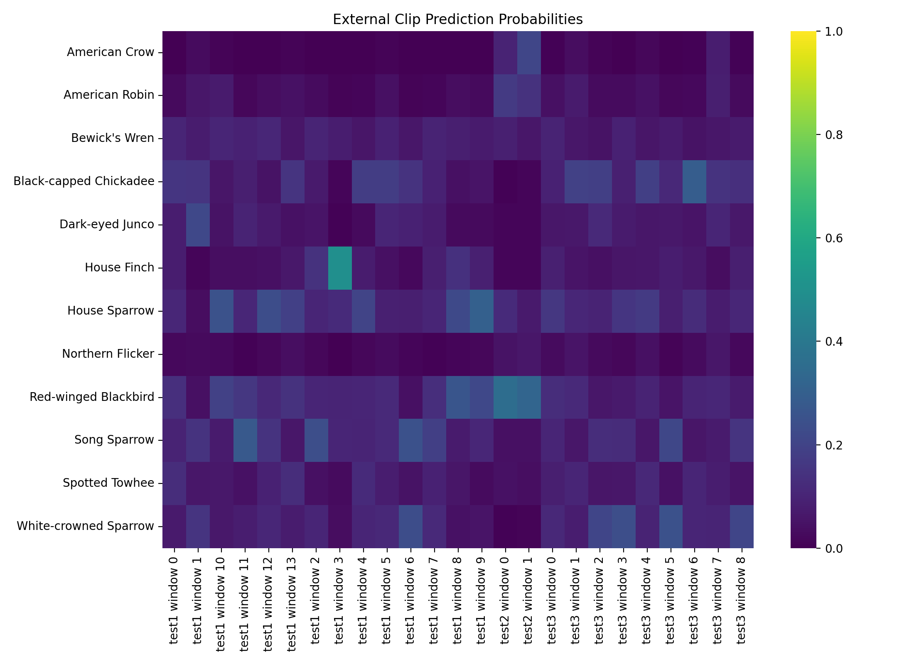
Figure 10. External test clip prediction probabilities across windows.
The heatmap shows prediction probabilities across multiple windows from the three mystery clips. This helps identify possible multi-bird clips because a clip with changing high-probability species across windows may contain more than one bird call.

Discussion
The most important limitation was data scale. 1,163 spectrograms belonging to 12 classes of birds were used in the experiment, while some of them were significantly less represented before limiting the larger classes. For example, Northern Flicker has only 37 spectrograms, while Black-capped Chickadee – only 45 spectrograms available. Thus, the neural network had limited evidence in order to train itself on these classes. A third limitation to be noted relates to computation: the experiment was run on a native Windows PC using CPU, not the GPU version of TensorFlow, which implied the creation of smaller models and resizing the spectrograms to 64x160 pixels each. Finally, the transformation of sounds into image-based spectrograms helps the convolutional neural networks to work, but can lead to some information loss as well.
Training time for all models turned out to be quite different. The training of the binary CNN required only 3.7 seconds. As for the multiclass models, it took them much more time: 8.2 seconds for the small CNN, 11.4 seconds for the deeper CNN, and 36.8 seconds for the wide CNN. Consequently, despite poor results, the latter provided the best multiclass accuracy at the expense of higher runtime.
The hardest-to-classify species were the following: Northern Flicker, Bewick's Wren, and White-crowned Sparrow. First, Northern Flicker showed zero recall, which means the model failed to find the proper structure for this species. Meanwhile, Bewick's Wren had F1-score equal to just 0.06, while White-crowned Sparrow – only 0.19. From the panel, it becomes evident that the small bird song shows narrow and repetitive high-frequency lines instead of one broad structure. Therefore, the confusing similarity leads to mistakes. At the same time, American Crow and House Finch managed to achieve the highest F1-scores, which implies that their calls create more distinctive patterns.

On the other hand, the binary problem was much easier, since there was only one decision boundary to learn between two categories. In the 12-species classification task, it was required to have several decision boundaries learned at once, including between species having similar spectrogram textures. It can be concluded from the confusion matrix above that the mistakes were systematic: there were a few familiar classes where the model tended to make predictions, such as House Sparrow and Song Sparrow. Therefore, the model has learned general patterns in acoustics but failed to capture the nuances of every species.

Some alternative modeling approaches could have been used. For example, traditional ones could calculate handcrafted acoustic features like MFCCs, spectral centroid, bandwidth, and tempo-like properties, followed by logistic regression, random forest, SVM, KNN, or gradient- or gradient-boosted trees. Sequence models such as recurrent neural networks or transformers could model time dependencies directly. Finally, transfer learning from a pretrained model on audio tasks seems to be a strong next step. Neural networks are appropriate in the current case because birdsongs contain both spatial and temporal patterns, which are impossible to summarize by humans, and recent bird-sound detectors, like BirdNET, perform multiclass classification based on spectrograms using deep learning

For the external test clips, test2 had more consistency in prediction windows, since there was only one species dominating in them. Conversely, test1 and test3 might include multiple birds, judging from different predictions in the leading species in different windows. However, the external predictions should not be treated very seriously since the best model achieved only about 29.6% test accuracy.

Conclusions
This assignment demonstrates the power of and the challenges involved in classifying birds using spectrograms. The binary model had decent performance when distinguishing between American Robin and Song Sparrow, while the multiclass model struggled with the greater number of similar-looking classes. Among the three CNN architectures considered, the wider model had better performance than the deeper and smaller models. Confusion matrix is the most valuable part of the analysis here because it provides insight on where this model works and where it fails and, therefore, what needs to be done next to improve it.

A useful application of such machine-learning tools as automatic bird call classification can be applied by ecological researchers as well as citizen science enthusiasts to process large volumes of recordings they collect in the field. The biggest value can be seen not in replacing human expertise with artificial intelligence but in providing decision support in cases involving many species, thus facilitating further processing and saving precious time. Improvements in future work include recording more samples per each species, keeping the audio file metadata intact, testing on a much larger and diverse number of external samples recorded under different conditions, implementing data augmentation techniques, and comparing the CNN with audio-based pre-trained models.

References
[1] Cornell Lab of Ornithology, Macaulay Library. "About the Cornell Guide to Bird Sounds." Updated February 2026. https://www.macaulaylibrary.org/guide-to-bird-sounds/
[2] S. Kahl et al. "BirdNET: A deep learning solution for avian diversity monitoring." Ecological Informatics, 2021. https://www.sciencedirect.com/science/article/pii/S1574954121000273
[3] librosa developers. "librosa.feature.melspectrogram." librosa 0.11.0 documentation. https://librosa.org/doc/latest/generated/librosa.feature.melspectrogram.html
[4] Keras Team. "Conv2D layer." Keras API documentation. https://keras.io/api/layers/convolution_layers/convolution2d/
[5] Keras Team. "ReduceLROnPlateau." Keras callbacks documentation. https://keras.io/api/callbacks/reduce_lr_on_plateau/
[6] scikit-learn developers. "confusion_matrix." scikit-learn documentation. https://scikit-learn.org/dev/modules/generated/sklearn.metrics.confusion_matrix.html
[7] scikit-learn developers. "classification_report." scikit-learn documentation. https://sklearn.org/stable/modules/generated/sklearn.metrics.classification_report.html
[8] J. D. Hunter. "Matplotlib: A 2D Graphics Environment." Computing in Science & Engineering, 2007; Matplotlib citation guidance. https://matplotlib.org/stable/project/citing.html
[9] TensorFlow/Keras software used for neural-network training; run environment recorded TensorFlow version 2.21.0. https://www.tensorflow.org/

Appendix A. Data and Model Details
The current run uses image dimensions of 64x160, batch size of 16, up to 20 requested epochs, early stopping, learning rate reduction and random seed of 42. The chosen wide CNN was selected as the top performing multiclass model according to its test performance. All figures in this report have been created out of the homework outputs; no figures have been used externally for this report.

