**Abstract**

Power quality monitoring is critical in modern electrical systems to ensure the reliability and efficiency of power distribution. This paper presents a comprehensive approach to implementing a Power Quality Monitoring System (PQMS) using the Siemens S7-1200 Programmable Logic Controller (PLC). The system is designed to monitor key power quality parameters, including voltage, current, frequency, harmonic distortion, and power factor, in real-time.

The Siemens S7-1200 PLC, with its advanced processing capabilities and robust communication interfaces, serves as the core of the PQMS. The system integrates with power measurement devices to collect real-time data, which is then processed and analyzed by the PLC. The collected data is used to identify power quality issues such as sags, swells, transients, and harmonic distortions that can adversely affect the performance of sensitive electrical equipment.

A key feature of the proposed system is its ability to provide continuous monitoring and immediate alerts for power quality anomalies. This is achieved through the PLC's built-in communication protocols, allowing seamless integration with SCADA systems for remote monitoring and control. The system also supports data logging and reporting, enabling historical analysis and trend detection.

The use of the Siemens S7-1200 PLC offers several advantages, including high reliability, scalability, and ease of integration with existing industrial automation systems. The proposed PQMS is ideal for industrial plants, commercial buildings, and utility companies looking to enhance their power quality management processes, reduce downtime, and ensure the efficient operation of their electrical infrastructure.

This paper will discuss the system architecture, the selection of power quality measurement devices, the programming and configuration of the Siemens S7-1200 PLC, and the integration with supervisory systems. The performance of the PQMS will be evaluated through case studies and real-world implementations, demonstrating its effectiveness in improving power quality and system reliability.

**CHAPTER ONE**

**1.1 BACKGROUND OF THE STUDY**

Introduction to Power Quality Monitoring

Power quality refers to the stability and consistency of the electrical power supply, ensuring that the voltage, current, and frequency of the power supply remain within acceptable limits. In industrial and commercial settings, poor power quality can lead to equipment malfunction, reduced efficiency, and significant financial losses due to downtime and maintenance costs. With the increasing complexity of modern electrical systems, maintaining high power quality is essential to ensuring the reliability and safety of electrical infrastructure. Several factors can affect power quality, including voltage sags, swells, transients, harmonics, and interruptions. These disturbances can be caused by a variety of sources, such as switching operations, lightning strikes, and the operation of non-linear loads like variable frequency drives and power electronics. The traditional methods of monitoring power quality often involve manual data collection and analysis, which can be time-consuming and prone to errors. Given the growing demand for continuous and reliable power, there is a critical need for advanced systems that can provide real-time monitoring, analysis, and management of power quality issues. Automation and control technologies, such as Programmable Logic Controllers (PLCs), offer a promising solution for improving power quality monitoring and management.

**1.2 AIM AND OBJECTIVES**

**1.2.1 AIM OF THE PROJECT**

This study aims to explore the design, implementation, and effectiveness of a PLC-based power quality monitoring system.

**1.2.2 OBJECTIVES OF THE PROJECT**

1. To build a Siemense s7-1200 series logic module based power quality monitoring system
2. To have a wider knowledge about programmable logic module
3. To carry out the wiring of a s7-1200 series logic module.

**1.3 SCOPE AND LIMITATION OF THE STUDY**

-**Scope of the Study**

This project involves designing and implementing a power quality monitoring system using a Siemens S7-1200 PLC and DC-DC transmitter. The system will monitor and analyze key parameters of electrical power voltage ensuring the quality and stability of the power supplied to various loads.

**The Siemens S7-1200 PLC** is the core control system, which will collect data from various sensors and devices, process it, and transmit relevant information to a central monitoring system. The PLC’s programmability allows for customized control and monitoring features and it also communicates with the **DC-DC Transmitter** which converts analog signals from the power network into standardized 4-20mA signals that the PLC can process. It will measure key electrical parameters and transmit them accurately over long distances with minimal signal loss.

The system aims to provide high-resolution, real-time monitoring of power quality, ensuring reliable operation, reducing downtime, and maintaining the longevity of electrical equipment.

**- Limitations of the Study**

i Hardware Constraints:

   - Sensor Accuracy and Range: The accuracy and range of the power quality sensors may limit the precision of the monitoring system. The study may not cover high-end sensors that offer ultra-precise measurements due to cost constraints.

ii Scope of Power Quality Parameters:

   - Limited Parameter Monitoring: The study may focus on a limited set of power quality parameters, such as voltage, current, and harmonics, while excluding others like flicker, power factor, and transients, depending on the specific application and sensor capabilities.

iii System Integration Challenges:

   - Compatibility with Legacy Systems: Integrating the PLC-based system with older or non-standardized systems may pose challenges that are outside the scope of this study.

   - Network Latency: The study might not fully address issues related to network latency or communication delays in larger, distributed systems, which can affect real-time monitoring and response.

**1.4 Contribution to Knowledge**

Contribution to Knowledge: Siemens S7-1200-Based Power Quality Monitoring System.

Advancement in Real-Time Power Quality Monitoring

-Enhanced Real-Time Analysis: The study contributes to the field by demonstrating how the Siemens S7-1200 PLC can be effectively utilized for real-time power quality monitoring. By leveraging the PLC’s processing capabilities and communication protocols, the research provides insights into how real-time data acquisition and analysis can be achieved, offering a more responsive approach to managing power quality issues in industrial and commercial settings.

Integration of Automation and Control Systems

- Automated Power Quality Management: This research highlights the integration of power quality monitoring with automated control systems using the Siemens S7-1200. The ability of the PLC to automatically trigger corrective actions based on real-time data, such as adjusting load distribution or activating compensatory devices, represents a significant step forward in the automation of power quality management, reducing the need for manual intervention and minimizing the impact of power disturbances.

- Real-World Application Scenarios: Through practical case studies and simulations, the research demonstrates the applicability of a PLC-based power quality monitoring system in real-world industrial and commercial environments. The findings provide valuable insights into how such systems can be deployed, managed, and optimized to enhance operational efficiency, protect sensitive equipment, and reduce downtime caused by power quality issues.

Integration with Modern Communication Protocols

- Profinet and Industrial Communication: The study contributes to the field by exploring the use of modern communication protocols, such as Profinet, in power quality monitoring systems. The integration of the Siemens S7-1200 with these protocols allows for seamless communication between the PLC and other industrial systems, enabling centralized monitoring, data sharing, and coordinated control actions across complex networks.

Contribution to Sustainable Power Management

- Energy Efficiency and Sustainability: By improving power quality and reducing the incidence of power disturbances, the study indirectly contributes to energy efficiency and sustainability. Better power quality leads to more efficient operation of electrical equipment, reducing energy waste and extending the lifespan of industrial components, which aligns with global goals for sustainable industrial practices.

**1.5 APPLICATIONS OF THE STUDY**

Area of Application: Siemens S7-1200-Based Power Quality Monitoring System

i. Industrial Manufacturing Facilities

-Application: In large manufacturing plants, maintaining stable power quality is critical for the smooth operation of machinery and equipment. The Siemens S7-1200-based power quality monitoring system can be applied to monitor and control the electrical parameters of heavy machinery, CNC machines, and production lines, ensuring consistent performance and minimizing downtime caused by power disturbances.

-Impact: Improved operational efficiency, reduced equipment wear and tear, and enhanced product quality by preventing disruptions in manufacturing processes.

ii. Data Centers and IT Infrastructure**

- Application: Data centers are highly sensitive to power quality issues, as even minor disturbances can lead to data loss, hardware damage, and service interruptions. The system can be employed to continuously monitor power quality parameters, providing real-time alerts and automatic corrective actions to safeguard critical IT infrastructure.

- Impact: Increased reliability and uptime of data centers, protection of sensitive IT equipment, and prevention of costly outages.

iii. Commercial Buildings and Office Complexes

- Application: In commercial buildings, such as office complexes, shopping malls, and hospitals, the system can be used to monitor and manage the power quality of HVAC systems, lighting, elevators, and other essential services. This ensures a stable and comfortable environment for occupants while optimizing energy consumption.

-Impact: Enhanced energy efficiency, reduced operational costs, and improved comfort and safety for building occupants.

iv. Renewable Energy Plants

- Application: In renewable energy installations, such as solar and wind farms, power quality can be affected by the variable nature of power generation. The Siemens S7-1200-based system can be applied to monitor the power output, ensuring that it meets grid standards and does not introduce instability into the electrical network.

- Impact: Better integration of renewable energy into the grid, improved reliability of power supply, and compliance with regulatory standards for power quality.

v. Utility Companies and Electrical Grid Management

- Application: Utility companies can use the system to monitor power quality across different sections of the electrical grid, including substations and distribution networks. This allows for early detection of issues such as voltage sags, swells, and harmonics, facilitating timely maintenance and reducing the risk of widespread outages.

- Impact: Increased grid reliability, reduced frequency and duration of power outages, and improved customer satisfaction.

**CHAPTER TWO**

**2.0 LITERATURE REVIEW**

**2.1 REVIEW OF RELATED STUDIES**

Although researchers have proposed and reported several PLC based power quality monitoring system that discuss the hardware connection of the input/output components. This page discusses the related works based on the logic controllers.

Here are three hypothetical article titles related to PLC-based Power Quality Monitoring Systems that could be the basis for research or study:

* **Ducpyo Hong(2009):Analysis of Characteristics of Residential Distribution Line for Design of Power Line Communication Systems**

- Abstract: This paper describes the measurement and analysis of the basic line constants in PLC(Power Line Communication) in the residential building. An apartment is considered as one of the conventional residences to get the line constants in this paper, Agilent 4263B LCR Meter is used to measure the detailed values each area and the specific results and averaged analysis data are shown in the tables. The measured results are a little bit different from the calculated values using conventional formula due to the line arrangement, neglected factors, complex permittivity, and etc. This paper describes many kinds of lines and wiring figures of domestic construction. It can be utilized with the analyzed line characteristics in frequency domain as a planning reference of PLC.

* **JunChang Guo(2011):Research on Power Quality monitoring system based on low-voltage PLC technology**

- Abstract: There are massive nonlinear,impulsive and undulatory loads in the power supply system. These loads may cause damage to the electrical network, such as wave distortion(wave distortion), voltage hunting, voltage flicker, three-phase unbalance, and the asymmetry. All of these had very bad effects on Power Quality of power supply network. As the development and construction of smart grid, the power consumers are getting more and more strict with the power quality. This paper proposed that a kind of power quality monitoring system based on low-voltage PLC technology, the power quality monitor module uses binuclear structure include DSP and MCU, carries on the high speed data communication through the HPI interface. The DSP chip adopt TMS320C6711,Which monitor each target of power quality through appropriate algorithm. Then MCU take further process to the data that has been processed by DSP. Simultaneously complete the function such as LCD display,the large capacity data storage,and remote data transmission. The low-voltage PLC module uses the MAX2990 communication module, which adopted OFDM mode to retransmit information. The OFDM mode has advantages such as stable performance and could sending data quickly.

characteristics in frequency domain as a planning reference of PLC.

# **C Santha Kumar (2021):Power quality monitoring (PQM)**

- Abstract:

Power quality (PQ) is a measure of the [electrical system](https://www.sciencedirect.com/topics/engineering/electrical-system" \o "Learn more about electrical system from ScienceDirect's AI-generated Topic Pages) or electrical grid to deliver “clean” and stable electrical power. Due to the increase in demand of energy per capita day by day, the loads that cause instabilities on the utility grid, subsequent deviation in the current and voltage. Mainly the industries are suffering from poor PQ which consequences not only increasing the energy demand and it is also reduce the production. These are the methods and equipment’s are used for the power quality measurements. When the industries operating with high power equipment, the PQ disturbances such as voltage and [current harmonics](https://www.sciencedirect.com/topics/engineering/current-harmonic" \o "Learn more about current harmonics from ScienceDirect's AI-generated Topic Pages), switching transients and RMS magnitude variations levels are very high. These are highly affecting the power factor (P.F) of the system and load reactive [power consumption](https://www.sciencedirect.com/topics/engineering/electric-power-utilization" \o "Learn more about power consumption from ScienceDirect's AI-generated Topic Pages) increased increases which leads the high power losses. In this paper, the method of PQ disturbances measurements has been proposed at different load condition at the different times during at [point of common coupling](https://www.sciencedirect.com/topics/engineering/point-of-common-coupling" \o "Learn more about point of common coupling from ScienceDirect's AI-generated Topic Pages) (PCC). Numerous studies have conducted about to investigated PQ examinations. Nevertheless, the reported PQ studies explorations are done in simulation level. Therefore, the proposes the real time PQ study at distribution feeders PCC point using power quality analyzer and reports the materialized producers of time based measurements. This examination produce will be a valuable guide for electrical engineers, and explore the prospects accessible by proposed methods for additional enhancement PQ trouble shooting in order to analyses and solve serious PQ problem. This paper provides an experimental approach of PQ real-time measurements in distribution Feeders using PQ analyzer. The study is conducted high-rated and low- rated electric machinery at the different feeders PCC level points for and provides the PQ problem optimize method with respect to events. This comprehensive PQ method can be exercise for grid PQ towards to locate the methods for the each optimization individual PQ problems.

* **R. Arul Jose , A.Shunmugam(2021):AUTOMATIC FAULT DETECTION SYSTEM IN SWITCH YARD**

**USING PLC/SCADA**

- Abstract:  
Automation means Delegation of human control to machine. A PLC (Programmable Logic Controller) is a device that was invented to replace the necessary sequential relay circuits for machine control. A SCADA (Supervisory Control & Data Acquisition System) is used to control the process where person cannot go or stay for longer period. The aim of tis paper is to provide information about electricity can be generated from Renewable sources & how its transmission done using automation system. Renewable Energy consists of energy generated from natural and unlimited sources, which include wind, solar, biomass and hydroelectricity. Programmable logic controllers (PLC) can be used for control & automation in Distribution of Energy. The main reason for this is cost effectiveness. Various functions and controls can be achieved by programming the PLC.They can be used for full plant automation including governing of auto operation includes speed control, load control, excitation control, and level control automatic start/stop sequencing, gate control, start/stop of auxiliary systems, and protection requirement etc. Functions other than control like continuous monitoring, data recording, instrumentation and protections can also be performed. For remote operation, communication with PLC can be performed. For continuous monitoring purpose, a personal computer can be interfaced with PLC and continuous data can be recorded regularly. In this paper I used different methods for generation of electricity like wind, PV (photovoltaic), hydro, biogas & distributed using PLC & controlling using SCADA.

* T.O Joshual Jarikre , A.Shunmugam(2018):Automatic Hydro Power Plant Monitoring and Controlling using PLC & SCADA

- Abstract:

In earlier year Hydro Power Plant controlling is manually and only qualified person operate and many person is needed for controlling the plant. In our project on controlling to process variable parameter such a level and limit of water with real time implementation of the gate controlling of stepper motor using programmable logic controller. In our project PLC is use as an industrial computer playing the major role of a control and micro switch provide incoming signal to the controlling unit.in our project system model is provide with two level in the one level is upper and one level output the ladder logic is actuated and SCADA give live monitoring display.

**2.2 BLOCK DIAGRAM OF PLC based PQMS**

Power

Supply

S7-1200

PLC

Fault

Indicators

DC Voltage Transmitter

0-500v

4-20mA

**Fig 2.1 : Block diagram of PLC based Power Quality Monitoring system**

* ****Power Supply of 220V AC 50Hz for PLC****

In industrial and commercial environments, PLCs (Programmable Logic Controllers) often need a stable and reliable power supply to function correctly. A common power supply standard in many regions is 220V AC at 50Hz.

**220V AC 50Hz Power Supply:**

* **Voltage and Frequency**: This standard power supply provides 220 volts of alternating current (AC) with a frequency of 50 hertz (Hz). The voltage alternates between positive and negative values, completing 50 cycles per second.
* **Global Standard**: The 220V AC 50Hz supply is widely used in Europe, Asia, Africa, and other parts of the world. It’s one of the most common power supply standards for residential, commercial, and industrial applications.

**PLC Power Requirements:**

* **Power Conversion**: Most PLCs require a low-voltage direct current (DC) power supply, typically 24V DC, to operate their logic circuits. However, the incoming 220V AC must be converted to the appropriate DC voltage using a power supply unit (PSU).
* **Built-In PSU**: Some PLC models have built-in power supply units that can accept 220V AC directly and convert it internally to the necessary DC voltage. Others may require an external PSU to step down and rectify the AC voltage to the required DC level.
* ****DC Voltage Transmitter****

**The **DC voltage transmitte**r** is a device used to measure DC voltage levels and convert them into a standardized signal that can be read and processed by a PLC, such as the Siemens S7-1200. In the context of a power quality monitoring system, a DC voltage transmitter plays a critical role in ensuring that the PLC receives accurate and reliable voltage data for real-time monitoring and analysis.

#### ****Functionality:****

* **Voltage Measurement**: The DC voltage transmitter is connected to the power lines or sources that need to be monitored. It measures the voltage directly from these sources.
* **Signal Conversion**: The transmitter converts the measured AC voltage into a standardized output signal, typically a 4-20 mA current loop or a 0-10 V voltage signal. This conversion ensures that the signal is compatible with the analog input module of the Siemens S7-1200 PLC.
* **Data Transmission**: The standardized signal is transmitted to the PLC's analog input module, where it is digitized and processed. The PLC can then use this data to monitor voltage levels, detect abnormalities, and trigger automated responses if necessary.

#### ****Integration with Siemens S7-1200:****

* **Analog Input Modules**: The Siemens S7-1200 PLC is equipped with analog input modules that can read the output from the DC voltage transmitter. The PLC’s software (such as TIA Portal) is used to configure these inputs, allowing the system to continuously monitor the DC voltage levels.

### ****S7-1200 PLC****

The **Siemens S7-1200** is a compact and powerful Programmable Logic Controller (PLC) designed for a wide range of industrial automation tasks. It is part of Siemens' SIMATIC family of controllers, known for their reliability, flexibility, and ease of integration in industrial environments.The S7-1200 PLC is designed to save space while providing robust functionality. Its compact size makes it ideal for applications with limited installation space.The S7-1200 comes with an integrated Profinet interface, allowing seamless communication with other devices and systems, such as Human-Machine Interfaces (HMIs), distributed I/O devices, and supervisory control systems.The S7-1200 is scalable, meaning it can be expanded with various I/O modules and communication options to meet the needs of both small-scale and more complex automation projects.The PLC supports various communication protocols, including Profinet, Modbus TCP/IP, and Ethernet/IP, enabling easy integration into existing networks and systems.With a powerful CPU and high processing speed, the S7-1200 is capable of handling complex automation tasks, including real-time control, monitoring, and data processing.

**2.3 Components Review**

## 2.3.1 POWER SUPPLY UNIT

The power supply is an AC mains which is rated at 220~240v AC at 50Hz frequency, this is obtain from the input of the project terminals.

**2.3.2 Siemense PLC S7-1200**

The Siemens S7-1200 PLC is a flexible and powerful solution for a wide range of automation tasks, making it a popular choice in both industrial and commercial settings.

it is an industrial digital computer designed for the control and automation of manufacturing processes, such as machinery on factory assembly lines, amusement rides, or lighting fixtures. The Siemens S7-1200 PLC is part of Siemens' Simatic family of industrial automation systems. It is widely used for small to medium-sized automation tasks due to its versatility, reliability, and ease of use.

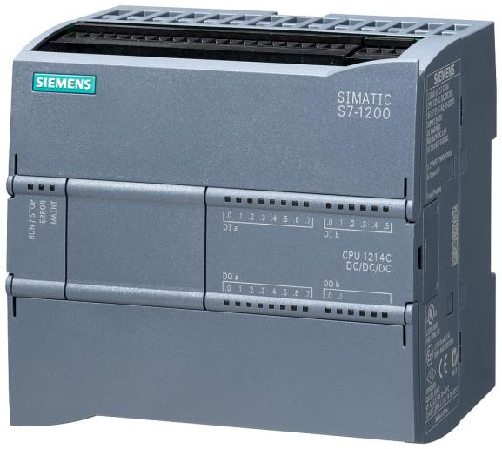

**Fig. 2.2: Siemense PLC S7-1200**

**2.3.2.1 Key Theoretical Concepts**:

i Modularity: The S7-1200 PLC is modular, meaning it can be expanded with additional input/output (I/O) modules, communication modules, and other extensions, allowing it to adapt to different tasks.

ii. Programming: The S7-1200 is programmed using Siemens' TIA (Totally Integrated Automation) Portal software. The programming languages supported include Ladder Logic (LAD), Function Block Diagram (FBD), and Structured Text (ST). These languages allow engineers to create programs that define the behavior of the PLC in response to input signals.

iii. Networking and Communication: The S7-1200 PLC is capable of connecting to various industrial networks (e.g., PROFINET, Ethernet) to communicate with other PLCs, SCADA systems, and human-machine interfaces (HMIs). This makes it ideal for distributed control systems.

iv. Real-Time Processing: The PLC operates in real-time, meaning it can process inputs and produce outputs within very short timeframes, critical for automation tasks where timing is crucial.

v.Safety and Reliability: PLCs like the S7-1200 are designed to operate in harsh industrial environments with high reliability, providing features like watchdog timers, fault diagnosis, and redundancy.

**2.3.2.2 Specifications of Siemens S7-1200 PLC**

i. CPU Variants:

- CPU 1211C: Basic model with 6 digital inputs, 4 digital outputs, and 2 analog inputs.

- CPU 1212C: 8 digital inputs, 6 digital outputs, expandable with additional I/O modules.

- CPU 1214C: 14 digital inputs, 10 digital outputs, with more expansion possibilities.

- CPU 1215C: 14 digital inputs, 10 digital outputs, designed for more complex tasks.

- CPU 1217C: Highest performance model with the largest memory and fastest processing speed.

ii. Memory:

- Program Memory: Varies from 50 KB to 125 KB depending on the CPU model.

- Data Memory: Ranges from 10 KB to 50 KB.

- Load Memory: Up to 4 MB with memory cards.

iii. I/O Modules:

- Digital and analog I/O modules are available for expansion.

- High-speed counters and pulse outputs for applications requiring precise timing.

iv. Communication:

- PROFINET: Integrated PROFINET interface for communication and networking.

- Ethernet: Standard Ethernet interface for programming and data exchange.

- RS485/RS232: Communication modules for serial communication.

- Communication Protocols: Supports Modbus TCP, S7 communication, and other standard protocols.

v. Power Supply:

- Operating voltage: 24 V DC.

- Power consumption: Depends on the CPU model and connected modules, typically ranging from 2 W to 20 W.

vi. Environmental Specifications:

- Operating Temperature: 0°C to 55°C.

- Storage Temperature: -40°C to 70°C.

- Protection Class: IP20, suitable for mounting in control cabinets.

vi. Real-Time Clock:

- Integrated real-time clock for time-based control tasks and logging.

vii. Expansion Capabilities:

- Supports up to 8 signal modules, 3 communication modules, and various function modules for specific tasks like positioning or temperature measurement.

viii. Safety Features:

- Watchdog Timer: Ensures the PLC does not enter an undefined state.

- Diagnostic Functions: Continuous monitoring and fault diagnostics for increased system reliability.

ix. Programming Languages:

- Ladder Logic (LAD), Function Block Diagram (FBD), and Structured Text (ST).

- TIA Portal software for programming, configuration, and diagnostics.

Applications

- Industrial Automation: Used in controlling machinery, conveyor systems, and assembly lines.

- Building Automation: Managing HVAC systems, lighting control, and access control systems.

- Process Control: In chemical plants, water treatment facilities, and other process industries.

- Energy Management: Monitoring and controlling energy usage in factories or buildings.

**2.3.3 DC Voltage Transmitter 0-500v 4-20mA**

A DC Voltage Transmitter that converts a DC voltage input (0-500V) to a standardized 4-20mA current output is commonly used in industrial applications for monitoring and controlling high-voltage systems. Below is an overview and some important specifications.

Functionality:

- The DC Voltage Transmitter is designed to take a varying DC voltage input (0-500V) and convert it into a corresponding 4-20mA current signal.

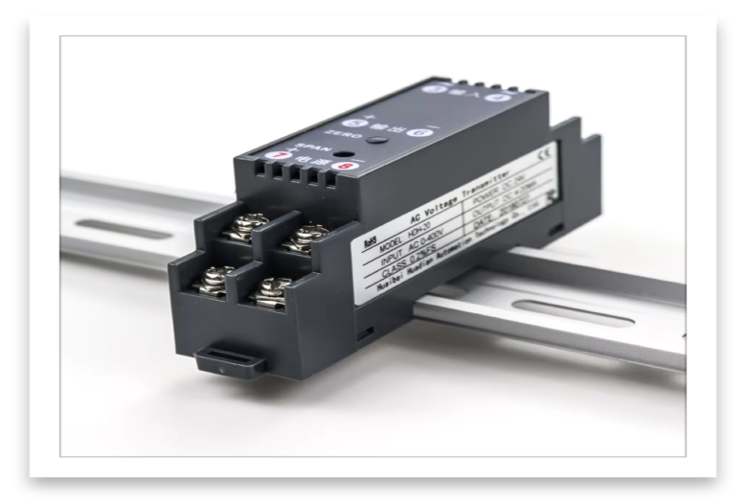

**Fig 2.4: DC Voltage Transmitter**

The 4-20mA output is a common standard in industrial automation and instrumentation, allowing the voltage signal to be transmitted over long distances with minimal signal loss and providing inherent signal integrity.

Applications:

- Power Systems: Monitoring voltage levels in power distribution systems.

- Battery Monitoring: Used in battery systems, including those in renewable energy setups.

- Industrial Equipment: For tracking voltage in various industrial machines and processes.

- Control Systems: Integrates with PLCs, DCSs, and SCADA systems for control and monitoring purposes.

Specifications

i. Input Specifications:

- Input Voltage Range: 0 to 500V DC

- Input Impedance: Typically high (e.g., >1MΩ) to minimize the load on the voltage source.

ii. Output Specifications:

- Output Signal: 4-20mA current loop

- 4mA represents the minimum input voltage (0V).

- 20mA represents the maximum input voltage (500V).

- Load Resistance: Commonly up to 500Ω (depends on the power supply voltage).

iii. Accuracy:

- Typical Accuracy: ±0.1% to ±0.5% of full-scale output.

- Linearity: Typically within ±0.1% of full scale.

iv. Power Supply:

- Supply Voltage: 12-36V DC, depending on the model and manufacturer.

v. Environmental Specifications:

- Operating Temperature: -25°C to +70°C (can vary by model).

- Humidity: 0-95% non-condensing.

- Protection Class: IP20 or higher, depending on the enclosure.

vi. Mounting:

- Mounting Options: DIN rail mounting, panel mounting, or enclosure-based designs.

vii. Isolation:

- Galvanic Isolation: Often features isolation between the input, output, and power supply to protect against electrical noise and ground loops, typically rated at 1500V or higher.

viii. Response Time:

- Typical Response Time: 10ms to 100ms, depending on the application requirements.

ix. Certifications:

- Safety Certifications: CE, UL, or other relevant standards for electrical safety and EMC (Electromagnetic Compatibility).

Usage Example

If a system is monitoring a battery bank with a voltage range of 0-500V DC:

- When the voltage is 0V, the transmitter outputs 4mA.

- When the voltage is 250V, the transmitter outputs 12mA.

- When the voltage is 500V, the transmitter outputs 20mA.

- This 4-20mA signal can be fed into a PLC or other monitoring equipment to observe or control the system based on the voltage levels.

Selection Considerations

When choosing a DC Voltage Transmitter for your application:

- Voltage Range: Ensure the transmitter can handle the specific voltage range (0-500V in this case).

- Accuracy Requirements: Depending on the precision needed for your application, choose a transmitter with the appropriate accuracy and linearity.

- Environmental Conditions: Consider the operating environment (temperature, humidity) and ensure the transmitter is rated accordingly.

- Output Compatibility: Verify that the 4-20mA output is compatible with your monitoring or control system.

**2.3.4 Indicator Lamps**

AC LED indicators are devices designed to visually indicate the status of an electrical circuit powered by alternating current (AC). Unlike traditional incandescent or neon lamps, these indicators use light-emitting diodes (LEDs) to provide illumination. LEDs operate by emitting light when an electric current flows through a semiconductor material, producing efficient and long-lasting light output.

Working Principle:

LEDs are inherently DC (Direct Current) devices, meaning they require a constant, unidirectional current to operate. However, in AC LED indicators, special circuitry is used to convert or adapt the AC power for LED use. This often involves the following methods:

- Bridge Rectifier: Converts the AC signal into a DC signal by rectifying both the positive and negative cycles of the AC waveform.

- Current Limiting Resistors: Reduce the current to a safe operating range for the LED.

- Capacitors: Smooth out fluctuations in the rectified signal to prevent flickering and ensure consistent illumination.

AC Compatibility:

AC LED indicators are designed to work with standard voltage levels, such as 110V or 220V, depending on the region. The internal circuitry ensures that the LED can handle the alternating nature of AC voltage without damage or flickering.

Advantages:

- Energy Efficiency: LEDs consume significantly less power than traditional lamps.

- Long Lifespan: LEDs can last up to 50,000 hours or more, making them highly reliable for long-term usage.

- Low Heat Generation: Unlike incandescent bulbs, LEDs produce minimal heat, reducing energy loss.

Applications:

AC LED indicators are commonly used in control panels, machinery, and electrical equipment to show the status of power, motor operation, or fault conditions, providing clear and immediate visual feedback.

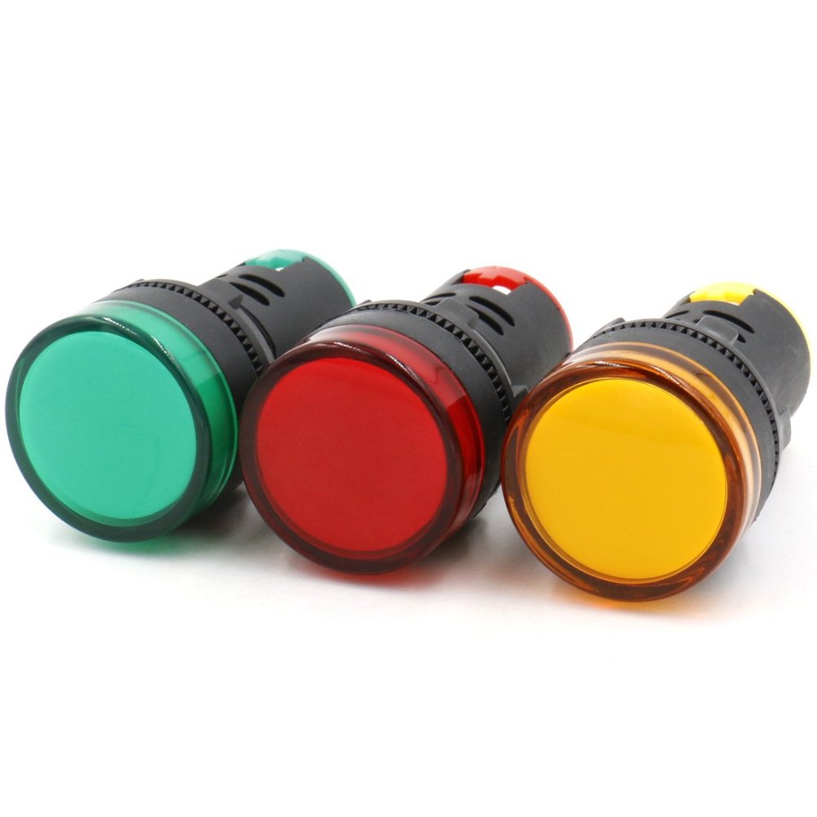

**Fig. 2.4: Indicator lamps**