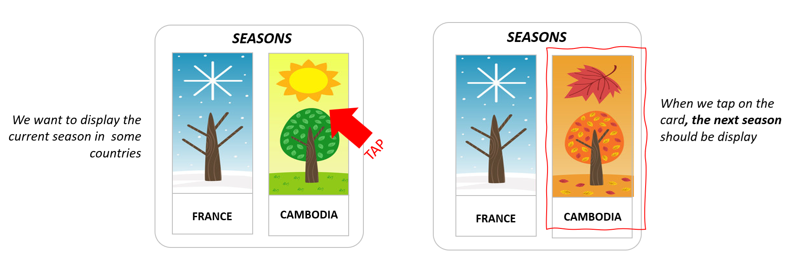

**STEP 1 –** Identify **widgets** you **need** for this app

|  |  |  |  |
| --- | --- | --- | --- |
| Widgets  Name | Type  Stateful / Stateless | Arguments  Name: Type | State  Name: Type |
| SeasonCard | State Stateful | No | Image: Enum |
| ch CountryCard | Stateless | CountryName: String | no no |

**STEP 2 –** Identify the type data for each UI element

|  |  |
| --- | --- |
| UI Elements property | Value source  From State / From Argument / Constant / Compute From XX |
| SEASONS | From State |
| CAMBODIA | Constant |
| Season image | Compute from enum |