Domain Name System
Software Design Document
ARICENT:
0.1
Copyright © 2006-2014The Aricent Group. All Rights Reserved. No part of this document may be reproduced, stored in a retrieval system, distributed or transmitted, in any form, or by any means, electronic or otherwise, including photocopying, reprinting, or recording, for any purpose, without the express prior written permission of The Aricent Group.
Printed in ________
TRADEMARKS: Aricent and the Aricent Logo are trademarks and registered trademarks of The Aricent Group or its subsidiaries or affiliates in the U.S. and certain other countries. The use of these trademarks without Aricent’s prior written consent is strictly prohibited. Other third party trademarks referenced are the property of their respective owners. Please note that the above list is not all-inclusive, and the absence of any mark from this list does not mean that it is not an Aricent trademark.
DISCLAIMER The information in this book is provided “AS - IS”, without warranty of any kind, express or implied, including but not limited to a warranty of merchantability, fitness for any particular purpose, title or non-infringement of third party rights, and Aricent specifically disclaims all other warranties, conditions or representations. This document is provided for informational purposes only, and should not be construed as a representation or a commitment on the part of Aricent. Information in this document is subject to change without notice.
REQUESTSFor information requests or for obtaining permission for the use of this work, please submit a written request to: Corporate Marketing and Legal, The Aricent Group, 303 Twin Dolphin Drive, Suite 600 Redwood City, CA 94065

DOCUMENT No.: ARICENT:

REVISION HISTORY
Revision No. | Date | Description of Change | Author | Reviewed & Approved By
0.2 | 24/02/2015 | Revision Draft | Deepesh Kumar, Divya Kansal, Shivani Badola, Sonia Verma, Sourav Kumar Singh | Rashi Arora

Contents
- 1. Introduction 7
1.1 Purpose 7
1.2 Scope 7
1.3 Definitions and Acronyms 8
1.3.1 Definitions 8
1.3.2 Acronyms 8
1.4 References 8
1.5 Document Organisation 8
1.6 Typographical Conventions (Optional) 9
1.7 Approvals and Authorizations 9
1.8 Distribution 9
- 2. High Level Design 11
2.1 Level 0 Design Description 11
2.1.1 Interface Description 11
2.2 Level 1 Design Description 11
2.2.1 DNS SERVER 12
2.2.1.1 Decomposition Description 12
2.2.1.2 Module Description 12
2.2.1.3 Process Description 13
2.2.1.4 Interface Description 13
2.2.1.5 Process Interface 13
2.2.1.6 Dependency Description 13
2.3 Level 2 Design Description 14
2.3.1 RESOLVER 14
2.3.1.1 Decomposition Description 14
2.3.1.2 Module Description 15
2.3.1.2.1 Process Description 15
2.3.1.3 Interface Description 15
2.3.1.3.1 Process Interface 15
2.3.1.4 Dependency Description 16
2.4 Structure charts 16
2.4.1 Server 16
2.4.2 Client 17
- 3. Alternate Design 18
3.1 Alternate Designs 18
3.2 Design Evaluation Report 18
3.3 Design Limitations 19
- 4. Detailed Design 20
4.1 CLIENT 21
4.1.1 Detailed Data Design 21
4.1.1.1 Data Structure DNS_HEADER 21
4.1.1.2 Data Structure QUESTION 22
4.1.1.3 Data Structure R_DATA 22
4.1.1.4 Data Structure RES_RECORD 22
4.1.1.4 Data Structure QUERY 23
4.1.2 Detailed Module design 23
4.1.2.1 Module 1 23
4.1.2.2 Module 2 24
4.1.2.3 Module 3 25
4.1.2.4 Module 4 27
4.1.2.5 Module 5 27
4.1.2.6 Module 6 28
4.1.2.7 Module 7 29
4.1.2.8 Module 8 29
4.1.2.9 Module 9 30
4.1.2.10 Module 10 31
4.1.2.11 Module 11 32
4.1.2.12 Module 12 33
4.2 SERVER 34
4.2.1 Detailed Data Design 34
4.2.2 Detailed Module Design 34
4.2.2.1 Module 1 34
4.2.2.2 Module 2 35
4.2.2.3 Module 3 36
4.2.2.4 Module 4 37
4.2.2.4 Module 5 38
4.2.2.4 Module 6 39
4.2.2.4 Module 7 41
- 5. System Issues 42
5.1 Performance 42
5.2 Scalability 42
5.3 System sizing 42
5.4 Logging 43
- 6. System Management Design Considerations 45
6.1 MIB Design 45
6.1.1 Standard MIB 45
6.1.2 Proprietary MIB 45
6.2 Configuration and control 46
6.2.1 Overview 46
6.2.2 Start-up 46
6.2.3 Shutdown 46
6.2.4 Creation of < Table name > New Entries 46
6.2.5 Deletion of < Table name > Entries 46
6.3 Error Handling 46
6.3.1 System Errors 46
6.3.2 Interface Errors 46
6.3.3 Protocol Errors 46
6.4 Resource Requirements 47
Revision History 48

Figures

Figure 2.1: Level 0 DFD………………………………………………………………….........11
Figure 2.2: Level 1 DFD……………………………………………………………………….12
Figure 2.3: Level 2 DFD……………………………………………………………………… 14
Figure 2.4: Structure chart for Server......................................................................................... 16
Figure 2.5: Structure chart for Client.......................................................................................... 17

Tables

Table 1-1: Definitions Used in this Document 8
Table 1-2: Acronyms Used in this Document 8
Table 1-3: Approvals and Authorizations 9
Table 1-4: Distribution 9

Chapter
1

Introduction

Purpose

- The Domain Name System is a service which is used by computers ( in Internet ) to map domain names to IP addresses and vice-versa.

Scope
DNS RESOLVER
This Product will simulate the working of a simple Domain Name System. It is only a representation and hence does not actually reflect the working of DNS servers.
The product can be used to resolve:
- IP address when domain name is given
- Domain name when IP address is given

Definitions and Acronyms

Definitions

Table 1-1: Definitions Used in this Document

< IP Address > | IP address is a logical address assigned to a computer used to identify destination computer in the Internet.
Resource Record | Resource record is a domain name to IP address mapping.
Resolver | An application present at client which accepts DNS request from user application and provides record by communicating name server.
Name Server | Name server responds to DNS query message by providing Resource records.

Acronyms

Table 1-2: Acronyms Used in this Document

Acronym | Explanation
DNS | Domain Name System
IP address | Internet Protocol address

References

Document Organisation

Table 1-3: Document Organisation
# | Chapter | Contents
1 | Introduction | Introductory information of the entire project and design document.
2 | High Level Design | Explains the context of the system, Level 0, Level 1 and Level 2 data flow diagrams.
3 | Alternate Design | Specifies any constraints and mentions choice of design over alternate design options
4 | Detailed Design | Pseudo code corresponding to the data flow diagrams
5 | System Issues | Detailed system issues relating to performance of the system.

Typographical Conventions (Optional)
NA

Approvals and Authorizations

Table 1-4: Approvals and Authorizations

 | Designation | Name | Date
Approved by | Mentor | Rashi Arora
Authorized by | Mentor | Rashi Arora

Distribution

Table 1-5: Distribution

Copy No. | Holder’s Designation | Issue Date
1 | Mentor
2 | Team members

Chapter
2

High Level Design

Level 0 Design Description

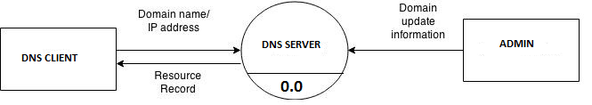

FIGURE 2.1 : Level 0 DFD

- DNS Client will generate query (either Domain name or IP address).
- DNS Server responds with resource record after processing user’s request.
- Administrator can update the DNS database by providing Domain update information to DNS Server System.

  - Level 1 Design Description
    - DNS SERVER

- A DNS Server, in a general sense, is the process by which a DNS record is returned from a Name server
- For example- This is like looking up a phone number in a phone book . Interconnected computers, servers and smart phones need to know how to translate the email addresses and domain names people use into meaningful numerical addresses.

Decomposition Description
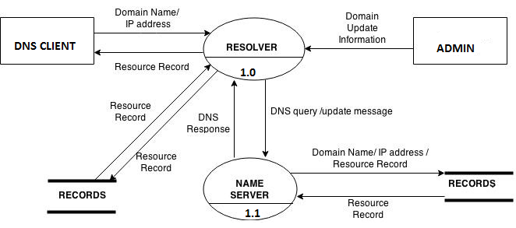

      - Module Description
Resolver
- The resolver’s function is to resolve users' queries.
- Once the resolver is configured, a machine can request DNS service from a name server.
- Whenever the resolver has to find the IP address of a host, or the host name corresponding to an address, the resolver builds a query package and sends it to the configured name server.
Name server
- At the Server’s end, after receiving query from resolver it looks for resource record in its database and reply with DNS response message.
Data Description
- Domain name/ IP address.
- Resource record.
- DNS response message.
- DNS query/update message.
- Domain’s update information.

Data 1
- Domain name- The part of a network addresses which identifies it as belonging to a particular domain.
- IP address- A unique string of numbers separated by full stops that identifies each computer using the Internet Protocol to communicate over a network.
- DNS query- When a DNS client needs to look up a name used in a program, it queries name server to resolve the name.
- DNS response- It’s a response message from name server.
- Resource record- Resource Records (RRs) are the DNS data records contains mapping between domain name and IP address.
- Domain update information- Update in DNS data base provided by network administrator.

      - Process Description
Name Server can support multiple clients simultaneously. Here we are creating threads for each client.
      - Interface Description
Here Client acts as an interface for the user.
      - Process Interface
NA
      - Dependency Description
NA

Level 2 Design Description

Resolver

2.3.1.1 Decomposition Description

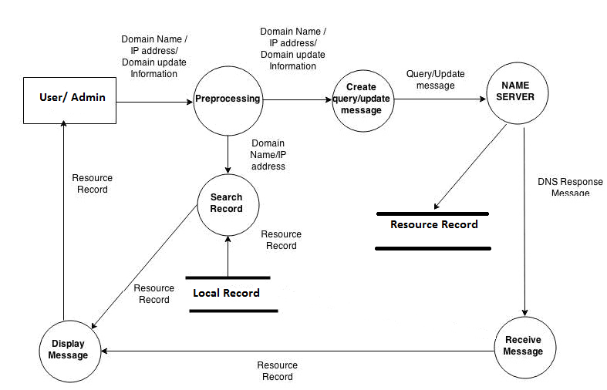
FIGURE: 2.3 Resolver DFD

Module Description
Preprocessing
- Input (One of the following) :
- Domain name with protocols for ex. http://www.google.com/.
- IP address.
- Update information.
- Processing:
- It processes the input and removes all the protocols for ex. google.com
- IP address- It checks whether provided IP address is valid or not.
For ex. 173.194.117.48 valid
260.203.161.8 Not valid or any special address.
- Update information- change in domain name or IP address at server’s data base.

Create query/Update message
- It takes input from preprocessing module and generates DNS queries/update message.

Receive message
- Input: DNS response message from name server.
- Output: Resource record written to Local DNS database and to the Display message module.

Display message
- Input: Resource record either from search record module or from receive message module.
- Output: Resource record is displayed to the user.

Search Record
- Input: Domain name/IP address.
- Output: Resource record to the display message module if present.

Data Description
Query update message- It contains either a query or update information for name server.

Process Description
NA

Interface Description
NA

Process Interface
NA

Dependency Description
NA

Structure Charts

Server

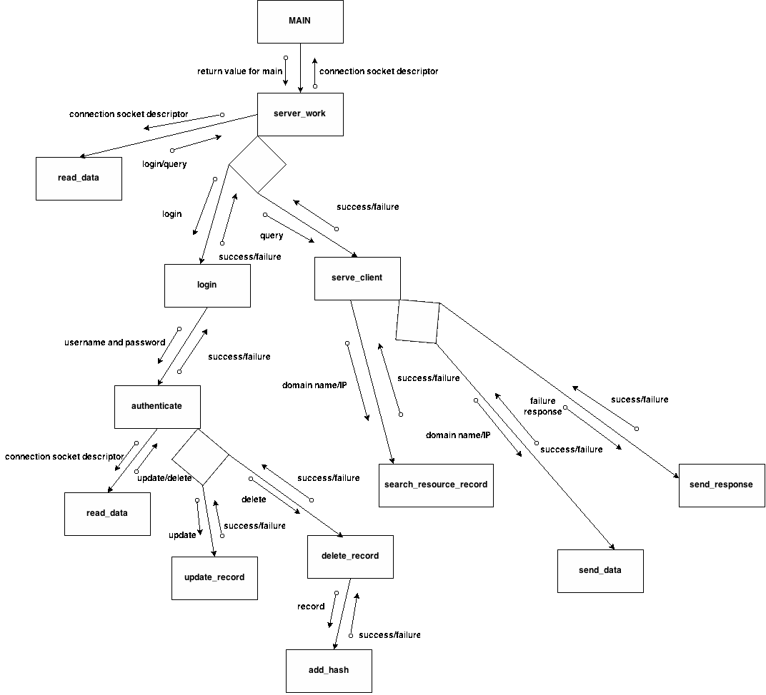
Figure 2.4 : Structure Chart for server

Client

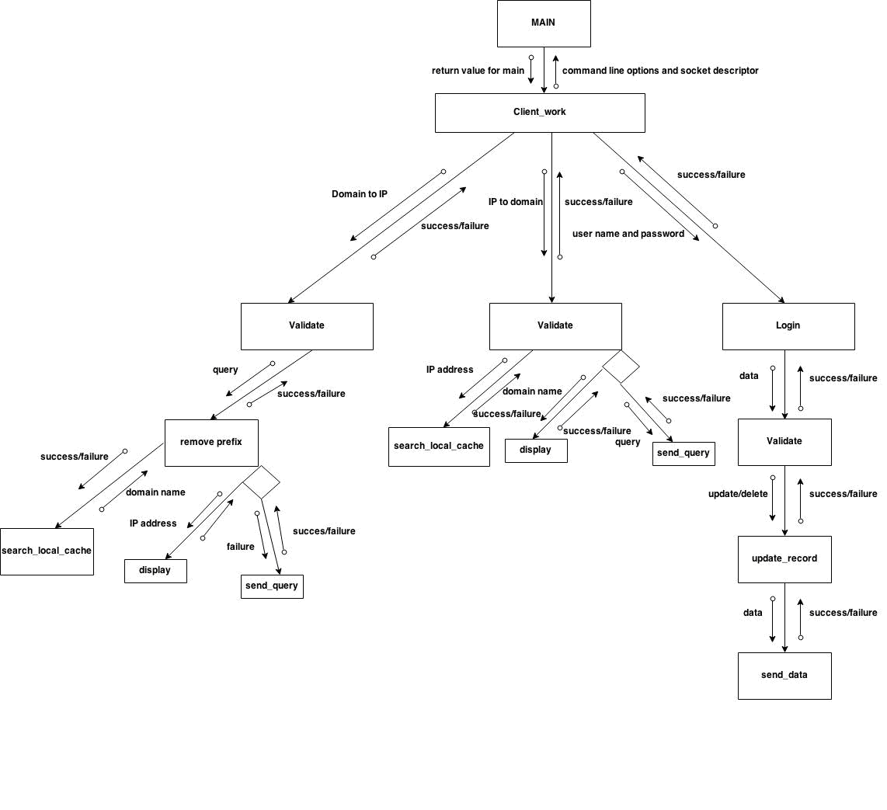

Figure 2.5 :Structure chart for client

Chapter
3

Alternate Design

Alternate Designs

- Fork can be used instead of using threads.
- In order to achieve reliability TCP can be used.

Design Evaluation Report

- In order to use fork, two independent processes has to be made communicable with other in some way. Extra cost is incurred to achieve this inter process communication.
- TCP can be used when response data is more than 512 bytes long.

Design Limitations

- In order to use fork, two independent processes has to be communicable with each other in some way. Extra cost is incurred to achieve this inter-process communication and also costs extra memory.

Chapter
4

Detailed Design

CLIENT

Detailed Data Design

Data Structure DNS_HEADER

Table 4-5: FIELD DESCRIPTION TABLE
Field Name | Field Description | Size (bytes)
ID | Identification number | size of(unsigned short)
Rd | Recursion desired | 1
Tc | Truncated message | 1
Aa | Authoritative answer | 1
Opcode | Purpose of message | 4
Qr | Query/response flag | 1
Rcode | Response code | 4
Cd | Checking disabled | 1
Ad | Authenticated data | 1
Z | Reserved | 1
Ra | Recursion available | 1
Q_count | Number of question entries | Size of(unsigned short)
Ans_count | Number of answer entries | Size of(unsigned short)
Auth_count | Number of authority entries | Size of(unsigned short)
Add_count | Number of resource entries | Sizeof(unsigned short)

DATA STRUCTURE QUESTION

Table 4-6: Question Field Descriptor Table
Field Name | Field Description | Size (bytes)
Qtype | Type of question | Size of(unsigned short)
Qclass | Class | Sizeof(unsigned short)

Data Structure R_DATA

Table 4-3: R_DATA Descriptor Table
Field Name | Field Description | Size (bytes)
Type | Type of resource record | sizeof(unsigned short)
_class | Class of resource record | sizeof(unsigned short)
Ttl | Time to live | sizeof(int)
Data_len | Length of resource record | Sizeof(unsigned short)

Data Structure RES_RECORD

Table 4-4: RES_REC Descriptor Table
Field Name | Field Description | Size (bytes)
Name | Name of resource record | Variable
R_DATA | Resource data | Sizeof(struct R_DATA)
Rdata | Response data | Variable

Data Structure Query

Field Name | Field Description | Size (bytes)
Name | Query name | Variable
Ques | QUESTION field | Sizeof(struct QUESTION)

    - Detailed Module design
      - Module 1

Prototype | int main(int C, char *V[]);
Purpose/  Description | main function performs the function of connecting end point at client and checking which type of query message user wants to create.
Pre-requisites | N A
Input(s) | Command line arguments
Output(s) | IP address/Domain name/update response
Return Value(s) | SUCCESS or FAILURE
Called By | User
Calls | Display_Help  remove_prefix  Dns_Query  validate_ip  Update

Pseudo code: main (arg C, arg 1, arg 2, ……….. )
BEGIN
Returns: 0 on success and 1 on failure
- If ( number of arguments ) < 3
- Dispaly_Help() //Display Instructions
- Return
- End if
- sd ← creating a UDP socket
- If ( arg 1 = ”-DI” ) //Domain to IP
- domain_name = remove_prefix( arg 2); //remove prefix
- Dns_Query (sd, domain_name) //sending domain_name
- Else If ( arg 1 = ”-ID” ) //IP to Domain
- is_valid ← validate_ip(arg 2) //Validating IP
- If (0 = is_valid)
- Dns_Query (arg 2) // sending IP
- Else
- Display_Help() //Display Instructions
- Return 1
- End if
- Else if ( arg1, ”-U” ) //add resource record
- Update ( sd, arg 2, arg 3 )
- Else if( arg1, “-D” ) //delete resource record
- Update( sd, arg 2, arg 3 )
- End If
- Display_Help() //Display Instructions
- close_socket (sd)
END

      - Module 2

Prototype | int Dns_Query ( int sd, struct sockaddr_in *nameserver, char *query, int option )
Purpose/  Description | sending query to server, getting response and then displaying the information to the user.
Pre-requisites | N A
Input(s) | - Client connection descriptor  - Address of structure containing port number  - IP or Domain name,  - Options either for IP or Domain
Output(s) | N A
Return Value(s) | SUCCESS or FAILURE
Called By | main()
Calls | search_local_cache  create_message  save_and_display

Pseudocode : Dns_Query (socket_descriptor,domain_name/IP)
Return: 0 on success and 1 on failure
BEGIN
- resource_record ← search_local_cache(domain_name/IP)
- If ( resource_record !=NULL ) // If found in local cache
- Display( resource_record )
- Return SUCCESS
- End if
- If ( Domain_name is second parameter )
- Domain_name ← Host_to_Dns ( Domain_name )
- End if
- Buffer ← create_message(Domain_name/IP, Query_type)
- Send message to server ( sd, Buffer )
- Receive message length from server ( sd, Buffer )
- If ( buffer.qr = 1 and buffer.rcode = 0 )
- RR ← Fetch from Resource Record (Buffer) //RR: resource record
- Open (local_file)
- append ( RR )
- Close ( file )
- Display( RR )
- return SUCCESS
- End if
- save_and_dispaly( buffer, message_length, “local_cache_file”);
- return FAILURE
End Dns_Query function
      - Module 3

Prototype | int create_message (char * buffer ,char * query ,int Type_Of_Message)
Purpose/  Description | To create DNS query message for DNS query and DNS inverse Query
Pre-requisites | N A
Input(s) | - Domain Name / IP  - Type Of Message
Output(s) | Buffer
Return Value(s) | Message Length
Called By | Dns_Query
Calls | N A

Pseudo code: create_message ( input ,Type_Of_Message)
Return value: Message Length
BEGIN
- buffer ← allocate_memory(dns_message)
- buffer.id ← process_id //set message id
- buffer.qr ← 0 // 0 for query message
- buffer.rcode ← 0
- buffer.rd ← 0
- buffer.qdcount ← 1
- If Type_Of_Message is 1 //Domain to IP
- buffer.question.domain_name← input
- buffer.question.type ← A
- buffer.question.class ← IN
- buffer.opcode ← 0
- Else If Type_Of_Message is 2 //IP to Domain
- buffer.question.IP← input
- buffer.question.type ← PTR
- buffer.question.class ← IN
- buffer.opcode ← 1
- else
- buffer.opcode ← 5 //Add to Records
- set fields according to the update message rules
- End If
- Return buffer
End Create_Message function

      - Module 4

Prototype | int validate_ip ( char *ip )
Purpose/  Description | To check if given IP address is a valid IP address and not a special IP address
Pre-requisites | N A
Input(s) | IP
Output(s) | N A
Return Value(s) | SUCCESS or FAILURE
Called By | main()
Calls | N A

Pseudocode : validate_ip ( ip )
BEGIN
Return value: 0 on success and 1 on failure
- if (ip address is out of range) // 34.53.250.876
- return FAILURE
- else if (ip address is special address) // 255.255.255.255
- return FAILURE
- End if
- If ( ip address is not in proper decimal format ) //13.22.36.49.50
- return FAILURE
- End if
- return SUCCESS
END
      - Module 5

Prototype | Char *HostToDns ( char *domain_name )
Purpose/  Description | To append length of each token in present in domain name
Pre-requisites | N A
Input(s) | Domain Name
Output(s) | Domain_name with length of each token in it
Return Value(s) | Char *
Called By | Dns_Query
Calls | N A

Pseudocode: Host_to_dns (domain_name)
Return value: domain_name with length of each token in it
BEGIN
- for token ← first to last token of domain_name
- token_length ← length_of (token)
- buffer ← append (token_length, token)
- end for
- return buffer
END
      - Module 6

Prototype | Char * search_local_cache ( char * domain/IP )
Purpose/  Description | To search for a record in file corresponding to the field domain_name or IP address
Pre-requisites | N A
Input(s) | Domain name/IP
Output(s) | N A
Return Value(s) | Resource record
Called By | Dns_Query
Calls | N A

Pseudocode : search_local_cache (domain/IP)
Return value: resource record if match is found or NULL if no match is found
BEGIN
- Open (file) //having resources records
- record ← Fetch first record
- Repeat
- If domain = record. domain_name/ IP = record. IP
- Return record
- End if
- record ← fetch next record
- Until all records are fetched
- close (file)
- Return NULL
END
      - Module 7

Prototype | Char * remove_prefix ( char * domain )
Purpose/  Description | To remove various protocol information present at the prefix of domain name
Pre-requisites | N A
Input(s) | Unformatted Domain name
Output(s) | Formatted Domain Name
Return Value(s) | Char *
Called By | main()
Calls | N A

Pseudocode : remove_prefix( char *domain/IP )
Return value: Domain name
BEGIN
1.remove protocol information from input Domain name.
2.Domain_name ← domain_without_protocol_information
END
      - Module 8

Prototype | Char *IPToDomain ( char *IP )
Purpose/  Description | To append length of each token in present in IP address
Pre-requisites | N A
Input(s) | IP Address
Output(s) | Converts IP to .IN-ADDR.ARPA. format
Return Value(s) | char *
Called By | Dns_Query
Calls | N A

Pseudocode: IPToDomain(IP Address)
Return value: domain_name with length of each token in it
BEGIN
- for token ← first to last token of domain_name
- token_array ← token
- end for
- for end of token array
- buffer ← append in reverse (token_length, token)
- end for
- append .IN-ADDR.ARPA. to buffer
- return buffer
END
      - Module 9

Prototype | void Update( int sd, struct sockaddr_in *nameserver, int update_option, char *domain_name, char *ip )
Purpose/  Description | To update new resource record provided by admin
Pre-requisites | N A
Input(s) | - Socket Descriptor  - Address of structure containing port number  - Add or Delete option  - Domain name  - IP address
Output(s) | Stores new resource record.
Return Value(s) | None
Called By | Main
Calls | create_update_message  update_local_cache

Pseudocode: Update( sd, *nameserver, update_option, domain_name, ip )
Return value: None
BEGIN
1.message_length ← create_update_message( buffer, update_option, domain_name, IP )
2.sending message length to name server (sd.buffer)
3.recieving update status from name server (sd.buffer)
4.if ( rcode == 0 )
5. update_local_cache( “local_cache_file”, update_option, domain_name, IP )
6. print SUCCESS
7.else
8. print FAILURE
9.End if
END
      - Module 10

Prototype | int Login_server( int sd, struct sockaddr_in *nameserver )
Purpose/  Description | To authenticate an administrator
Pre-requisites | N A
Input(s) | - Socket Descriptor  - Address of structure containing port number
Output(s) | Login successfull or unsuccessfull
Return Value(s) | SUCCESS or FAILURE
Called By | Main
Calls | NA

Pseudocode: Login_server( sd, *nameserver )
Return value: SUCCESS or FAILURE
BEGIN
1.Accept user_name and password.
2.Send user_name and password to server(sd.info).
3.Recieve Response from server.(sd.info)
4.if ( 0 == Response )
5.SUCCESS
6.else
7.FAILURE
8.End if
END
      - Module 11

Prototype | int update_local_cache( char *filename, int update_option, char *domain_name, char *ip )
Purpose/  Description | To update local cache file.
Pre-requisites | N A
Input(s) | - File name  - Add or delete option  - Domain name  - IP address
Output(s) | Updates local cache
Return Value(s) | None
Called By | Update
Calls | NA

Pseudocode: update_local_cache( filename, update_option, domain_name, IP )
Return value: None
BEGIN
1.open(“local_cache_file)
2.while(TRUE)
3.if ( update_option == ADD )
4. add resource record to file.
5. close(file)
6.else if ( update_option == DELETE )
7. delete resource record from file
8. close(file)
9.End if
10.End while
END
      - Module 12

Prototype | void save_and_display( char *buffer, int length, char *file )
Purpose/  Description | To save and display resource records
Pre-requisites | N A
Input(s) | - Buffer holding the response from server  - Length of the message recieved  - Local cache file
Output(s) | Saves and displays the resource record.
Return Value(s) | None
Called By | Dns_Query
Calls | NA

Pseudocode: save_and_display( buffer, length, file )
Return value: None
BEGIN
1.if ( qr == 1 and rcode == 0 )
2. resource_record ← buffer
3. End if
4. open( “local_cache_file” )
5. if query
6.print domain_name and corressponding IP address
7.if inverse_query
8.printf IP address and corresponding domain name.
END
  - Server
    - Detailed Data Design

Data structures are same as described in section 4.1.1.
    - Detailed Module Design
      - Module 1

Prototype | int main(int C, char *V[]);
Purpose/  Description | main function performs the function of creating end point so that messages can be received from clients and then calling appropriate functions so that server can provide functionality to the client.
Pre-requisites | N A
Input(s) | NA
Output(s) | N A
Return Value(s) | SUCCESS or FAILURE
Called By | NA
Calls | Authenticate  Update_Record(thread)

- Function : Main()
Return : SUCCESS or FAILURE
BEGIN
1. sd ← create_socket
2. while(0 < count) //count = 10
3. recvfrom(client,buffer)
4. if ( buffer == “login” )
5. Authenticate( sd, client_addr)
6. Recieve packet from client side
7. if (thread created) // concurrency
8. send_buffer ← process_message(buffer)
9. Form_and_Send_message (socket_des, send_buffer)
10. END if
11. else
12 Recieve packet from client side
13. if (thread created) // concurrency
14. send_buffer ← process_message(buffer)
15. Form_and_Send_message (socket_des, send_buffer)
16. END if
17. END if
18. Close(socket_des)
END
      - Module 2

Prototype | int Authenticate( ind sd, struct socketaddr_storage *clientaddr )
Purpose/  Description | To authenticate an administrator
Pre-requisites | N A
Input(s) | -socket descriptor  -socket structure containing port number
Output(s) | Successfull or unsuccessfull login
Return Value(s) | SUCCESS or FAILURE
Called By | Main
Calls | NA

BEGIN
1.Recieve packet from client side (sd.login_info)
2.open(“login_file”)
3. if (login_info.username == login_file.username && login_info.password == login_file.password)
4. login_info.response = SUCCESS
5 send the packet to the client
6. END if
7. close(“login_file”)
8. END
      - Module 3

Prototype | Void Update_Record( void * arg )
Purpose/  Description | Routine of the client thread
Pre-requisites | NA
Input(s) | NA
Output(s) | Updates Resource records
Return Value(s) | NULL
Called By | Main
Calls | update_res_record

Function: Update_Record(*arg)
Return: NULL
BEGIN
1.status ← update_res_record(“resource records file”, buffer, head->z )
2.head->qr = 1
3.if ( SUCCESS == status )
4. head->rcode = 0 //set response code success
5.else
6. head->rcode = 1 // set response code to server failure
7.END if
7. send packet to client(sd.buffer)
END
      - Module 4

Prototype | Int update_res_record( char *filename, char *buffer, unsigned char update_option )
Purpose/  Description | To add or delete resource records in resource file
Pre-requisites | N A
Input(s) | -Resource file name  -Header information  -Add or delete option
Output(s) | N A
Return Value(s) | SUCCESS or FAILURE
Called By | Update_Record
Calls

Function : int update_res_record( char *filename, char *buffer, unsigned char update_option )
Returns : SUCCESS or FAILURE
BEGIN
1.record ← buffer
2.mutex_lock
3.open(“Resource record file”)
4.while (TRUE)
5. read the contents from the file
6. if ( ADD == update_option and FAILURE == flag )
7. file_res.name ← record
8. write in file resource record
9. mutex_unlock
10. file(close)
9. else if ( (record->rdata == file_res.rdata ) and (record->name == file_res.name )
10. mutex_unlock
11. file(close)
12. END if
13. if ( DELETE == update_option )
14. Delete entry from resource record.
15. file(close)
16. mutex_unlock
17 END if
18 END while
END
      - Module 5

Prototype | Void serve_client( void *arg )
Purpose/  Description | Thread routine when query or inverse query is to be done
Pre-requisites | N A
Input(s) | Query packet structure
Output(s) | Serves client for query and inverse query.
Return Value(s) | NULL
Called By | Main
Calls | Search_Record

Function : void serve_client( void *arg )
Returns : NULL
BEGIN
1.mutex_lock
2. count = count -1 // 1 client served
3. mutex_unlock
4,head ← buffer
5.qname ← buffer
6.qinfo ← buffer + qname
7. search_return ← Search_Record( “Resource record file”, buffer, qtype,record_count)
8,if ( SUCCESS == search_return )
- head -> rcode = 0
- length ← length of query
11.else
12 head -> rcode ← 2
- length ← length of query
12.END if
13.head->qr ← 1
14.send packet to server(sd.buffer)
15.mutex_lock
16.count ← count + 1
17.mutex_unlock
END
      - Module 6

Prototype | int Search_Record(char *file_name, char *buf, unsigned short type, int *count )
Purpose/  Description | function performs the searching of associated record in file according to the query type.
Pre-requisites | N A
Input(s) | -resoure record file name  -buffer containg query  -type of message  -count of clients
Output(s) | NA
Return Value(s) | Resource_record
Called By | serve_client
Calls | dnstohost  assign_record

Function: Search_record (filename,buffer,type,count)
Return: on success returns resource record on failure returns null
BEGIN
1. Do
2. Fetch(RES_REC)
3. If(opcode = 0)
4. If(Question.qname = RES_REC.domain)
5. Return RES_REC
6. Else If(opcode = 1)
7. If(Question.qname = RES_REC.ip)
8. Return RES_REC
9. Else if(opcode = 5)
10. If(Question.RR = RES_REC) //compare all the fields
11. Return RES_REC
12. Until (End of file)
END

      - Module 7

Prototype | Char *dnstohost( char * dns )
Purpose/  Description | Converts dns format of domain name to host  (Eg. : 3www6google3com0 to www.google.com )
Pre-requisites | N A
Input(s) | dns format domain name
Output(s) | Converts dns format of domain name to host
Return Value(s) | Host name
Called By | Search_Record
Calls | NA

Function: dnstohost(domain_name)
Return: host name
BEGIN
1.while(reading domain_name byte by byte )
2. if ( isdigit(domain_name) )
3. read the number of characters as per the digit encountered
5. store in hosts
4. concatenate “.”
5. end if
6.END while
END

Chapter
5

System Issues

Performance

- Child process are suggested as alternate design over processes.

Scalability

- Server can handle various clients and various clients requests at the same time.

System sizing

NA

Logging

NA
Chapter
6

System Management Design Considerations

MIB Design

Standard MIB

NA

Proprietary MIB

NA

Configuration and control

Overview

NA

Start-up

NA

Shutdown

NA

Creation of < Table name > New Entries

NA

Deletion of < Table name > Entries

NA

Error Handling

System Errors

NA

Interface Errors

NA

Protocol Errors

NA

Resource Requirements

NA

Revision History

Rev | Date of Issue | Author | Approver | Scope
2.0 | 18-Sep-07 | Anjana Gangadharan | QG/SEPG | Supersedes FS DP081
2.1 | 25-Jul-11 | Jalaj Puri | Ramachandran S | Updated company logo and copyright information.
2.2 | 29-May-14 | Gunjan Srivastava | Ramachandran S | Updated Company Logo and copyright information

