Lab 1 | CS471 Web Technologies
Student name: بدر المطيري
Student ID: 431107809

Part 1 HTTP request
Field | Observed value
Request packet | 733
Method and URI | GET /
Host | neverssl.com
Version | HTTP/1.1
Client | 192.168.1.12:58001
Server | 34.223.124.45:80
Connection | keep-alive

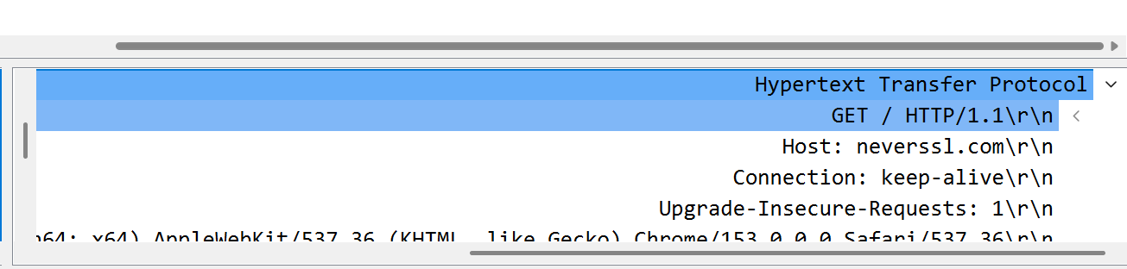
Figure 1. HTTP request headers in packet 733.
GET requests the home page, represented by /. The Host header identifies the website. The keep-alive value requests reuse of the connection for additional requests. The http display filter isolates HTTP packets.

Part 1 HTTP response and conversation
Field | Observed value
Response packet and status | 752; HTTP/1.1 200 OK
Server software | Apache/2.4.68
Content type | text/html; charset=UTF-8
Content encoding | gzip
Body length | 1900 bytes compressed; 3961 bytes after decompression
Time since request | 0.265295 seconds
Linked request | Frame 733; http://neverssl.com/

The 200 OK status indicates a successful response. Content-Length describes the compressed response body, not the whole Ethernet frame. HTTP headers are readable because this exchange uses unencrypted HTTP.
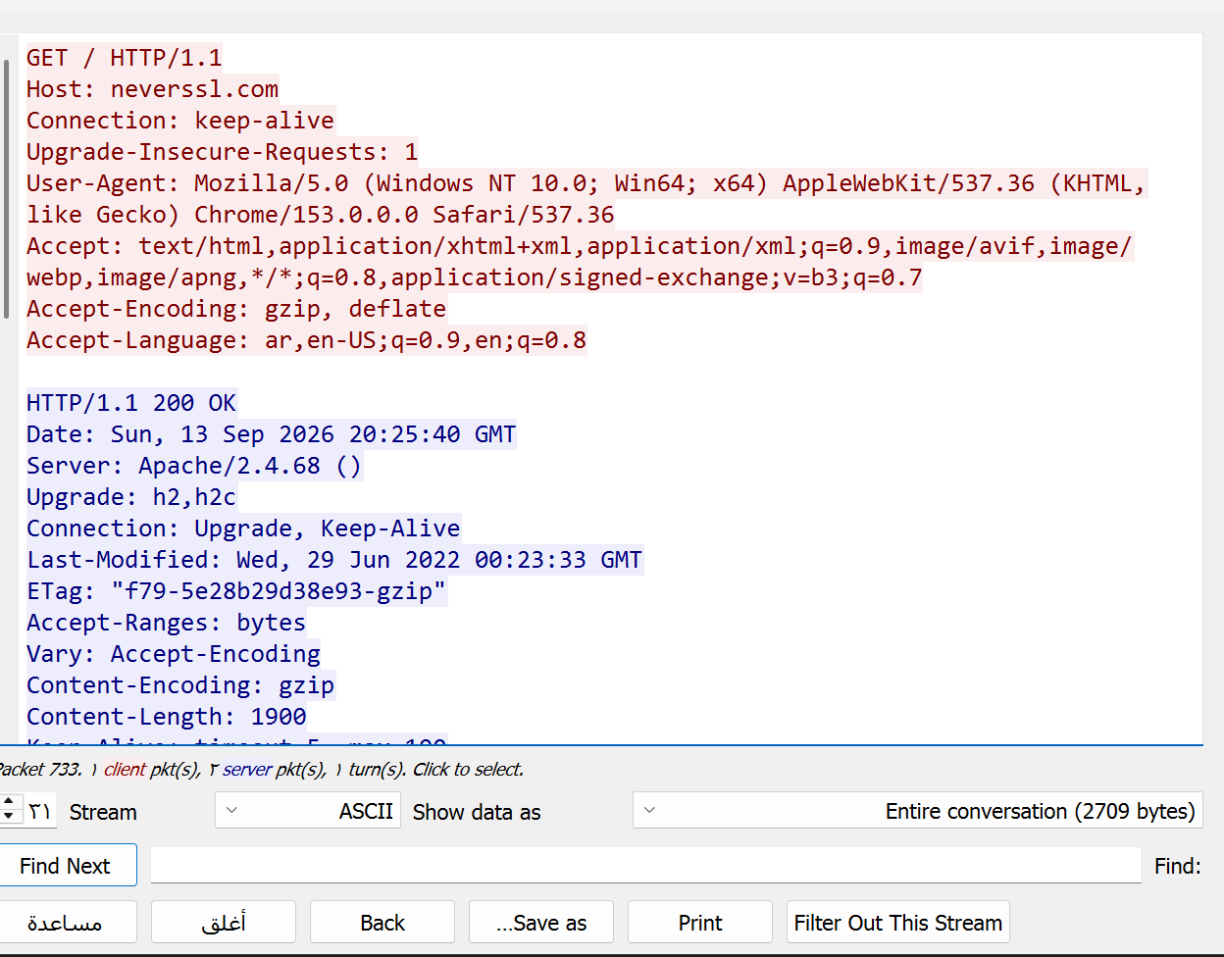
Figure 2. Follow TCP Stream displays the client request in red and the server response in blue.

Part 2 TCP connection establishment
Selecting the HTTP packet and choosing Follow > TCP Stream identifies TCP stream 31. The client is 192.168.1.12:58001 and the server is 34.223.124.45:80. IP addresses identify the network endpoints; TCP ports identify the endpoint services or applications.
Packet | Direction | Flags | Seq | Ack
604 | Client to server | SYN | 0 | Not valid
649 | Client to server | SYN retransmission | 0 | Not valid
662 | Server to client | SYN, ACK | 0 | 1
663 | Client to server | ACK | 1 | 1

The three-way handshake is SYN, SYN-ACK, and ACK. Packet 649 is marked as a retransmission before the SYN-ACK arrives; the screenshots do not establish its cause. The ACK field is not valid in an initial SYN without the ACK flag.
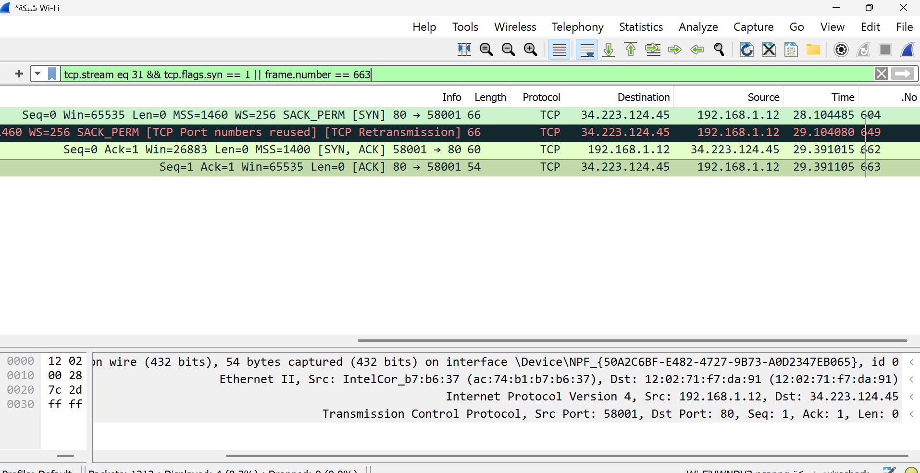
Figure 3. TCP handshake and the additional SYN retransmission.
Wireshark displays relative sequence numbers here. A SYN consumes one sequence number, explaining the acknowledgment value of 1. Sequence numbers identify byte positions; acknowledgment numbers indicate the next expected byte.
Display filter used: (tcp.stream eq 31 && tcp.flags.syn == 1) || frame.number == 663

Part 2 Data transfer and termination
Packet 733 carries the GET request with 436 bytes of TCP payload. Packets 751 and 752 carry the response; Wireshark reassembles the response and labels packet 752 as HTTP 200 OK. Packet 753 acknowledges the response with Ack=2274.
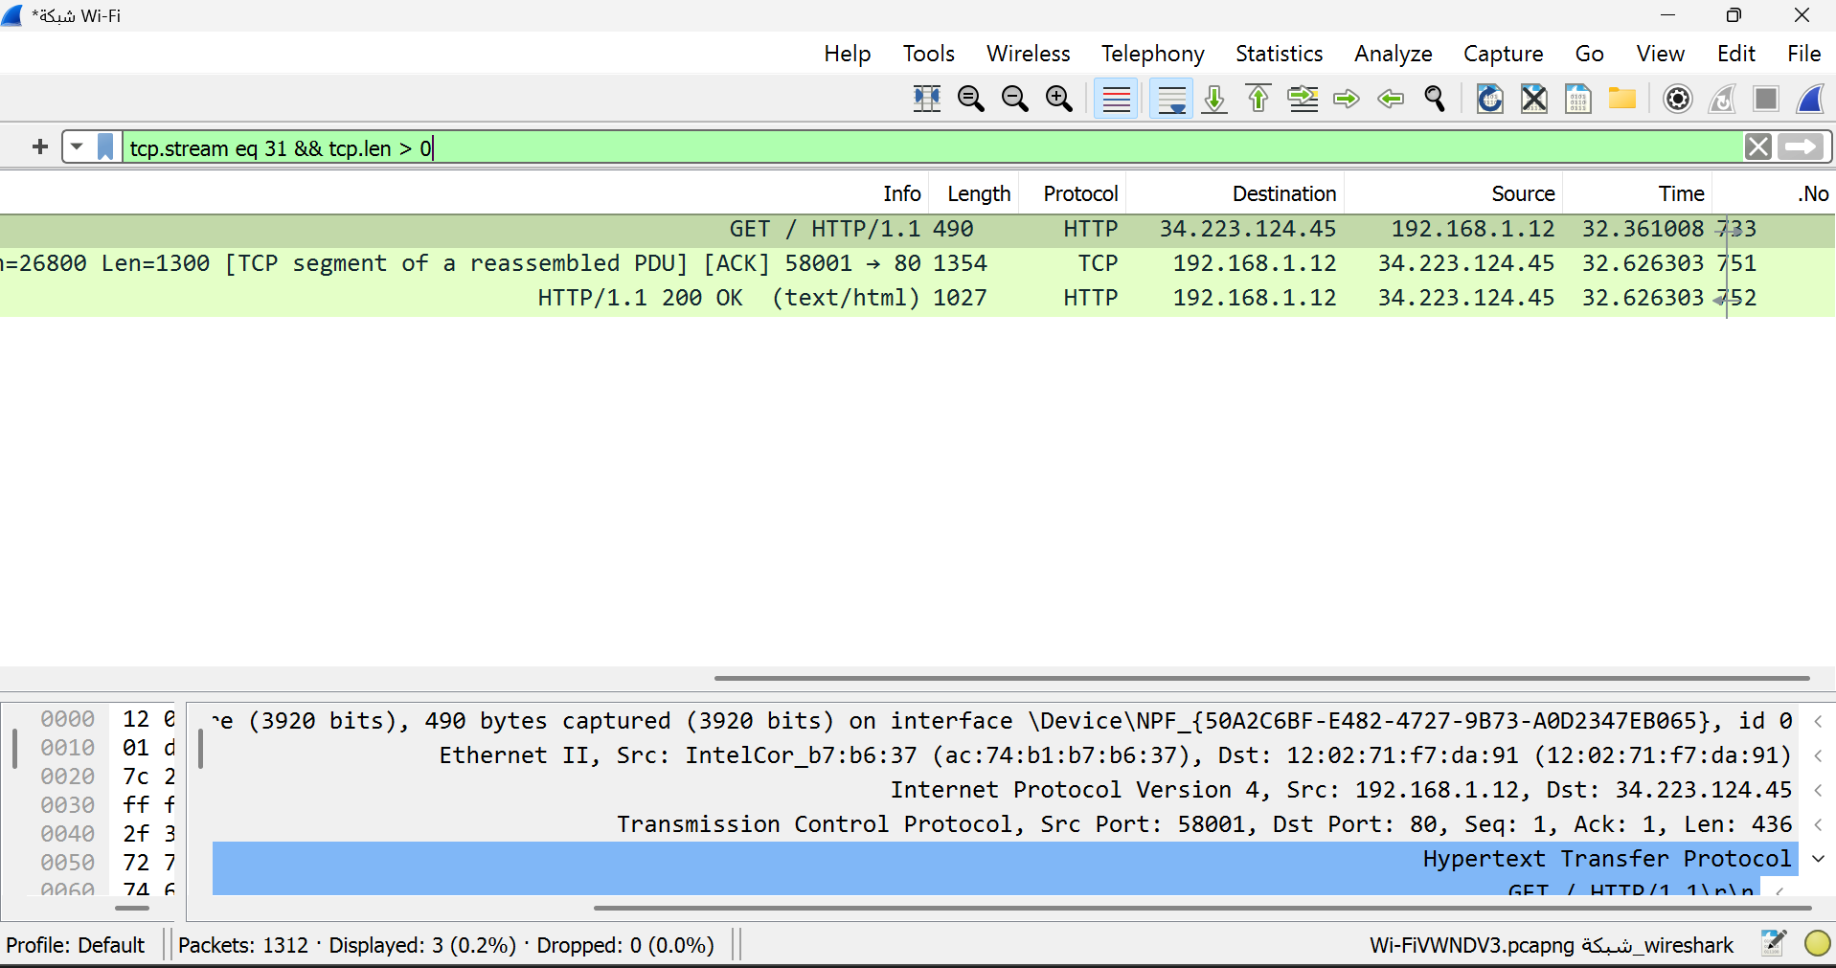
Figure 4. Data packets selected with tcp.stream eq 31 && tcp.len > 0.
Packet | Sender | Flags | Seq | Ack
986 | Server | FIN, ACK | 2274 | 437
987 | Client | ACK | 437 | 2275
1000 | Client | FIN, ACK | 437 | 2275
1009 | Server | ACK | 2275 | 438

The server closes its sending direction first, followed by the client. Each FIN is acknowledged and consumes one sequence number. The final ACK completes the observed four-packet closing exchange.
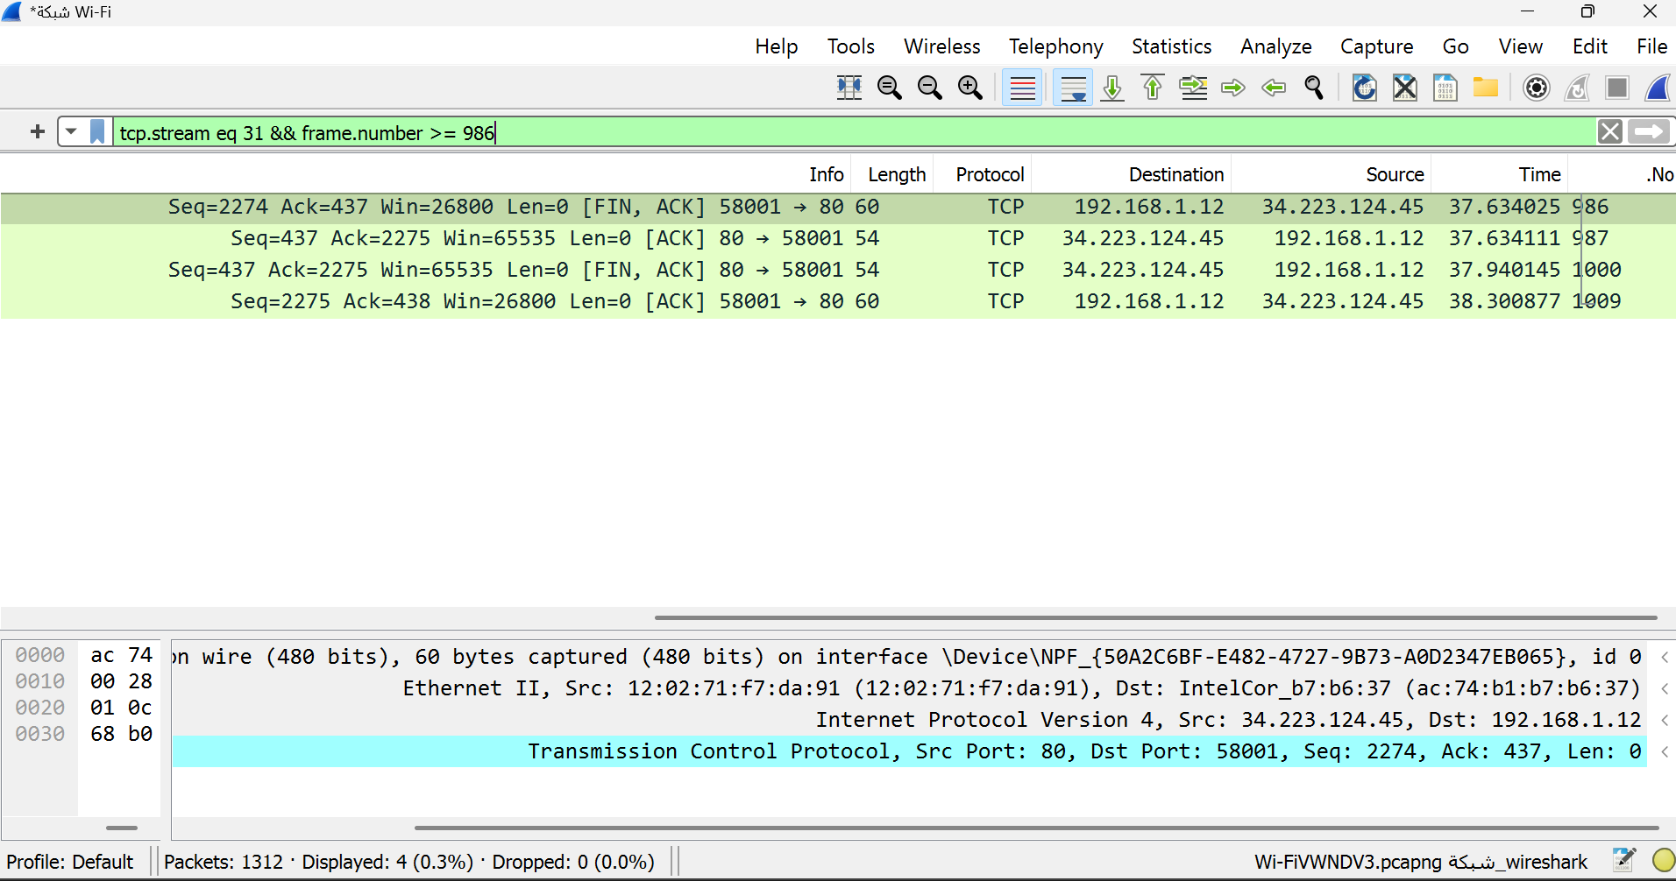
Figure 5. Connection termination selected with tcp.stream eq 31 && frame.number >= 986.

Part 3 UDP analysis
The command nslookup example.com generated DNS traffic. The udp && dns display filter isolates DNS messages transported by UDP. Packet 957 is an A query requesting IPv4 addresses for example.com; packet 958 is its response.
Field | Observed value in packet 957
Source | 192.168.1.12; UDP port 59896
Destination | 86.51.34.24; UDP port 53
UDP length | 37 bytes including header and payload
UDP payload | 29 bytes; DNS A query for example.com
Checksum | 0x3a36; status Unverified
Full frame length | 71 bytes

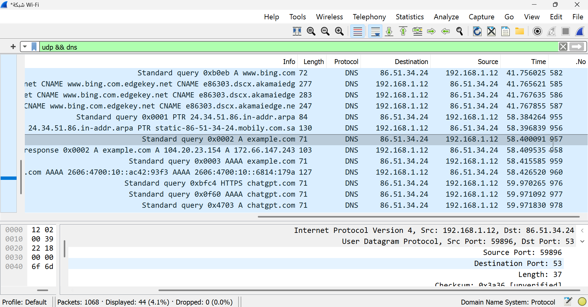
Figure 6. DNS query and UDP source port, destination port and length.
The UDP header is 37 - 29 = 8 bytes. It contains only source port, destination port, length and checksum. TCP has a minimum 20-byte header with additional fields for sequence numbers, acknowledgments, flags and flow control. Unverified means Wireshark did not validate the checksum; it is not evidence of an incorrect checksum.
The DNS response lists IPv4 addresses 104.20.23.154 and 172.66.147.243 in this capture. UDP itself has no TCP-style handshake, delivery acknowledgment, retransmission or ordering. The DNS response is an application message, not a UDP transport acknowledgment.

Part 4 TCP and UDP comparison

Task 1 Reliability and data ordering
Criterion | TCP or UDP | Reasons
Reliability and Connection Establishment | TCP | TCP establishes a connection using a three-way handshake. Acknowledgments and retransmissions provide reliable transport. UDP does not establish a transport connection or guarantee delivery.
Data Integrity and Ordering | TCP | TCP uses a checksum to detect corruption and sequence numbers to deliver data in order. Lost data can be retransmitted. UDP also supports checksum-based error detection but does not itself reorder or retransmit data.

Task 2 Use cases and performance
Criterion | TCP | UDP
Use cases | HTTP/1.1 and HTTP/2 web traffic, email, file transfers and SSH. | DNS queries, real-time voice and video, online games, and QUIC/HTTP/3.
Performance | Connection setup, acknowledgments and retransmissions add overhead and may add delay. Reliable ordered delivery is useful when all data must arrive correctly. | An 8-byte header and no transport handshake reduce overhead. Suitable for delay-sensitive applications, but delivery and ordering require application or higher-layer support.

UDP is not always faster in practice. Actual performance depends on the application, network conditions and any additional reliability mechanisms implemented above UDP.

